**Prerequisite for Tm1Exportify**

|  |  |  |  |
| --- | --- | --- | --- |
| **Date** | **Version** | **Author** | **Change Description** |
| **24-1-2025** | **1.0** | **Mahima Jain** | **Initial Release** |

Contents

Install Visual Studio Code. 1

Install Python. 2

# Install Visual Studio Code.

**Step 1:** Click on this link to download -> [Download Visual Studio Code - Mac, Linux, Windows](https://code.visualstudio.com/Download)

* Based on your operating system (Windows, Linux) download the VS Code.

**Step 2:** In file explorer click download and run as administrator for Vscode exe file (application file).



**Step 3:** Click Next, (Click Next…. until finish button appear) and click on finish. (Installing with default settings).

**Step 4:** Open **Visual Studio Code** and click on extension.

**Step 5:** Search Python and Click python and install. This will help to autocomplete the python code when developing.

**Step 6:** Search Python and Click Pylance and install. This will help to autocomplete the windows and python dependent code when developing. It is depend on Python extension (Step 5). A screen shot of a computer

# Install Python.

**Step 1:** Download and install Python from the official Python website: <https://www.python.org/downloads/>

**Step 2:** Click Next, (Click Next…. until finish button appear) and click on finish. (Installing with default settings)

**Step 3:** After installation, you can verify that Python is correctly installed by searching Python app. Search **python.**

* **Type 10 +10 and press enter.**

**Step 5:** Add environment variable

* Go to the location where python is installed and copy the location till script folder

eg:

**C:\Users\004M1Y744\AppData\Roaming\Python\Python311\Scripts**

* Search in your laptop - “**Edit the system environment variable**” and click on **Environment variable**
* A screenshot of a computer program

  Description automatically generated
* Click on **Path** and click on **Edit**.

* **Click new and paste the location which you have copied. Click ok ok and ok.**

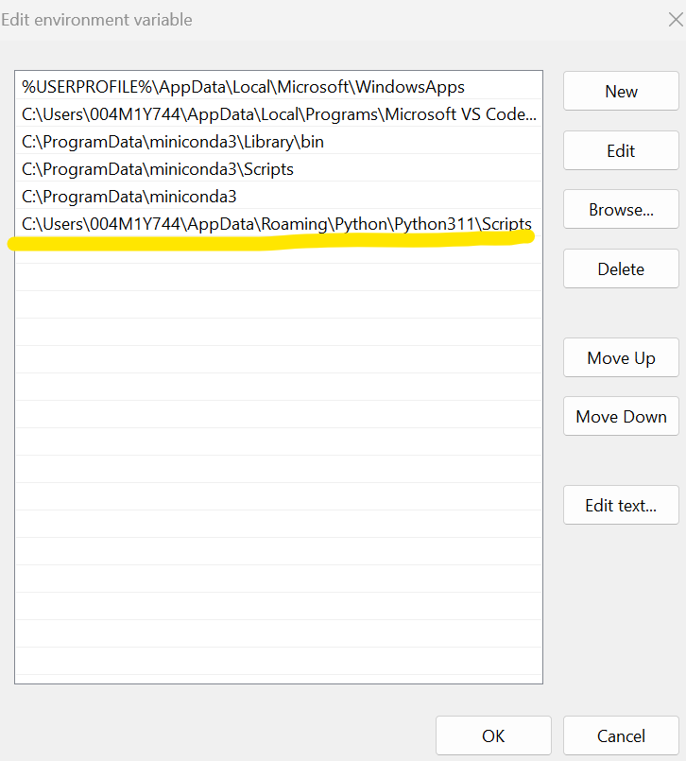

**step 4:** Configure Python Interpreter in VSCode:

* Open VSCode and press **Ctrl+Shift+P** (or Cmd+Shift+P on macOS) to open the Command Palette.
* Type "**Python: Select Interpreter**".
* Choose the Python interpreter you installed from the list of available interpreters. (Select Python you have installed).

