OUTPUT:

SAMPLE CASE 1:

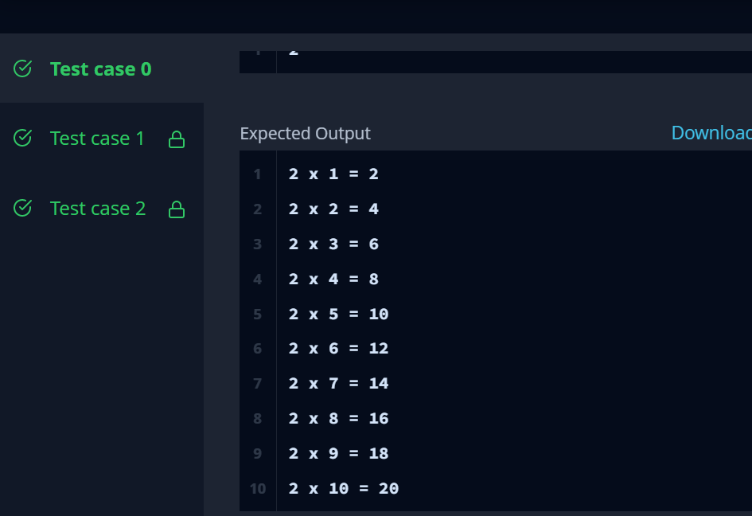

SAMPLE CASE 2:

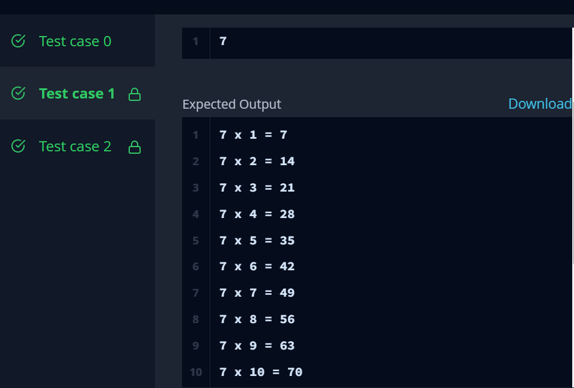

SAMPLE CASE 3:

