Git and Flask Project Assignment

1. Create Repository, Clone Using SSH, Create Branch and Merge

Generate SSH Key
ssh-keygen -t ed25519 -C "mahithakkar59l@example.com"

View Public Key
cat ~/.ssh/id_ed25519.pub

Copy the key and add it to GitHub:
GitHub → Settings → SSH and GPG Keys → New SSH Key

Clone Repository Using SSH
git clone git@github.com:Mahimendha28/flask-assignment.git
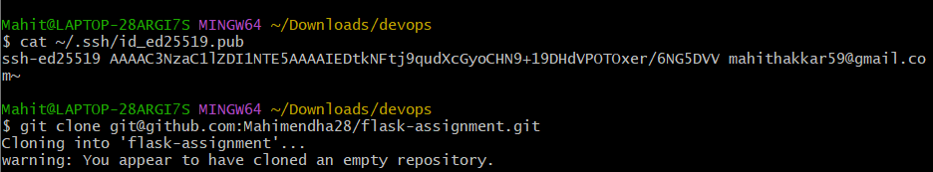

Create Branch Named After Username
git checkout -b tutedude

Add Flask Project Files
git add .
git commit -m "Added Flask project files"

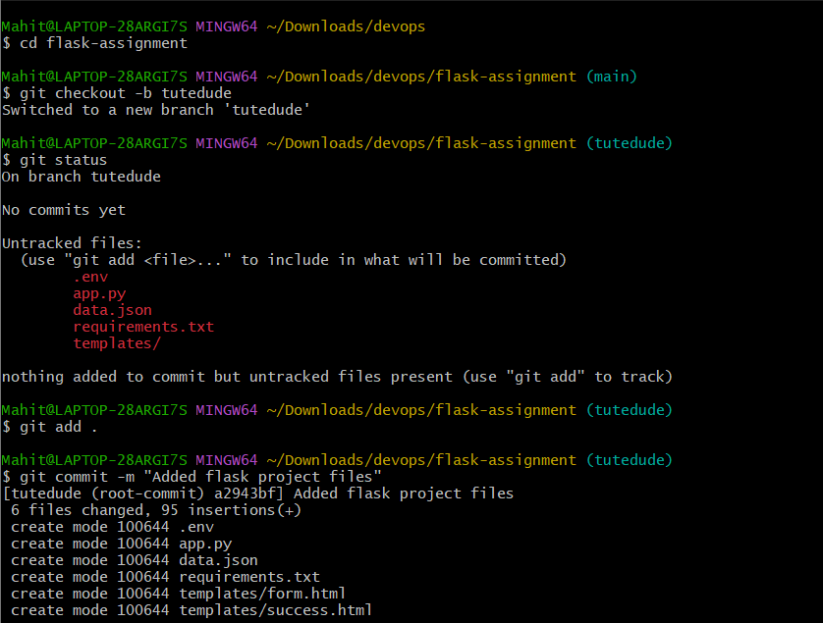

Push Branch
git push origin tutedude

Merge Into Main Branch
git checkout main
git merge tutedude
git push origin main

2. Create New Branch and Update JSON File

Create Branch
git checkout -b Mahit_new

Update data.json
Example:
[
{
"id": 1,
"name": "Mahit"
},
{
"id": 2,
"name": "John"
}
]

Commit Changes
git add data.json
git commit -m "Updated API JSON data"
git push origin Mahit_new

Merge Into Main
git checkout main
git merge Mahit_new
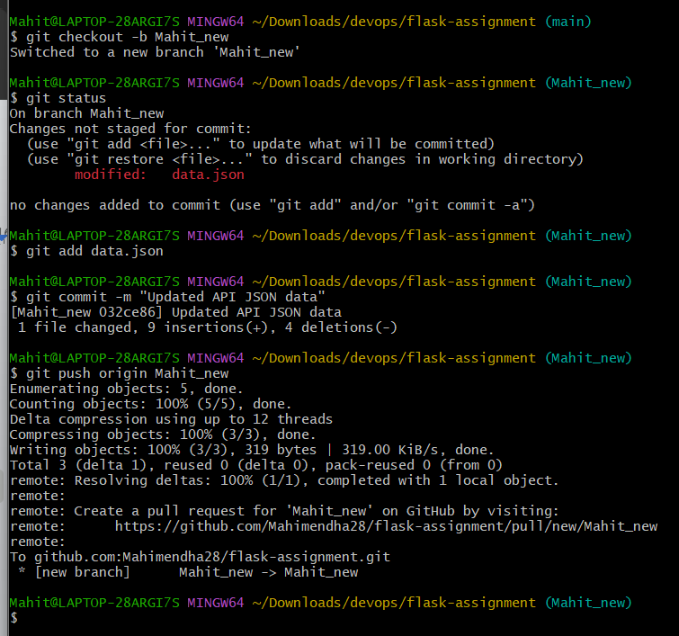

Resolve Merge Conflict (If Any)
Accept changes from Mahit_new branch.
git add .
git commit -m "Resolved merge conflict"
git push origin main

3. Create mater_1 and mater_2 Branches

Create Branches
git checkout main

git checkout -b mater_1

git checkout main

git checkout -b mater_2
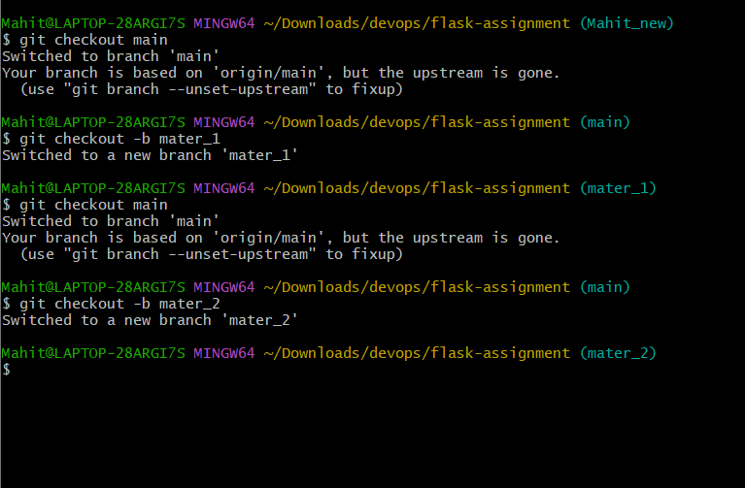

mater_1 - Create To-Do Form
File: templates/todo.html
<form method="POST">
<input type="text" name="itemName" placeholder="Item Name">
<br><br>

<textarea name="itemDescription" placeholder="Item Description"></textarea>
<br><br>

<button type="submit">Submit</button>
</form>

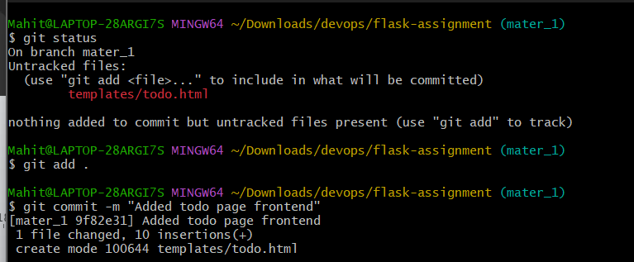

Commit Changes
git add .
git commit -m "Added todo page frontend"
git push origin mater_1
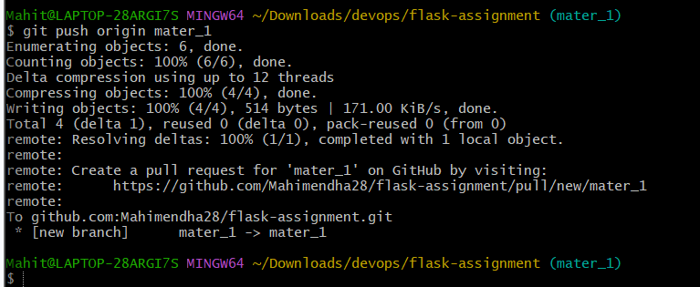

mater_2 - Backend Route
@app.route('/submittodoitem', methods=['POST'])
def submit_todo():

item_name = request.form['itemName']
item_description = request.form['itemDescription']

collection.insert_one({
"itemName": item_name,
"itemDescription": item_description
})

return "Todo Item Saved"

Commit Changes
git add .
git commit -m "Added todo backend API"
git push origin mater_2
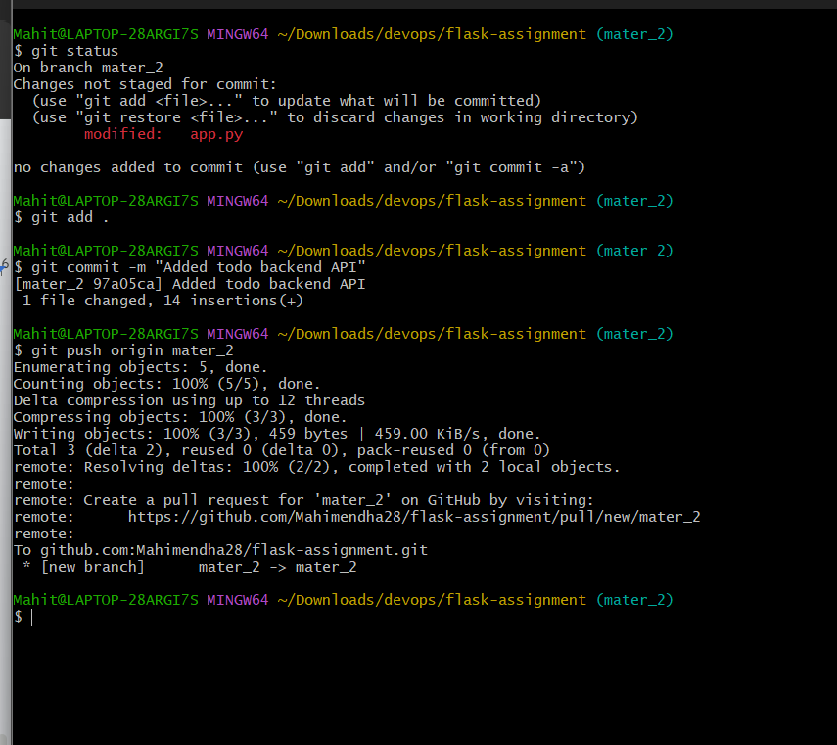

Merge Both Branches Into Main
git checkout main

git merge mater_1

git merge mater_2

git push origin main


4. Add Item ID, UUID and Hash Fields

First Commit - Item ID
<input type="text" name="itemId" placeholder="Item ID">

git add .
git commit -m "Added Item ID field"

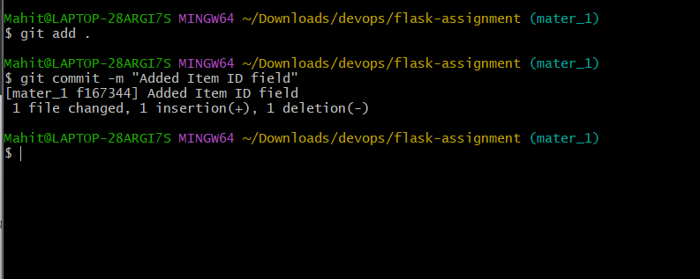

Second Commit - Item UUID
<input type="text" name="itemUUID" placeholder="Item UUID">

git add .
git commit -m "Added Item UUID field"

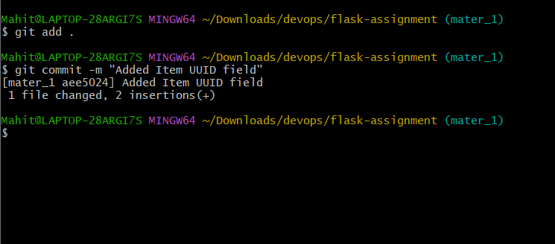

Third Commit - Item Hash
<input type="text" name="itemHash" placeholder="Item Hash">

git add .
git commit -m "Added Item Hash field"
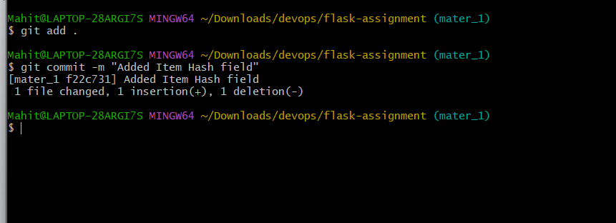

Merge mater_1 Into Main
git checkout main

git merge mater_1

View Commit History
git log --oneline
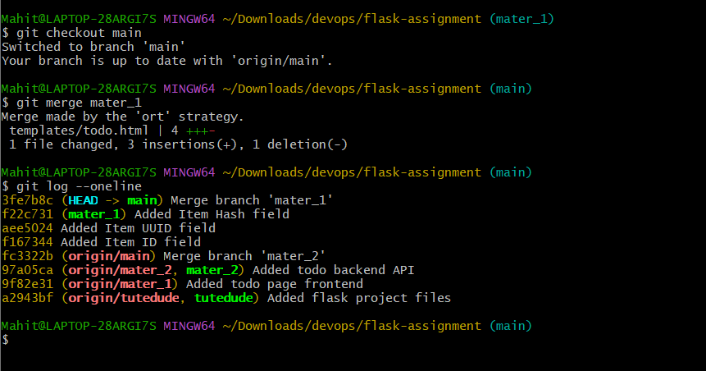

Reset to Commit with Item ID Only
Copy commit hash and run:
git reset --soft COMMIT_HASH

Re-Commit
git commit -m "Rollback to Item ID state"
git push origin main --force
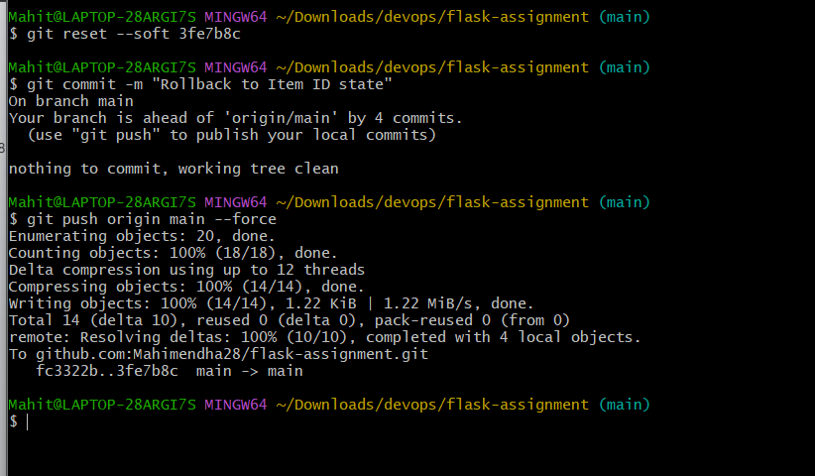

Rebase Main Into mater_1
git checkout mater_1

git rebase main

Push Rebased Branch
git push origin mater_1 --force
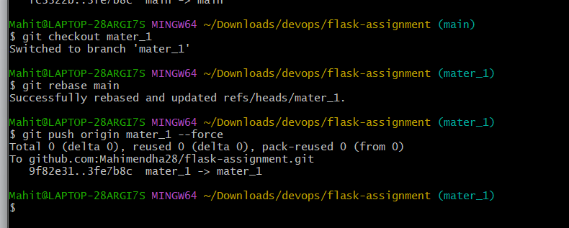

GitHub Repository Link
https://github.com/Mahimendha28/flask-assignment.git

