Assignment 3: Flask API and MongoDB Atlas Integration
Question 1
Create a Flask application with an /api route. When this route is accessed, it should return a JSON list. The data should be stored in a backend file, read from it, and sent as a response.
Implementation
A JSON file named data.json was created to store sample data.
Example:
[
{ "id": 1, "name": "mahi" },
{ "id": 2, "name": "yakin" },
{ "id": 3, "name": "saniya" }
]
The Flask application reads the data from data.json and returns it using the /api route.
Route Used
@app.route('/api')
def api():
with open('data.json', 'r') as file:
data = json.load(file)

return jsonify(data)
Output
When the URL below is accessed:
http://127.0.0.1:5000/api
the JSON data stored in data.json is returned as a response.
Screenshot
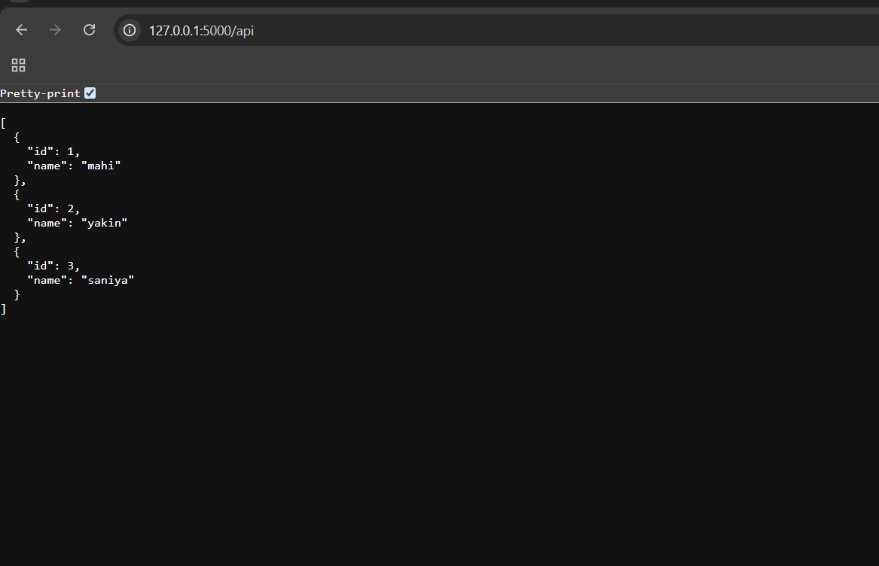
Question 2
Create a form on the frontend that, when submitted, inserts data into MongoDB Atlas. Upon successful submission, the user should be redirected to another page displaying the message "Data submitted successfully". If there's an error during submission, display the error on the same page without redirection.
Implementation
A Student Registration Form was created using HTML to collect:
- Name
- Email
When the user submits the form, Flask receives the data and inserts it into MongoDB Atlas using PyMongo.
Form Submission Code
@app.route('/submit', methods=['POST'])
def submit():
try:
name = request.form['name']
email = request.form['email']

collection.insert_one({
"name": name,
"email": email
})

return redirect(url_for('success'))

except Exception as e:
return render_template('form.html', error=str(e))

@app.route('/success')
def success():
return render_template('success.html')
Success Route
@app.route('/success')
def success():
return render_template('success.html')

Success Message
Data submitted successfully
Error Handling
If MongoDB insertion fails, the error message is displayed on the same form page without redirection.
Screenshots
- Student Registration Form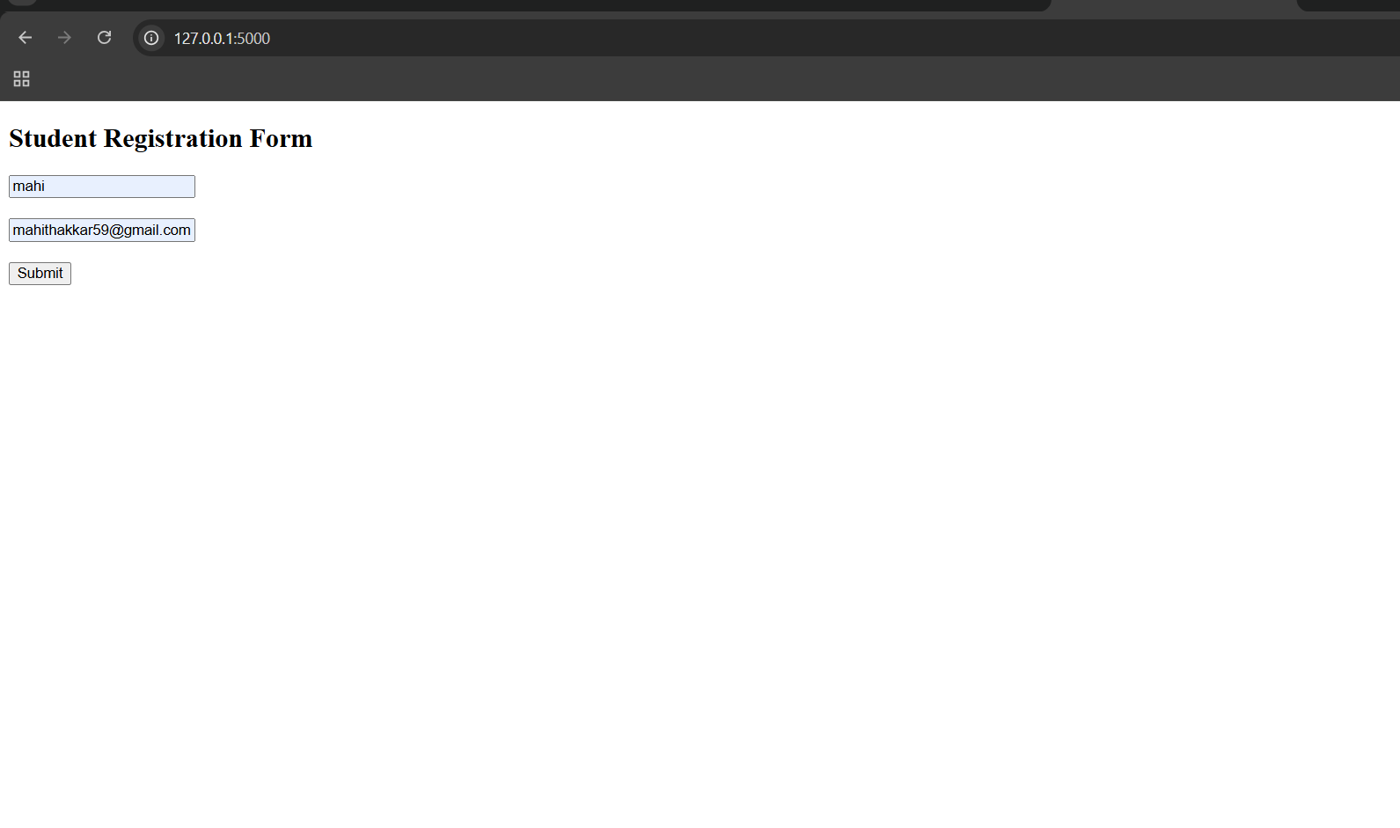
- MongoDB Atlas Collection Showing Inserted Data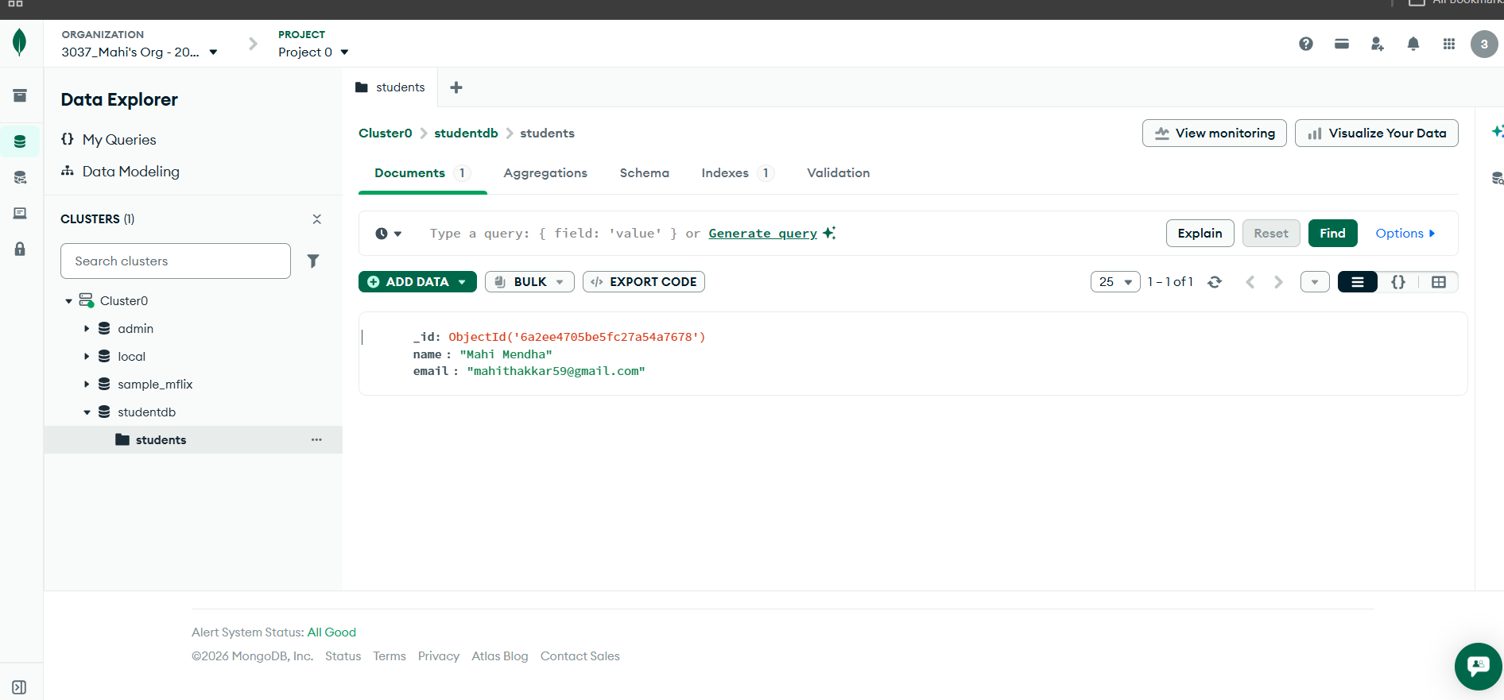
- Success Page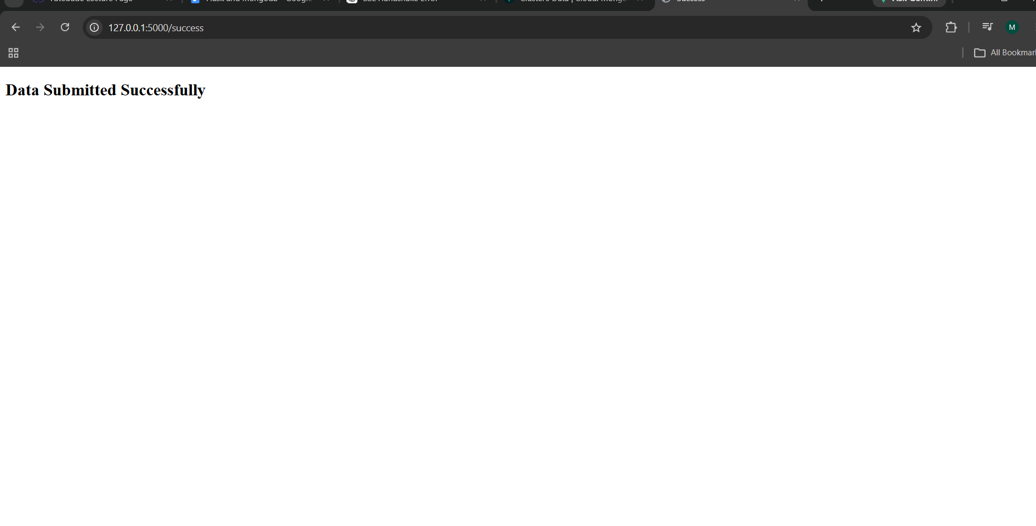

Commands Used
pip install flask pymongo python-dotenv
python app.py

GitHub Repository Link
https://github.com/Mahimendha28/linux-assignment.git
Result
The Flask application successfully returned JSON data through the /api route and stored form data in MongoDB Atlas. Successful submissions redirected users to a success page, while errors were displayed on the same page.

