Blinkit Sales Analysis Report
Executive Summary
This comprehensive analysis examines BlinkIt's retail sales performance across multiple dimensions including outlet performance, product categories, customer preferences, and operational factors. The analysis encompasses 10 core queries and 10 advanced analytical questions to identify performance drivers, growth opportunities, and areas requiring strategic intervention.

Database Overview
The analysis is based on the blinkit_cleaned dataset containing detailed transaction records including outlet information, product attributes, pricing, and sales data.

Core Business Metrics Analysis
Total Revenue Performance
The first query provides the foundational financial metric for all BlinkIt operations. Total revenue represents the aggregate sales across all outlets and products, serving as the baseline for all subsequent performance comparisons and growth calculations.
Query Purpose: Establish the total revenue baseline across the entire organization.
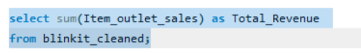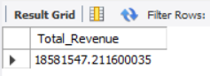

Key Finding: This metric serves as the denominator for all percentage-based analyses and provides the starting point for identifying growth opportunities. Understanding total revenue allows management to contextualize individual outlet performance and establish realistic growth targets.

Sales Growth by Outlet
This analysis ranks all outlets by total sales and average transaction value, providing critical insights into which locations are driving revenue and customer engagement patterns.
Query Purpose: Identify top-performing outlets and compare transaction values across locations.

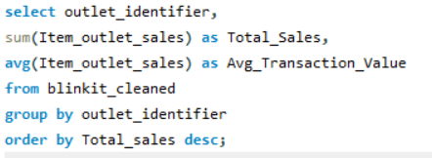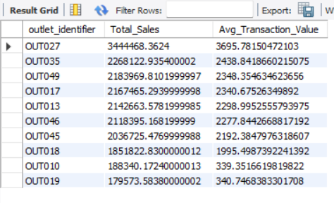

Strategic Insight: Outlets with high total sales but low average transaction values indicate high volume, low-margin operations. Conversely, outlets with high average transaction values but moderate total sales suggest premium positioning or niche customer bases. This distinction guides inventory and pricing strategies.
Key Metrics:
- Total Sales: Indicates outlet revenue contribution
- Average Transaction Value: Reflects customer spending behavior and operational efficiency

Transaction Value Analysis
The analysis of average, minimum, and maximum transaction values provides a comprehensive view of customer purchasing behavior and transaction distribution.
Query Purpose: Understand the range and central tendency of customer purchases.
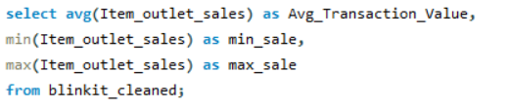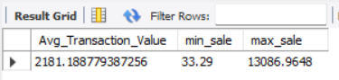

Interpretation: The spread between minimum and maximum sales reveals transaction variability. Outlets with narrow spreads indicate consistent customer behavior, while wide spreads suggest mixed customer bases or product portfolios. Average transaction value serves as a benchmark for assessing individual outlet performance.

Top 3 and Bottom 3 Performing Outlets
Identifying extreme performers at both ends of the spectrum reveals operational excellence and critical problem areas requiring immediate attention.
Query Purpose: Spotlight best practices and identify outlets needing intervention.
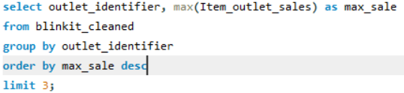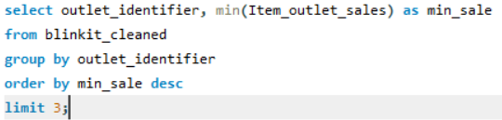
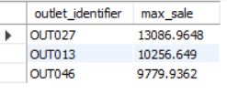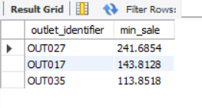
Strategic Application:
- Top 3 Outlets: Serve as templates for replication. Analysis of their configurations, product mix, and operations provides a roadmap for improving other locations.
- Bottom 3 Outlets: Candidates for intensive performance improvement programs, operational restructuring, or closure evaluation. Understanding why they underperform informs strategic decisions.

Product Category Performance Analysis
Top 5 Selling Product Categories
Revenue concentration by product type reveals which categories drive profitability and consumer demand.
Query Purpose: Identify primary revenue generators and high-demand product types.
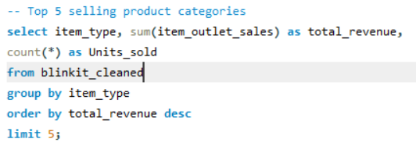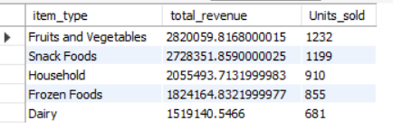

Business Application: Categories with high revenue but low unit sales indicate premium, high-margin products. Categories with high unit sales but moderate revenue suggest volume-driven, lower-margin items. This guides shelf allocation, supplier negotiations, and promotional strategies.

Bottom 5 Selling Product Categories
Understanding underperforming categories informs decisions about discontinuation, repositioning, or elimination from inventory.
Query Purpose: Identify candidates for category rationalization and operational streamlining.
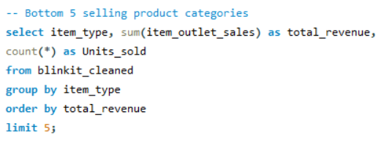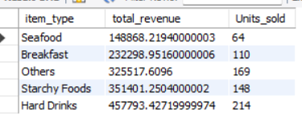

Key Consideration: Low-revenue categories may serve essential functions (e.g., customer convenience items) despite low direct profitability. Decisions to discontinue require analysis of their role in overall store traffic and basket size.

Product Visibility Impact on Sales
This analysis examines the relationship between product visibility (display prominence) and sales performance across categories.
Query Purpose: Quantify the impact of product placement and merchandising on sales outcomes.
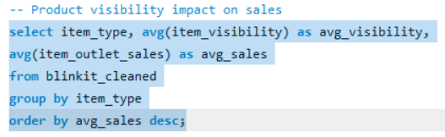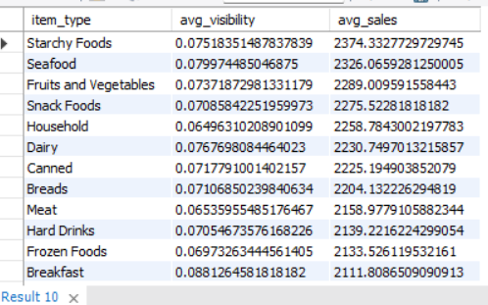

Strategic Finding: Categories with high visibility but low sales may indicate poor product-market fit or need for promotional support. Categories with low visibility yet strong sales demonstrate consumer loyalty and suggest opportunity for revenue growth through increased visibility.
Visibility Metric Interpretation: Item visibility represents the percentage of total store visibility dedicated to a product. Higher visibility indicates better shelf placement and consumer exposure.

Outlet Type and Location Analysis
Outlet Type Performance Comparison
Different outlet formats (supermarket, grocery store, hypermarket) serve different customer needs and operate at different efficiency levels.
Query Purpose: Compare revenue and outlet count across retail formats.
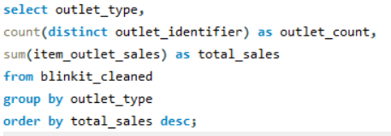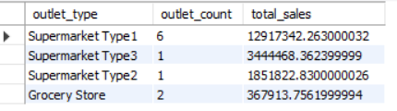

Strategic Insight: This analysis reveals which format is most profitable (revenue per outlet) and which drives volume. Format profitability guides expansion strategy and capital allocation decisions.

Location Tier Performance
Geographic positioning significantly impacts customer base demographics, purchasing power, and product preferences.
Query Purpose: Quantify sales performance across different location tiers (urban, suburban, rural).
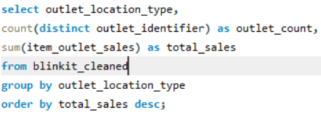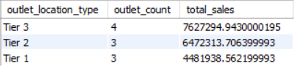

Key Finding: Tier differentiation reveals customer density and purchasing power variations. Higher-tier locations typically command higher prices and volumes. Understanding tier-specific performance guides format and product mix decisions.

Outlet Age and Sales Performance
Outlet establishment history (measured in age) influences brand loyalty, customer base maturity, and operational efficiency.
Query Purpose: Assess whether newer or established outlets perform differently.
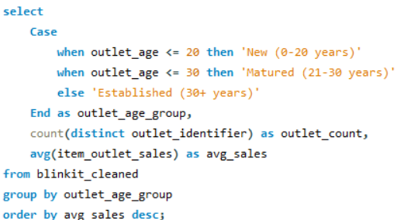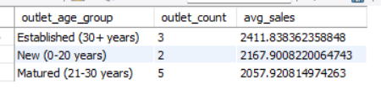

Interpretation: New outlets may show growth potential but face establishment costs. Established outlets benefit from brand loyalty but may face saturation. Mature outlets represent the steady-state performance benchmark.

Advanced Analytical Questions
Q1: Product Types by Outlet Size
This analysis examines which product categories are most important across small, medium, and large outlets.
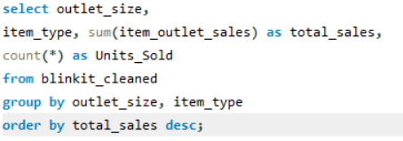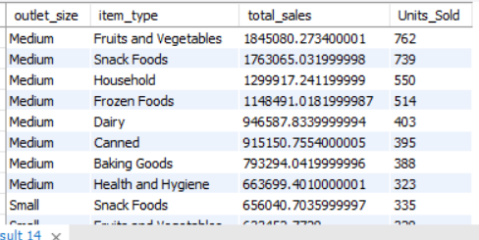

Strategic Application: Small outlets require high-margin, fast-moving categories due to limited shelf space. Large outlets can support broader assortments including slower-moving specialty items. This guides differentiated assortment strategies by outlet size.

Q2: Low-Fat vs Regular Products by Location
Consumer preferences for low-fat versus regular (full-fat) products vary significantly by geography and demographic characteristics.
Query Purpose: Identify fat content preferences across location types to optimize product assortment.
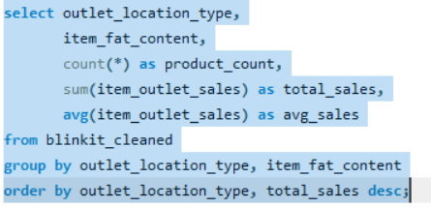
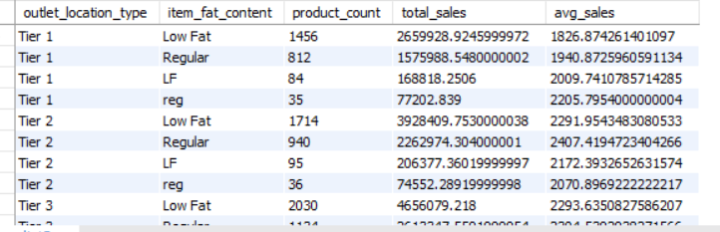
Finding Drivers: Urban tier-3 locations typically show stronger low-fat preferences due to higher health consciousness. Rural tier-1 locations may favor regular products. This geographic preference guides procurement and promotional strategies.

Q3: Underperforming Outlets Analysis
This query identifies outlets performing below their outlet type average, establishing the performance gap that improvement initiatives should address.
Query Purpose: Pinpoint outlets requiring operational intervention and quantify improvement potential.
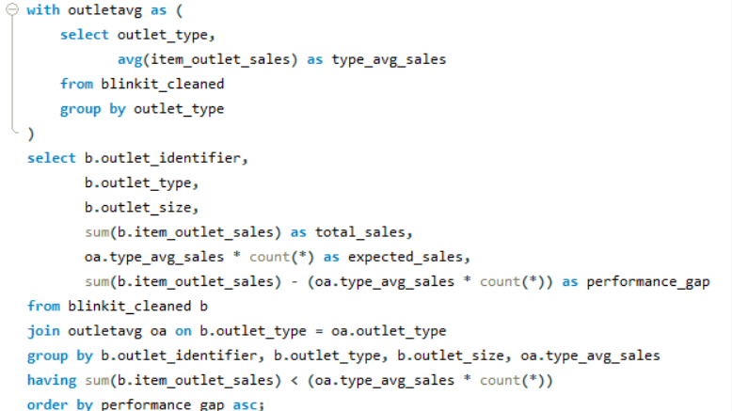
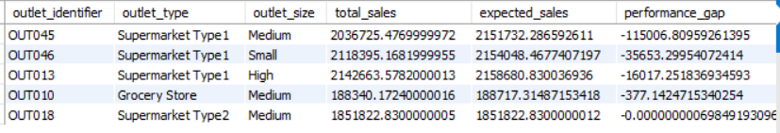
Metric Explanation:
- Expected Sales: Calculated as outlet type average multiplied by transaction count
- Performance Gap: Actual sales minus expected sales (negative values indicate underperformance)
Strategic Use: The magnitude of performance gaps guides intervention priority and resource allocation for turnaround efforts.

Q4: Outlet Establishment Year vs Sales Performance
This time-series analysis tracks how outlets perform based on their age and establishment period.
Query Purpose: Assess performance trends and growth patterns over an outlet's lifecycle.
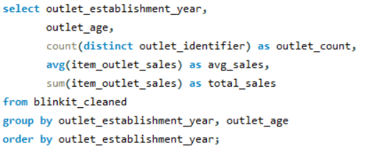
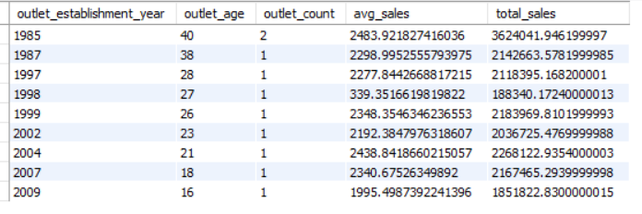
Key Variables:
- Establishment Year: Shows period of opening
- Outlet Age: Calculated years since opening
- Average Sales: Indicates per-transaction performance at different outlet ages
Insight: Performance trends across outlet ages reveal whether the organization has become more effective at opening and managing new outlets over time.

Q5: Sales Performance by Product Visibility Levels
This categorical analysis groups products into visibility tiers to assess merchandising impact.
Query Purpose: Quantify the sales benefit of high-visibility placement versus low-visibility products.
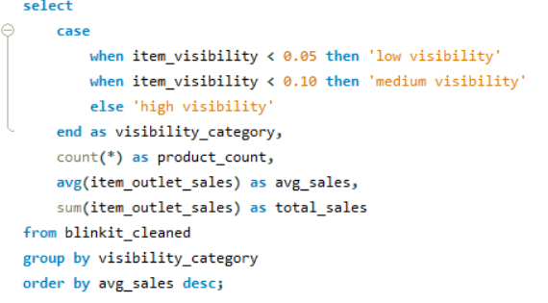
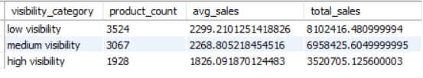
Visibility Categories:
- Low Visibility (< 5%): Products with limited shelf exposure
- Medium Visibility (5-10%): Standard shelf placement
- High Visibility (> 10%): Premium shelf positions
Finding Application: Large differences between visibility categories justify increased investment in premium shelf space for high-performing products.

Q6: Price Range Category Performance
This analysis assesses which product categories perform best at different price points.
Query Purpose: Optimize pricing and category positioning by price segment.
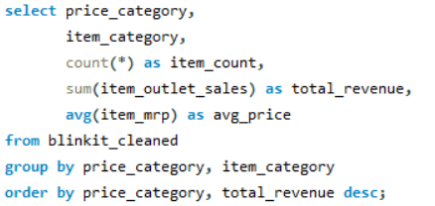
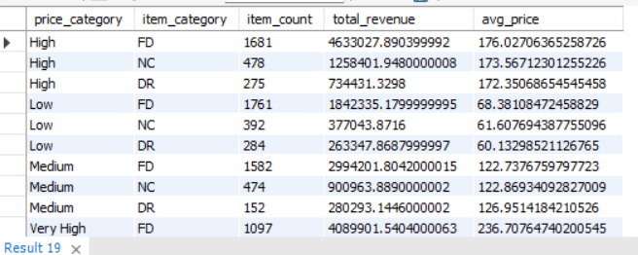
Strategic Consideration: Some categories perform better at premium prices (higher margins) while others are volume-driven at lower price points. This guides promotional strategy and category management.

Q7: Item Weight Impact on Sales
Product weight affects handling costs, shelf space, and customer purchase decisions.
Query Purpose: Assess whether product weight correlates with sales performance.
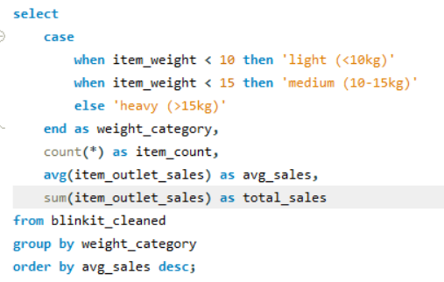
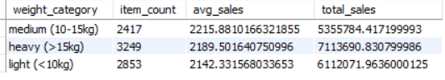
Weight Categories:
- Light (< 10kg): Typically impulse items with lower margins
- Medium (10-15kg): Standard products
- Heavy (> 15kg): Bulk items requiring customer effort
Finding: Weight impact on sales reveals customer preferences and handling cost implications for different product types.

Q8: Optimal Outlet Configuration Analysis
This query identifies the most profitable combinations of outlet type, size, and location.
Query Purpose: Guide expansion and format decisions based on revenue performance of different configurations.
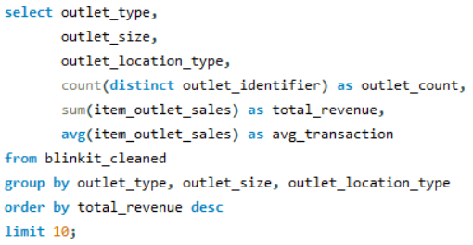
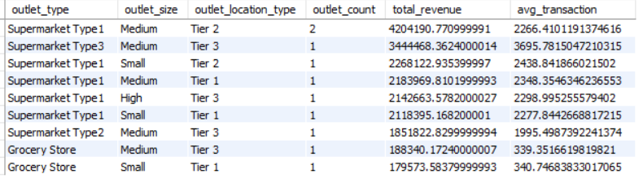
Strategic Value: The top 10 configurations represent proven business models with strong revenue potential. New outlet openings should prioritize these configurations.
Metrics:
- Outlet Count: Number of existing locations with each configuration
- Total Revenue: Aggregate sales from all outlets with this configuration
- Average Transaction: Efficiency metric indicating per-transaction performance

Q9: Sales Percentage by Item Type at Each Outlet
This analysis reveals the product portfolio composition at each location and how it contributes to overall outlet revenue.
Query Purpose: Understand the revenue drivers at each outlet and identify portfolio optimization opportunities.
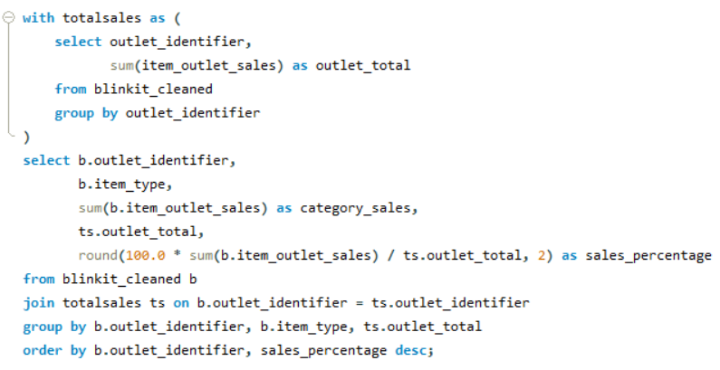
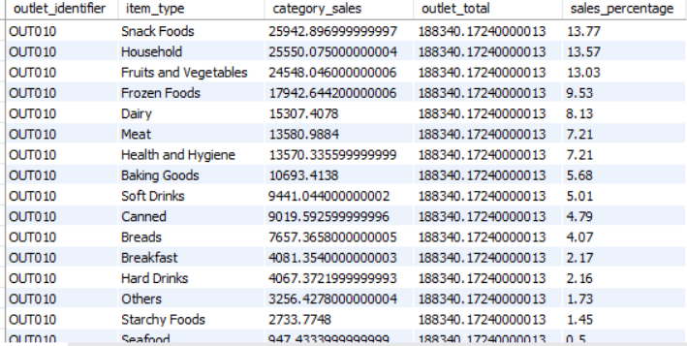
Finding Use: Outlets with narrow product concentration (few categories driving most sales) face revenue risk. Outlets with balanced portfolios show more stable performance. This guides category expansion efforts at underbalanced locations.

Q10: High-Performance Outlets with Low Product Visibility
This query identifies outlets that achieve strong sales despite below-average product visibility, indicating operational excellence and strong management.
Query Purpose: Identify best-practice outlets for operational replication across the network.
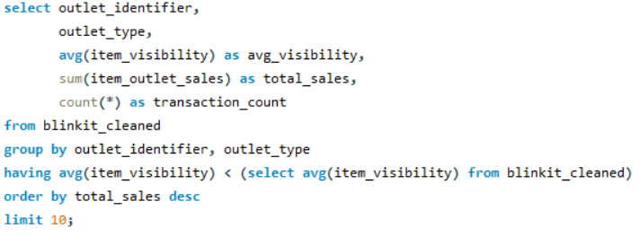
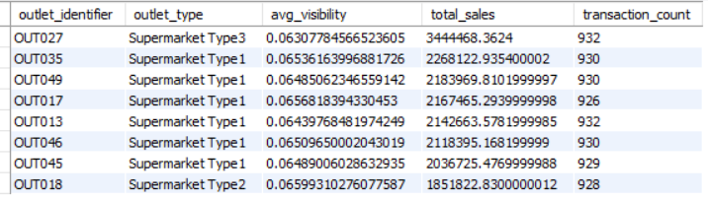
Finding Significance: Outlets overperforming on low visibility represent either:
- Exceptional merchandising and customer service
- Strong location-based customer loyalty
- Effective word-of-mouth and local reputation
Replication Strategy: Analyze management practices, staff training, and operational procedures at these locations for transfer to lower-performing outlets.

Conclusion
This comprehensive SQL analysis provides a multi-dimensional view of BlinkIt's retail operations. The findings support strategic decisions regarding:
- Outlet Network Optimization: Identifying top configurations and underperformers
- Product Assortment: Guiding category selection by location and outlet size
- Merchandising Strategy: Optimizing visibility allocation based on sales impact
- Geographic Expansion: Prioritizing location tiers and configurations
- Operational Improvement: Learning from high-performance outlets
The combination of core business metrics, product analysis, and outlet-specific insights provides a foundation for data-driven decision-making across all levels of BlinkIt's operations.

