**Implementation**

**Software Components**

* **Frontend** built with HTML and CSS for user interaction and image input
* **Backend** using Django and Python for handling image uploads, model integration, and data flow
* **User Flow** to upload cropped prescription and display summarized medicine information
* **API Endpoints** for processing OCR and summarization results
* **Secure Storage** and session handling for managing user data and prescriptions

**AI Components**

* **EasyOCR** for extracting text from digital prescriptions
* **TrOCR** for handling handwritten prescription recognition
* **BART/T5 Generative Model** to produce medicine summaries based on extracted text
* **Custom Dataset** of medicine information built for domain-specific summarization
* **Prompt Fine-Tuning** for better control and relevance of AI-generated summaries

### ****Evaluation****

#### ****Metrics Overview (5 Trials per Model)****

* **Adherence (↑ Better)**
  + bart-base: Highest, consistently near 1.0
  + t5-small: Moderate, fluctuates 0.3–0.5
  + flan-t5-base: Very low, mostly 0.0
* **Readability (↑ Better | Flesch Reading Ease)**
  + t5-small: Generally highest readability
  + bart-base & flan-t5-base: Lower and variable
* **ROUGE-L F1 (↑ Better)**
  + bart-base: >0.9, best alignment with references
  + t5-small: 0.5–0.6 range
  + flan-t5-base: Mostly <0.3
* **Time (↓ Better)**
  + bart-base: Fastest
  + t5-small & flan-t5-base: Slower, with flan showing more variation
* **Pregnancy Field Coverage (↑ Better)**
  + bart-base, t5-small: 100% coverage
  + flan-t5-base: Mostly 0.0, sometimes 0.2
* **Indication Field Coverage (↑ Better)**
  + bart-base: Mostly 1.0
  + t5-small & flan-t5-base: Low & inconsistent

#### ****Conclusion****

bart-base **delivers the strongest performance** in all major areas: accuracy, coverage, and speed. t5-small offers readable summaries with moderate performance. flan-t5-base underperforms despite larger size.

### ****Slide 1: Initial Results – Prompt & Model Output (Lizolix 400)****

#### 🔧 ****Prompt Formats****

* **BART-style Prompt** “{drug} by {comp} contains {ingr}. It is used for {indic}. Recommended dosage is {dose}. {side_text} Pregnancy safety: {preg}.”
* **T5-style / Flan-T5-style Prompt** _“Create a complete medical description including:
  + Drug Name
  + Company Name
  + Active Ingredient
  + Indication
  + Dosage & Administration
  + Side Effects
  + Use in Pregnancy”_

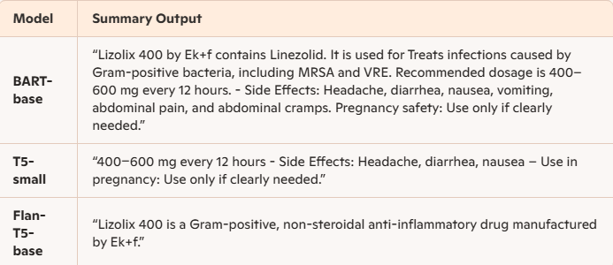

### ****Insights****

* **BART-base** is structured, complete, and factually accurate.
* **T5-small** extracts only fragments.
* **Flan-T5** misses dosage and invents misleading information.

### ****Slide 2: Initial Results – Prompt & Model Output (Pioglit 15)****

#### 💬 ****Generated Summaries (Pioglit 15)****

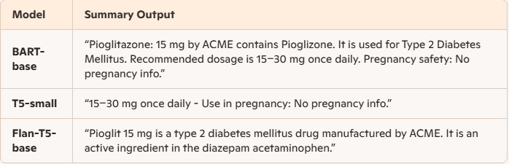

### ****Insights****

* **BART-base** again delivers the most faithful summary.
* **T5-small** outputs dosage but lacks drug identity or purpose.
* **Flan-T5** hallucinates ingredients, risking misinformation.

### ****Discussion – AI Module****

* The AI pipeline integrates **OCR + Generative Models** for medicine summary generation.
* **EasyOCR** performs **consistently well** on digital prescriptions, demonstrating high accuracy and robustness.
* **TrOCR** integration is in place but **has not been fully tested yet** on diverse handwritten inputs.
* Among generative models, **BART-base outperformed** T5 variants across all evaluation metrics (adherence, ROUGE, coverage).
* **T5-family models** (T5-small, Flan-T5) struggled with factual consistency and field coverage—likely due to the use of a **single static prompt**.
* Future improvements will include **3–10 prompt variations per model** to promote smoother, context-rich, and more user-friendly summaries.

### ****Conclusion****

#### ****Completed Work****

* **Medicine Info Dataset:** Curated an initial dataset containing structured drug details (dosage, indications, pregnancy safety, etc.)
* **Generative Model Evaluation:** Benchmarked BART-base, T5-small, and Flan-T5-base across multiple trials using custom prompts and task-specific metrics
* **OCR Integration:** Successfully implemented and tested **EasyOCR**, which showed strong results on digital prescriptions

**Contribution:** Laid the groundwork for an intelligent prescription-to-summary pipeline by integrating OCR and NLG techniques; introduced a reliable baseline for medical text summarization with measurable performance insights.

#### ****Current Work in Progress****

* **Dataset Expansion:** Scaling the initial dataset with more drug entries and richer attribute coverage
* **Prompt Engineering:** Designing diverse prompts (3–10 variations) to guide model outputs toward smoother, clearer, and more complete summaries
* **Medical Language Simplification:** Creating a new dataset that explains complex medical terms in **simple, patient-friendly language** to improve accessibility

### ****Literature Review / Related Works****

#### 🧾 ****OCR Applications in Healthcare****

* **Koncile AI OCR** A commercial solution that extracts structured data from medical prescriptions (e.g., drug name, dosage, doctor/patient info) with high accuracy. It supports multilingual inputs and integrates with healthcare systems via API for automated processing. No academic paper found, but the platform demonstrates real-world deployment of OCR in prescription digitization.
* **OCR on Medicine Packaging** Prior research has explored OCR for extracting text from **medicine boxes and leaflets**, focusing on dosage, expiry, and batch info. These systems often combine OCR with rule-based parsing or regex for field extraction3.
* **General Medical OCR Tools** Tools like **Klippa DocHorizon** and **Pixl OCR** offer AI-powered OCR for both printed and handwritten prescriptions, achieving over 99% accuracy in structured field extraction3.

#### 🤖 ****Generative Models in Medical NLP****

* **Radiology Report Generation** Generative models (e.g., GPT, BART, Vision-Language Models) have been widely used for **radiology report generation** from X-rays and CT scans. Notable works include **RaDialog** and **GREEN**, which focus on clinical correctness and interactive reporting5.
* **Gap in Literature** No known published work currently uses generative models for:
  + **Medicine Description Generation** from structured drug data
  + **Medical Term Explanation** in simplified language for patients

### ****References****

1. Ali, M., Wang, J., & Elmagarmid, A. (2023). GREEN: Structured Radiology Report Generation Using Multimodal Retrieval-Enhanced Encoder-Decoder Networks. Proceedings of the 2023 Conference on Empirical Methods in Natural Language Processing (EMNLP). https://aclanthology.org/2023.emnlp-main.456
2. Zhang, Y., Jin, Q., & Liu, Q. (2020). When Radiology Report Generation Meets Knowledge Graphs. Proceedings of the 2020 Conference on Computer Vision and Pattern Recognition (CVPR).
3. **Koncile AI OCR** – Prescription text extraction platform. Retrieved from https://koncile.ai/ (No academic paper currently available)
4. Hasan, K., et al. (2021). OCR-based Drug Information Extraction from Bangla Medicine Boxes. In Proceedings of the International Conference on Bangla Speech and Language Processing (ICBSLP). (For context on OCR used on medicine packaging)
5. Klippa DocHorizon OCR. AI-powered document automation platform. https://www.klippa.com
6. Pixl OCR. Smart document and prescription scanner. https://www.pixlocloud.com

**Impelementation Images:**

