**A System for Medical Assistance by Text Conversation**

By

**Mahin Rashid Chowdhury**

Roll: 1907021

&

**Jobair Al Nahian**

Roll: 1907071



**Supervisor:**

Dr. K. M. Azharul Hasan

Professor

Dept. of Computer Science and Engineering Signature

Khulna University of Engineering & Technology

**Department of Computer Science and Engineering**

**Khulna University of Engineering & Technology**

**Khulna 9203, Bangladesh**

**November 2023**

**Acknowledgements**

First and foremost, I must be grateful to and wish to acknowledge my insightful indebtedness to Dr. K. M. Azharul Hasan, Professor of the Department of Computer Science and Engineering and the supervisor of the project. His unfathomable knowledge in this field influenced me to carry out this project up to this point. His endless endurance, scholarly guidance, continual encouragement, constant and lively supervision, constructive criticism, and priceless suggestions made it possible to come up to this phase. Without his inspiring, enthusiasm, and encouragement, this work could not have been completed. Last, but by no means least, I thank Allah for the talents and abilities I was given that made it possible to undertake this project.

Next, We want to express gratitude to all of my class teachers who have shared their knowledge with us, which has aided us in completing our project. Also, a big thanks to my classmates for sharing their knowledge and always giving support, which helped us finish this project.

**Authors**

**Abstract**

In the medical field, it's often tough to get quick and reliable information about symptoms, health conditions, and what to do next. Many people can't easily reach healthcare professionals, and there's a growing number of health questions. This situation calls for a smart solution to make sure everyone can access the information they need.

Fixing the problem we talked about would be good for both doctors and regular people. If everyone can easily find accurate health information, it helps people make better choices about their health. This could also mean fewer trips to the emergency room for things that aren't super urgent. And overall, it helps everyone understand more about staying healthy.

The idea is to create a smart computer assistant known as a chatbot, with expertise in medical information. This chatbot uses advanced language skills and a database (150 X 4) of medical knowledge. It's designed to help people by giving them accurate and timely information about symptoms, conditions, and what steps to take. The chatbot's design aligns to address the broader problem of limited accessibility to reliable medical information. make it more simple.

For health-related queries, the chatbot is like having a health assistant. Its vast knowledge base contains current and reliable medical information, so users can rely on its advice. Speaking with the chatbot enables people to make informed decisions and have a better understanding of their health.

**Contents**

|  |  |  |
| --- | --- | --- |
|  |  | **Page** |
| Acknowledgement |  | ii |
| Abstract |  | iii |
| Contents |  | iv |
| List of Tables |  | vi |
| List of Figures |  | vii |

|  |  |  |
| --- | --- | --- |
| **1** | **Introduction** | 1 |
|  | 1.1 Background / Problem statement | 1 |
|  | 1.2 Objectives | 1 |
|  | 1.3 Scopes | 2 |
|  | 1.4 *Unfamiliarity of the problem/topic/solution* | 3 |
|  | 1.5 *Project planning* | 3 |
|  |  |  |
| **2** | **Related Work** | 3 |
|  | 2.1 Existing solutions | 3 |
|  | 2.2 Limitation in existing solutions | 4 |
|  |  |  |
| **3** | **System Design** | 4 |
|  | * 1. Analysis of the system   3.1.1 DFD Diagram  3.1.2 Use Case Diagram | 4  5  5 |
|  | 3.2 System architecture  3.2.1 Class Diagram  3.2.2 Schema Diagram | 6  7  7 |
|  | 3.3 *Tools / Platform used* | 8 |
|  | 3.3.1 Flask | 8 |
|  | 3.3.2 Google Colab  3.3.3 VS Code  3.3.4 React  3.3.5 MySQL | 8  8 8  8 |
|  |  |  |
| **4** | **Project Implementation** | 22 |
|  | 4.1 System implementation | 22 |
|  | 4.2 *Morality or Ethical issues* | 24 |
|  | 4.3 *Socio-economic impact and sustainability* | 25 |
|  | 4.4 *Financial analyses and budget* | 26 |
|  |  | 27 |
| **5** | **Conclusions** | 28 |
|  | 5.1 Conclusion and challenges faced | 28 |
|  | 5.2 Future work | 29 |
|  |  | 30 |
|  |  |  |
|  | **References** | 31 |
|  |  |  |

**List of Tables**

|  |  |  |
| --- | --- | --- |
| **Table No.** | **Description** | **Page** |
| 2.1 | Network construction using Physarum. | 6 |
| 3.1 | Time comparison in car, bus and bicycle. | 23 |

**List of Figures**

|  |  |  |
| --- | --- | --- |
| **Figure No.** | **Description** | **Page** |
| 3.1 | Real traffic network. | 16 |
| 4.1 | Selected Dhaka city Map. | 18 |

1. Introduction
   1. Background

In the world of health, sometimes it's hard to find the right information quickly. People have questions about symptoms, illnesses, and what to do to feel better, but they might not always have easy access to a doctor. That's where our smart friend, the ChatBot, comes in. It's here to help bridge that gap and make sure everyone can get reliable information about their health. Think of it like having a knowledgeable friend who can answer your health questions anytime, day or night. The idea is to solve the challenge of not always being able to find accurate and timely health information when you need it. This ChatBot is like a friendly guide in the world of health, ready to assist and provide trustworthy advice whenever someone has a health-related question. People may feel a little uncertain or concerned about their health in numerous circumstances, particularly if they find it difficult to get in touch with a medical practitioner. The ChatBot is intended to be a comforting and trustworthy information source. It's similar to getting a nice virtual health companion that comprehends your inquiries.

Ensuring that everyone, wherever they may be, has hassle-free access to clear and accurate health information is the challenge we're taking on. The ChatBot simplifies health information for all users by speaking your language like a human encyclopedia. People will be able to take control of their health and well-being and make knowledgeable decisions about it. The ultimate objective is to equip people with the knowledge they need to maintain their health and feel.

* 1. Objectives
* Create a Medical Chatbot System: Develop a system that can answer health questions and help people understand possible medical issues.
* Make an Easy and Friendly Interface: Design a website that's simple to use, so anyone can find the health information they need without confusion.
* Understand Questions Better: Teach the chatbot to comprehend what people say in a natural way, improving its ability to figure out possible health problems.
* Give Simple Info on Diseases: Ensure that the Chatbot shares clear and easy-to-understand details about what might be causing a health issue and what can be done about it.
* Maintain a database: The system maintains a database to store user information and past conversations. This ensures that users can easily refer back to previous responses, promoting reliability and continuity in interactions.

These objectives aim to build a Medical Chatbot that's not only good at tech stuff but also makes it easy and helpful for everyone who needs health info, using regular language.

* 1. Scope

The medical Chatbot project has a broad scope that includes a variety of elements to offer a customized and broad user experience. This is a summary of the project's scope:

* User Authentication and Profile Management: Users can log in to the website, creating individual profiles that allow for personalized interactions and secure storage of health-related data.
* Chat Interface: A user-friendly chat interface where users can communicate with the Chatbot by providing symptoms and asking health-related questions.
* Symptom Analysis: The Chatbot analyzes user-inputted symptoms to identify potential health conditions or diseases.
* Disease Information: Provides detailed information about identified diseases, including causes, symptoms, and preventive measures to enhance user awareness and understanding.
* Treatment Recommendations: Offers personalized treatment recommendations based on identified diseases, guiding users on potential courses of action or medical interventions.
* Conversation History: Saves and categorizes each user's conversation history, allowing users to review previous interactions, symptoms, and responses for ongoing health management.
  1. Unfamiliarity of the problem

The unfamiliarity with the problem in the context of a medical chatbot lies in the challenge of limited accessibility to timely and accurate health information. Many individuals face difficulty obtaining quick and reliable answers about symptoms, conditions, and healthcare options. The unfamiliarity arises from the gap in easily reaching healthcare professionals and the increasing need for accessible and trustworthy health guidance. The medical chatbot aims to address this unfamiliarity by providing a user-friendly solution that offers reliable information, empowers users, and contributes to improved health literacy.

* 1. Project planning

Our plan for the medical Chatbot is like a roadmap showing how we'll turn our idea into reality. We want to solve the problem of people not easily getting health info. The plan includes features like checking symptoms, explaining diseases, and suggesting treatments. We've set a clear schedule and figured out what we need, like people and money, to make it happen. We're also thinking about possible problems and how to make sure everything works well. Our plan is like a guide, making sure we stay on track and create a helpful and easy-to-use chatbot for everyone.

1. Related Works

* “**Maya - It's ok to ask for help**” [1]: A online android based application. It’s a health care app which connects users with hundreds of doctors, psychiatrists and beauticians ready to serve 24 hours a day. Here user can write questions about his problems about health and the doctors’ advice giving reply and facility to video call and can get digital prescription from doctors and there is extra facility to shop and read medical blogs.
* “**Text messaging-based medical diagnosis using natural language processing and fuzzy logic.**” [2]: The service focuses on assessing the symptoms of tropical diseases in Nigeria. Telegram Bot Application Programming Interface (API) was used to create the interconnection between the chatbot and the system, while Twilio API was used for interconnectivity between the system and a short messaging service (SMS) subscriber.
  1. Gap in Existing Solutions
* “**Maya - It's ok to ask for help**” [1]: There are some limitations. In the app, the user has to wait for doctors, psychiatrists and beauticians to reply which is frustrating and may delay treatment. Manpower is a limitation here. In some cases, users have to pay for conversations with doctors.which may make these technologies less accessible to some patients.
* “**Text messaging-based medical diagnosis using natural language processing and fuzzy logic.**” [2]: Here a limitation is the conversation is based on question-answering. Its algorithm makes decisions by asking questions and based on the reply the bot gives the solution for diseases. So it is time-consuming and the user may get monotonous.

1. System Design

The proposed approach involves the use of a chatbot that can interact with users through text conversation, providing them with an avenue to express their concerns in a way that is comfortable and accessible to them. To respond to the user's queries, the system uses an expert model that uses advanced algorithms to provide intelligently and accurate responses.

* 1. Analysis of the system

The system is analyzed through a couple of diagrams to depict the procedures and interactions of various elements. It follows with DFD and a Use Case diagram to exhibit the flow of working steps.

* + 1. **DFD Diagram**

The user input, which usually consists of a list of symptoms connected to a specific medical condition, is analyzed by the chatbot using advanced algorithms. To produce an accurate result, these algorithms are designed to process and interpret the user's input. Working with large amounts of data or sensitive information requires an efficient understanding of the system flow. As such the movement of data is shown in the Data Flow Diagram (DFD), figure 3.1

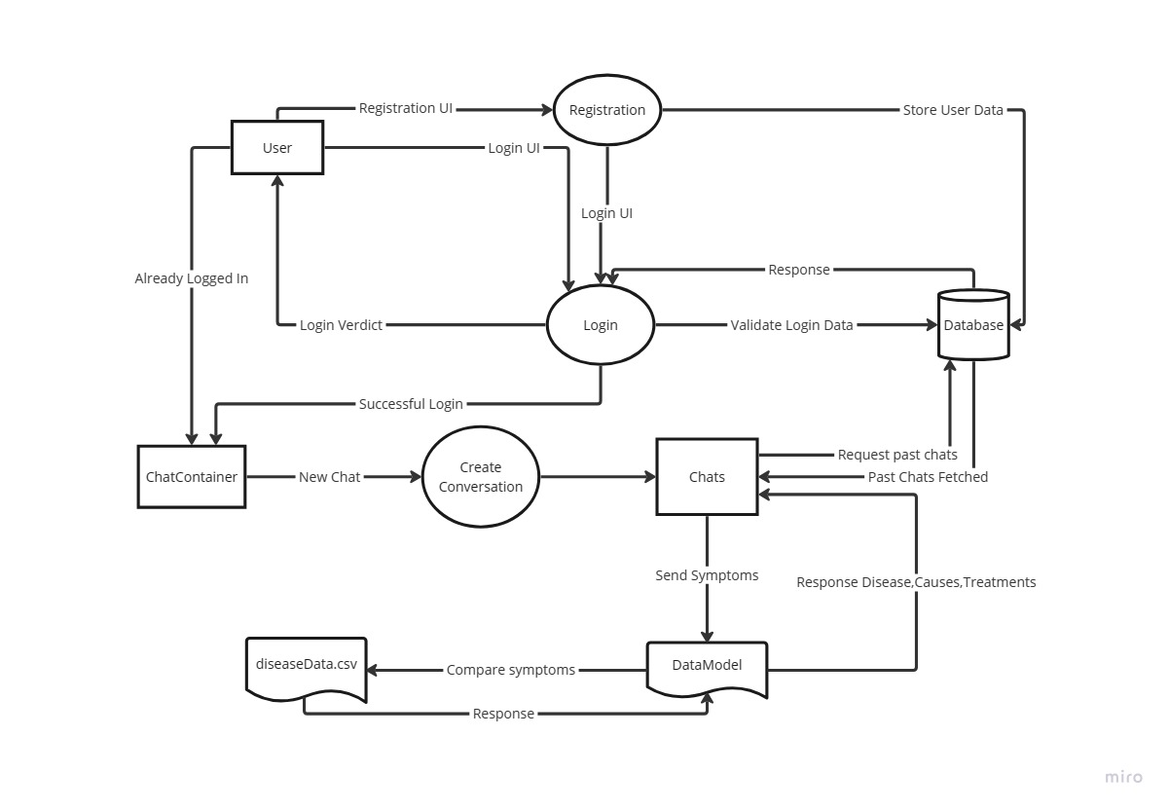

Figure 3.1: Data Flow Diagram of the medical chatbot system.

* + 1. **Use Case Diagram**

There are many different types of roles in the system. The figure 3.1.2 illustrates these roles' points of view.

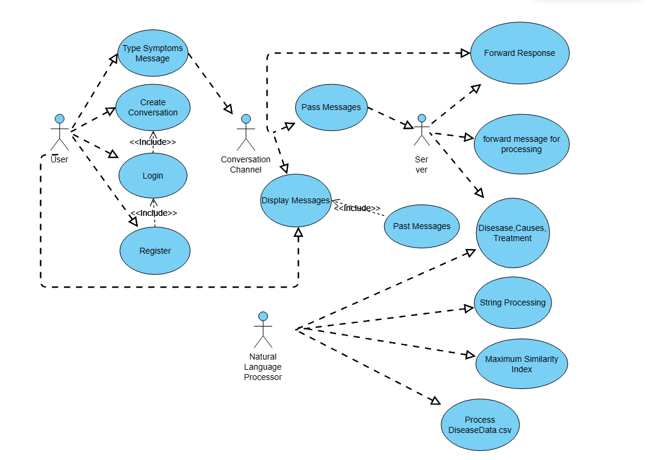

Figure 3.2: Use case diagram of Medical chatbot System

* 1. System architecture

The project's architecture must be fully understood in order to build it. A class diagram displays the project's structure by encapsulating and associating important classes, while an ER diagram displays the database that houses the information and the relationships that are related to it.

* + 1. **Class Diagram**

The information and functionality of association and encapsulation of each individual class or building block is shown in the figure 3.3. where the necessary information is reflected by the blocks.

* + 1. **Schema Diagram**

A schema diagram visually represents the structure and relationships within a database, illustrating tables, fields, and their connections. The Schema diagram for this project illustrates the key entities and relationship among them in the figure 3.4.

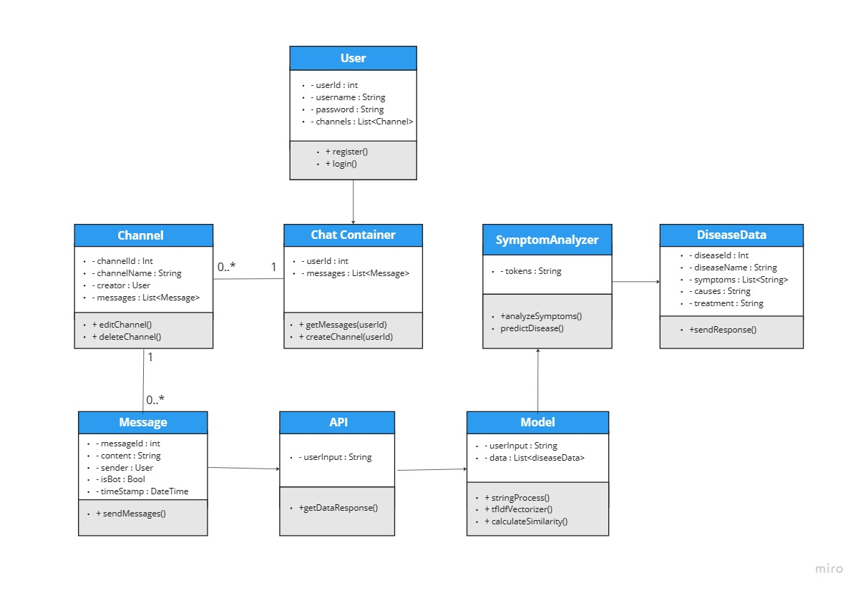

Figure 3.3: Class Diagram of Medical Chatbot System.

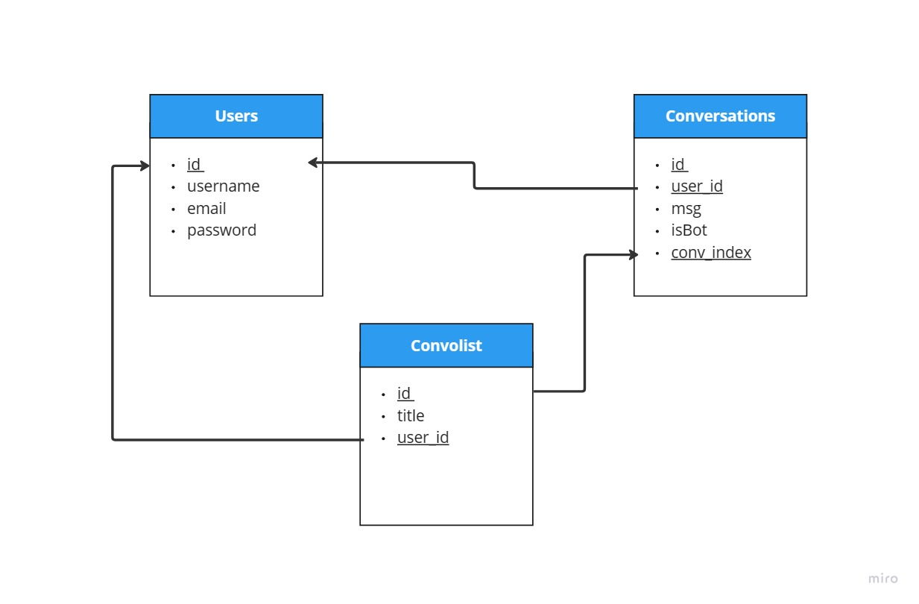

Figure 3.4: Schema Diagram for Medical Chatbot System.

* 1. Model Design
     1. Tokenization
     2. Stop word removal
     3. Tf-idf
  2. Tools used

To finish the system, many different types of tools were employed. Every tool contributed significantly to the project's success.

* + 1. Flask

Flask is a lightweight Python web framework that provides useful tools and features for creating web applications in the Python Language. It gives developers flexibility and is an accessible framework for new developers because you can build a web application quickly using only a single Python file. [4]

* + 1. Google Colab

Colaboratory, or “Colab” for short, is a product from Google Research. Colab allows anybody to write and execute arbitrary python code through the browser, and is especially well suited to machine learning, data analysis and education. More technically, Colab is a hosted Jupyter notebook service that requires no setup to use, while providing access free of charge to computing resources including GPUs. [5]

* + 1. React

When using React to create interactive websites, styles such as Tailwind CSS or Bootstrap are frequently used to make the website responsive. By writing styles that adapt to screens and starting with mobile design, by using React website will look good and work smoothly, whether on a computer, tablet, or phone.

* + 1. VS Code

One useful code editor is Visual Studio Code. Coding productivity is increased by the many extensions available for web development languages and Python.

* + 1. MySQL

It is an open-source relational database management system (RDBMS). MySQL is widely used for managing and organizing data within databases. It uses a structured query language (SQL) to interact with databases, making it a popular choice for web applications that require data storage and retrieval. MySQL is known for its speed, reliability, and ease of use. It is often used in conjunction with programming languages like PHP, Python, and others to create dynamic and data-driven websites.

* + 1. Apache

Apache is one of the most widely used web servers globally. Its primary function is to serve web pages and handle HTTP requests from clients (such as web browsers).

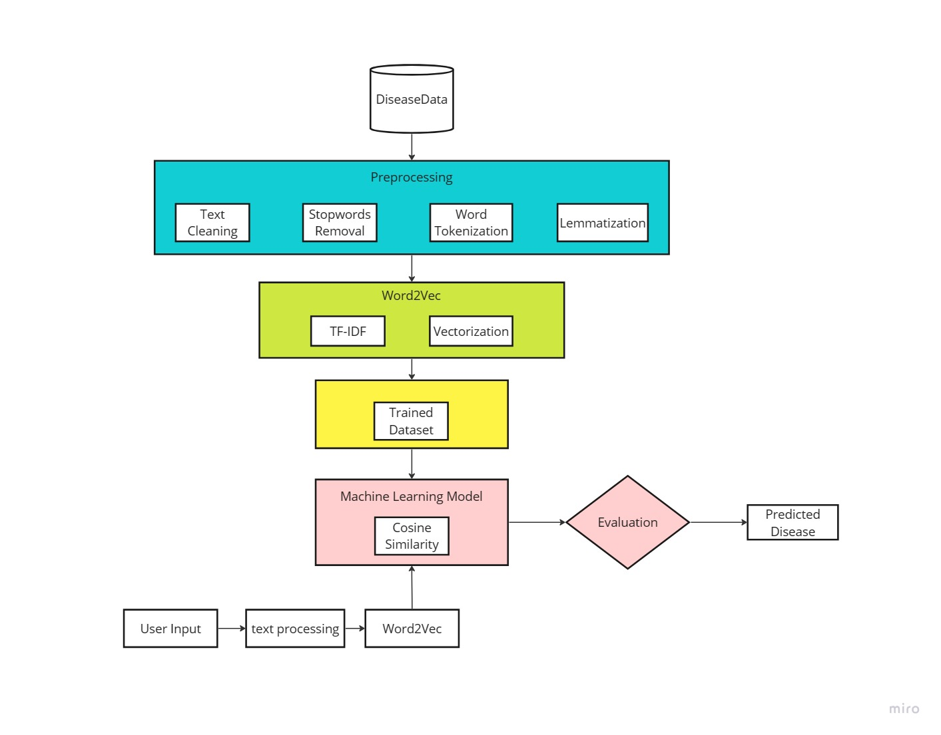

Figure 3.5: Workflow of medical chatbot detecting diseases category.

1. Project Implementation

The procedures and individual steps that were taken to finish the system project will be covered in this chapter

* 1. System implementation

The system being a web application a website was designed using Flask as the backend and React basic HTML, CSS as the frontend. The NLP technique was used for the model training and pre-trained model was collected for the task. The dataset for the task was created from different websites. The details of these procedures are as following,

* + 1. Web Implementation

The frontend implementation is done ….

* + 1. Model Implementation

The Model utilizes colab ……..

* + 1. Model Architecture

The model utilizes …

* + 1. Dataset

Dataset is very important for training a model. As

* 1. Morality or ethical issues

Many different sources were used in the development of the project. The website from which the dataset was gathered. Several libraries, including the Spacy, Pandas, and Scikit-learn (sklearn) libraries for the TfidfVectorizer and cosine_similarity functions, were used to create the model. The official documentation provided information on the procedures. The project's suggested technique was picked up from some papers and articles. Images and icons used for masking were gathered from open-source websites. For the web application, smooth productivity was ensured by adhering to the Flask documentation. The class diagrams and database system implementation were taken from earlier academic curricula. Personal information about its users is also included in the system, but it is fully guaranteed that the information or data will be kept private from others. The information will remain private and secure within the system, with no access granted to third parties. The project respects moral principles, giving users' privacy top priority.

* 1. Socio-economic impact and sustainability

* A medical chatbot can enhance accessibility to healthcare information. People in remote or underserved areas may benefit by obtaining medical advice and information without the need for physical presence.
* Chatbots can assist in early detection of symptoms and provide preventive measures. This can lead to early intervention and improved health outcomes.
* Chatbot poses a risk of providing incorrect advice or misdiagnosing conditions, potentially leading to delayed or inappropriate medical interventions.
* Timely advice and information from a medical chatbot may reduce unnecessary visits and thereby lowering overall healthcare costs for individuals and the healthcare system.
* Ensuring robust data security and privacy measures is crucial for the sustainability of a medical chatbot project.
* It is essential to conduct routine updates and enhancements to the chatbot's knowledge base and functionality to guarantee its applicability and efficacy in furnishing precise and current medical information.
  1. Financial analyses and budget

Financial analysis and budget for this project involves the cost of development, equipment, implementation, maintenance and other relevant expenses. A general measurement of the budget has been estimated in following table 4.1:

**Table 4.2:** Financial analysis and budget of the project

|  |  |
| --- | --- |
| **Types of cost** | **Budget(tk)** |
| Personnel Salaries | 50,000 – 70,000 |
| Online Services | 10,000 – 20,000 |
| Software | 10,000 – 20,000 |
| Data collection and processing | 5,000 – 10,000 |
| Development tools | 5,000 – 10,000 |
| Project management tools | 5,000 – 14,000 |
| Miscellaneous | 5,000 – 6,000 |
| Total: | 90,000 – 1,50,000 |

The budget as a whole is distinguished by low external spending, the bulk of which are self-funded, and the use of readily available software and technologies.

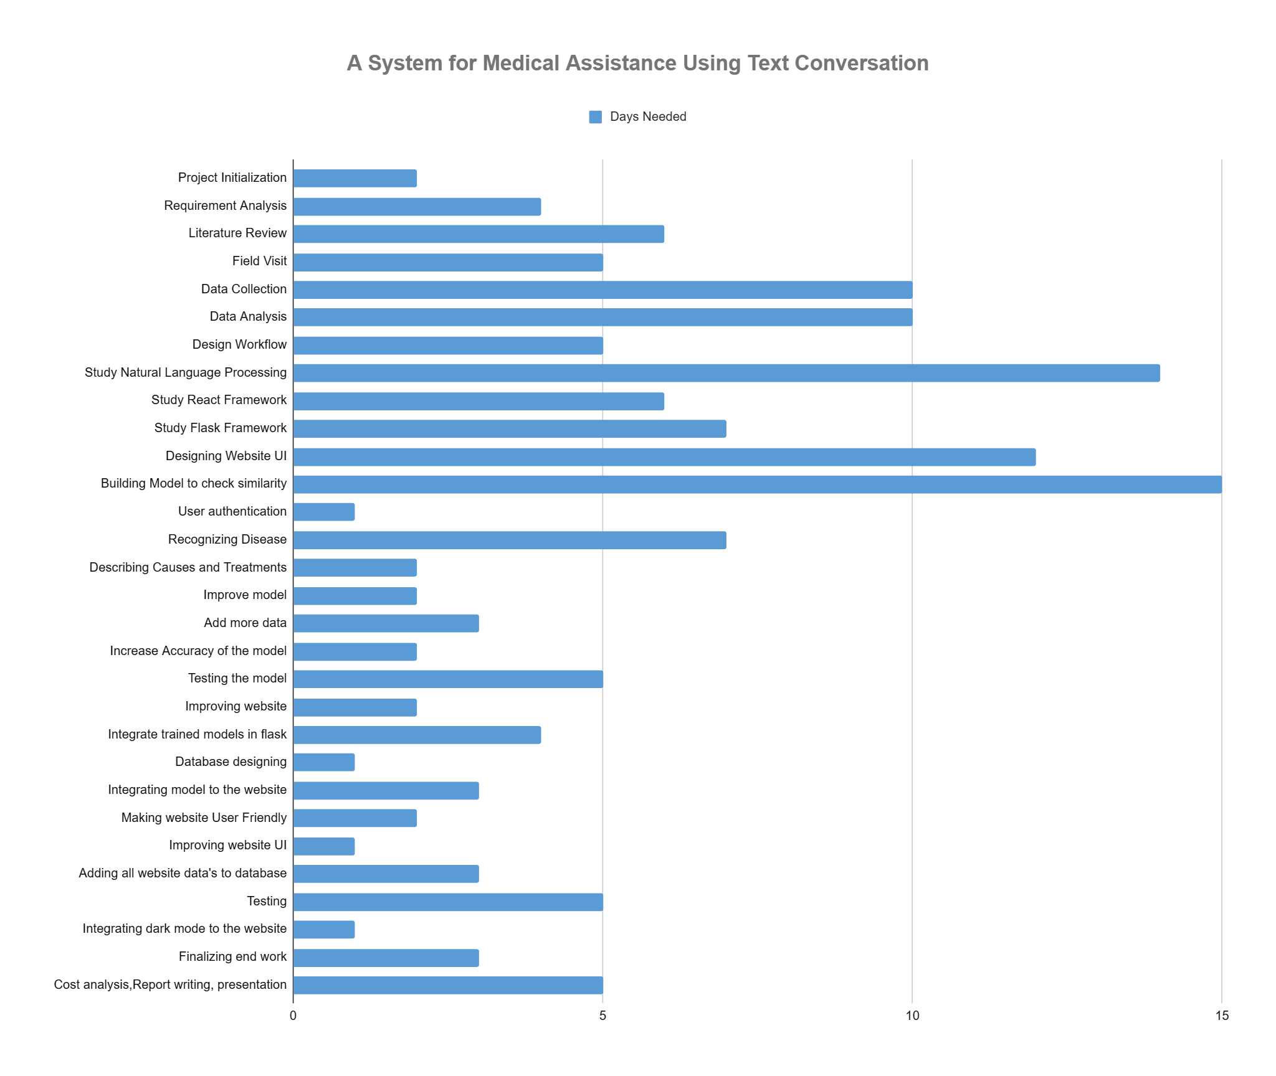

Figure 4.2: Gantt Chart of Medical Chatbot System project

1. Conclusion

A chatbot is an artificial intelligence (AI) program that can talk with users via text or voice commands by using natural language processing (NLP). Chatbots can be made to mimic human-like interactions with users, answering their questions quickly and precisely.

* 1. Conclusion and challenges faced

The platform provides users with an easy-to-use means of having enlightening discussions about various illnesses. Its advanced Natural Language Processing (NLP) capability, which deftly extracts base words and comprehends the user's actual symptoms, excels in producing accurate results by providing detailed symptoms. The process of developing this effective system wasn't without its difficulties. One significant obstacle was the lack of detailed descriptions provided by users, which negatively impacted the model's ability to accurately detect diseases. To overcome this obstacle, multiple models had to be trained on different datasets. Moreover, precision was hampered by the limitations of a big dataset. Another obstacle in the realm of web technology surfaced during the integration of models, where prolonged loading times and UI/UX design issues needed addressing. Despite these challenges, the team confronted them directly, ensuring the project's overall success and reinforcing the system's efficacy in delivering valuable health information.

* 1. Future Study

# This model can be further made to broaden its scope. To increase the efficiency of medical chatbots, more word combinations can be added to their databases, allowing them to manage a wider range of ailments. By adding more data and improving algorithms, medical chatbots will become increasingly accurate in diagnosing and treating patients. Chatbots can be integrated with various messaging platforms, such as Facebook Messenger, WhatsApp, and Slack, making them accessible to users on their preferred messaging platform. The use of chatbots has become increasingly popular in recent years, and it is expected to continue to grow as businesses and organizations look for ways to improve customer engagement and streamline their operations.

# References

[1] https://play.google.com/store/apps/details?id=com.maya.mayaapaapp&hl=en&gl

=US

[2] Kevin, Bruce, Brikes VIkin, and Manju Nair. "BUILDING A CHATBOT FOR HEALTHCARE USING NLP." (2023).

[3] Omoregbe, Nicholas AI, et al. "Text messaging-based medical diagnosis using natural language processing and fuzzy logic." *Journal of Healthcare Engineering* 2020 (2020): 1-14.

[4] https://www.digitalocean.com/community/tutorials/how-to-create-your-first-web-application-using-flask-and-python-3

[5] https://research.google.com/colaboratory/faq.html#:~:text=Colaboratory%2C%20or

%20%E2%80%9CColab%E2%80%9D%20for,learning%2C%20data%20analysis%20and%20education.

[6] https://www.codeproject.com/Articles/1204813/Lina-ChatBot-Generating-Response-Using-Document-Re