Bangladesh Army University of Engineering &

Technology (BAUET)

Qadirabad, Natore-6431



**Department of**

**Computer Science and Engineering (CSE)**

**Project Report**

**Course Code:** CSE-3212

**Course Title:** Computer NetworkSessional

**SUBMITTED BY**

Name: Md. Moktadir Ul Islam

ID: 0812110205101010

Batch: 13th

Year: 3rd

Semester:2nd

Session:2020-2021

**SUBMITTED TO**

Mithun Kumar

Assistant Professor,

Dept. of CSE

BAUET

Md Rafiqul Islam (Rafiq)

Lecturer, Dept. of CSE

BAUET

TABLE OF CONTENTS

|  |  |  |
| --- | --- | --- |
| 1. | Abstract | 1 |
| 2. | Introduction | 1-2 |
| 3. | Objective | 2 |
| 4. | Study of BAUET Computer Network System | 2 |
| 5. | Software and hardware requirements | 3-4 |
| 6. | Design and Implementation | 4-14 |
| 7. | Project Layout | 15 |
| 8. | Conclusion | 15 |
| 9. | References | 16 |

**Abstract :**

Computer networks have a significant impact on the working of an organization. Universities depend on the proper functioning and analysis of their networks for education, administration, communication, e-library, automation, etc. An efficient network is essential to facilitate the systematic and cost-efficient transfer of information in an organization in the form of messages, files, and resources. The project provides insights into various concepts such as topology design, IP address configuration, and how to send information in the form of packets to the wireless networks of different areas of a University.

The aim of this project is to design the topology of the university network using the software Cisco Packet Tracer with the implementation of wireless networking systems. This university network consists of the following devices:

1) Router (1941)

2) Switches (2960-24TT)

3) Email server

4) DNS server

5) WEB server (HTTP)

6) Wireless Device (Access Point)

7) PCs

8) Laptops

9) Smartphones

The design includes the following parts of the University:

Hall: Bonolota and Boral

Academic Blocks: Panaroma and Nexus

Administrative Building and Lab

**Introduction :**

The word “digital” is very significant in today’s world, with an increase in the development of technology the entire world is moving towards the digital era. The educational institution plays an important role in this digitalization, hence the campus should adapt to digital means of networking as well and become a “digital campus”. Going wireless plays an important role in this digitalization. The wireless network makes the connection easy with a reduction in the use of wires or cables. A wired connection makes it difficult to keep track of all the devices and to manage the cable connection, which is not only chaotic but also challenging to handle.

Campus networking via wireless connection becomes an important part of campus life and provides the main way for teachers and students to access educational resources, which gives an important platform to exchange information. As laptops and intelligent terminals are widely used, demand for access to information anytime and anywhere has become more and more urgent, but traditional cable networks cannot meet this requirement. Then wireless network construction becomes necessary and essential. The wireless network is one of the important components of a digital campus and wisdom campus. It provides an efficient way to explore the internet with a mobile terminal for teachers and students regardless of cables and places. This is an important mark of the modern campus as a supplement of a cable network. With the development of network and communication technology, cable networks on a university campus bring much convenience for teaching and research work. But for mobility and flexibility, it has obvious shortcomings. A wireless network can overcome these drawbacks and has been applied to the university campus.

1/16

**Objective:**

In this project, we defined a simulation of campus networks based on wireless networking. The network is divided into two sets: one for the campus area and the other for the hostel area.The major aim of this project is to show the wireless connectivity that is used in universities to make the network efficient and mobile at the same time. Mobility is the major concentration of this project. In order to provide equal functionality to all the users (college staff and students), we have added DNS, Email, and HTTP servers for the maximum utilization of resources. Hence the campus network provides different services such as connecting the user to the internet, data sharing among users (students, teachers, and different university members), accessing different web services for different functionalities, so it needs wireless networking for smooth processing.

**Study of BAUET Computer Network System:**

A campus network or corporate area network. CAN is a computer network made up of an interconnection of local area network (LANs) within a limited geographical area. The networking equipment such as switches, routers & transmission media live optical fiber, cabling etc. are almost entirely owned by the campus owner. Our university campus network (Bauet campus network), there is a server room which is consist of two servers. In one. Server is connected with switches and routers connected in Mirotic Server which have center server Model-1036, IG port. There also have Media converter which transfer electric signal to data signal. There have two switches which are divided in three sub categories of core layer. In the Academic building, there have three switches. 1st switch cover for the ground floor, 1st & 2nd floor network. 2nd switch cover for 3rd, 4th & 5th floor network. 3 rd switch cover for 6th & 7th floor network. They serve network to administrative buildings two hall (Boral & Bonolota). They have static IP addresses. The server room, there are five cables which are implemented VLAN connection. In two halls, Boral Hall and Bonolota Hall, there are connected with LAN port. When we are trying to implement our network system, a connection comes from a Server –PT which is an email server (20.0.0.0/30) then the connection came to a router which is indicates as 2901 clouds in the picture. Then the connection come to the main campus router (30.0.0.0/30). Then the connection speared in two router also, (10.0.0.0/30) and (11.0.0.0/30). Here total three router provides the connection of full campus. Router 2 and Router 3 supply connection to Administration office and Hostile. Administration office has three section Register office (VLAN 100, 192.168.10.0/24) Finance Office (VLAN 110,

2/16

192.168.11.0/24) and VICE Chancellor office (VLAN 120, 192.168.12.0/24). Router three provide connection to hall. For Boral hall we use VLAN 130, 192.168.13.0/24 and for Bonolota hall we use VLAN 140, 192.168.14.0/24. Main campus router provides the academic 45 building internet connection. At 2 nd floor LAB we use VLAN 20, 192.168.1.0/24 for 2nd floor CE and ME VLAN 20(192.168.2.0/24) and VLAN 30(192.168.3.0/24). VALN 40(192.168.4.0/24), VLAN 50 (192.168.5.0/24), VLAN 60 (192.168.6.0/24)we use in third floor. As well as we use VLAN 70 (192.168.7.0/24), VLAN 80 (192.168.8.0/24) and VLAN 90 (192.168.9.0/24)in the 4th floor.

**Software and hardware requirements:**

Before heading towards the implementation we need to make sure of the following requirements.

* A proper workstation (any mid-high range laptop will suffice).
* Packet Tracer by Cisco
* 8 GB RAM.
* Any 10,000+ Average CPU Mark scored processor.
* 16 GB of dedicated hard disk space.
* USB 3.0+ port.

**1.Brief knowledge about our approach:**

The proposed wireless network is implemented for a university campus. We have made a virtual visualization of the network using the Cisco Packet tracer which provides a huge platform for users to test their projects using simulation tools. A Wireless network in an educational campus makes it easier for teachers and students to access educational resources, by enabling an important platform to exchange information.

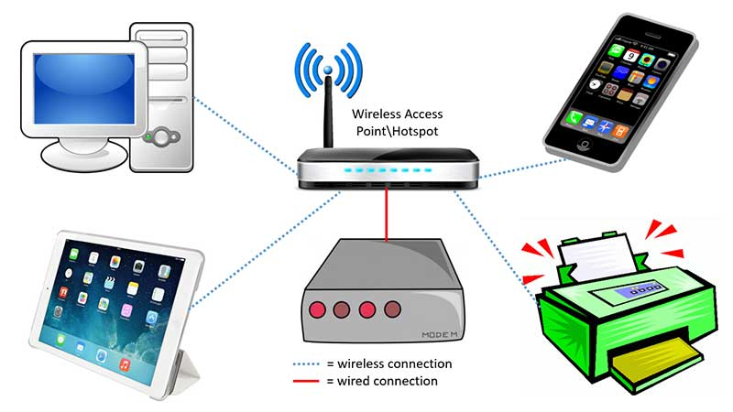

Figure 1: Shows the wireless connection access by various tool

3/16

**2.Devices Used In The Network:**

|  |  |
| --- | --- |
| Devices | Quantity |
| 1) Router (1941) | 3 |
| 2) Switches (2960-24TT) | 3 |
| 3) EMAIL server | 1 |
| 4) DNS server | 1 |
| 5) WEB server (HTTP) | 1 |
| 6) Wireless Device (Access Point) | 7 |
| 7) PCs | 12 |
| 8) Laptops | 10 |
| 9) Smartphones | 2 |

Figure 2: Devices used in the network

**Design and Implementation:**

* To design the wireless network of the university we initially started by placing the core devices into the frame as mentioned in the layout.
* Firstly, we placed the **main router** at the center of the university outline, which was further connected to the **server switch** using the gigabit ethernet port with copper straight-through cable and sub routers (**campus router and hall router**) using the serial port with serial DCE cable at the hostel area and campus area respectively.
* The server switch was further connected to the **EMAIL, DNS, and WEB** servers respectively.
* Campus router was connected to the campus switch which was further connected with wireless access points of the academic block (**Panaroma and Nexus**), **Administrative building** and **lab.**

4/16

* The wireless access points were then connected to computing devices (PCs, laptops, and smartphones).
* Similarly, the hostel router was connected to the hostel switch which was further connected with the wireless access point of Boral and Bonolota.
* The wireless access points were then connected to the computing devices (PCs, laptops, and smartphones), every area has a dedicated access point which can only be connected with the help of a password.
* All these connections are made through ethernet ports (gigabit ethernet and fast ethernet) using copper straight-through cables.

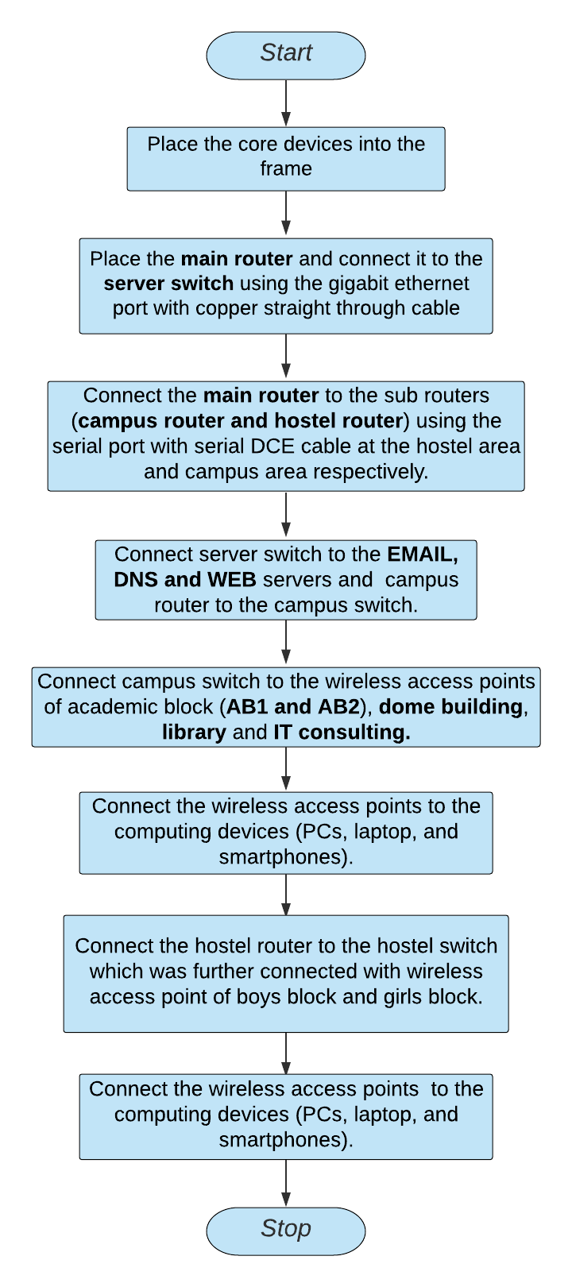

Connect campus switch to the wireless access points of academic block(Panaroma and Nexus),Administrative Building and Lab

Figure 3: Flow Diagram of the network

5/16

**1.Configuring IP Addresses**

We have attached the screenshots of all the IP configuration below:

* Main Router configuration

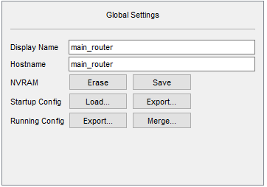

GigabitEthernet0/1

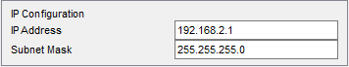

Serial0/1/0

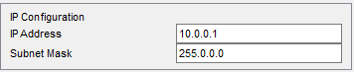

Serial0/1/1

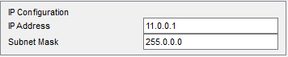

RIP

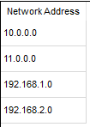

6/16

* 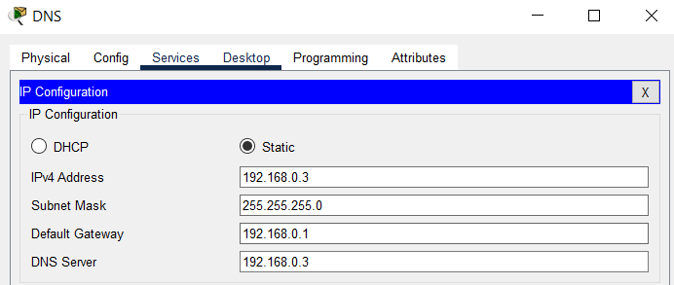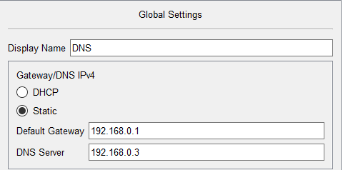DNS SERVER
* WEB SERVER

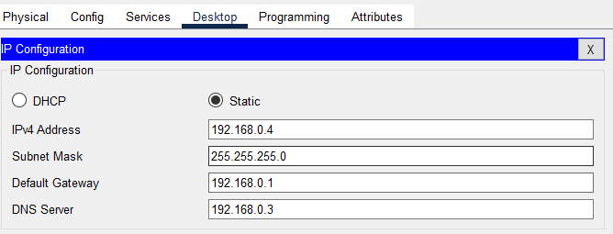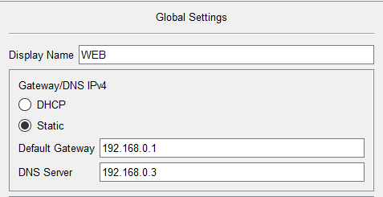

7/16

* EMAIL SERVER

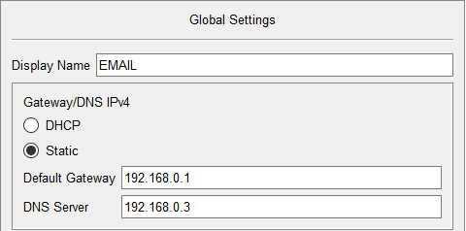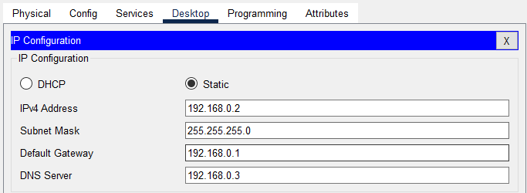

* CAMPUS ROUTER

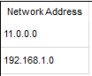

GigabitEthernet0/0

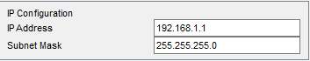

Serial0/1/0

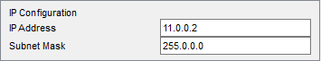

8/16

* PANAROMA:

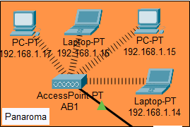

IP Address are as follows

192.168.1.14- Laptop

192.168.1.15- PC

192.168.1.16- Laptop

192.168.1.17- PC

Subnet Mask- 255.255.255.0

Default Gateway- 192.168.1.1

DNS Server- 192.168.0.3

* NEXUS:

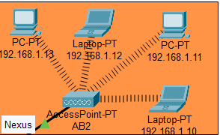

IP Address are as follows

192.168.1.10- Laptop

192.168.1.11- PC

192.168.1.12- Laptop

192.168.1.13- PC

Subnet Mask- 255.255.255.0

Default Gateway- 192.168.1.1

DNS Server- 192.168.0.3

9/16

* BUILDING:

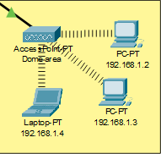

IP Addresses are as follows

192.168.1.2- PC

192.168.1.3- PC

192.168.1.4- Laptop

Subnet Mask- 255.255.255.0

Default Gateway- 192.168.1.1

DNS Server- 192.168.0.3

* LAB:

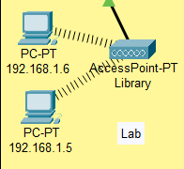

IP Addresses are as follows

192.168.1.5- PC

192.168.1.6- PC

Subnet Mask- 255.255.255.0

Default Gateway- 192.168.1.1

DNS Server- 192.168.0.3

10/16

* Administrative Building:

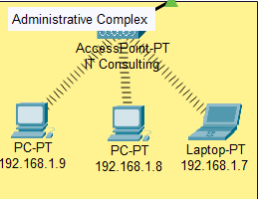

IP Addresses are as follows

192.168.1.7- Laptop

192.168.1.8- PC

192.168.1.9- PC

Subnet Mask- 255.255.255.0

Default Gateway- 192.168.1.1

DNS Server- 192.168.0.3

* Hall ROUTER:

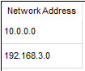

GigabitEthernet0/0

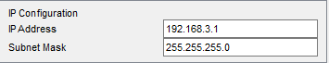

Serial0/1/0

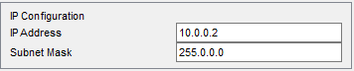

11/16

* BORAL:

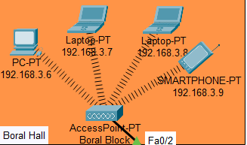

IP Addresses are as follows

192.168.3.6- PC

192.168.3.7-Laptop

192.168.3.8- PC

192.168.3.9- Smartphone

Subnet Mask- 255.255.255.0

Default Gateway- 192.168.3.1

DNS Server- 192.168.0.3

* BONOLOTA:

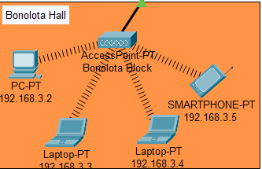

IP Addresses are as follows

192.168.3.2- PC

192.168.3.3-Laptop

192.168.3.4- PC

192.168.3.5- Smartphone

Subnet Mask- 255.255.255.0

Default Gateway- 192.168.3.1

DNS Server- 192.168.0.3

12/16

1. **Securing the network:**

Passwords are used in accessing the router and all the wireless networks (mentioned in step 5 wireless access point) to make the access limited to University authorized users only.

Routers are also secured with ssh (Secure Shell). Routers and their assigned passwords are mentioned below:

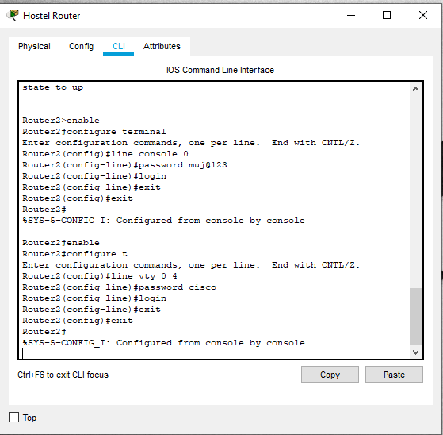

|  |  |
| --- | --- |
| Router Name | Passwords |
| 1)main_router | Console password: cisco  ssh password: admin |
| 2)Router1(Campus Router) | Console password:muj@123  ssh password: admin |
| 3)Router2(Hall Router) | Console password:muj@123  ssh password: admin |

13/16

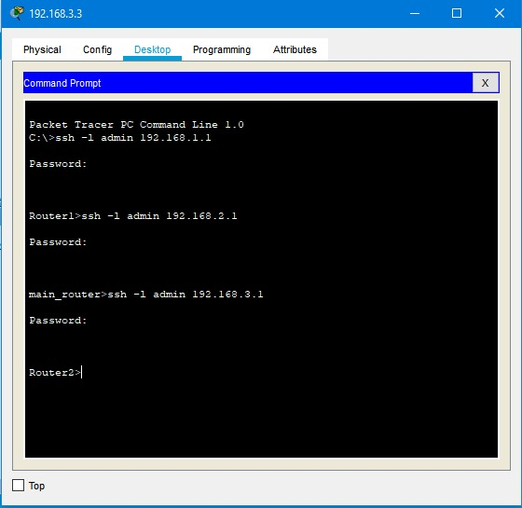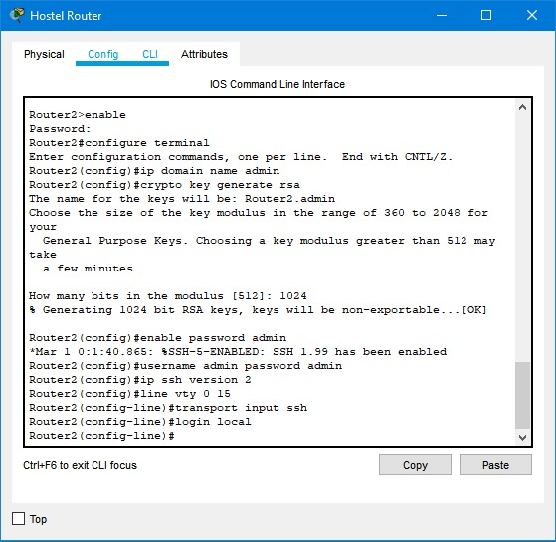

14/16

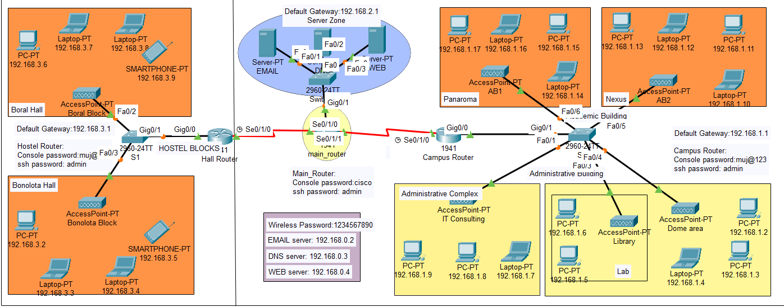**Project Layout:**

The complete diagram of the University Area Network Scenario created in Packet Tracer environment

**Conclusion:**

We started our discussion with the word “digitalization” and in order to achieve it, we aimed to start with an educational institute, and finally, we designed a network for a University, which is wireless. As we mentioned, mobility and efficiency are the key aspects of wireless networks, which were our main goal, and hence, we decided to shift to a wireless network instead of a wired one, making our network clean and less chaotic.In this project, we designed a University Network using Cisco Packet Tracer that uses a networking topology implemented using servers, routers, switches, and end devices in a multiple area networks. We have covered all the necessary features that are required for a network to function properly. We have included a DNS server and a web server for establishing a smooth communication system between different areas of our network and specifically for the communication between students and teachers. We have included an email server to facilitate intra university communication through emails within the domain. We have used console passwords and ssh protocol to ensure a safe and secure transfer of data.

15/16

**References :**

[1] <https://en.wikipedia.org/wiki/Packet_Tracer>

[2] <https://www.paessler.com/it-explained/server>

[3]<https://computernetworking747640215.wordpress.com/2018/07/05/secure-shell-ssh-configuration-on-a-switch-and-router-in-packet-tracer/>

[4] <http://router.over-blog.com/article-how-to-configure-cisco-router-password-106850439.html>

[5] <https://www.cognoscape.com/benefits-going-wireless/>

16/16