**BIG MART SALES PREDICTION**

|  |  |
| --- | --- |
| Written By | Mahin Prakash |
| Document Version | 1.0 |
| Last Revised Date | 08-07-2023 |

**Document Change Control Record**

|  |  |  |  |
| --- | --- | --- | --- |
| **Version** | **Date** | **Author** | **Comments** |
|  |  |  |  |
|  |  |  |  |
|  |  |  |  |
|  |  |  |  |
|  |  |  |  |
|  |  |  |  |
|  |  |  |  |
|  |  |  |  |
|  |  |  |  |
|  |  |  |  |
|  |  |  |  |
|  |  |  |  |
|  |  |  |  |
|  |  |  |  |
|  |  |  |  |
|  |  |  |  |

**Reviews**

|  |  |  |  |
| --- | --- | --- | --- |
| **Version** | **Date** | **Reviewer** | **Comments** |
|  |  |  |  |

### **Approval Status:**

|  |  |  |  |  |
| --- | --- | --- | --- | --- |
| **Version** | **Review date** | **Reviewed By** | **Approved By** | **Comments** |
|  |  |  |  |  |

**Homepage**

On the homepage the user will be able to see the title of the project and there will be input fileds which the user is supposed to fill.

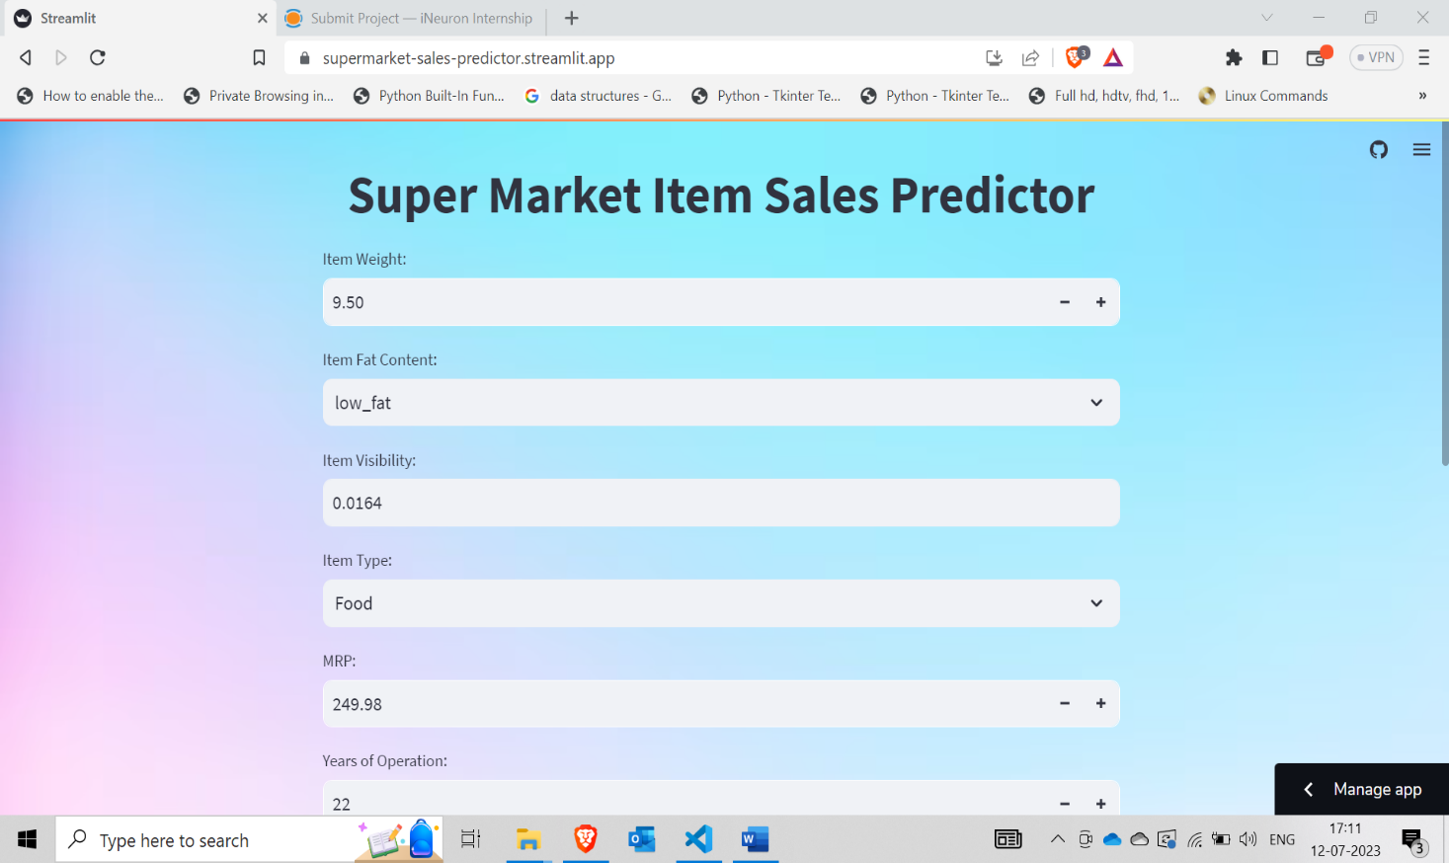

**Prediction**

After the user gives the inputs,on clicking predict button the prediction will be shown for the given inputs right below the button

