**Calculation for EMDB**

EMDB Load = Total ESDB Load * 0.7 + Lift Load * 0.7

Total ESDB Load =9*4*ESDB(Type_1)+9*2*ESDB(Type_1) +

ESDB_Ground+ESDB_Lobby+ ESDB_Basement

EMDB Current = $\frac{EMDBLoad}{\sqrt{3}∗LineVoltage∗pf}$

Phase Voltage = 220 V

Line Voltage = $\sqrt{3}$* 220 = 381.05 V

Power Factor, pf = 0.8

Total ESDB Load = 9*3294*4+9*3210*2+9*70+560+406 =177960W = 177.96 kW

Lift Load =2* 18.5 kW=37kW

EMDB Load = 177960 * 0.7 + 37000 * 0.7 =150472 W = 150.472 kW

EMDB Current = $\frac{150472}{\sqrt{3}∗381.05∗0.8}$ =284.98 A

So300 A TP MCCB is needed from EMDB to MDB.

**(reference slide) PWD RATE SCHEDULE for Subhead Wiring and Cables 1.14.1.14 g**

Wire is 4x240 sqmm NYY +120 sqmm BYA ECC

**Generator Sizing**

EMDB LOAD =150 KW, Assumed pf = 0.75

Generator size= LOAD/pf = 150 kW/ 0.75

=200 KVA

**FROM PWD RATE SCHEDULE(Subhead-2.2 Generator & Related works )**:

200 KVA with ATS is vailable

**Lift Sizing**

**https://www.indiamart.com/proddetail/elevators-lift-drivers-delta-make-3-75-kw-to-18-75-kw-24416869530.html**

**lift load = 18.75 reference**

Lift load =37 kW assumed Pf =0.6 for current calculation

Line current = 37 KW /(aqrt(3) *381.05* 0.6 =93.4 A

Wire needed = 4* 70 NYY sqmm BYM+ 35 sqmm BYA ECC

(reference slide) PWD RATE SCHEDULE for Subhead Wiring and Cables 1.14.1.9

(Country lift BD : motor 6.2 KW+ 6.8 KW for 10 person and 1.5 m/s)

**Calculation for MDB**

MDB Load = Total SDB Load * 0.7 + (EMDB Load + Pump Load) * 0.7

Total SDB Load = 9*4*SDB(Type_1)+9*2*SDB(Type_1) +

SDB_Ground+SDB_Lobby+ SDB_Basement

MDB Current = $\frac{MDBLoad}{\sqrt{3}∗LineVoltage∗pf}$

Phase Voltage = 220 V

Line Voltage = $\sqrt{3}$* 220 = 381.05 V

Power Factor, pf = 0..8

Total SDB Load = 9*3840*4+9*3854*2+9*182+644+462 =210356 W =210.356 kW

Pump Load = 15000 W

MDB Load = 210356 * 0.7 + (150472 +1 5000) * 0.7 = 263079.6 W = 263.0796 kW

MDB Current = $\frac{263079.6}{\sqrt{3}∗381.05∗0.8}$ = 498.25A

So, 500 A TP MCCB is needed from MDB to Main Line.

Wire : 4x 400 sqmm NYY +185 sqmm BYA ECC

(reference slide) PWD RATE SCHEDULE for Subhead Wiring and Cables 1.14.1.16

**Pump Current Calculation**

Pump power = 15000 W 3 phase ; assumed pf= 0.7

Pump Current = 15000 / ( sqrt(3)*381.05*0.7 ) = 32 A

CB : 40 A

Wire : 4 x 16 sqmm NYY +16 sqmm BYA ECC

**Calculation for Transformer**

**Total MDB LOAD**

S = sqrt(3) V I = 3 * 220 * 498.25 = 328845 KVA = 328.845 kVA

A power factor of 0.8 has been used for all SDB load

Taking an overload factor of 0.8

required Transformer = 328.845 KVA/ 0.8 = 411 KVA

So, 11/0.415 kV, 50 Hz, 400 kVA, DYN 11, Oil Immersed Transformer with 4-6% Impedance is needed.

(reference ) PWD RATE SCHEDULE 2.1.4.7

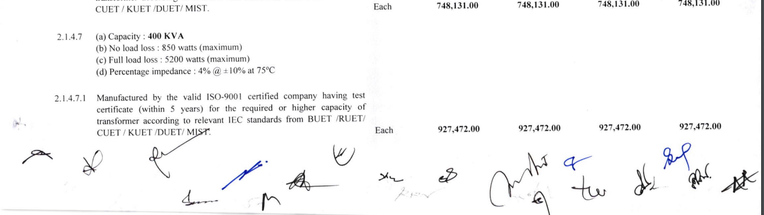

**Calculations For PFI Plant:**

Q=PtanѲ=263079.6*tan(36.86)=197.2381 kvar

Desired power factor=0.95

So PFI plant of 150 KVAR is needed. Then power factor will be : cos (arctan (47,238/263079) )= 0.985

###### I=Q/(3V)=150 kVAR/(3*220)=228 A

CB : 250 A

Wire : 4 x 185 sqmm NYY + 95 sqmm BYA ECC