Cucumber BDD Framework Requirements

Automation Tools:

* IntelliJ IDE 2021.3.1
* Selenium Server 4.1.2
* Chrome web driver
* Firefox driver
* Jdk 17.0.1

Install Plugins: Go to File ->settings🡪plugins

* Cucumber
* Cucumber for Java
* Gherkin
* Apache-Maven 3.8.4

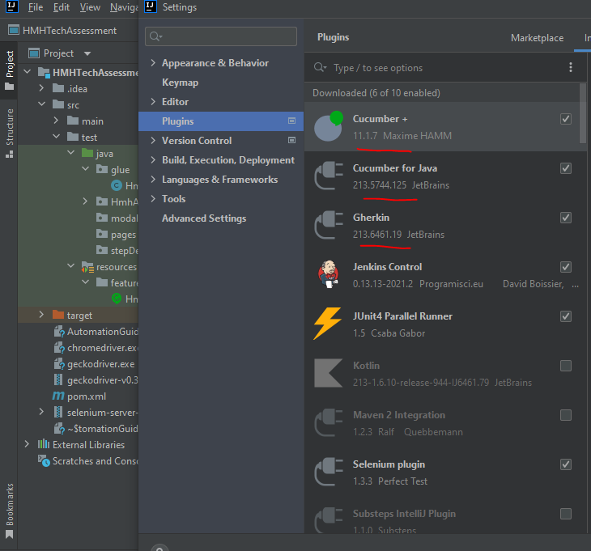

Execution flow of Automation Test:

Step1: Clone the project from GitHub to your local machine

<https://github.com/Mahindra552/HMHTechAssessment>

Step2: Open the project in Intellij

Step3: Right click on screen and run HmhUiTechTest.main() method

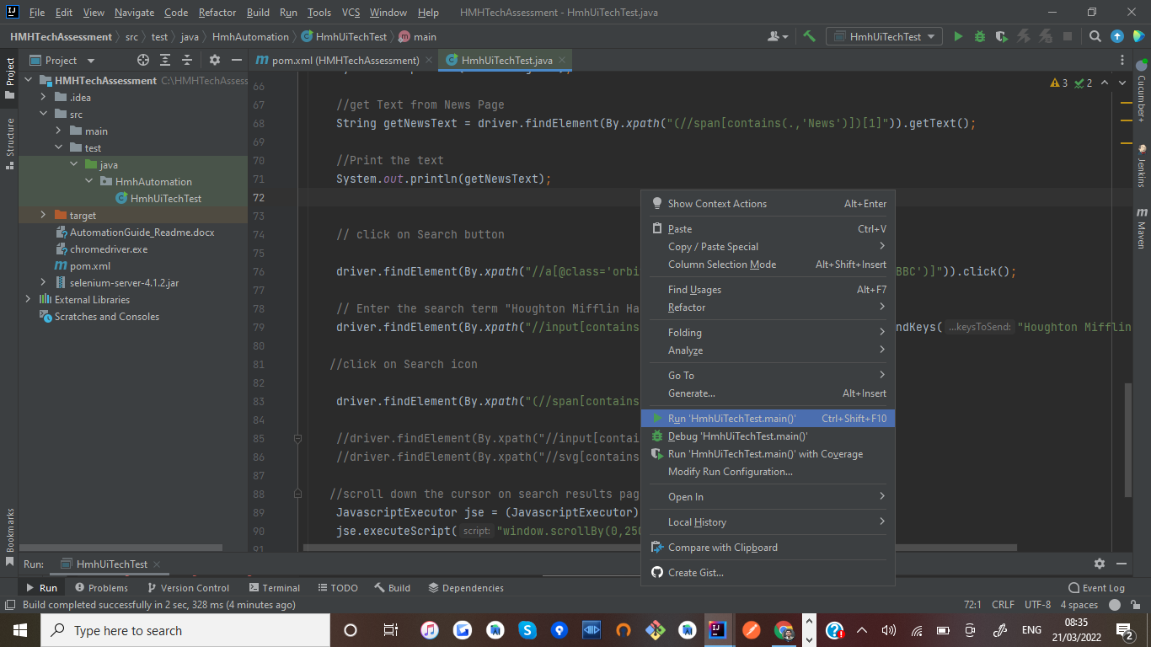

Console output:

