Book Recommendation System
A PROJECT REPORT
Submitted By:
[Your Name]
[Your Enrollment Number]
Under the Guidance of:
[Supervisor's Name]
November - 2024
Submitted in partial fulfillment of the Degree of
BACHELOR OF TECHNOLOGY
IN
COMPUTER SCIENCE & ENGINEERING
Department of Computer Science & Engineering
JAYPEE UNIVERSITY OF ENGINEERING & TECHNOLOGY,
A-B ROAD, RAGHOGARH, DT. GUNA - 473226, M.P., INDIA

Declaration by the Student
I hereby declare that the work reported in the B. Tech. project entitled as “Book Recommendation System”, in partial fulfillment for the award of degree of Bachelor of Technology, submitted at Jaypee University of Engineering and Technology, Guna, is my original work. As per the best of my knowledge and belief, there is no infringement of intellectual property rights and copyright. In case of any violation, I will solely be responsible.
[Your Name]
Department of Computer Science and Engineering
Jaypee University of Engineering & Technology
Guna, M.P., India
Date: 10-11-2024

Certificate
This is to certify that the work titled “Book Recommendation System” submitted by [Your Name] in partial fulfillment for the award of degree of Bachelor of Technology of Jaypee University of Engineering & Technology, Guna, has been carried out under my supervision. As per the best of my knowledge, this work has not been submitted partially or wholly to any other University or Institute for any other degree or diploma.
Signature of Supervisor
[Supervisor’s Name]
Designation
Date

Acknowledgement
I would like to express my sincere gratitude to my project supervisor, [Supervisor’s Name], for their continuous support and guidance throughout this project. I am grateful to the Department of Computer Science & Engineering at Jaypee University for providing the resources necessary to complete this project. Lastly, I would like to thank my family and friends for their encouragement and support.
Signature of Student
[Your Name]

Executive Summary
The Book Recommendation System is developed to assist users in discovering books based on their preferences. Leveraging machine learning techniques such as content-based filtering (KNN, Naive Bayes) and collaborative filtering (SVD), the system provides personalized recommendations. Additionally, a time-based module generates weekly trending books, ensuring up-to-date suggestions. The project utilizes Python, Streamlit, and various data science libraries to create a user-friendly interface. This report outlines the project's implementation, methodology, results, and conclusions.

Table of Contents
1. Introduction
2. Literature Review
3. Requirement Analysis
4. Design and Implementation
5. Results and Discussion
6. Conclusion and Future Work
7. References
Appendices

Introduction
This chapter introduces the project, its objectives, and scope.

Literature Review
This chapter covers existing research in the domain of book recommendation systems.

CHAPTER 3
REQUIREMENT ANALYSIS
The project develops a book recommendation system using collaborative filtering and content-based filtering with data from Goodreads. By leveraging some of the techniques like Cosine Similarity, it identifies patterns in user interactions, such as ratings and reviews, to create personalized book suggestions. User profiles are constructed to track reading preferences, and recommendations are generated by comparing books in the user's profile to those they haven’t explored. A hybrid model combines collaborative filtering, which finds similar users, with content-based filtering that analyzes book metadata. The system uses Python and Streamlit for an interactive interface, enhancing user engagement and delivering relevant book recommendations.

SOFTWARE REQUIREMENTS SPECIFICATION DOCUMENT
3.2.1 Hardware Requirements
- System : Intel® Core™ i5-9300H CPU @ 2.40GHz.
- Processor: Intel i5 or equivalent (minimum)
- RAM: 8GB (minimum), 16GB (recommended) for handling large datasets and efficient processing.
- Monitor : LED.
- Mouse : Logitech.
- Ram : 8.00 GB or above 8.00 GB
- Hard Disk : 1 TB
- Internet Connection :
- Recommended: A stable internet connection with a minimum speed of 10 Mbps.
- Rationale: Required for downloading the dataset, installing Python packages, and deploying the web application online

  - Software Requirements:
1. Programming Language
- Python 3.x: The primary language used for data analysis, machine learning algorithms, and developing the web application interface.
  - Python is chosen due to its extensive support for data processing, machine learning, and web frameworks.

2. Integrated Development Environment (IDE)
- Jupyter Notebook: For interactive coding, data analysis, experimentation, and visualizations during the initial development phase.
- Visual Studio Code (VS Code): For writing, debugging, and managing the codebase, especially for the Streamlit application.

3. Python Libraries and Frameworks
- Pandas: Used for data manipulation and analysis, especially for loading, cleaning, and preprocessing the Goodreads dataset.
- NumPy: For efficient numerical computations and matrix operations.
- scikit-learn: Implements machine learning algorithms, including collaborative filtering, content-based filtering, and hybrid models.
- Streamlit: Used to create an interactive and user-friendly web interface for the recommendation system.
- datetime: For handling date and time calculations, especially for implementing the Time Sync feature and tracking recent book interactions.
- streamlit-option-menu: For building the sidebar menu to navigate between different sections of the app.
4. Data Source
- Goodreads Dataset: The primary dataset containing information on book titles, authors, genres, ratings, and user interactions.
- CSV and JSON Files:
  - goodreads_interactions.csv: Contains data on user ratings, reviews, and interactions with books.
  - books_titles.json: Contains metadata for books, such as titles, authors, and descriptions.
5. Data Storage and Management
- Session State (Streamlit): Used to manage and persist user session data, such as liked books and search queries.
- Local Storage: Book metadata and interaction data are stored locally in CSV and JSON formats for quick access.
6. Web Application Framework
- Streamlit: An open-source Python framework used to build the web interface. It provides an interactive platform where users can search for books, get recommendations, and view popular books.
7. Additional Tools
- Anaconda: For managing Python environments and packages to avoid compatibility issues.
- Pip: The Python package installer used to install all required libraries.
- Excel / Google Sheets: For data inspection, analysis, and manipulation when working with the Goodreads dataset.
8. Operating System Compatibility
- The application is compatible with major operating systems, including:
  - Windows
  - macOS
  - Linux

3.3 Python Features
Python's features include −
- Easy-to-learn − Python has few keywords, simple structure, and a clearly defined syntax. This allows the student to pick up the language quickly.
- Easy-to-read − Python code is more clearly defined and visible to the eyes.

- Easy-to-maintain − Python's source code is fairly easy-to-maintain and since to handle this large dataset we can use python which is easy to maintain .

- Portable − Python can run on a wide variety of hardware platforms and has the same interface on all platforms.

- Framwork : Python provide its easy framework like Streamlit which we can use for our web-interface.

3.4 Functional Requirements :
The functional requirements of the Book Recommendation System describe the specific features that the system must implement to achieve its objectives of recommending books based on user preferences.
User Profile Management
- The system maintains user profiles using session state to store liked books and user interactions.
- Users can like books, and the system stores this information for personalized recommendations.

Search Functionality
- The system allows users to search for books by entering a query in the search bar.
- The search feature uses a custom search module to filter books based on the user’s input and display relevant results.
- The search query is stored in the session state to persist user input across page reloads.

Book Display with Cover Images
- The system displays book details, including cover images, titles, ratings, and a link to more information.
- Users can click a button to "like" a book, which saves the book to their profile using session state.
- Book details are displayed in a grid format with three books per row for a clean, organized interface.

Personalized Book Recommendations
- The system provides personalized recommendations in the Recommendations section using a collaborative filtering approach.
- Recommendations are generated based on books that the user has liked, using a custom recommend module.

Liked Books Section
- The system maintains a separate section where users can view all the books they have liked.
- This section displays book details using data stored in the session state.

Popular Books Feature
- The system analyzes recent user interactions to display the most popular books over different time frames (e.g., weekly, monthly).
- The popular books are filtered based on the date of interaction and ratings, with only highly rated books being shown.
- Users can customize the time range to view popular books for a specific number of days using a slider widget.

Data Loading and Caching
- The system loads interaction data (goodreads_interactions.csv) and book metadata (books_titles.json) with caching to improve performance.
- The use of @st.cache_data ensures that the data is not reloaded unnecessarily, reducing load times.

Time Sync Functionality
- The system includes a Time Sync feature that customizes book recommendations based on the user’s available reading time.
- Users can specify how much time they have for reading (e.g., hours per week), and the system will recommend books that fit within that timeframe.
- For example, if a user has only 5 hours available, the system will prioritize shorter books or those that can be completed within that time frame.

Interactive User Interface
- The entire application is built using Streamlit, allowing for a dynamic and interactive user experience.
- Navigation between different sections (Home, Search, Recommendations, Liked Books, About) is handled using an option menu in the sidebar.
- The interface includes interactive components like text inputs, buttons, and sliders to enhance user engagement.

Data Loading and Caching
- The system loads interaction data (goodreads_interactions.csv) and book metadata (books_titles.json) with caching to improve performance.
- The use of @st.cache_data ensures that the data is not reloaded unnecessarily, reducing load times.

Book Popularity Analysis
- The system identifies popular books based on recent user ratings and interactions.
- It displays the top-rated books in a given timeframe (e.g., week, month, or user-defined range).
- The results include clickable links to Goodreads pages and cover images for easy browsing.

Time Sync Feature for Customized Book Recommendations
The Time Sync feature is a unique functionality designed to personalize book recommendations based on the amount of time users have available for reading. This feature ensures that users can find books that fit within their busy schedules, optimizing their reading experience.

It Working
- The system allows users to specify how much time they can dedicate to reading (e.g., a certain number of hours per week) using an interactive slider widget.
- Once the user sets their available reading time, the system filters books based on their length, estimated by the number of pages and average reading speed (e.g., pages per hour).
- The system prioritizes shorter books or novellas if the user has a limited amount of time. Conversely, if the user has more time, the system may recommend longer novels or series.

Use Cases
- Busy Professionals: A user with only 2 hours of reading time per week will receive recommendations for shorter books that they can complete within that time frame.
- Students or Casual Readers: For users with 5 or more hours available, the system may suggest longer books or series that require more time commitment.
- Flexible Customization: Users can adjust the time range using the slider, and the system dynamically updates the recommendations to align with the new input

Benefits of the Time Sync Feature
- Efficient Use of Time: Helps users maximize their reading by suggesting books that fit within their available reading schedule.
- Personalized Experience: Tailors book recommendations not just based on user preferences but also on practical time constraints.
- User Satisfaction: Reduces the overwhelm of choosing a book by filtering options to those that can realistically be completed, leading to higher user engagement.

CHAPTER 4
Design and Implementation

4.1 System Architecture
The system architecture of the Book Recommendation System is designed to efficiently manage data flow, process recommendations, and provide a user-friendly interface.

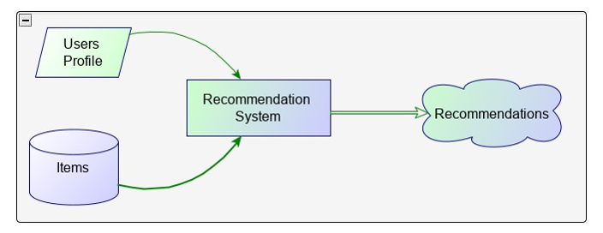
Fig 4.1: System Architecture

The architecture is divided into four main components:
- Data Collection and Preprocessing: Data is collected from the Goodreads dataset and is cleaned, transformed, and prepared for analysis.
- Recommendation Engine: The core component of the system, which uses collaborative filtering, content-based filtering, and a hybrid approach to generate book recommendations.
- User Interface: A dynamic web interface built using Streamlit, allowing users to interact with the system through various widgets like search bars, buttons, and sliders.
- User Feedback Loop: The system captures user feedback (e.g., liked books) to refine and improve future recommendations.

4.2 Data Collection and Preprocessing
To provide accurate book recommendations, the system relies on data from the Goodreads dataset, which includes information on book titles, authors, genres, ratings, and user interactions.
Data Sources:
- goodreads_interactions.csv: Contains user interactions, ratings, and timestamps.
- books_titles.json: Includes metadata such as book titles, descriptions, and cover images.

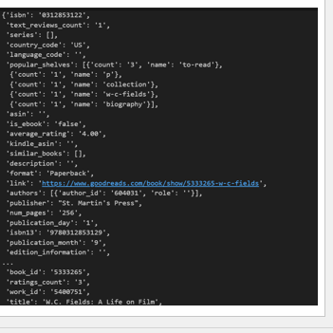
Fig.4.2.1 goodreads_books.json.gz

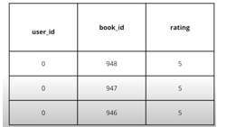
Fig.4.2.2 goodreads_interactions.csv

Data Cleaning:
- Handling Missing Values: Records with missing essential information were removed to ensure data integrity.
- Normalization: Ratings were standardized to a consistent scale (e.g., 1 to 5 stars).
- Text Preprocessing: Book descriptions were tokenized, and stopwords were removed using NLTK to enhance content-based filtering.
Feature Extraction:
- The TF-IDF Vectorizer was used to convert book descriptions into numerical vectors, enabling content-based similarity calculations.
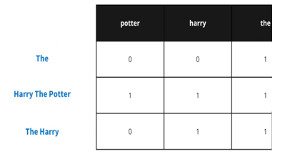
Fig.4.2.3 document frequency matrix

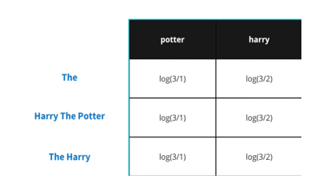
Fig.4.2.4 Inverse document frequency matrix
- Genre and author information were encoded to improve recommendation relevance.

4.3 Database and Storage
The project utilizes local storage and caching mechanisms to manage data efficiently.
Session State:
- The system uses Streamlit’s session state to store user preferences, liked books, and search queries. This ensures that user data is preserved during their browsing session.
Data Caching:
- The @st.cache_data decorator is used in Streamlit to cache data, reducing redundant computations and improving load times.
Local Storage:
- The dataset files (CSV and JSON) are stored locally, making it easy to access and update them as needed.

4.4 Recommendation Engine
The recommendation engine is the core component of the system, responsible for generating personalized book suggestions.

Recommendations systems rely on different technologies for computing recommendations. The most important approaches are content-based filtering and collaborative filtering. Content-based filtering displays users as individuals, while recommender systems employing the collaborative filtering approach display the user as a part of a group (Fasli, 2006). In addition, an advanced recommender system that combines content-based and collaborative filtering to avoid the limitations of each approach, is called a hybrid approach.
4.4.1 Content based filtering approach
The content-based filtering approach identifies the similarity between a user and the new items using the content of the previously evaluated items in the user profile. In addition, each item in a user profile is characterized by a set of attributes which is constructed by extracting a set of features from an item. Such a profile is used to determine if the new item is similar to the item that a user has preferred in the past. For instance, the Newsweeder is a netnewsfiltering system that suggests news articles to the user based on the user’s profile (Lang, 1995). Most content-based approaches are performed on textual documents, such as web pages and articles. The textual document can be easily broken down into individual words, unlike video and physical resources, which required sophisticated analysis.
Content-based filtering has some shortcomings in recommending items. A user's selection is based on the subjective attributes (such as the quality) of the item (Goldberg et al., 1992); in contrast, content based approaches are based on objective attributes (such as the description of an item) about the items. Also, some items the users may be interested in cannot be recommended to them because content-based methods compare new items with the items previously seen by the user, while the user's interests may be beyond the scope of the previously seen items. Finally, multimedia technology such as sound, video or physical items cannot be analysed automatically for relevant attribute information, due to limitations of resources (Jennings et al., 2005).

4.4.2 Collaborative Filtering approach
Collaborative filtering recommendations are based on the opinions of a community of similar users. The basic idea is that users recommend items to one another. Collaborative filtering makes this possible by asking the users to rate items, which allows the system to recommend new items that similar users have rated highly. For instance, MovieLens is a movie recommender system that uses collaborative filtering to help people find movies they will like in the huge stream of available movies. Collaborative filtering works well for multimedia technology such as music and movies. However, it also has some limitations:
New user problem: A new user starts off with a profile of interests from scratch. The system needs to know the user preferences in different items to generate accurate recommendations.
Cold start problem: New items cannot be recommended until more information is obtained when another user either rates an item or provides feedback on the item (Fasli, 2006). As a result, the recommendations generated by the system will not recommend items similar enough to the users’ interests.

Scalability: A collaborative filtering algorithm should address the scalability issue as the number of users increase and their collective profile size becomes large (Fasli, 2006).
The schematic diagram of the collaborative filtering process is showed in Figure 4.1. As you can see from the figure, there is a list of users denoted by U= {u1, u2,…,um} and a list of items I={i1,i2,….,in}. Each user has a list of items. The collaborative filtering algorithm will generate recommendations(fig 4.1), a list of N items that the active user will mostly like, according to the active user. Also, the process will output a prediction, which is the result prediction on item j for the active user (Sarwar et al., 2001).

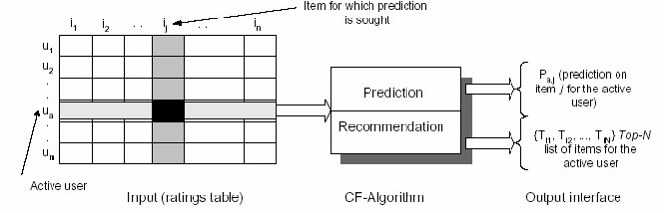
Fig 4.4.2 Collaborative Filtering Process

ALGORITHM

- Content based filtering mechanism : This approach analyzes book metadata, such as descriptions, genres, and authors, to recommend books similar to those a user has previously enjoyed.
- Collaborative based filtering algorithm : Collaborative filtering uses past user interactions to recommend books liked by users with similar tastes.
- Cosine similarity: Cosine similarity is used to find books with similar content attributes And also measure the similarity between users.

Results and Discussion
This chapter evaluates the system’s performance and presents results.

Conclusion and Future Work
This chapter concludes the report and discusses potential future enhancements.

References
1. Aggarwal, C. C. (2016). Recommender Systems: The Textbook. Springer.
2. Goodreads Dataset: https://www.goodreads.com/
3. Scikit-learn documentation: https://scikit-learn.org/
4. Streamlit documentation: https://streamlit.io/

Appendices
Appendix A: Sample Code
Appendix B: Screenshots of the Interface

Chapter 4
4.3 Model Implementation
4.3.1 collaborative filtering : In collaborative filtering, cosine similarity is often used to measure the similarity between users based on their ratings or interactions with items. This helps in finding users with similar preferences to make recommendations. Here’s how it works:
- Represent User Preferences as Vectors: Each user’s ratings or interactions with items are represented as a vector. For example, if there are five movies, and User A has rated three of them, User A’s vector might look like [4, 0, 3, 5, 0] where each position corresponds to a movie, and the value represents the rating (0 means no rating).
- Calculate Cosine Similarity: Cosine similarity between two users (say, User A and User B) is calculated by finding the cosine of the angle between their vectors. The formula is:
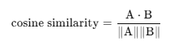
- Interpretation of Cosine Similarity: The cosine similrity score ranges from -1 to 1, where:
  - A score close to 1 means the users have similar preferences (vectors point in nearly the same direction).
  - A score close to 0 means there’s little similarity between users’ preferences.
  - A negative score (rare in collaborative filtering) indicates opposite preferences.
- Use in Recommendations: Users with high cosine similarity scores are considered "neighbors." The preferences of these similar users are then used to predict ratings for items the target user hasn’t rated, helping generate personalized recommendations.

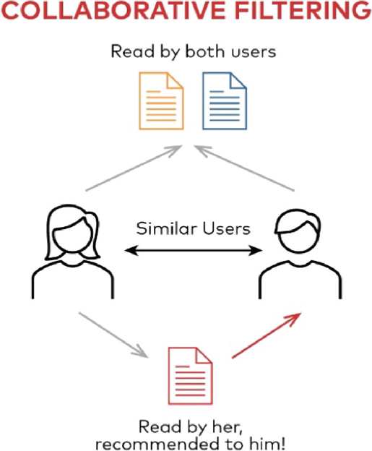
4.3.2 Content-Based Filtering : In content-based filtering, Term Frequency-Inverse Document Frequency (TF-IDF) is a popular technique to recommend items based on their features. Here's how it works in this context:
- Representing Item Content with TF-IDF: Content-based filtering focuses on the features of the items, such as keywords describing a movie, product, or article. Each item is treated as a "document," and its keywords are given weights based on their importance using TF-IDF. This technique gives higher weights to terms that are important for the item (frequent in the item description) but not common across all items.
- TF-IDF Formula:
  - TF (Term Frequency) measures how often a term appears in a document (e.g., the movie's description).
  - IDF (Inverse Document Frequency) measures how unique a term is across all documents.

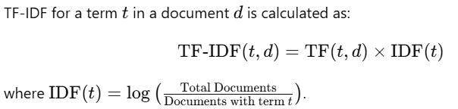

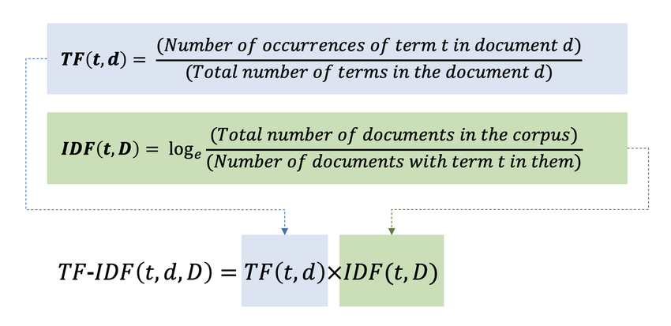

- Building Item Profiles: Each item gets a "profile" vector with its TF-IDF scores. For example, a movie's vector might have high TF-IDF values for keywords like "sci-fi," "space," and "adventure" if those terms are specific and important for the movie.
- Matching Items to User Preferences: A user’s profile is created based on the content of items they’ve previously liked. Then, content-based filtering calculates the similarity between the user’s profile and each item’s TF-IDF vector to recommend new items with similar features.
Using TF-IDF in content-based filtering helps capture the uniqueness and importance of each item's features, making the recommendations more relevant to the user’s known preferences.

4.4 Technologies Used
4.4.1 Streamlit : Streamlit is an open-source Python framework designed to build interactive, data-driven web applications quickly and easily. It is widely used in data science and machine learning projects due to its simplicity and compatibility with Python libraries, allowing users to create powerful interfaces without needing advanced web development skills.
Streamlit's framework provides a wide array of built-in widgets—such as sliders, checkboxes, file uploaders, and dropdowns—that make it easy to build interactive user interfaces. It also integrates well with visualization libraries like Matplotlib, Plotly, and Altair, enabling dynamic visualizations that update based on user interactions. With minimal code, Streamlit applications can gather user inputs, display data, and even showcase model outputs, making it an ideal choice for rapid prototyping and data exploration.
In this project, we used Streamlit to develop an interactive interface, allowing users to engage with the application seamlessly. This interactive approach enhances user experience, making complex data or model results more accessible and understandable.
Key Features of Streamlit
- Python-Based: Write web apps using only Python code, which makes it accessible to data scientists without requiring extensive frontend skills.
- Live Re-rendering: Automatically updates the app in real-time as the underlying data or code changes, making it interactive and dynamic.
- Widgets for Interaction: Provides built-in widgets, like sliders, buttons, checkboxes, and file uploaders, allowing users to interact with the app without HTML or JavaScript.
- Data Visualization: Integrates with popular Python libraries like Matplotlib, Plotly, and Altair to create interactive visualizations.
4.4.2 Python Library
Pandas: Pandas is a Python library used for working with data sets. it has functions for analyzing, cleaning, exploring, and manipulating data. The name "Pandas" has a reference to both "Panel Data", and "Python Data Analysis" and was created by Wes McKinney in 2008. Pandas allows us to analyze big data and make conclusions based on statistical theories. Pandas can clean messy data sets, and make them readable and relevant. Relevant data is very important in data science.
- A widely-used Python library for data manipulation and analysis.
- Provides data structures like DataFrame for handling and processing structured data.
- Enables data cleaning, filtering, merging, reshaping, and aggregation.
- Ideal for data preprocessing and exploration in data science.
- Supports operations like sorting, re-indexing, iteration, concatenation, data conversion, visualizations, and aggregations.

NumPy: NumPy is the fundamental package for scientific computing in Python. It is a Python library that provides a multidimensional array object, various derived objects (such as masked arrays and matrices), and an assortment of routines for fast operations on arrays, including mathematical, logical, shape manipulation, sorting, selecting, I/O, discrete Fourier transforms, basic linear algebra, basic statistical operations, random simulation and much more.
- Stands for "Numerical Python" and is a widely used library.
- Supports large matrices and multi-dimensional data.
- Provides in-built mathematical functions for easy computations.
- Used internally by libraries like TensorFlow for tensor operations.
- Core library for numerical and scientific computing in Python.
- Efficient operations on arrays and matrices, foundational for fast mathematical calculations.
- Many data science libraries are built on top of NumPy for handling large datasets and array manipulation.
Scikit-learn: Scikit-learn (Sklearn) is the most useful and robust library for machine learning in Python. It provides a selection of efficient tools for machine learning and statistical modeling including classification, regression, clustering and dimensionality reduction via a consistence interface in Python. This library, which is largely written in Python, is built upon NumPy, SciPy and Matplotlib.
- A popular open-source Python library for machine learning.
- Supports both supervised and unsupervised algorithms (e.g., linear regression, classification, clustering).
- Works in association with NumPy and SciPy.
- Offers a broad range of algorithms for classification, regression, clustering, and dimensionality reduction.
- Provides tools for data preprocessing, model evaluation, and parameter tuning.
- Versatile for building and evaluating machine learning models.

Chapter 5
5.1 Result
/* screenshots
Accuracy metries for the rec system */

5.2 Conclusion
/* summary of findings and project achievements */

5.3 Future Enhancements :

/* improving rec quantity with hybrid modes
Incorporating more datasets to diversify book suggestion */

