**Oracle Database 19c Client Installation**

**Prerequisites:**

Windows OS 64-bit or 32-bit(x86) system

Oracle Database 19c client software package available at Oracle software Downloads (<https://www.oracle.com/in/database/technologies/oracle19c-windows-downloads.html>)

**Installation steps:**

1. After the software package is downloaded, unzip it and get it into client32 directory from unzipped folder. Run setup.exec file

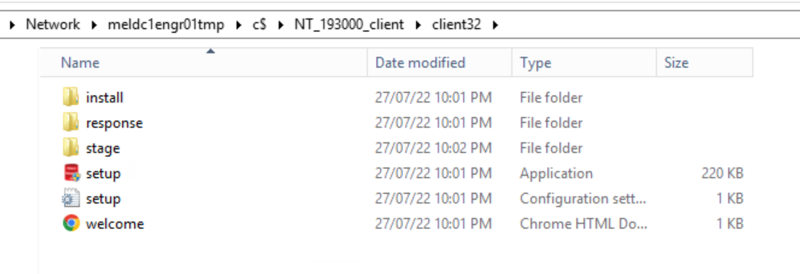

1. 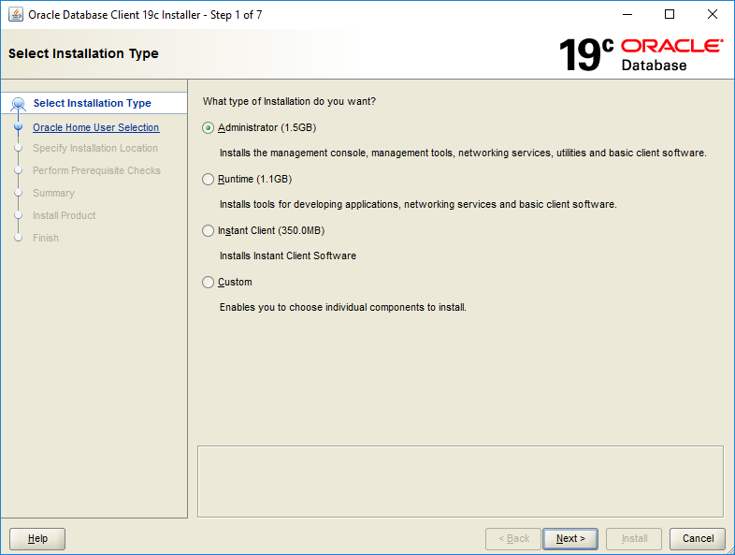It prompts with installation screen and step 1 is to select the installation type, choose Administrator if you want complete setup with all services and click next like below:
2. At step 2, it asks to specify Oracle Home user, select windows Built-in account to have super user permissions on oracle and click next like below:

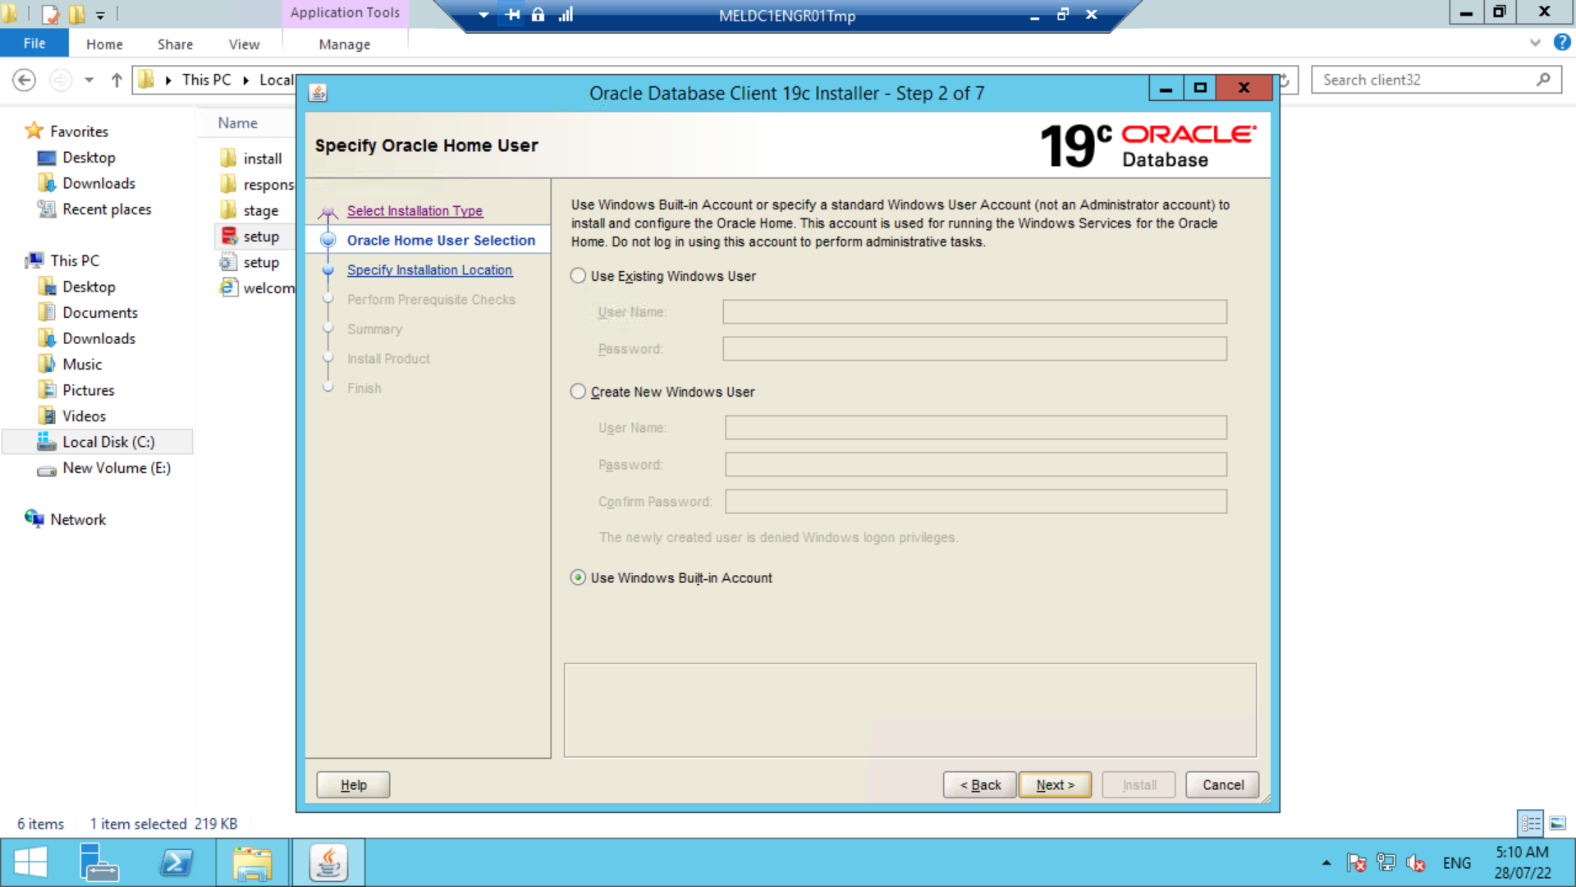

1. At step 3, it asks to specify the Oracle Base and Oracle Home locations to place all the software and configuration files at specified directories. After choosing the location click on next like below:

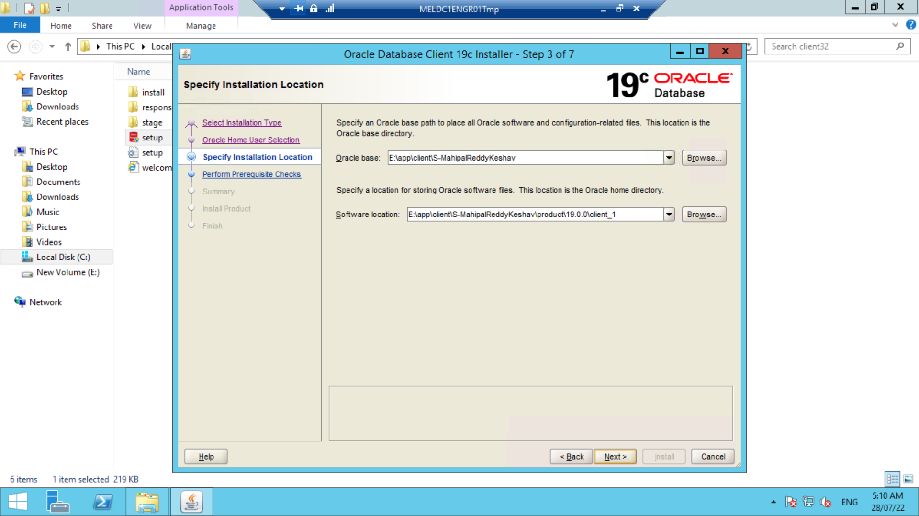

1. At step 4, it performs all prerequisite checks and at fifth step it summarizes the information like below:

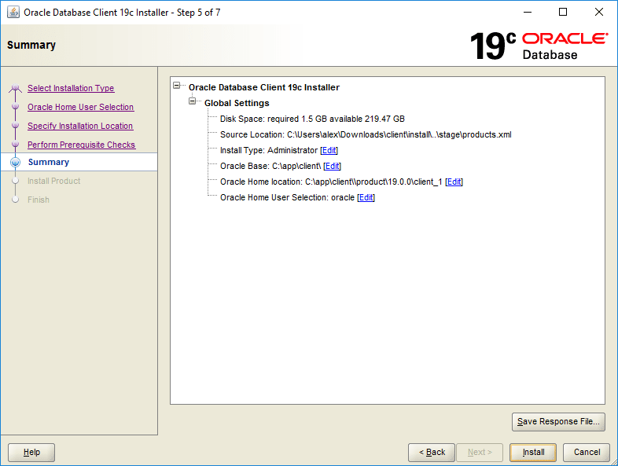

1. 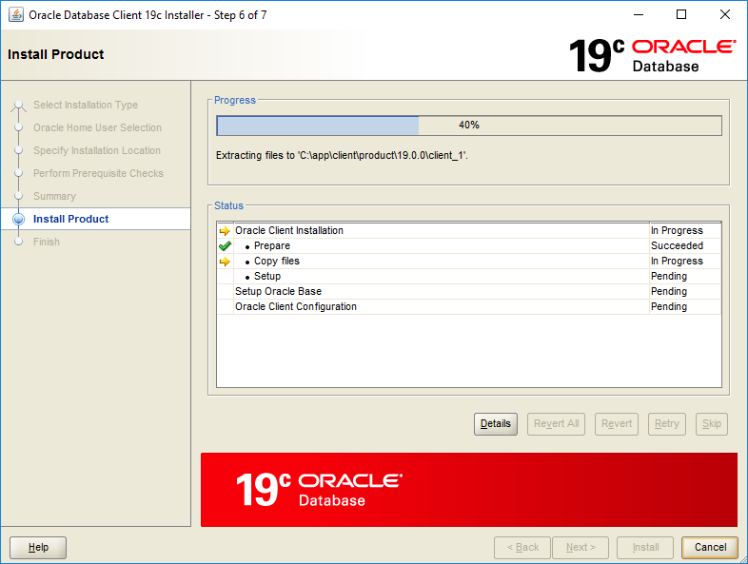At step 6, it installs the client product by taking some time and shows the status like below:
2. At final step, if product installation went well it shows the below screen:

