**To reduce the used space on /orahome mount point**

1. Delete the older trace files at trace location (E.g: /orahome/oracle/product/19.3/diag/traxma/diag/rdbms/traxmanw/traxmanw/trace)

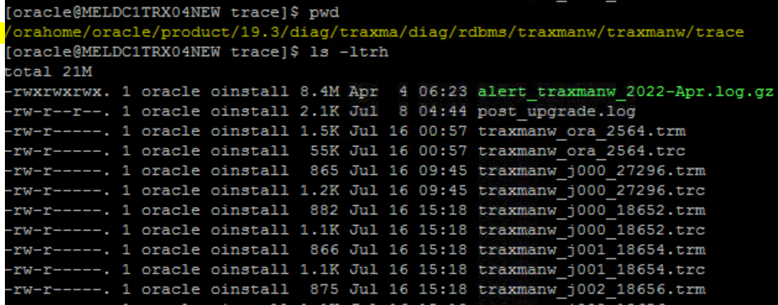

1. Delete the older audit files from the specified audit file destination (E.g: /orahome/oracle/product/19.3/admin/traxma/adump)

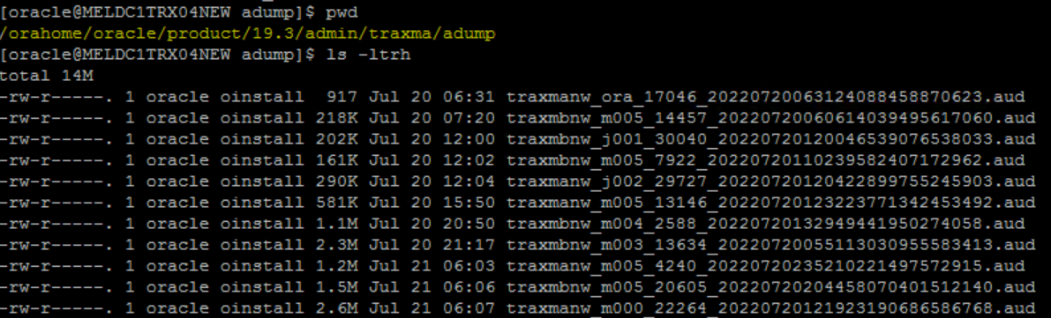

1. Delete the temporary files created under the tmp directory (E.g: /orahome/oracle/product/19.3/db_1/ctx/tmp)

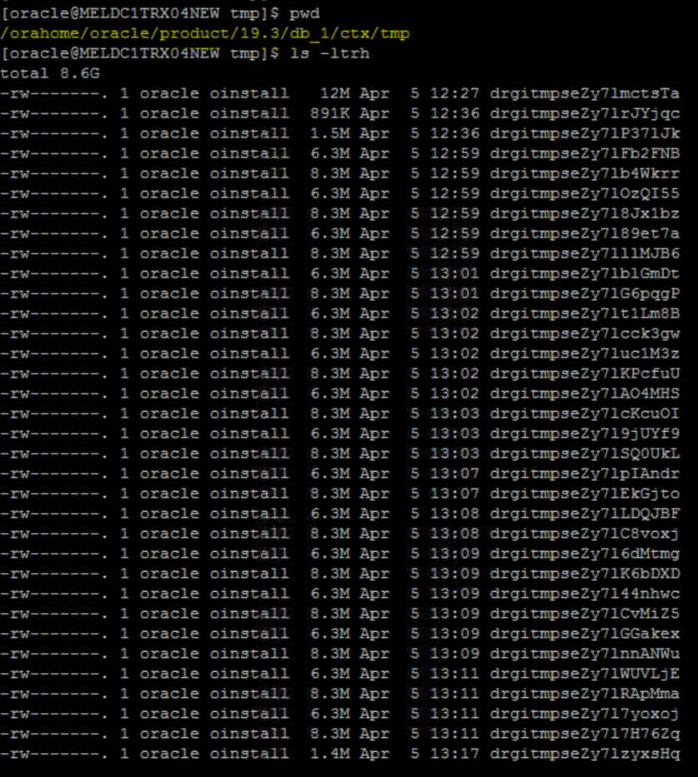

* If the temporary files are generating more, follow below recommended steps for removing or reducing the generation of files:

1. As per Oracle support, it is considered as an unpublished Bug 9660624 and Bug 10154750 in oracle versions 11.1 to 11.2.0.3 that fills /tmp directory and they are not automatically deleted resulting in adding more space to /tmp.
2. It is always recommended to upgrade the oracle Database software to newer versions or apply ‘[**Patch 10404530**](https://support.oracle.com/epmos/faces/ui/patch/PatchDetail.jspx?parent=DOCUMENT&sourceId=1366635.1&patchId=10404530)**’** or later which includes the fix for above referenced bugs.
3. It is recommended to set, on UNIX the TMPDIR environment variable and on MS Windows user environment variable TMP, to a different directory than /tmp or /var/tmp, to direct the creation of temporary files to the new directory, and delete the old files from time to time for example using an operating system cron job.