Github link: <https://github.com/Mahipal9/chatbot_for_examination_query->

CHAT BOT FOR EXAMINATION QUERY

END TERM REPORT

***by***

**MAHIPAL SINGH, MONU KUMAR, MOLLA KHASIME AMAN**

**Section: K18RD**

**Roll no: 12, 13, 32**



Department of Intelligent Systems

Lovely professional University, Jalandhar

04-2020

# **Student Declaration**

This is to declare that this report has been written by us. No part of the report is copied from other sources. All information included from other sources have been duly acknowledged. We ever that if any part of the report is found to be copied, we are shall take full responsibility for it.

Name: Mahipal Singh

Reg no: 11802752

Roll no: 12

Name: Kunal Malhotra

Reg no: 11812096

Roll no: 13

Name: Molla Khasime Aman

Reg no: 11802421

Roll no: 32

Place: Lovely professional university.

Date: 08-april-2020.

# TABLE OF CONTENTS

**TITLE**  **PAGE NO.**

1. **Background of Project……..……………………………..**  **4**

**2.Chatbot……………………..……………………………….. 5**

**2.1 Natural Language Understanding Engine……………. 6**

**2.2 Artificial Intelligence…………………………………… 6**

**3. Objectivs of Project………………………………………... 6**

**4. Description of Project……………………………………… 7**

**4.1 Prototype screenshot of our chatbot…………………… 8**

**4.2 Individual Student Role for chatbot…………………… 9**

**4.3 Technologies and Framework to be used……………… 9**

**4.4 SWOT Analysis achieved in project…………………… 10**

**5. Bonafide Certificate………………………………………… 11**

**1.Background**

Chatbots has emerged as a hot topic in the latest years, and it is used by numerous

companies in various areas - help desk tools, automatic telephone answering systems,

e-commerce and so on. Even though the technology has been around since the 60’s (Atwell

& Shawar, 2007). Why are we suddenly so interested in this technology now? This can likely

be explained by the recent year's advancements in messaging applications and AI

technology (Brandtzaeg & Følstad, 2017).

In the article Chatbots: Are they really useful? Atwell and Shawar provide real-life examples

of different chatbots in different contexts. One of the examples is Sophia, a robot that was

developed to assist in mathematics at Harvard by answering students questions. This

turned out to be applicable in many other contexts. In Norway you have probably

noticed “Kommune Kari”. A chatbot that many of the municipality have available on their

web-pages. Kari is there to answer “easy” questions like “when will the garbage truck

come?” and “where can I find available jobs?”. Kari’s goal and the job is to provide

information so that you as a user don’t have to navigate the “massive information flow”

(Schibevaag, 2017). This way of using a chatbot is a part of the Question Answering (QA) field which is a combination between AI and information retrieval (Molla & Vicedo, 2007). QA can be defined as “... the task whereby an automated machine (such as a computer) answers arbitrary questions formulated in natural language. QA systems are especially useful in situations in which a user needs to know a very specific piece of information and does not have the time—or just does not want—to read all the available documentation related to the search topic in order to solve the problem at hand”. (Molla & Vicedo, 2007).

Sophia and Kari are examples of chatbots that operate in “very specific” domains. This

means that if you were to ask Kari about math and Sophia about when the garbage truck

comes none of them would know the answer - because the question is outside of their

domain. Chatbots have what is called a natural language user interface and therefore

communicate with users via natural language ㅡ how a human would talk on a regular basis

(Brandtzaeg & Følstad, 2017). Therefore they use what is called natural language processing

(NLP) where the chatbot uses computational techniques to analyze text, where the goal is

to produce a human-like answer based on a linguistic analysis (Hirschberg & Manning, 2015).

For a chatbot to be especially useful to a certain domain some criteria have to be met.

Minock (2005) proposes the following criteria for a domain to be successful in answering

domain-specific questions: a domain should be circumscribed, complex and practical. This

is summarized in the table below.

|  |  |
| --- | --- |
| **Criteria** | **Description** |
| **Circumscribed** | Clearly defined knowledge sources and comprehensive resources available (a database etc.) |
| **Complex** | If you could develop a simple FAQ then it would not be useful with a QA system. There has to be some level of complexity in the domain while still being able to meet the circumscribed criteria. |
| **Practical** | Should be of use to a large group of people in the domain and take into account: how the users will formulate questions, what is commonly asked and how detailed the answers should be. |

When designing an intelligent system that provides decision support one must consider the

human as something outside the system, but also as an integrated system component that

in the end, will ultimately determine the success or the failure of the system itself

(Cumming, 2004).

**2.Chatbot**

Chatbot (also known as a talkbot, chatterbox, Bot, IM bot or Artificial Conversational Entity) is a computer program that mimics human conversations in its natural format including text or spoken language using artificial intelligence techniques such as Natural Language Processing (NLP), image and video processing, and audio analysis.

A chatbot is a software tool that utilises natural language processing (NLP) for human machine interaction (HMI) and Machine Learning (ML). “The complexity of a chatbot is directionally proportional to the scope of the domain”. An open domain requires a larger knowledge base, whereas, a closed domain has a more specific knowledge base that was developed to achieve a specific goal.

Chatbot technology initially began in the 1960s to determine whether a chatbot could be portrayed as a human. Throughout the 1980s there was an elevated amount research carried out on natural language interfaces which lead to the development of sophisticated chatbot architectures such as A.L.I.C.E. This chatbot architecture is one of the earlier chatbots developed in 1995 by Dr Wallace which is now opensource, the acronym stands for Artificial Linguistic Internet Computer Entity. This is a chatbot you can create through interaction as it will learn from previous interactions to create its knowledge base. Its knowledge is saved in AIML (Artificial Intelligent Mark-up Language) files which evolved from the Extensible Mark-up Language (XML).

Chatbots are developed using two approaches; a rule based approach where chatbots operate by moving through branches of a tree diagram of an expert system. The second approach involves advanced artificial intelligence and machine learning, thus the chatbot can learn from the conversations, generating appropriate responses to continuously improve over time (Watson, A. 2017).

**2.1 Natural Language Understanding Engine**

The chatbot engine is thought of as one of the most critical elements of a chatbot, alias “Natural Language Understanding (NLU) engine”. The NLU holds liability for the translation of conversational dialogs to actions which are understood by the machine. NLU engines use a variety of artificial intelligence methods to understand the natural language used in conversational interfaces such as chatbots. These methods consist of: Natural Language Processing (NLP) and Machine Learning (ML) (Kar, R and Haldar, R. 2016).

**2.2 Artificial Intelligence**

“Artificial Intelligence is neither a new technology nor a machine”. Artificial intelligence is the recognition of outcome-direction which is the rapid analysis of live data to achieve the expected goal. Outcome-directed thinking splits from the confines of the rule-directed approach that is accomplished through artificial intelligence.

**3. Objectivs**

A chat-bots aims to make a conversation between both human and machine so that our aim is to make conversation between student and examination system easier. The machine has been embedded knowledge to identify the sentences and making a decision itself as a response to answer a question. Chat-bots will be completely based on a text-based user interface, allowing the user to type commands and receive text . Chat-bots are usually stateful services, remembering previous commands in order to provide functionality. It can be utilized securely by an even larger audience when chat-bots technology is integrated with popular web services. The college inquiry chat-bots will be built using artificial algorithms that analyze user's queries and understand user's message. The response principle is matching the input sentence from a user. The User can ask the any question examination-related activities through the chat-bot without physically available to the college for inquiry. The System analyses the question and then answers to the user. With the help of artificial intelligence, the system answers the query asked by the students. The system replies using an effective Graphical User Interface as if a real person is talking to the user. Natural language processing technologies are used for parsing, tokenizing, stemming and filtering the content of the complaint.

Chat-bot for examination management system project will be developed using artificial intelligence algorithms that will analyze users queries. This system will be a web application which will provide answers to the analyzed queries of the user. Users will just have to select the category for queries and then ask the query to the bot that will be used for answering it. Artificial intelligence will be used to answer the user's queries. The user will get the appropriate answers to their queries. The answers will be given using the artificial intelligence algorithms. Users won't have to go personally to the college for inquiry. User can access the various helping pages. There will be various helping pages through which the user can chat by asking queries related to college activities. The system will reply to the user with the help of effective graphical user interface (GUI). It will help the students/user to be updated about the exam activities.

We wanted to investigate user’s trust in an AI ​​system such as a chatbot. We therefore  designed a research questions we wanted to look further into. “How will helpfulness affect trust in chatbot technology for students when it comes to  exam-related information?”    A chatbot needs a purpose, and if we consider that if this purpose is to be helpful, it also  needs to gain trust from the users. There is no need to ask a chatbot for help if you don’t  trust the information it gives you. With this in mind we consider the first question to be a bit  too ambiguous and large for us to investigate in this course. We have therefore used this  question as a guideline for what we can actually manage to explore in this course and what  we can find on the existing literature in this field. Trust is an important factor for reliance on  and implementation of technology (Lee & See, 2004). In relationships trust means being  reliable, having confidence in the other person both physically and emotionally (Lewicki &  Bunker, 1995). So one can say that trust will also play a role in the interplay between human  and machine.

**4. Description**

In our project we explore how a chatbot can give information to students about exam-related information. In the first iteration of the project we created a chatbot for giving students information about where to get information etc. One of our hypothesis was that information given by chatbots would be useful for students, giving them information about things that we consider to be important when you’re search about examination. In the second iteration we wanted to explore the use of chatbots through theory and used this in combination with testing to learn more about how a chatbot for this context should be. In the final iteration, iteration three, we improved and changed the chatbot based on the results from the last iteration and made a plan for evaluate the chatbot. The plan was then executed with five participants. In our conclusion we discuss the results from the evaluation in the light of our research question.This work aims to provide a fast and convenient way to manage your information about examination. The chatbot will help facilitate the user with queries and assist with examination system. We listed a set of questions and tasks, wich we asked the participants to answer and preform. We also included a few control questions to investigate the participants experience with the chatbot and to find out if they had any suggestions for further improvement. The evaluation ended with a short talk about the experience, where we were open for any kind of feedback the evaluators could provide.We found the chatbot to be nice to interact with and enjoyed that it had a friendly and casual tone. We found it hard to get the right answer but when we did we were very satisfied with the answers. “It was a good answer when I finally got the right one..”. It was pointed out that the chatbot was not a smart chatbot, but that it provided the most necessary information sparing them from precious time spent on ‘Google’. We also reported that we trusted the answers we got, and we all pointed out that it was good that the chatbot provided a source along with the information it gave. So finally our chatbor is ready to use.

**4.1 Prototype screenshot of our chatbot :**

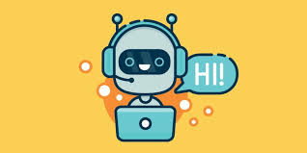

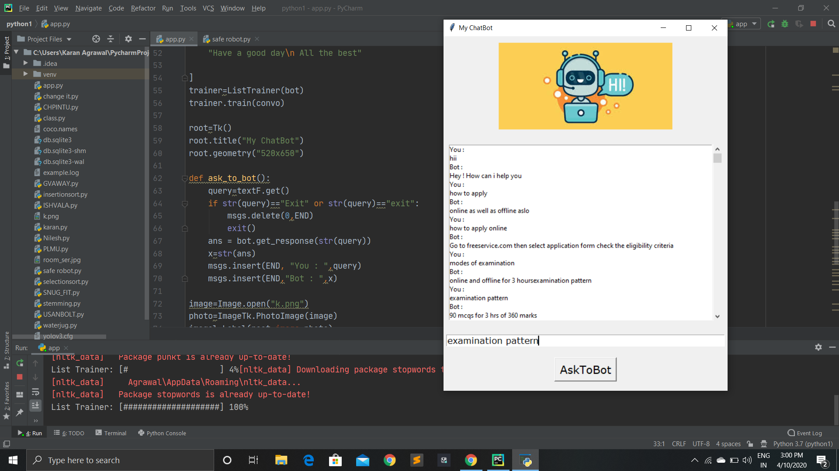

**4.2 Individual Student Role for chatbot**

* Mahipal Singh did coding for project and help in project report.
* Monu kumar did information and data collection and made Report for project.
* Molla Khasime Aman did data collection and help in coding.

**4.3 Technologies and Framework to be used**

We used pycharm to implement are code and used windows operating system.

We used Python programming language in our project to implement our chatbot project.

We used some python libraries for our chatbot project which are Tkinter, Chatterbot.

**4.4 SWOT Analysis achieved in project**

The project gradually evolved and progressed throughout its entirety and the main objectives and requirements have been met. This chatbot allows users to connect to information about their examination. They can use it within the one communication channel through natural language.

It was determined that exmination chatbot perform at a very high standard and provide reliable and rapid responses to users compared to that of traditional methods. The average time spent interacting with the chatbot is very low as it provides an efficient way for users to manage their questions about examination. The low interaction time reflects the high understanding, offered through the adoption of conversational user interfaces thus allowing users to freely interact with the chatbot to meet the demands of modern life. The chatbot has proven to fulfil the demand of users wanting instant access and availability information and services.

**BONAFIDE CERTIFICATE**

Certified that this project report “ CHAT BOT FOR EXAMINATION QUERY ” is the bonafide work of “ Names: MAHIPAL SINGH, MONU KUMAR, MOLLA KHASIME AMAN” who carried out the project work under my supervision.

<<Signature of the Supervisor>>

<<Name of supervisor>>

<<Academic Designation>>

<<ID of Supervisor>>

<<Department of Supervisor>>