
FarmEase

A PROJECT REPORT
Submitted by
Gandhi Mahir Prashantkumar (220130107027)
Patel Krish Rakeshkumar
(220130107092)

In partial fulfillment for the award of the degree of

BACHELOR OF ENGINEERING
in

Computer Engineering
Government Engineering College, Sector-28, Gandhinagar



Gujarat Technological University, Ahmedabad April-May, 2026




Government Engineering College, Sector-28, Gandhinagar

CERTIFICATE

This is to certify that the INTERNSHIP project entitled “FarmEase” has been carried out by Gandhi Mahir Prashantkumar under my guidance in COMPUTER ENGINEERING (8-SEM) of Gujarat Technological University, Ahmedabad during the academic year 2025-2026.

Prof M.H.Valera Dr. D.A.Parikh
Internal Guide Head of the Department




Government Engineering College, Sector-28, Gandhinagar

CERTIFICATE

This is to certify that the INTERNSHIP project entitled “FarmEase” has been carried out by Patel Krish Rakeshkumar under my guidance in COMPUTER ENGINEERING (8-SEM) of Gujarat Technological University, Ahmedabad during the academic year 2025-2026.

Prof M.H.Valera Dr. D.A.Parikh
Internal Guide Head of the Department

COMPANY COMPLETION CERTIFICATE
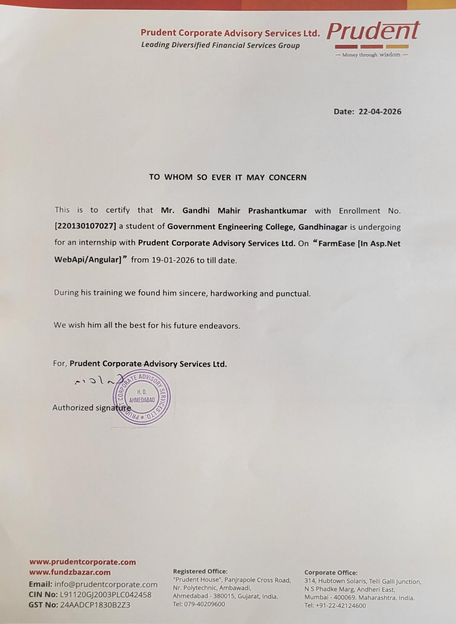

COMPANY COMPLETION CERTIFICATE

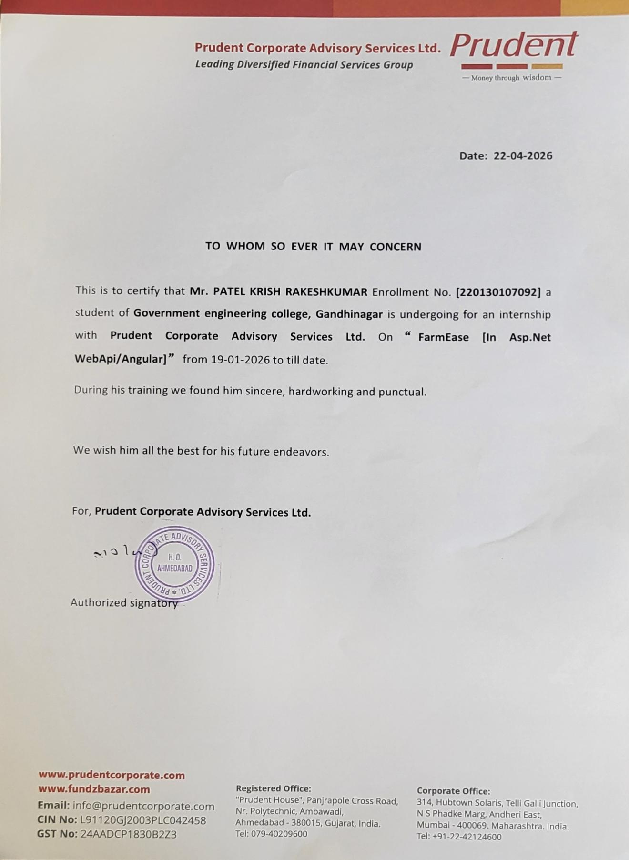



Government Engineering College,Sector-28, Gandhinagar

DECLARATION

We hereby declare that the Internship Project entitled FarmEase submitted in partial fulfillment for the degree of Bachelor of Engineering in Computer Engineering to Gujarat Technological University, Ahmedabad, is a bonafide record of original project work carried out by us at PRUDENT CORPORATE ADVISORY SERVICE LTD. under the supervision of Meghna Shah and that no part of this report has been directly copied from any students reports or taken from any other source, without providing due reference.

Name of the Student Sign of Student

- Gandhi Mahir Prashantkumar

- Patel Krish Rakeshkumar

Gujarat Technological University I GEC, Gandhinagar

ACKNOWLEDGEMENT

- I would like to express my heartfelt gratitude to all those who contributed to the successful completion of my final year project on FarmEase.
- I am deeply thankful to the faculty members of Government Engineering College, Sector-28, Gandhinagar, for providing the necessary resources and fostering an environment conducive to research and learning.
- I extend my sincere appreciation to my classmates and friends for their encouragement, insightful discussions, and continuous moral support throughout the various stages of this project.
- I would also like to acknowledge the developers and contributors of the open-source tools and libraries that formed the foundation of this project. Their dedication to advancing technology and sharing knowledge has been truly invaluable.
- Last but not least, I express my deepest gratitude to my family for their unwavering love, patience, and understanding during this journey.
- This project would not have been possible without the collective efforts and support of everyone mentioned above. I sincerely thank you all for your invaluable contributions.

Gujarat Technological University II GEC, Gandhinagar

ABSTRACT

- FarmEase is a web-based agriculture support platform designed to simplify and modernize farming practices by connecting farmers with essential agricultural services through a single digital interface.
- The primary objective of FarmEase is to empower farmers by providing easy access to information, tools, and resources that help improve productivity, decision-making, and profitability.
- The platform is user-friendly, responsive, and accessible, ensuring that farmers with basic digital knowledge can efficiently use it.

Gandhi Mahir Prashantkumar (220130107027) Patel Krish Rakeshkumar (220130107092)

Gujarat Technological University
III
GEC, Gandhinagar

LIST OF FIGURES

Figure No. | Title | Page No.
Figure 1 | Waterfall model….......................................................................... | 13
Figure 2 | Incremental Waterfall Model…................................................... | 14
Figure 3 | Gantt Chart…................................................................................ | 20
Figure 4 | Flow Chart…................................................................................. | 26
Figure 5 | DFD Level 0…............................................................................... | 27
Figure 6 | DFD Level 1…............................................................................... | 27
Figure 7 | Use Case Diagram (Farmer)…............................................…….. | 28
Figure 8 | Use Case Diagram (User)…................................................…….. | 29
Figure 9 | Use Case Diagram (Admin)….............................................…….. | 30
Figure 10 | Farmer Activity Diagram…........................................................... | 31
Figure 11 | User Activity Diagram…............................................................... | 32
Figure 12 | Admin Activity Diagram…........................................................... | 33
Figure 13 | Farmer Sequence Diagram…........................................................ | 34
Figure 14 | User Sequence Diagram…............................................................ | 35
Figure 15 | Admin Sequence Diagram…........................................................ | 36
Figure 16 | ER Diagram…............................................................................... | 37
Figure 17 | Program.cs…................................................................................. | 46
Figure 18 | Database…...…............................................................................. | 47
Figure 19 | Login Code…............................................................................... | 47
Figure 20 | Services Code…........................................................................... | 48
Figure 21 | Products Code….......................................................................... | 48
Figure 22 | AgriService code…...................................................................... | 49
Figure 23 | ConnectionDB code…................................................................. | 49
Figure 24 | Helper Code…............................................................................. | 50
Figure 25 | Home Page…............................................................................... | 50

Gujarat Technological University IV GEC, Gandhinagar

Figure 26 | About Us Page…........................................................................ | 51
Figure 27 | Service…...............................................................................…. | 51
Figure 28 | FAQ’S…...............................................................................…. | 52
Figure 29 | Contact Us….............................................................................. | 52
Figure 30 | Footer…...............................................................................….. | 53
Figure 31 | Login Page…............................................................................. | 53
Figure 32 | Admin Dashboard….................................................................. | 54
Figure 33 | User Profile…............................................................................ | 54
Figure 34 | Register Page…......................................................................... | 55
Figure 35 | Machinery….............................................................................. | 55
Figure 36 | Total Farmers…......................................................................... | 56
Figure 37 | Total Customers…..................................................................… | 56
Figure 38 | News Page…............................................................................... | 57
Figure 39 | Products Page…......................................................................... | 57
Figure 40 | Product Modal…....................................................................... | 58
Figure 41 | Cart Page…............................................................................... | 58
Figure 42 | Wishlist Page…......................................................................... | 59
Figure 43 | Purchase History…................................................................... | 59
Figure 44 | Chat Page…............................................................................... | 60
Figure 45 | Cold Storage Page…................................................................. | 60

Gujarat Technological University V GEC, Gandhinagar

 | LIST OF TABLES
Table No. | Title | Page No.
Table 1 | User……................................................................................. | 38
Table 2 | Machinery............................................................................... | 38
Table 3 | Order……............................................................................... | 39
Table 4 | OrderItem................................................................................ | 39
Table 5 | CartItem…............................................................................... | 40
Table 6 | WishList…............................................................................... | 40
Table 7 | Chat………............................................................................... | 40
Table 8 | AgriItem…................................................................................ | 41
Table 9 | Test Cases........................................................................…..... | 63

Gujarat Technological University VI GEC, Gandhinagar

 | TABLE OF CONTENTS
Sr No. | Title | Page No
 | Declaration………………………………………………………………….. | i
 | Acknowledgment…………………………………………………………… | ii
 | Abstract……………………………………………………………………... | iii
 | List of Figures………………………………………………………………. | iv
 | List of Tables….……………………………………………………………. | vi
 | Table of Contents…..……………………………………………………….. | vii
1. | Overview of Company | 1
 | 1.1 Introduction of Company……………………………………………. | 2
 | 1.2 History………………………………………………………………. | 2
 | 1.3 Different Products/Scope of work.…………………………………. | 3
 | 1.4 Capacity of the company…………………………………………… | 3
2. | Overview of FarmEase | 4
 | 2.1 Introduction of Project………………………………………………. | 5
 | 2.2 Key Features & Main Objectives…………………………………… | 5
 | 2.3 Scope of the Project…………………………………………………. | 7
3. | Background & Context | 8
 | 3.1 Importance of FarmEase……………………………………………. | 9
 | 3.2 Current Challenges In FarmEase…………………………………… | 10
 | 3.3 Need for a Custom FarmEase………………………….…………… | 11
 | 3.4 Users of the System…………………………………………………. | 12
 | 3.5 Project Planning…………………………………………………….. | 13
4. | System Analysis | 16
 | 4.1 Hardware and Software Requirements……………………………… | 17
 | 4.2 Constraints………………………………………………………….. | 18

Gujarat Technological University
VII
GEC, Gandhinagar

  - Requirements of the System……………………………………….…... 18
    - System Requirements………………………………………… 18
    - Functional Requirements………………………...…………… 19
    - Non-Functional Requirements……………………………….. 19
  - Project / Internship Scheduling (Gantt Chart)……………….…...…… 20
  - Software Requirement Specification (SRS)………………….…...…… 21
- System Design 25
  - Flow Chart of the System………………………………………….……. 26
  - Data Flow Diagram…………………………………………………….. 27
  - Unified Modeling Language ……………………………………….….. 28
    - Use Case Diagram……………………………………….….. 28
    - Activity Diagram……………………………………….…… 31
    - Sequence Diagram…………………………………………... 34
  - Entity-Relationship Diagram…………………………………………... 37
  - Data Dictionary…………………………………………………….…… 38
- Implementation Planning And Details 42
  - Technologies Used for FarmEase………………………………….…… 43
  - Coding Standards…………………………………………………...….. 45
  - Development Environment Setup…………………………………..….. 45
  - Coding Screenshots…………………………………………………….. 47
  - Project Screenshots…………………………………………………….. 50
- Testing 61
  - Testing Plan…………………………………………………………….. 62
  - Test Cases…………………………………………………………..… 63
- Risk Management 65
  - Risk Identification…………………………………………………..….. 66

Gujarat Technological University
VIII

GEC, Gandhinagar

  - Risk Assessment………………………………………………………. 67
  - Risk Monitoring & Control……………………………………………. 68
- Conclusion………………………………………………………………….. 69
- References…………………………………………………………………… 71

CHAPTER 1

OVERVIEW OF COMPANY

INTRODUCTION
Prudent Corporate Advisory Services Ltd. (Prudent CAS) is a leading diversified financial services company headquartered in Ahmedabad, Gujarat. The company was established in 2000 and has grown into one of the prominent players in India's retail wealth management sector. Prudent CAS offers a wide range of financial products and services including mutual funds distribution, insurance (life and general), equity broking, fixed income products, realty services, loans, and other allied financial solutions.

The company went public in 2022 and is listed on both NSE and BSE. With more than 25 years of experience in the financial services industry, Prudent CAS focuses on empowering individuals and families with comprehensive wealth management solutions. The company operates through a strong network of distributors and advisors, serving a large retail customer base across India.

During my internship at Prudent Corporate Advisory Services Ltd., I worked under the guidance of Meghna Shah on the development of “FarmEase” – a web-based agriculture support platform. This project provided me with valuable exposure to real-world software development practices within a professional corporate environment.

HISTORY
Prudent Corporate Advisory Services Ltd. was founded in 2000 in Ahmedabad with a vision to simplify and strengthen retail wealth management in India. Starting as a mutual fund distribution company, it has steadily expanded its portfolio over the years.

In 2022, the company made its market debut as a publicly listed entity on the National Stock Exchange (NSE) and Bombay Stock Exchange (BSE). This milestone marked a significant step in its growth journey. Today, Prudent CAS has established itself as a trusted name in the financial services sector by maintaining high standards of transparency, compliance, and client-centric services.

The company has successfully built a robust ecosystem of financial products and technology-driven solutions to cater to the evolving needs of Indian investors.

DIFFERENT PRODUCTS/SCOPE OF WORK
Prudent Corporate Advisory Services Ltd. provides a comprehensive range of financial products and services focused on retail wealth management. The major offerings include:

Core Services:

    - Mutual Fund Distribution
    - Life and General Insurance Solutions
    - Equity Broking and Trading Services
    - Fixed Deposits and Fixed Income Products
    - Realty (Property) Services
    - Loan and Financing Solutions
    - SIP with Insurance and Gold Accumulation Plans
    - Asset Allocation and Portfolio Management Support

Scope of Work:

    - Acting as a distributor and advisor for various financial products
    - Providing technology-enabled platforms for investors and distributors
    - Offering end-to-end support in wealth creation and management
    - Ensuring regulatory compliance and transparent services
    - Developing digital tools and applications to enhance customer and distributor experience

The company continuously invests in technology to improve operational efficiency and deliver better user experiences through digital platforms.

CAPACITY OF THE COMPANY
    - Establishment Year: 2000
    - Listed: 2022 (NSE & BSE)
    - Headquarters: Ahmedabad, Gujarat
    - Team Size: Large professional team with dedicated departments for sales, operations, technology, compliance, and customer support
    - Network: Strong pan-India presence through distributors and advisors
    - Clients Served: Extensive retail investor and distributor base across India

CHAPTER 2

OVERVIEW OF FARMEASE

INTRODUCTION

FarmEase is a web-based agriculture support platform designed to simplify and modernize traditional farming practices using digital technology. In many regions, farmers still rely on conventional methods and lack access to timely and reliable information, which negatively impacts productivity and profitability. This platform addresses these issues by providing a centralized system where farmers can easily access essential agricultural services. These services include crop-related information, weather updates, and a digital marketplace, all integrated into one interface. The goal is to reduce complexity and make farming more efficient and informed.

The platform is developed with a strong focus on user-friendliness so that farmers with basic digital knowledge can easily use it without difficulty. It provides a responsive design that works efficiently on both desktop and mobile devices, ensuring accessibility across different platforms. By combining multiple services into one system, FarmEase eliminates the need for farmers to depend on multiple sources. This improves convenience and saves time. Overall, the project represents an effort to bridge the gap between agriculture and modern technology, enabling farmers to adopt smarter farming techniques.

KEY FEATURES AND MAIN OBJECTIVES

KEY FEATURES:

User Authentication System
FarmEase provides a secure user authentication system that allows farmers and other users to register and log in safely. This feature ensures that user data is protected and only authorized individuals can access the platform. It also helps in maintaining personalized data such as user preferences, history, and activities within the system.

Crop Information & Guidance
The platform offers detailed crop-related information, including suitable crops based on seasons, soil type, and region. It also provides guidance on planting techniques, irrigation methods, fertilizers, and harvesting processes. This helps farmers make informed decisions and adopt better farming practices for higher productivity.

Weather Forecast Integration
FarmEase integrates weather forecasting features to provide real-time updates on weather

conditions such as temperature, rainfall, and humidity. This helps farmers plan their agricultural activities like sowing, irrigation, and harvesting more effectively, reducing risks caused by unexpected weather changes.

Online Marketplace
The system includes a digital marketplace where farmers can directly buy and sell agricultural products such as crops, seeds, and equipment. This reduces dependency on middlemen and allows farmers to get better prices for their products, ultimately improving their income and transparency in transactions.

Expert Advice System
FarmEase provides a feature where farmers can consult agricultural experts for guidance and problem-solving. Farmers can seek advice on crop diseases, pest control, and best farming practices. This ensures that they receive professional support whenever needed.

Responsive and User-Friendly Design
The platform is designed to be simple and easy to use, even for users with basic digital knowledge. It is fully responsive, meaning it works efficiently on various devices such as smartphones, tablets, and computers. This ensures accessibility for farmers in both rural and urban areas.

MAIN OBJECTIVES:

Centralized Agricultural Platform
The primary objective of FarmEase is to provide a single platform where farmers can access all essential agricultural services. This eliminates the need to use multiple sources and makes the process more efficient and convenient.

Improving Productivity
By providing accurate and timely information, FarmEase helps farmers improve their productivity. Access to proper crop guidance and weather updates allows them to make better farming decisions and achieve higher yields.

Enhancing Decision-Making
The system aims to support farmers in making informed decisions by providing reliable data and expert advice. This reduces uncertainty and increases the chances of successful farming outcomes.

Promoting Digital Transformation
FarmEase encourages the use of digital technology in agriculture. It helps farmers transition from traditional methods to modern, technology-driven approaches, improving overall efficiency.

Increasing Accessibility of Resources
The platform ensures that important agricultural resources such as information, tools, and services are easily accessible to farmers anytime and anywhere. This reduces barriers and improves convenience.

Empowering Farmers Economically
By reducing dependency on intermediaries and providing direct market access, FarmEase helps farmers earn better profits. It strengthens their financial condition and promotes self-reliance

SCOPE OF THE PROJECT

Real-Time Information Access
FarmEase provides real-time information such as crop guidance and weather updates, helping farmers make timely decisions.

Marketplace Functionality
The system allows farmers to buy and sell agricultural products directly, improving transparency and profitability.

Ease of Access
The platform is accessible anytime and anywhere, making it convenient for farmers to use.

Support Services
It provides expert advice and guidance for better farming practices.

Future Enhancements
The project can be expanded with AI-based recommendations, IoT integration, and mobile app development.

Scalability
The system is designed in a way that it can be easily upgraded with new features in the future.

CHAPTER 3

BACKGROUND & CONTEXT

Importance of FarmEase

Role of Agriculture in Economy
Agriculture plays a vital role in the economy, especially in a country like India where a large portion of the population depends on farming for their livelihood. It contributes significantly to employment and food production. However, traditional farming methods often limit productivity. FarmEase helps in improving this sector by introducing digital solutions. It supports farmers in adopting modern practices. This leads to better efficiency and economic growth.

Need for Digital Solutions in Farming
Many farmers still lack access to timely and reliable agricultural information. This results in poor decision-making and lower productivity. FarmEase addresses this issue by providing a digital platform where farmers can access all required information easily. It reduces dependency on outdated methods. The use of digital tools helps improve accuracy and efficiency. This makes farming more productive and sustainable.

Bridging the Gap Between Farmers and Technology
There is a significant gap between traditional farming practices and modern technological advancements. FarmEase acts as a bridge by introducing farmers to digital tools in a simple and understandable way. It helps them adapt to new technologies without difficulty. This reduces resistance to change. It also increases awareness about modern agricultural techniques.

Improving Efficiency in Farming Activities
FarmEase helps farmers perform their daily activities more efficiently by providing structured guidance and real-time information. It reduces manual effort and saves time. Farmers can plan their work better using the platform. This leads to improved productivity and reduced wastage of resources.

Enhancing Decision-Making Capabilities
Access to accurate data and expert advice allows farmers to make better decisions regarding crop selection, irrigation, and harvesting. This reduces risks and increases success rates. Better decision-making directly impacts productivity and profitability.

Economic Benefits for Farmers
By providing direct market access and reducing dependency on intermediaries, FarmEase helps farmers earn better profits.

CURRENT CHALLENGES IN FARMEASE

Lack of Awareness of Modern Techniques
Many farmers are still unaware of modern agricultural practices and technologies. They continue to use traditional methods, which may not be efficient. This lack of awareness limits productivity and growth. FarmEase aims to solve this by providing updated information and guidance.

Limited Access to Accurate Data
Farmers often do not have access to reliable weather forecasts and crop-related information. This leads to poor planning and unexpected losses. FarmEase provides real-time data to overcome this challenge. Accurate information helps in better planning and execution.

Dependence on Middlemen
Farmers rely heavily on intermediaries to sell their products. This reduces their profit margins as middlemen take a significant share. FarmEase eliminates this dependency by providing a direct marketplace. This ensures fair pricing and transparency.

Low Digital Literacy
Some farmers lack the knowledge to use digital platforms effectively. This creates a barrier in adopting new technologies. FarmEase addresses this by providing a simple and user-friendly interface. It reduces complexity and improves usability.

Inefficient Resource Management
Poor management of resources such as water, fertilizers, and seeds leads to reduced productivity. Farmers may not have proper guidance on how to use resources efficiently. FarmEase provides structured information to improve resource utilization.

Communication Gap with Experts
Farmers often face difficulties in accessing expert advice when needed. This delay in guidance can lead to crop damage. FarmEase solves this problem by providing an expert consultation feature. It ensures quick and reliable support.

NEED OF CUSTOM FARMEASE

Requirement of a Centralized Platform

Farmers currently use multiple sources to gather information, which is time-consuming and inefficient. A centralized platform like FarmEase provides all services in one place. This simplifies the process and improves convenience.

Simplification of Complex Systems

Many existing agricultural systems are complex and difficult to use. Farmers need a simple and easy-to-understand platform. FarmEase is designed with simplicity in mind, making it accessible to all users.

Integration of Multiple Services

There is a need to integrate different agricultural services such as weather updates, crop guidance, and marketplace into a single system. FarmEase fulfills this requirement by combining all features into one platform.

Personalized Experience for Users

Farmers have different needs based on location, crops, and resources. A custom platform can provide personalized recommendations. FarmEase can be extended to include such features.

Improved Accessibility and Availability

A custom system ensures that farmers can access services anytime and anywhere. This improves usability and efficiency. It also ensures that important information is always available.

Enhancing Overall Efficiency

By providing structured and organized services, FarmEase improves overall efficiency in farming activities. It reduces time and effort required to perform tasks.

USERS OF THE SYSTEM

Farmers (Primary Users)
Farmers are the main users of the system. They use the platform to access crop information, weather updates, and marketplace services. The system is designed primarily to meet their needs. It helps them improve productivity and profitability.

Agricultural Experts
Experts use the platform to provide guidance and advice to farmers. They help solve problems related to crops, diseases, and farming techniques. Their role is important in ensuring accurate information.

Customers
Customers are users who interact with the platform to purchase agricultural products and services. They use the marketplace feature to browse, select, and buy items such as seeds, fertilizers, pesticides, and farming equipment.

Customers can view product details, compare prices, and place orders directly through the system. They may include farmers as well as other buyers who are interested in agricultural products.

Admin (System Administrator)
The admin manages the entire system. They monitor user activities, maintain data, and ensure smooth functioning of the platform. They also handle security and updates.

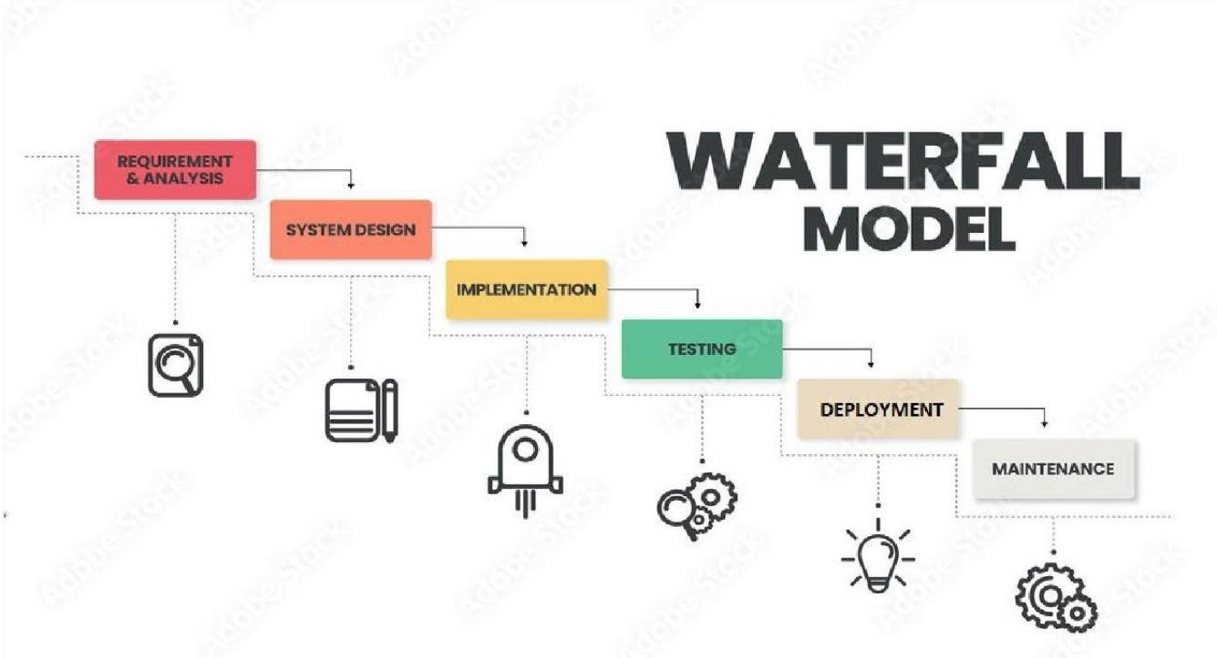
Project Planning WATERFALL MODEL

Figure 1 Waterfall model

- The waterfall model is a traditional software development methodology that follows a linear and sequential approach. In this model, the development process is divided into distinct phases, with each phase building upon the deliverables of the previous phase. The waterfall model typically consists of the following sequential phases :

Requirement Gathering Phase
In this phase, all the requirements of the system are identified. Information is collected from users and stakeholders. This helps in understanding what features are needed.

System Design Phase
The system architecture and design are created in this phase. Diagrams such as DFD and UML are prepared. This acts as a blueprint for development.

Development Phase
In this phase, the actual coding of the system is done. Frontend and backend components are developed. Database integration is also completed.

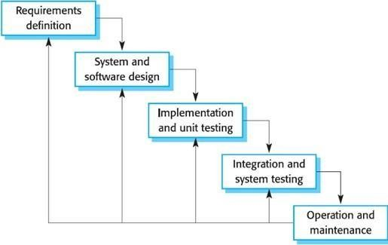

Testing Phase
The system is tested to identify and fix errors. Different types of testing are performed to ensure quality. This ensures that the system works correctly.

Deployment Phase
In this phase, the system is launched and made available to users. It is hosted on a server and configured properly. After deployment, maintenance and updates are performed to ensure smooth functioning.

INCREMENTAL WATERFALL MODEL
I Used Incremental Model to Complete this Project. The increment model applies the waterfall model incrementally. The series of releases is referred to as “increment”, with is increment providing more Functionality to the customer. After the first increment, a core product is delivered, which can already be used by the customer. Based on customer feedback, a plan is developed for next increments, and modifications are made accordingly.

Figure 2 Incremental Waterfall model

This process continues, with increment being delivered until the complete product is delivered. With incremental development, each increment is tested individually before moving on to the next one. This ensures that any issues or bugs are caught early and can be addressed before they become bigger problems.

CHAPTER 4

SYSTEM ANALYSIS

HARDWARE & SOFTWARE

HARDWARE REQUIREMENTS

Basic Computing Device
The system requires a basic device such as a computer, laptop, or smartphone to access the platform. Since FarmEase is web-based, high-end hardware is not necessary. Even low-configuration devices can run it efficiently. This makes the system affordable and accessible to farmers in rural areas.

Internet Connectivity
A stable internet connection is required to access the platform and its features. Since the system provides real-time updates like weather and marketplace data, continuous connectivity is important. Poor internet may affect performance and usability.

Memory and Processing Power
The device should have sufficient RAM and processing capability to run a web browser smoothly. This ensures that the platform loads quickly and works without lag. Basic configurations are enough for smooth operation.

SOFTWARE REQUIREMENTS

Frontend Technologies
The system uses Angular, Typescript and CSS for designing the user interface. These technologies help in creating a responsive and interactive layout. They ensure a smooth user experience.

Backend Technologies
.NET is used for backend development. It handles server-side logic and user requests efficiently. This ensures fast processing and scalability.

Database System
A database such as SQL Server is used to store user data, product details, and other system information. It ensures proper data management and retrieval.

Browser Compatibility

Cross-Browser Support
FarmEase is compatible with modern browsers like Chrome, Edge, and Firefox. This ensures that users can access the system without any compatibility issues. It improves accessibility and user experience.

  - CONSTRAINTS

Internet Dependency
The system depends on internet connectivity to function properly. In areas with poor network coverage, users may face difficulties. This can limit accessibility.

Limited Technical Knowledge
Some users may not be familiar with digital platforms. This can make it difficult for them to use the system. However, a simple interface helps reduce this problem.

Budget Limitations
The development of advanced features may require higher investment. Limited budget can restrict implementation of some functionalities.

Data Reliability Issues
The system depends on external data sources like weather APIs. If the data is incorrect, it may affect user decisions. Reliable sources are important.

Requirements of the System

System Requirements:

Secure Authentication
The system must provide secure login and registration features. It should protect user data using proper validation and encryption techniques.

Fast Performance
The system should respond quickly to user actions. Fast loading and processing improve user experience.

      - Mobile Compatibility : The platform must work efficiently on smartphones. Responsive design ensures usability on different screen sizes.
      - Database Management System: Microsoft SQL Server for storing and managing society data.
      - Programming Languages : Utilize languages such as Angular ,Typescript and backend frameworks (e.g., ASP.NET) for website development.
      - Development Tools : Integrated Development Environment (IDE) like Visual Studio for coding and testing.

Functional Requirement:

User Management
The system should allow users to register, log in, and manage their profiles. This ensures personalized experience.

Information Access
Users should be able to view crop details and weather updates. This helps in planning farming activities.

Marketplace Operations
The system must support buying and selling of products. It should include product listing and transaction features.

Expert Interaction
Users should be able to communicate with experts and get advice. This improves problem-solving.

Non-Functional Requirement:

Performance
The system should work efficiently even when multiple users are accessing it at the same time. Good performance ensures smooth operation.

Security
User data must be protected from unauthorized access. Basic securities must be done.

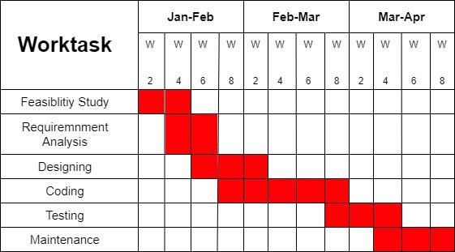

Scalability
The system should be able to handle future growth. New users and features should be added without affecting performance.

Usability
The platform should be simple and easy to use. A user-friendly interface ensures that even beginners can operate it without difficulty.

PROJECT/ INTERNSHIP SCHEDULING (GANTT CHART)

Figure 3 Gantt Chart

  - SOFTWARE REQUIREMENT SPECIFICATION ADMIN

R :- FarmEase [AdminPanel]

R1 :- Log in
Input :- Enter Username and Password
Output :- Login Successfully
Process :- In this process, the Admin enters valid credentials to access the system. If the username and password are correct, the admin is redirected to the dashboard. If incorrect credentials are entered, an error message is displayed. The system allows a maximum of three login attempts for security purposes.

R2 :- User Registration
R2.1 :- The Admin User should be Registered User
Input :- Admin Can Enter Basic Details Of User For Registration Process
Output :- User Registered Successfully.
Process :- The admin adds new users such as farmers or experts by entering their basic details. After successful registration, the system stores the information in the database.

R2.2 :- Update User
Input :- Admin User Should Be Enter Updated Details of User
Output :- User Details Updated Successfully
Process :- Here, Admin User Can Change Details

R3 :- Manage Services

R3.1 :- Add Crop Information
Input :- Enter crop details (name, season, fertilizers, methods)
Output :- Crop Information Added Successfully
Process :- Admin adds detailed information about crops into the system. This information is stored and made available to farmers for reference and guidance.

R3.2 :- Update/Delete Crop Information Input :- Modify or delete crop details
Output :- Crop Information Updated/Deleted Successfully
Process :- Admin can edit or remove outdated or incorrect crop data. This ensures that only accurate and updated information is available.

R4 :- Manage Marketplace
Input :- Approve/Delete product listings
Output :- Marketplace Updated Successfully.
Process :- Admin monitors products listed by farmers or vendors. The admin can approve valid listings or remove inappropriate or incorrect entries.

R5 :- View Reports
Input :- Select report type (users, sales, activity)
Output :- Report Generated Successfully
Process :- Admin can view system reports such as number of users, transactions, and activities. This helps in monitoring system performance and usage.

R6 :- Submit Feedback
Input :- Enter feedback and rating
Output :- Feedback Submitted Successfully
Process :- Admin can provide feedback regarding system performance or improvements. This feedback is stored for future enhancements.

R7 :- Logout
Process :- Logout Successfully from the system

FARMER / USER PANEL

R :- FarmEase [User Panel] R1 :- Login
Input :- Enter Username and Password
Output :- Login Successfully
Process :- User enters valid credentials to access the system. If correct, the user is redirected to the dashboard. If incorrect, an error message is displayed. Maximum three attempts are allowed.

R2 :- View Crop Information Input :- Select crop or category Output :- Crop Details Displayed
Process :- User selects a crop and views detailed information such as season, fertilizers, and farming techniques. This helps in better planning.

R3 :- Weather Information

Input :- Select location or allow auto-detection
Output :- Weather Details Displayed
Process :-The system fetches real-time weather data and displays it to the user. This helps farmers plan their farming activities accordingly.

R4 :- Marketplace
R4.1 :- Add Product
Input :- Enter product details (name, price, quantity)
Output :- Product Added Successfully
Process :-User can add agricultural products for selling. The details are stored and displayed in the marketplace.

R4.2 :- View / Buy Products
Input :- Select product
Output :- Product Details Displayed / Purchase Successful
Process :-User can browse available products and purchase them. The system processes the request and confirms the transaction.

R4.3 :- Update/Delete
Product Input :- Modify or delete product
Output :- Product Updated/Deleted Successfully
Process :-User can update product details or remove listings that are no longer required.

R5 :- Expert Consultation
Input :- Enter query or problem
Output :- Advice Received
Process :-User submits a query related to farming. Experts respond with solutions and guidance. This helps in solving agricultural issues.

R6 :- Submit Feedback
Input :- Enter feedback and rating
Output :- Feedback Submitted Successfully
Process :-User can provide feedback about the system. This helps in improving the platform.

R7 :- Logout
Process :- Logout Successfully from the system

CHAPTER 5

SYSTEM DESIGN

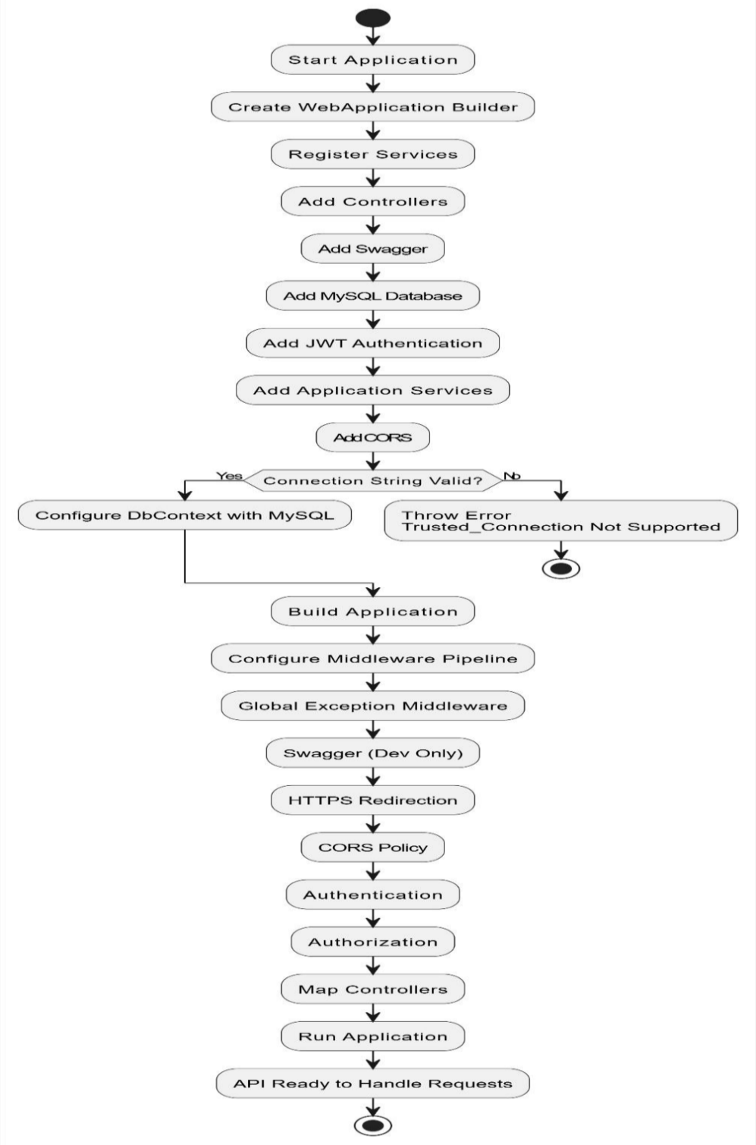

FLOW CHART OF THE SYSTEM
This flowchart provides a visual representation of the FarmEase process, outlining the steps involved from bug identification to resolution or closure.

SYSTEM FLOWCHART:

Figure 4 Flow Chart

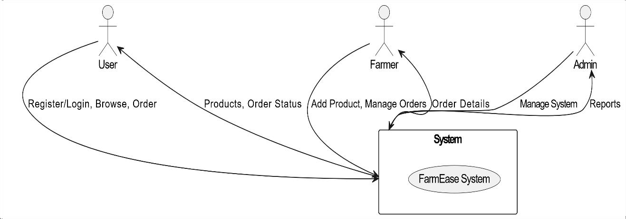
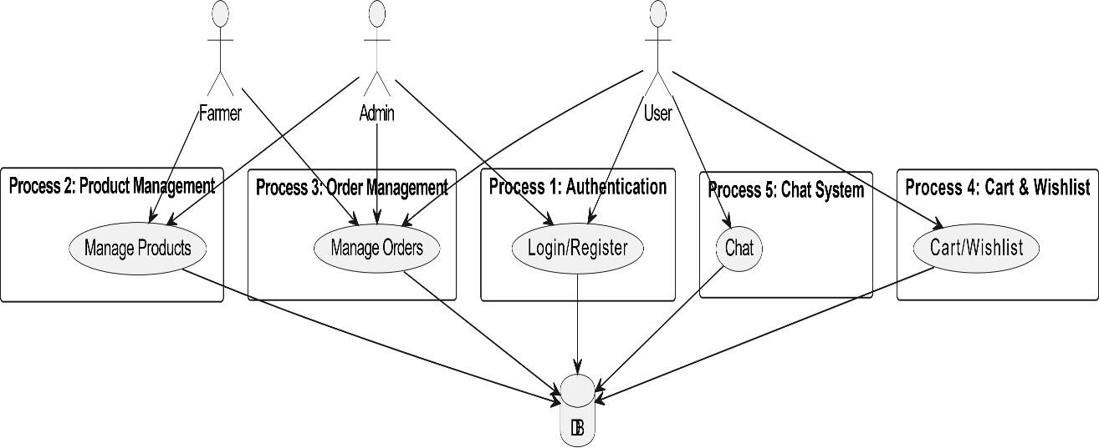

DATA FLOW DIAGRAM
This DFD outlines the main processes, data flows, data stores, and external entities involved in your FarmEase. A Data Flow Diagram (DFD) depicts the flow of data within a system, illustrating how data is input, processed, and output.

Figure 5 DFD Level 0

Figure 6 DFD Level 1

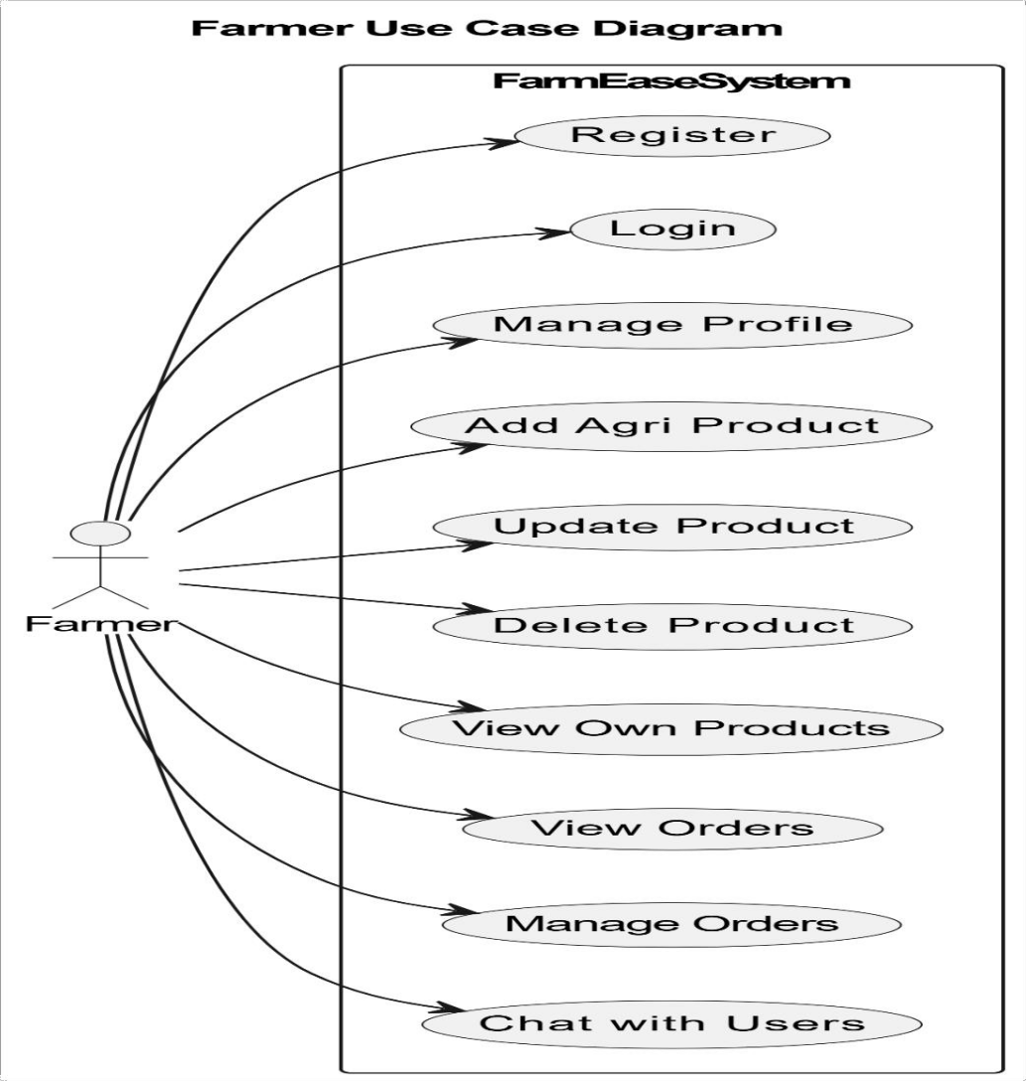

UNIFIED MODELING LANGUAGE
Unified Modeling Language (UML) is a standardized modeling language used in software engineering for visualizing, specifying, constructing, and documenting the artifacts of software systems. It provides a set of graphical notations for representing various aspects of a system's structure and behavior.

Use Case Diagram
A use case diagram in Unified Modeling Language (UML) is a type of diagram that represents the interactions between actors (users) and a system. It provides a high-level overview of the functionalities provided by the system and the actors involved in using those functionalities.

Figure 7 Use Case Diagram(Farmer)

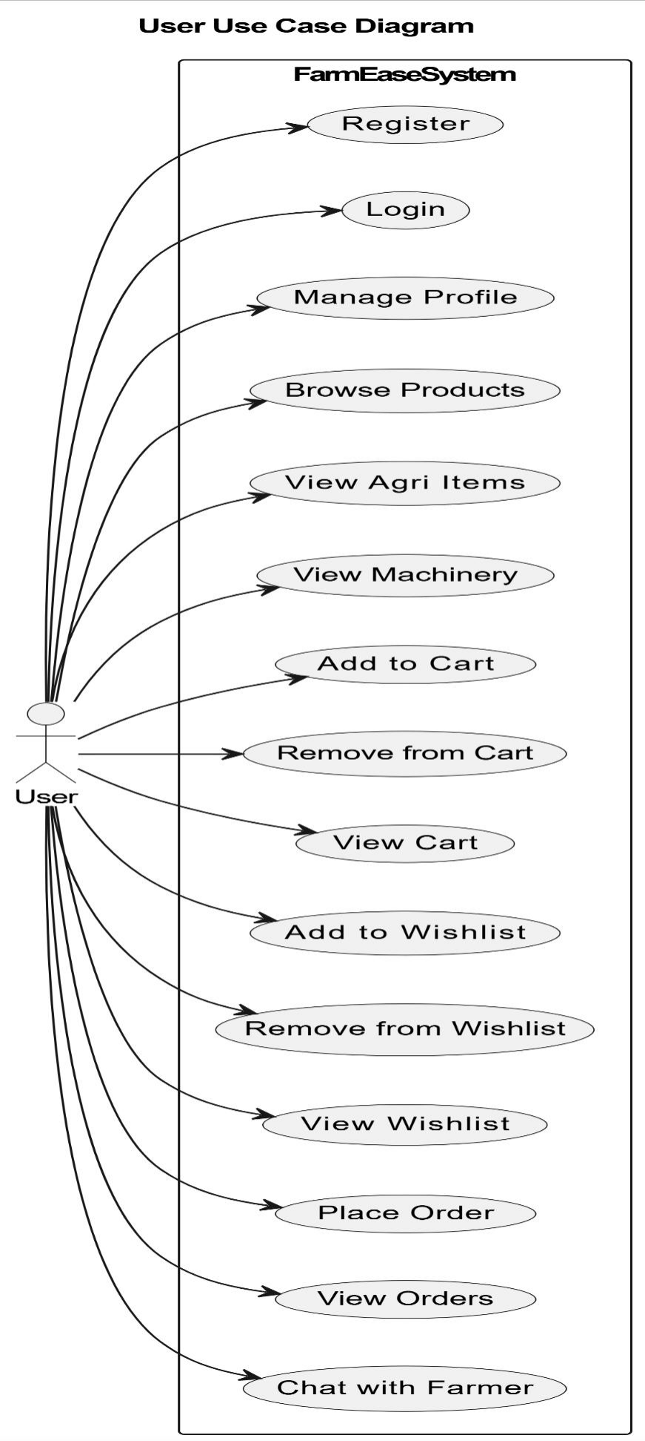

Figure 8 Use Case Diagram(User)

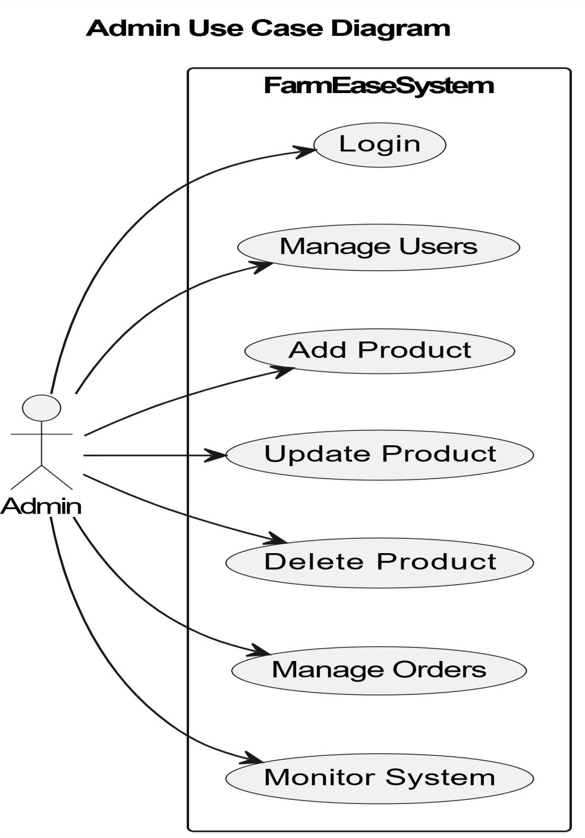

Figure 9 Use Case Diagram(Admin)

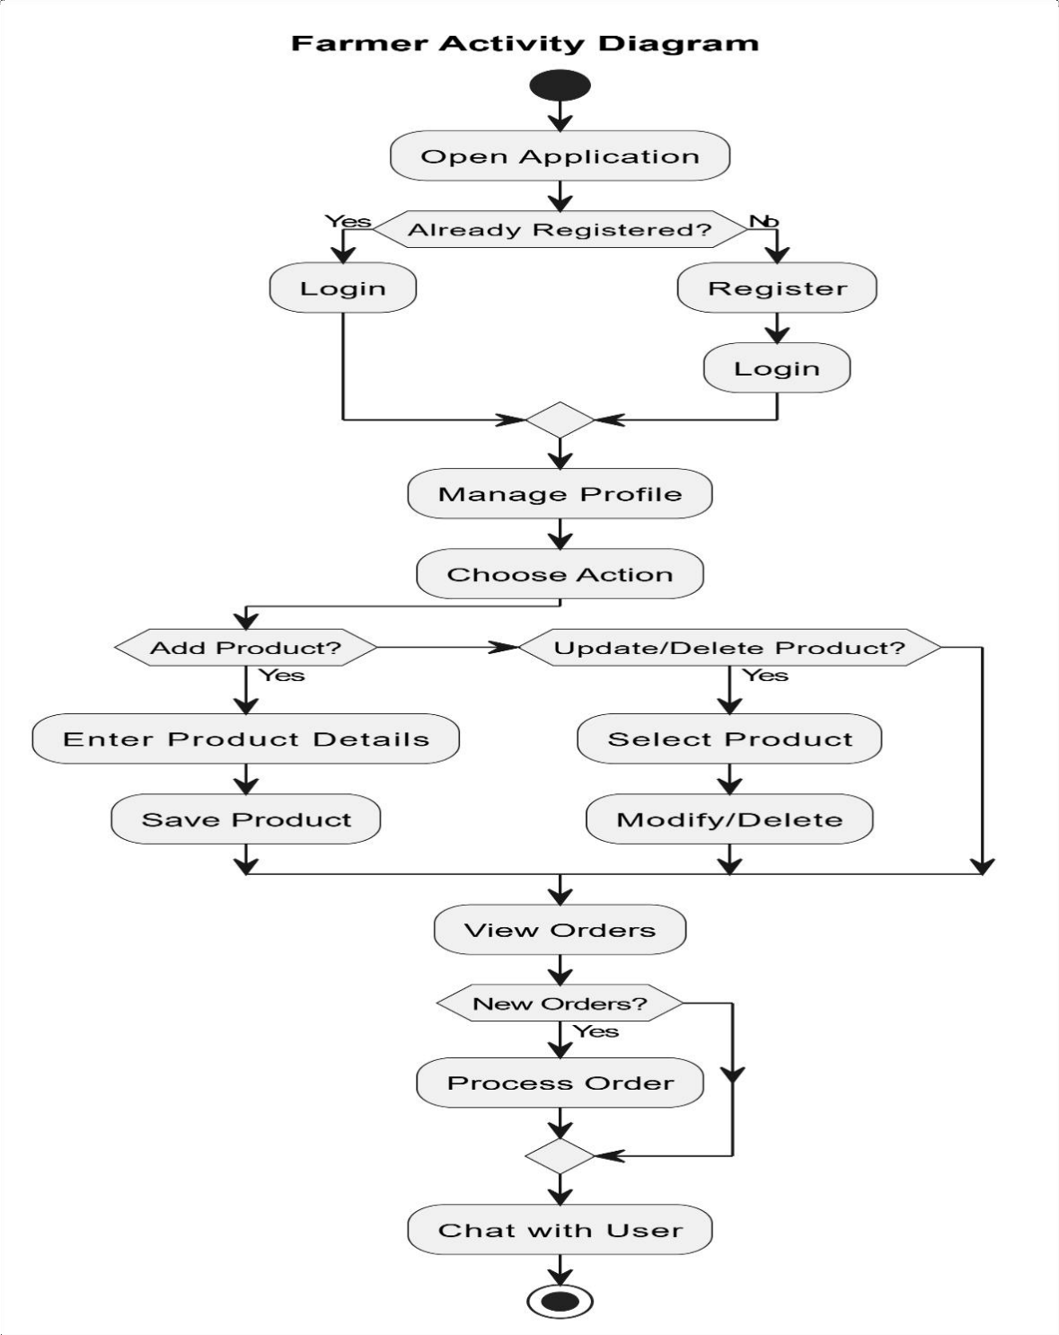
Activity Diagram
An activity diagram is a type of UML diagram that shows the workflow or flowchart of a system or process. It represents the steps, decisions, and activities involved in a process or workflow in a visual way, using symbols such as rectangles, diamonds, and arrows.
Activity diagrams are commonly used in business process modeling, software engineering, and project management to illustrate the steps involved in a complex process or workflow.

Figure 10 Farmer Activity Diagram

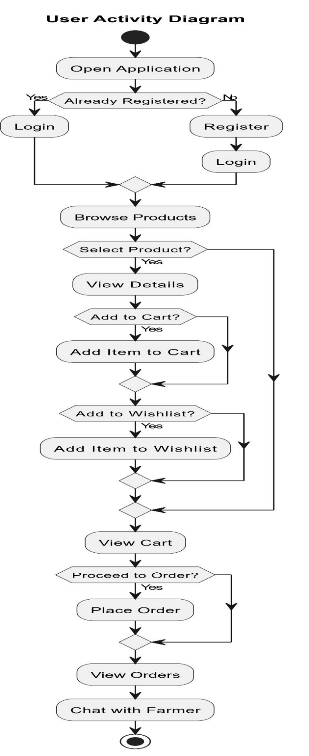

Figure 11 User Activity Diagram

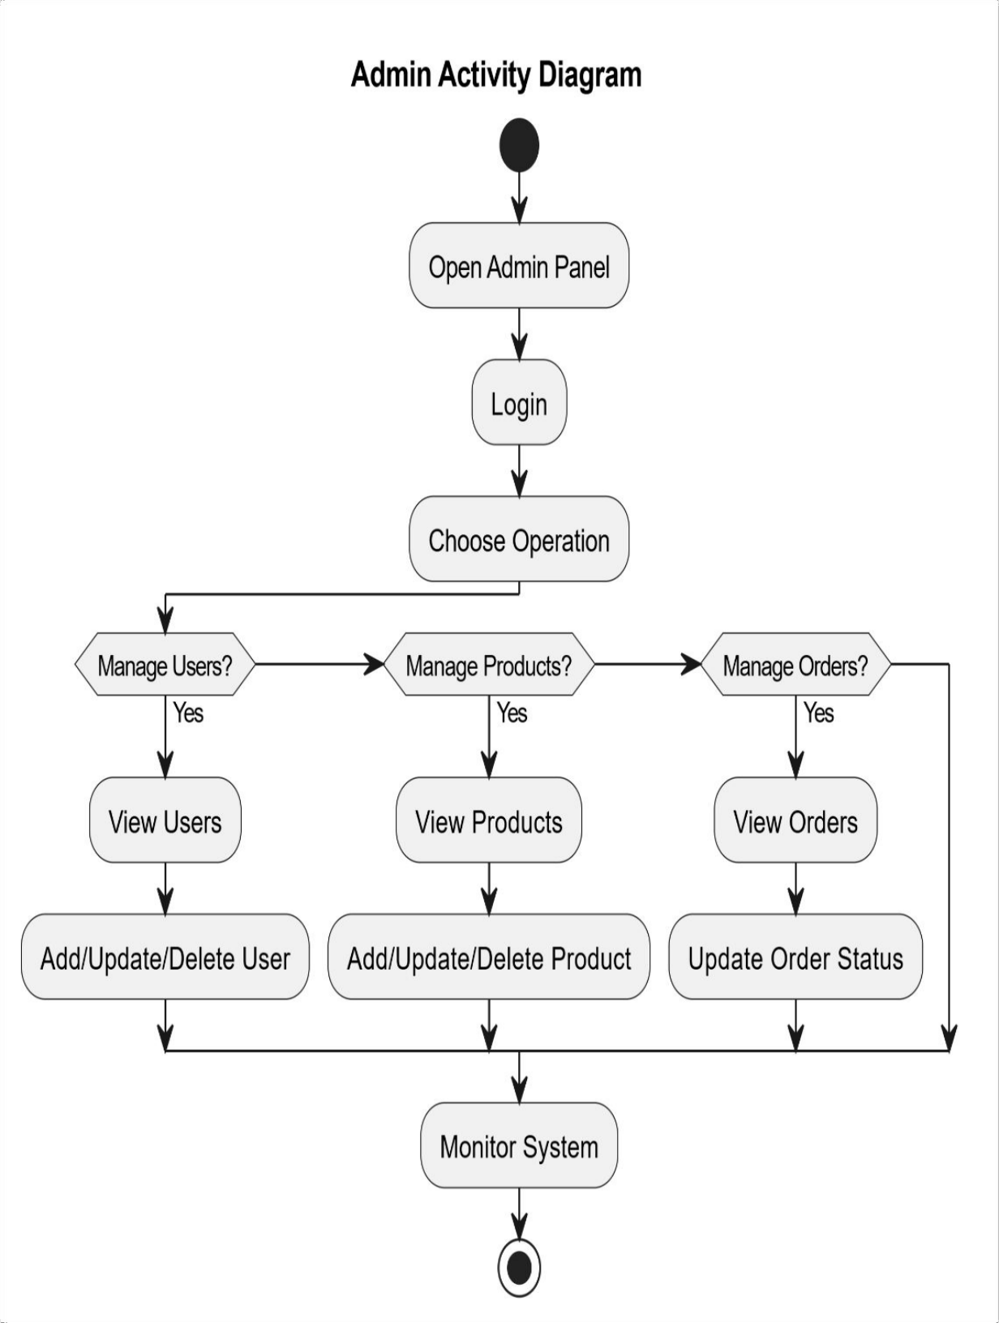

Figure 12 Admin Activity Diagram

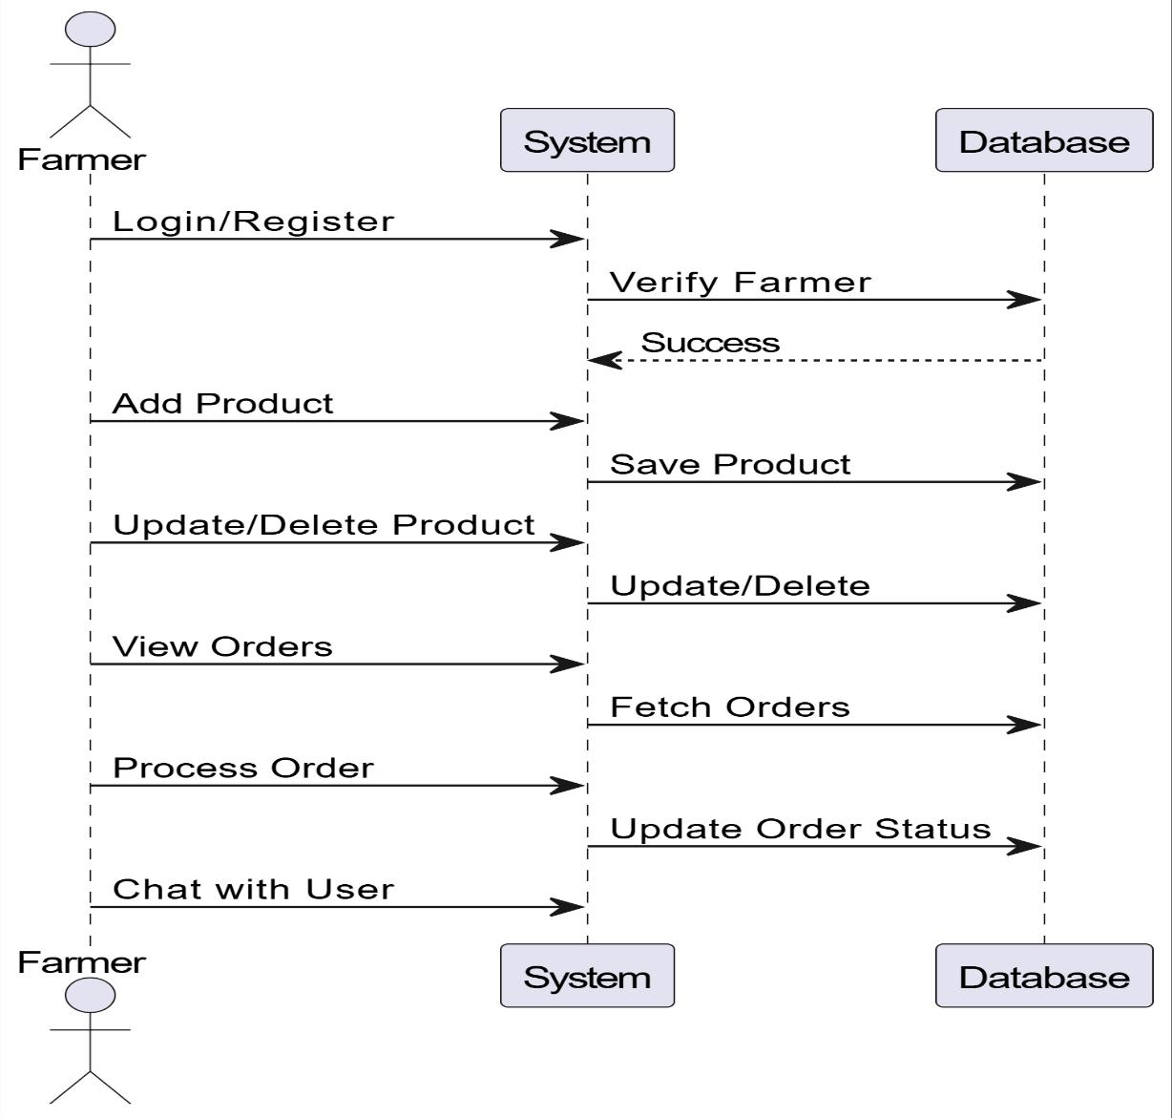
Sequence Diagram
A sequence diagram in Unified Modeling Language (UML) is a type of interaction diagram that illustrates the interactions and message exchanges between objects or components within a system over time.

FARMER:

Figure 13 Farmer Sequence Diagram

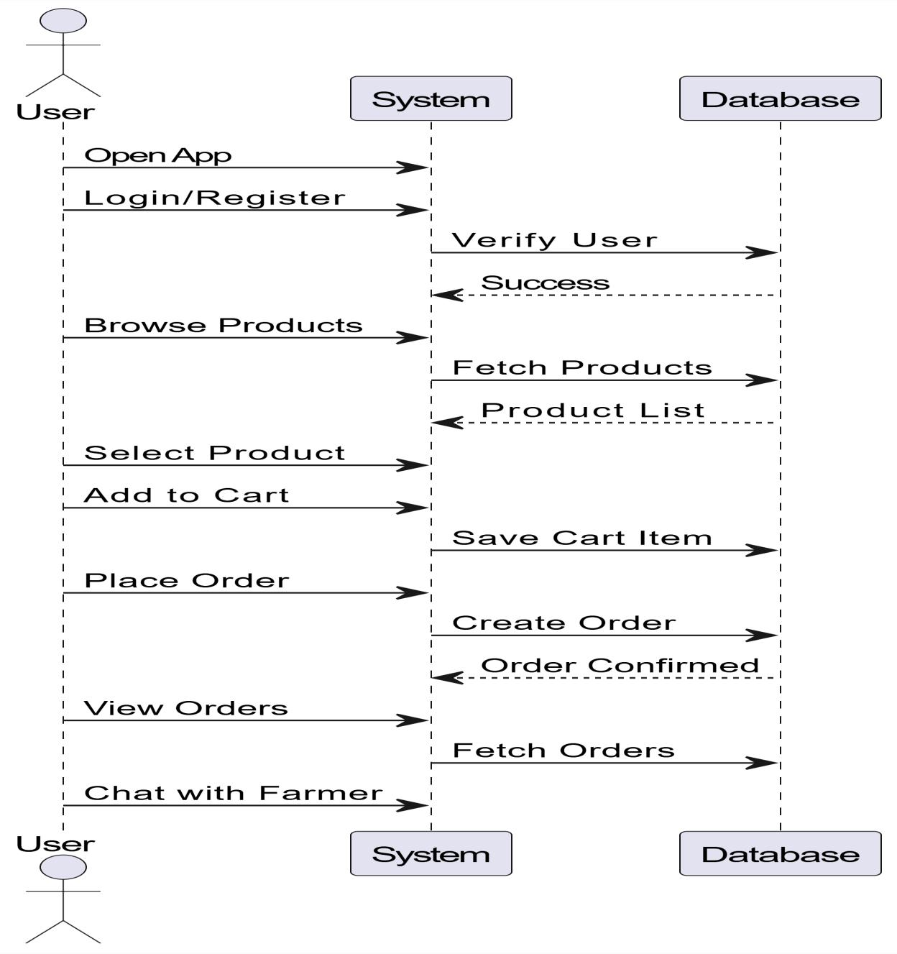

USER:

Figure 14 User Sequence Diagram


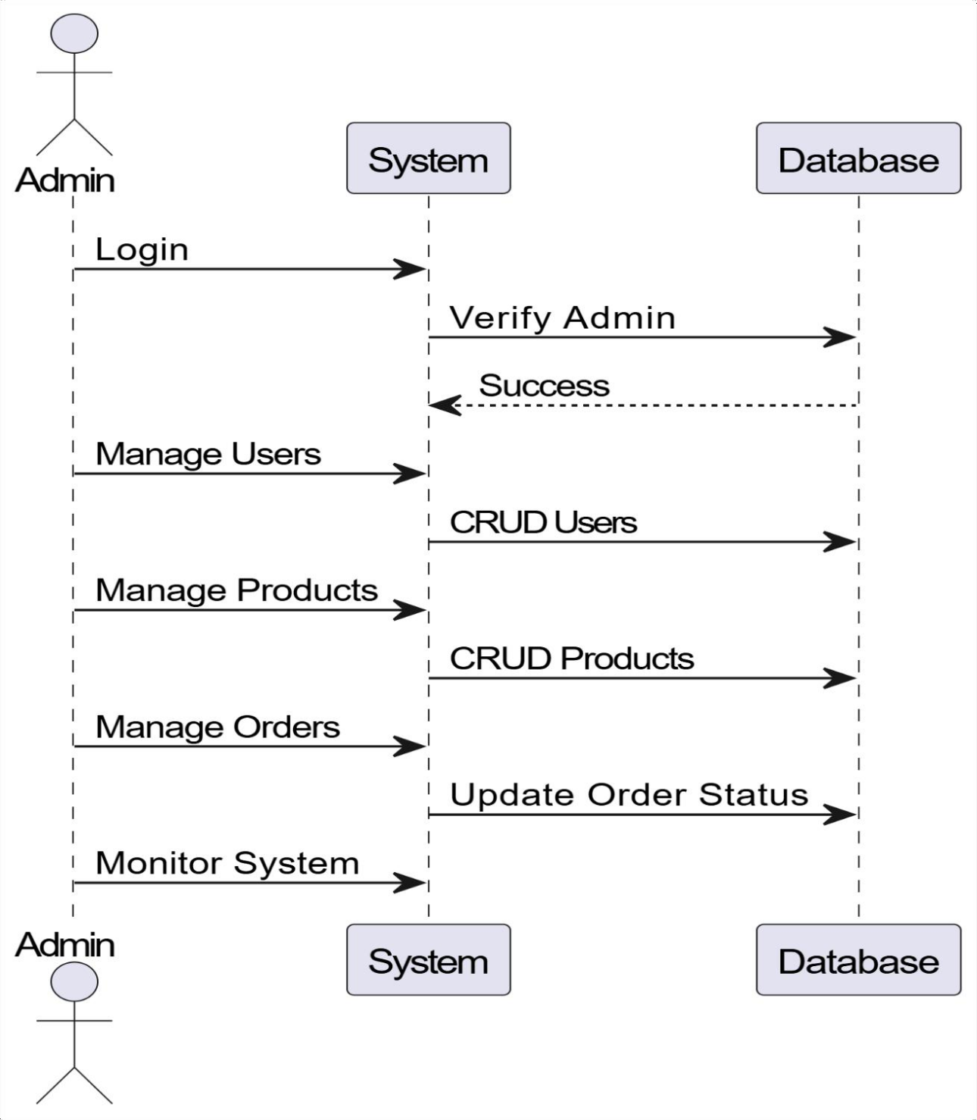

ADMIN:

Figure 15 Admin Sequence Diagram

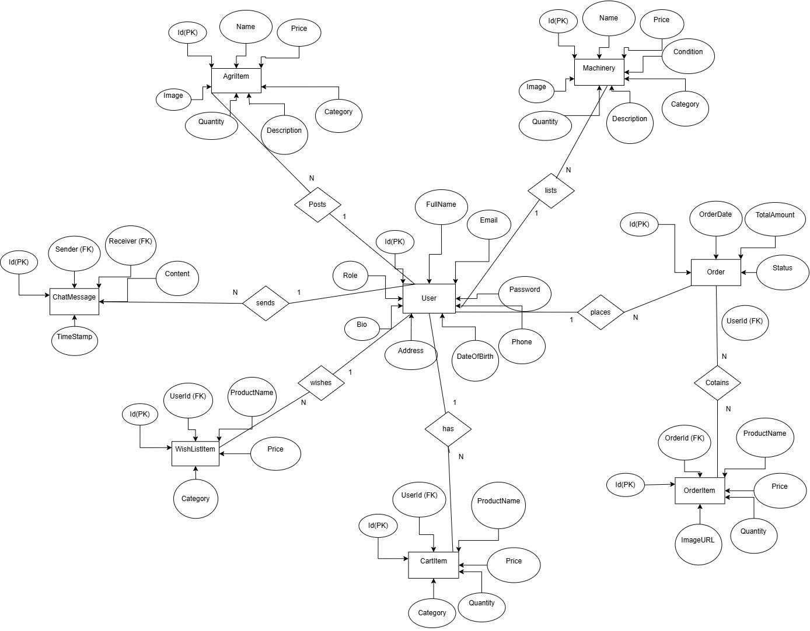

ENTITY-RELATIONSHIP DIAGRAM
Entity-Relationship (ER) diagrams are a type of visual representation used in database design to model the structure of a database.Entities represent real-world objects or concepts within the system being modeled. In an ER diagram, entities are depicted as rectangles, with each rectangle representing a specific entity type.

Figure 16 ER Diagram

DATA DICTIONARY:

Table 1 User

Field | Data Type | Size | Constraint | Description
Id | INT | - | PK,  AUTO_INCREMENT | Unique identifier  for each user
FullName | VARCHAR | 100 | NOT NULL | Full name of the  user
Email | VARCHAR | 100 | NOT NULL, UNIQUE | User email
Password | VARCHAR | 255 | NOT NULL | Hashed password
Phone | VARCHAR | 15 | NOT NULL | Phone number
DateOfBirth | DATE | - | NULL | DOB
Address | VARCHAR | 255 | NULL | Address
Bio | TEXT | - | NULL | Bio
Role | VARCHAR | 20 | DEFAULT Farmer | Role

Table 2 Machinery

Field | Data Type | Size | Constraint | Description
Id | INT | - | PK,  AUTO_INCREMENT | Unique  identifier
Name | VARCHAR | 100 | NOT NULL | Name
Price | DECIMAL(10,2) | - | NOT NULL | Price
Condition | VARCHAR | 20 | NOT NULL | Condition
Category | VARCHAR | 50 | NOT NULL | Category
Description | TEXT | - | NULL | Description
Quantity | INT | - | DEFAULT 1 | Stock
Image | VARCHAR | 255 | NULL | Image URL

Table 3 Order

Field | Data Type | Size | Constraint | Description
Id | INT | - | PK,  AUTO_INCREMENT | Unique identifier
OrderDate | DATETIME | - | DEFAULT CURRENT_TIMESTA  MP | Order date
TotalAmount | DECIMAL(10,  2) | - | NOT NULL | Total
Status | VARCHAR | 20 | DEFAULT Pending | Status
UserId | INT | - | FK | User reference

Table 4 OrderItem

Field | Data Type | Size | Constraint | Description
Id | INT | - | PK,  AUTO_INCREMENT | Unique identifier
OrderId | INT | - | FK | Order reference
ProductName | VARCHAR | 100 | NOT NULL | Product name
Price | DECIMAL(10,2) | - | NOT NULL | Price
Quantity | INT | - | NOT NULL | Quantity
ImageURL | VARCHAR | 255 | NULL | Image

Table 5 CartItem

Field | Data Type | Size | Constraint | Description
Id | INT | - | PK,  AUTO_INCREMENT | Unique identifier
UserId | INT | - | FK | User reference
ProductName | VARCHAR | 100 | NOT NULL | Product
Price | DECIMAL(10,2) | - | NOT NULL | Price
Quantity | INT | - | DEFAULT 1 | Quantity
Category | VARCHAR | 50 | NULL | Category

Table 6 WishList

Field | Data Type | Size | Constraint | Description
Id | INT | - | PK,  AUTO_INCREMENT | Unique  identifier
UserId | INT | - | FK | User  reference
ProductName | VARCHAR | 100 | NOT NULL | Product
Price | DECIMAL(10,2) | - | NOT NULL | Price
Category | VARCHAR | 50 | NULL | Category

Table 7 Chat

Field | Data Type | Size | Constraint | Description
Id | INT | - | PK, AUTO_INCREMENT | Unique  identifier
Sender | INT | - | FK | Sender
Receiver | INT | - | FK | Receiver
Content | TEXT | - | NOT NULL | Message
TimeStamp | DATETIME | - | DEFAULT  CURRENT_TIMESTAMP | Time

Table 8 AgriItem

Field | Data Type | Size | Constraint | Description
Id | INT | - | PK,  AUTO_INCREMENT | Unique identifier
Name | VARCHAR | 100 | NOT NULL | Name
Category | VARCHAR | 50 | NOT NULL | Category
Price | DECIMAL(10,2) | - | NOT NULL | Price
Quantity | INT | - | NOT NULL | Quantity
Description | TEXT | - | NULL | Description
Image | VARCHAR | 255 | NULL | Image

CHAPTER 6

IMPLEMENTATION & PLANNING DETAILS

TECHNOLOGIES USED FARMEASE FRONTEND TECHNOLOGIES :
Angular is used as the main frontend framework to build the user interface of the FarmEase.
It follows a component-based architecture, which helps in dividing the application into reusable parts.
This improves code organization and maintainability. Angular also supports two-way data binding, which ensures real-time synchronization between UI and data.

TypeScript is used as the programming language for Angular development. It is a superset of JavaScript that provides strong typing and better error detection during development. This helps in writing more reliable and maintainable code. It also improves debugging and reduces runtime errors.
CSS is used for designing and styling the web application. It helps in creating a visually appealing and user-friendly interface. CSS ensures proper layout, colors, and responsiveness of the application. It also improves user experience by making the UI attractive and easy to use.

Bootstrap is a popular front-end framework for building responsive and mobile-first websites and web applications. It provides a collection of pre-designed components, such as navigation bars, buttons, forms, and grids, along with CSS and JavaScript plugins, to streamline the process of building modern and visually appealing user interfaces. Bootstrap's grid system and responsive design features make it easy to create layouts that adapt to different screen sizes and devices.

BACKEND TECHNOLOGIES :
C# (pronounced "C sharp") is a powerful and versatile programming language developed by Microsoft. It is widely used for building a variety of software applications, including web applications, desktop applications, mobile apps, games, and more. C# is part of the .NET framework and provides features such as strong typing, object-oriented programming, asynchronous programming, and support for generics, LINQ (Language Integrated Query), and dynamic programming. C# is known for its simplicity, readability, and robustness, making it a popular choice for developers across different domains.

.NET (ASP.NET Core)
The backend of FarmEase is developed using ASP.NET Core, which is part of the .NET framework. It is used to handle server-side logic, API creation, and request processing. It ensures secure communication between frontend and database. ASP.NET Core is known for its performance, scalability, and security features.

Database Technology:
Microsoft SQL Server is a relational database management system (RDBMS) developed by Microsoft. It provides a secure, scalable, and reliable platform for storing, retrieving, and managing structured data. SQL Server supports a wide range of features, including transaction processing, data warehousing, business intelligence, and analytics. It offers tools and services for database development, administration, and performance optimization, as well as integration with other Microsoft technologies such as Visual Studio and .NET framework.

API & Integration:

RESTful APIs
REST APIs are used to connect the frontend (Angular) with the backend (.NET). These APIs handle data exchange between different parts of the system. They allow smooth communication and ensure real-time updates in the application.

Development Tools:

Visual Studio / Visual Studio Code
These tools are used for writing and managing code for both frontend and backend. They provide features like debugging, code suggestions, and extensions.

Postman
Postman is used to test APIs during development. It helps verify whether backend services are working correctly before connecting them with the frontend.

CODING STANDARDS

Angular Frontend Code
Screenshots of Angular components, HTML templates, and TypeScript files showing UI implementation and logic.

.NET Backend Code
Screenshots of controllers, models, and API routes showing server-side implementation.

Database Queries
Screenshots of SQL queries used for data insertion, retrieval, and updates.logic, algorithms, or non-obvious code.

DEVELOPMENT ENVIRONMENT SETUP

Microsoft Visual Studio 2022 :
Microsoft Visual Studio 2022 is a comprehensive integrated development environment (IDE) designed to support a wide range of software development activities, including web development, desktop application development, mobile app development, cloud-based development, and more. With a powerful set of tools, features, and services, Visual Studio 2022 enables developers to build, debug, test, and deploy applications efficiently and effectively.

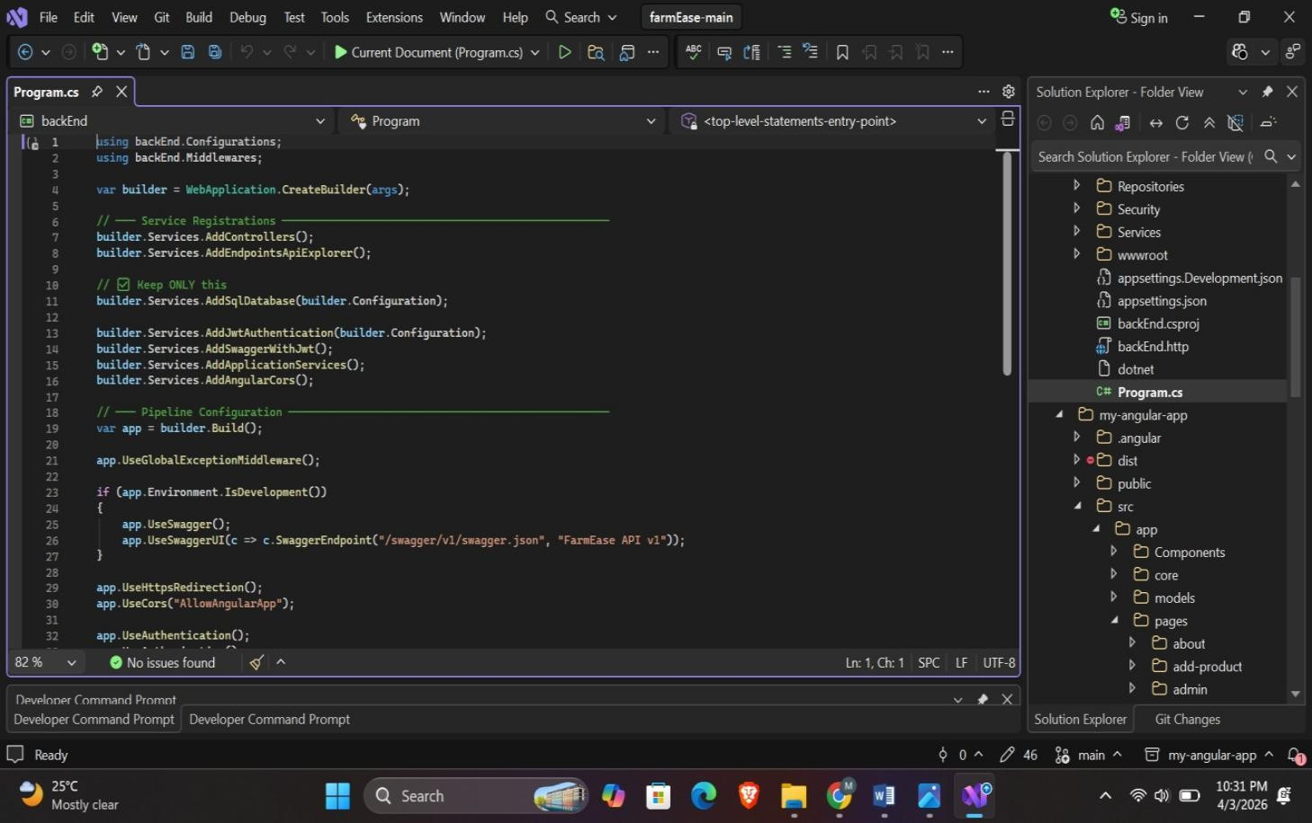

Figure 17 Program.cs

Microsoft SQL Server 2019 :
Microsoft SQL Server 2019 is a powerful and feature-rich relational database management system (RDBMS) developed by Microsoft. It provides a robust platform for storing, managing, and analyzing structured and unstructured data, enabling organizations to build scalable and high-performance data-driven applications.

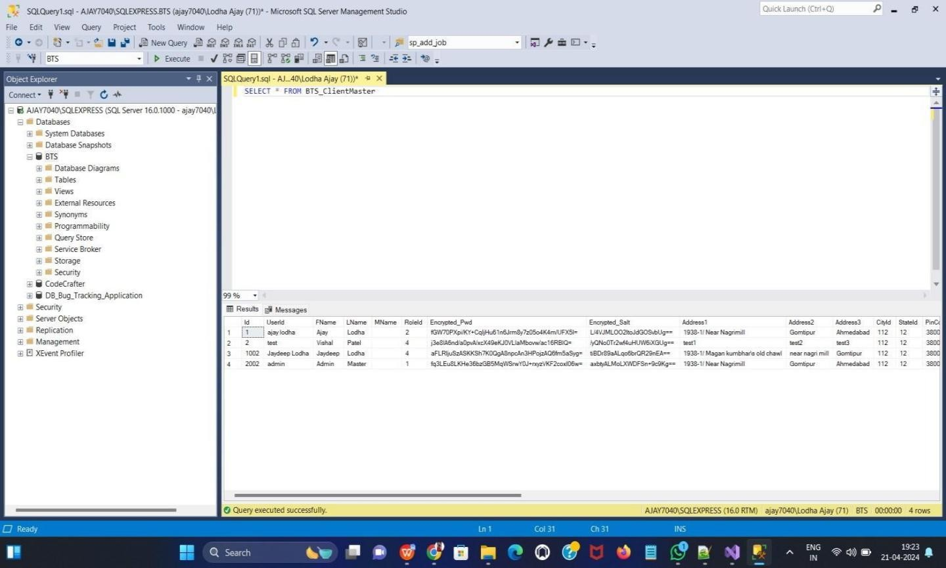
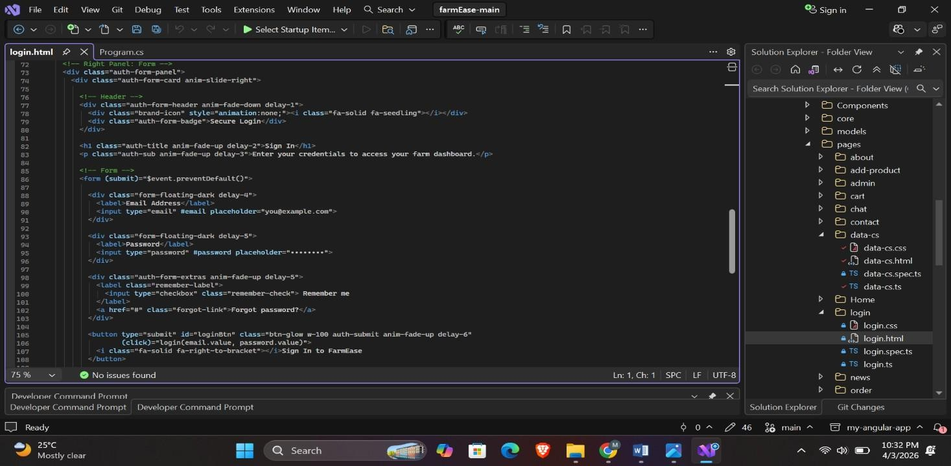

Figure 18 Database

CODING SCREENSHOTS

Login :

Figure 19 Login Code

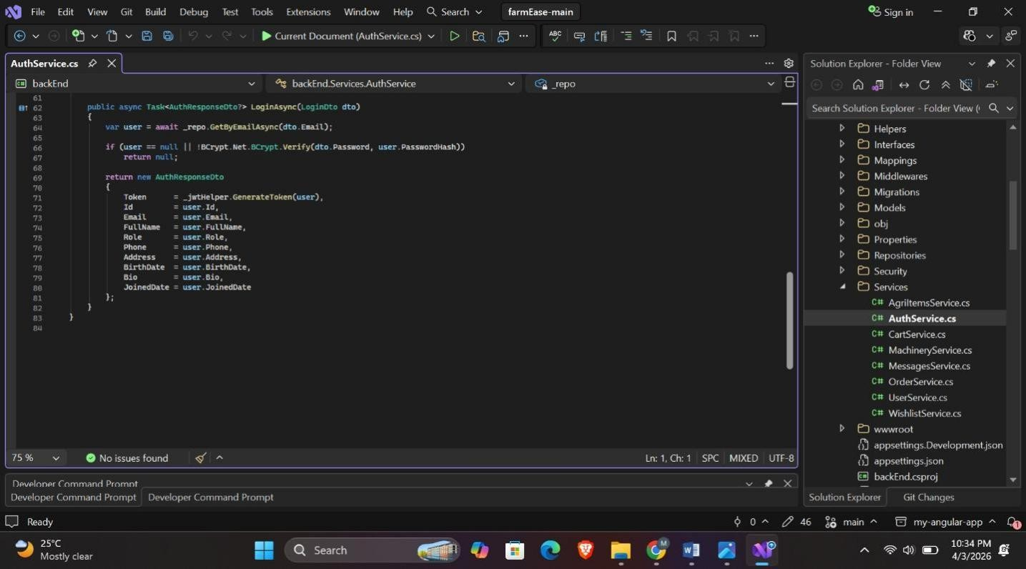
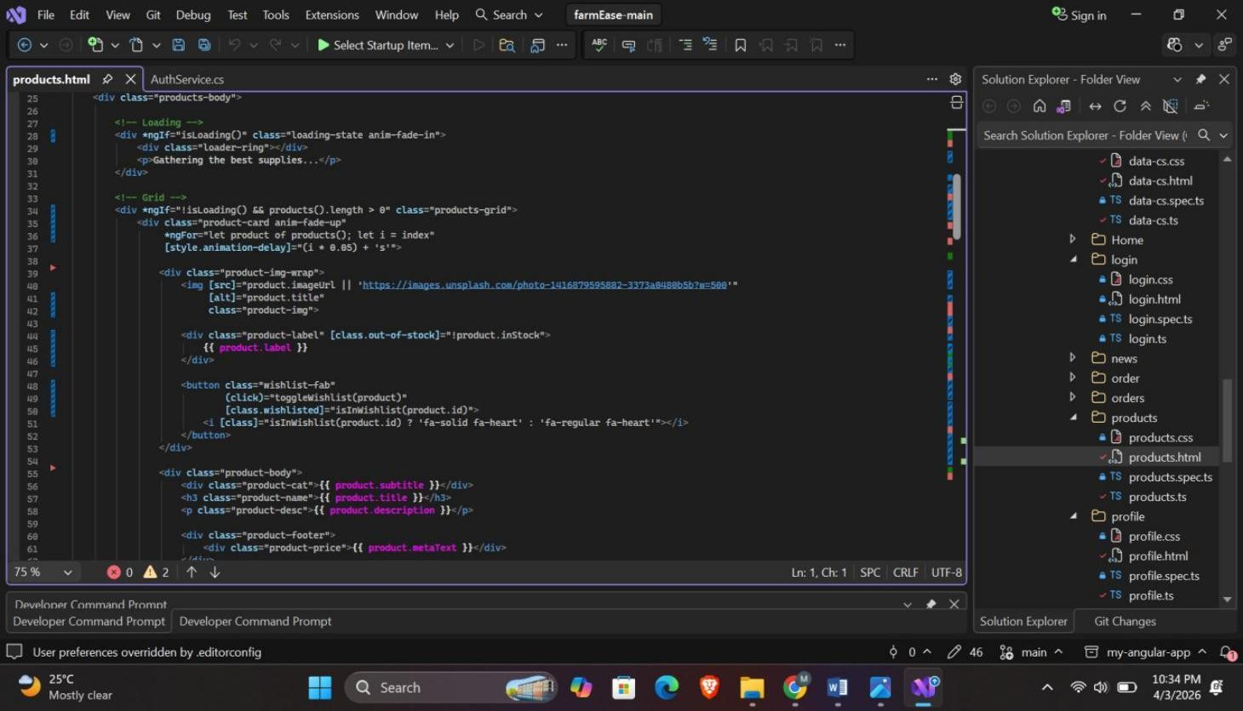

Figure 20 Services Code

Products :

Figure 21 Products Code

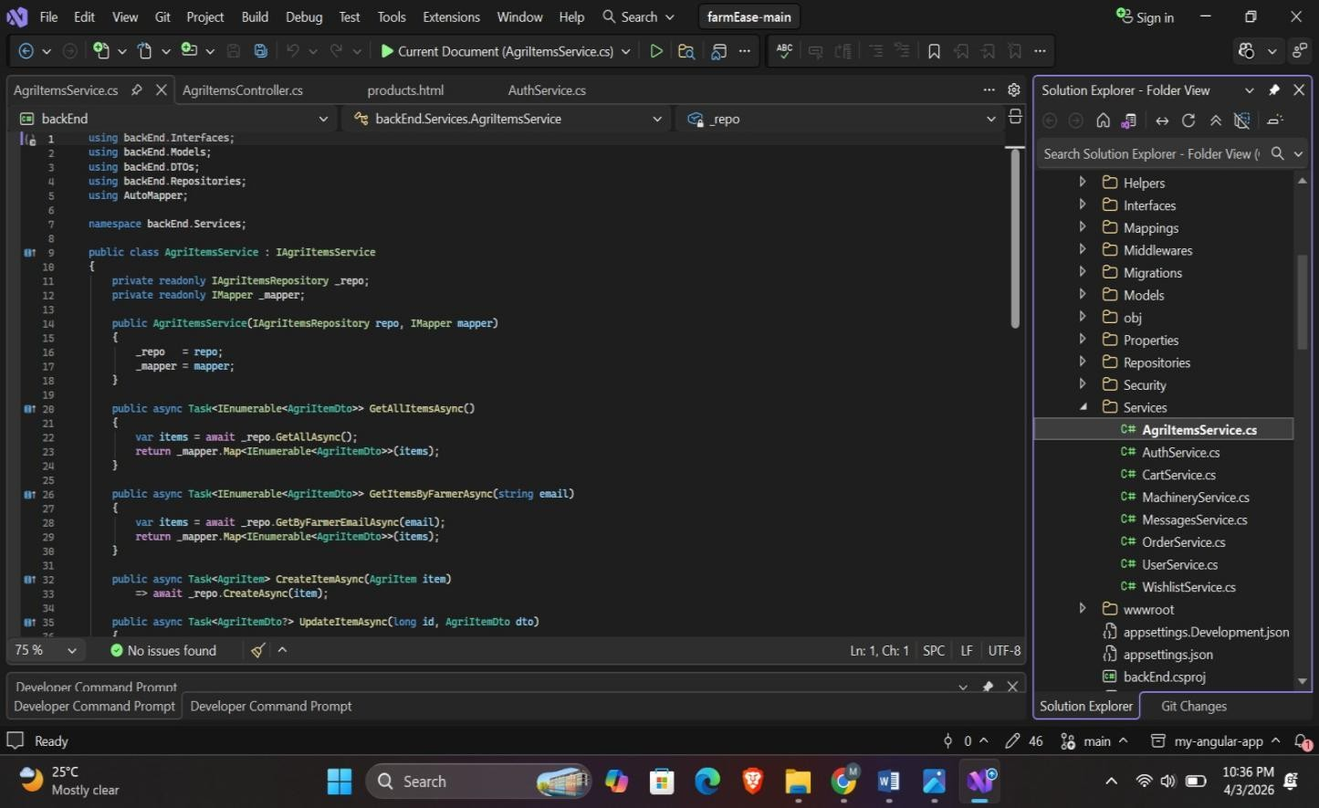
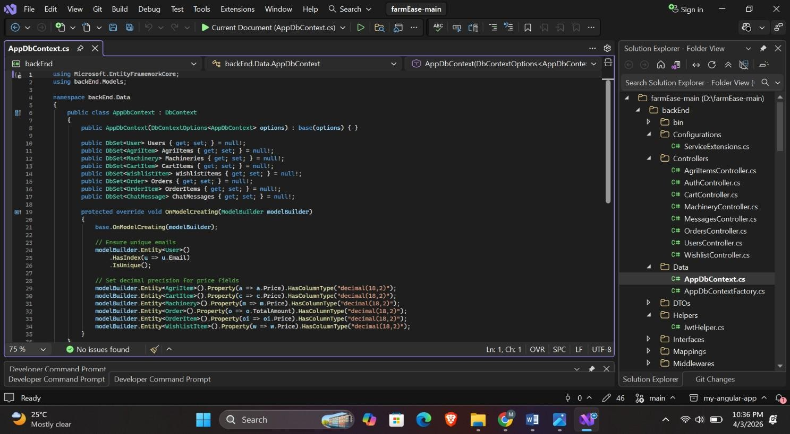

Figure 22 AgriService code

ConnectionDB :

Figure 23 ConnectionDB code

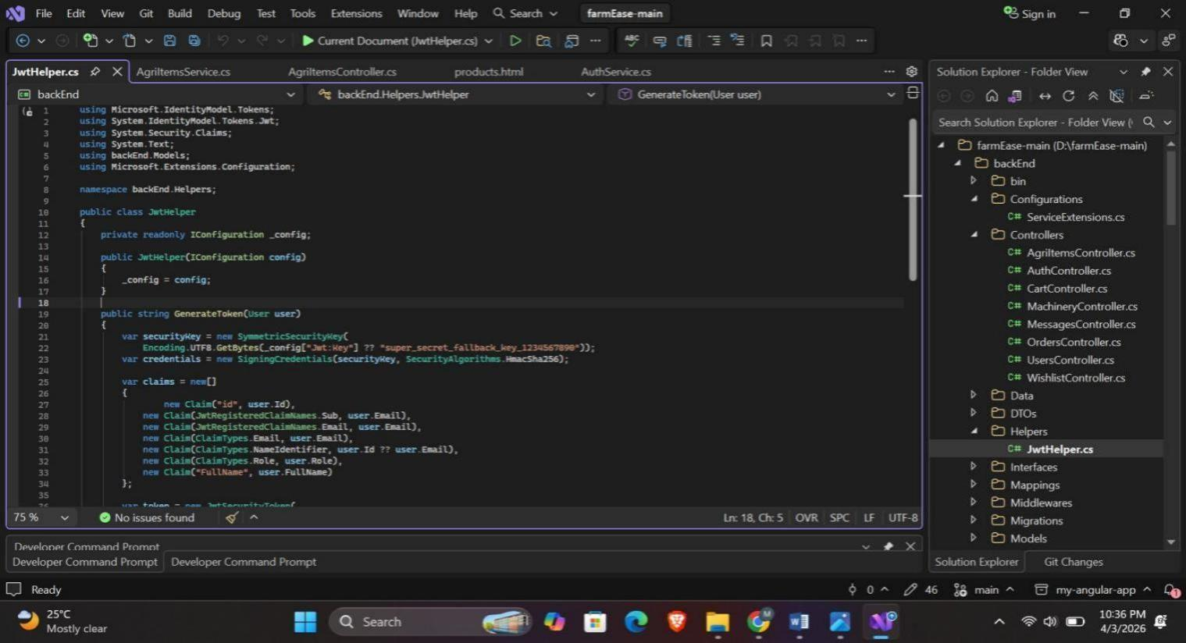
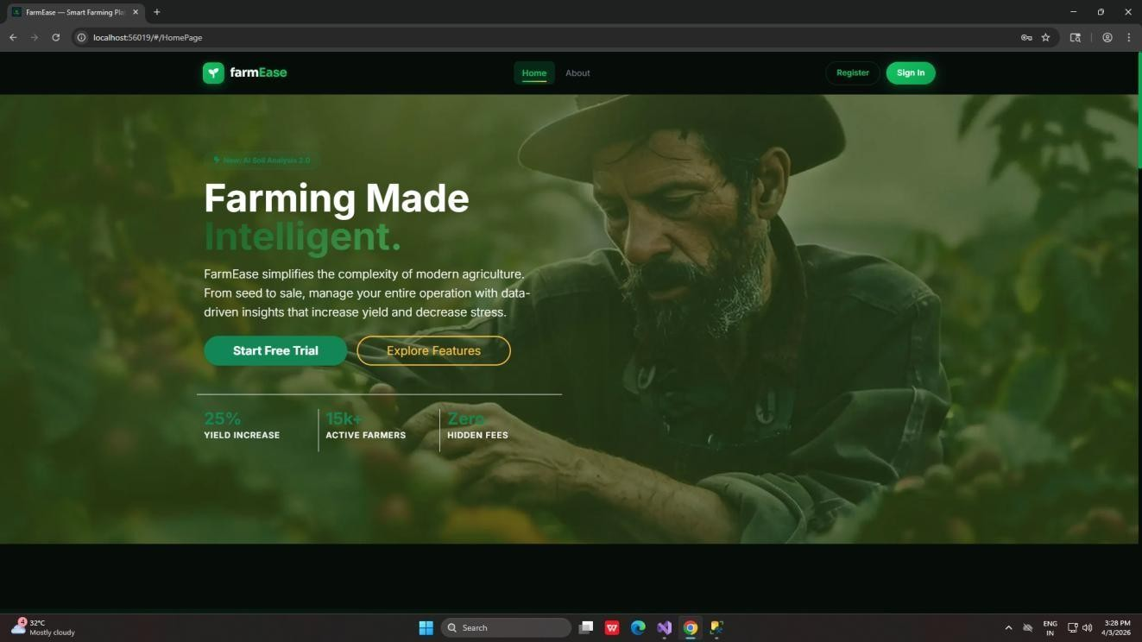

CommonHelper :

Figure 24 Helper Code

PROJECT SCREENSHOTS

Home Page:

Figure 25 Home Page

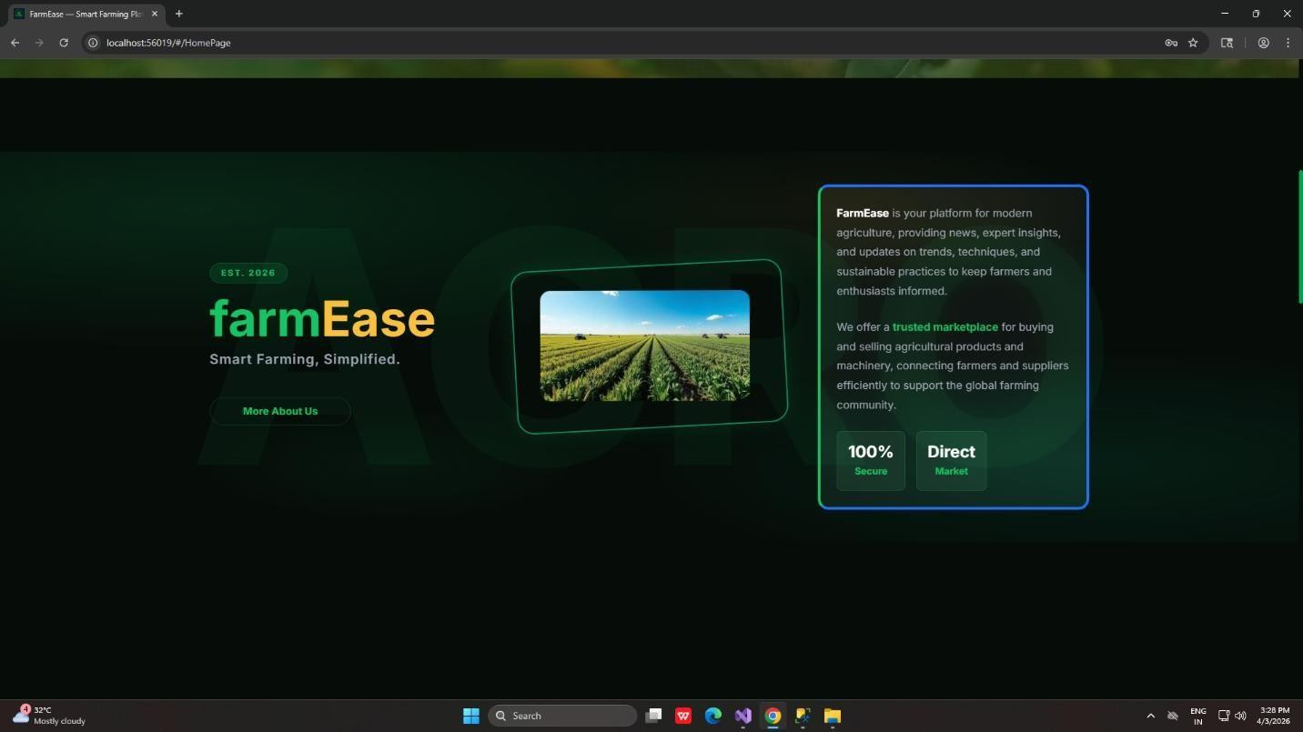
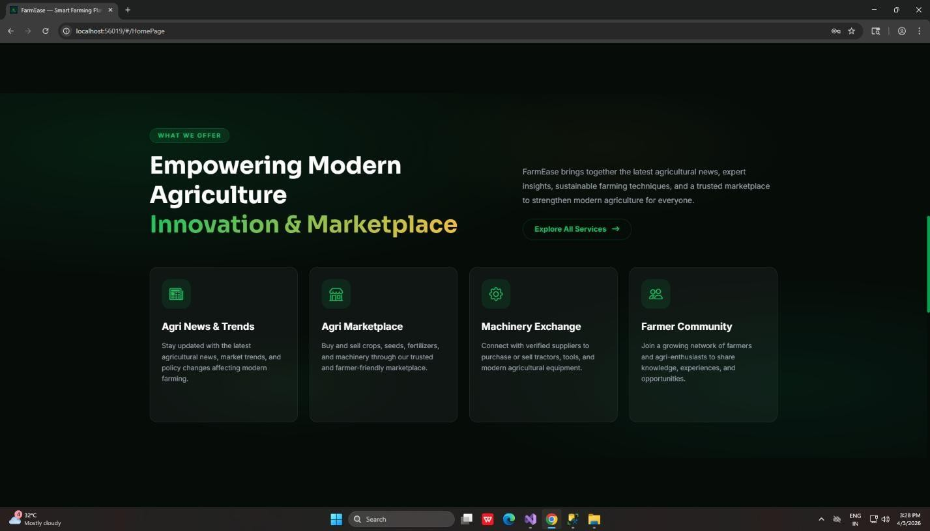

About Us:

Figure 26 About Us Page

Our Services :

Figure 27 Service

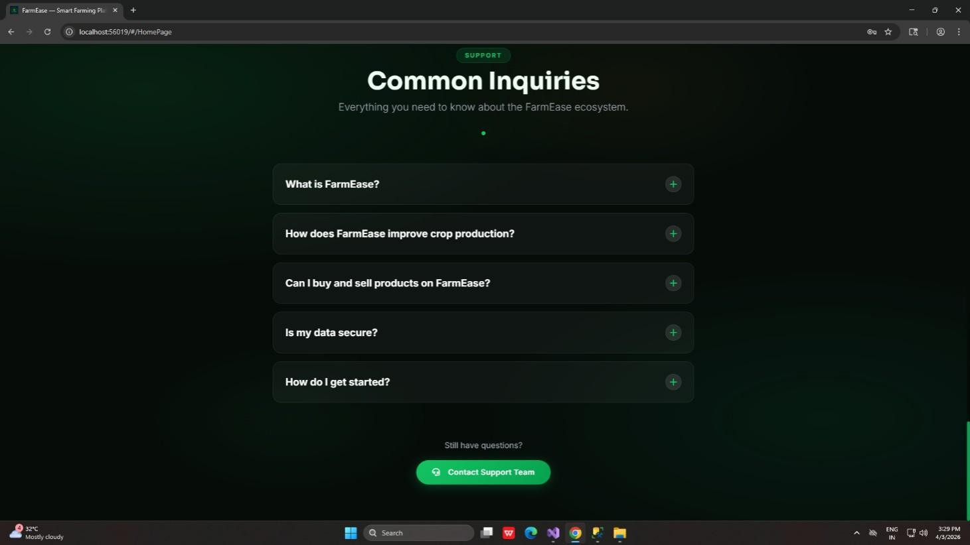
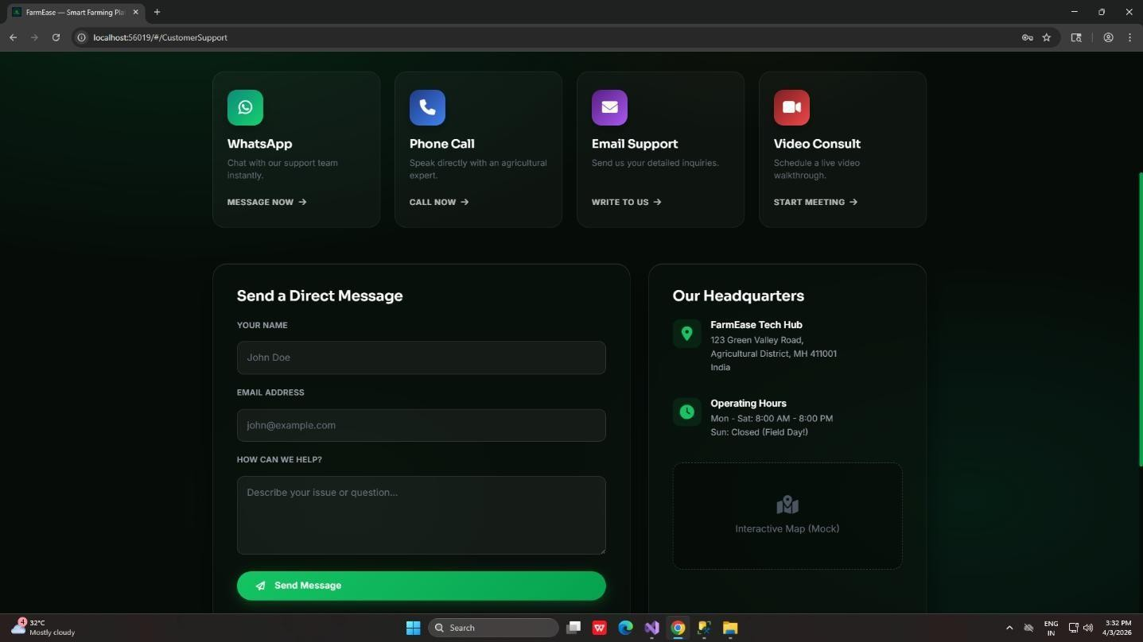

FAQ’s :

Figure 28 FAQ’S

Contact us:

Figure 29 Contact Us

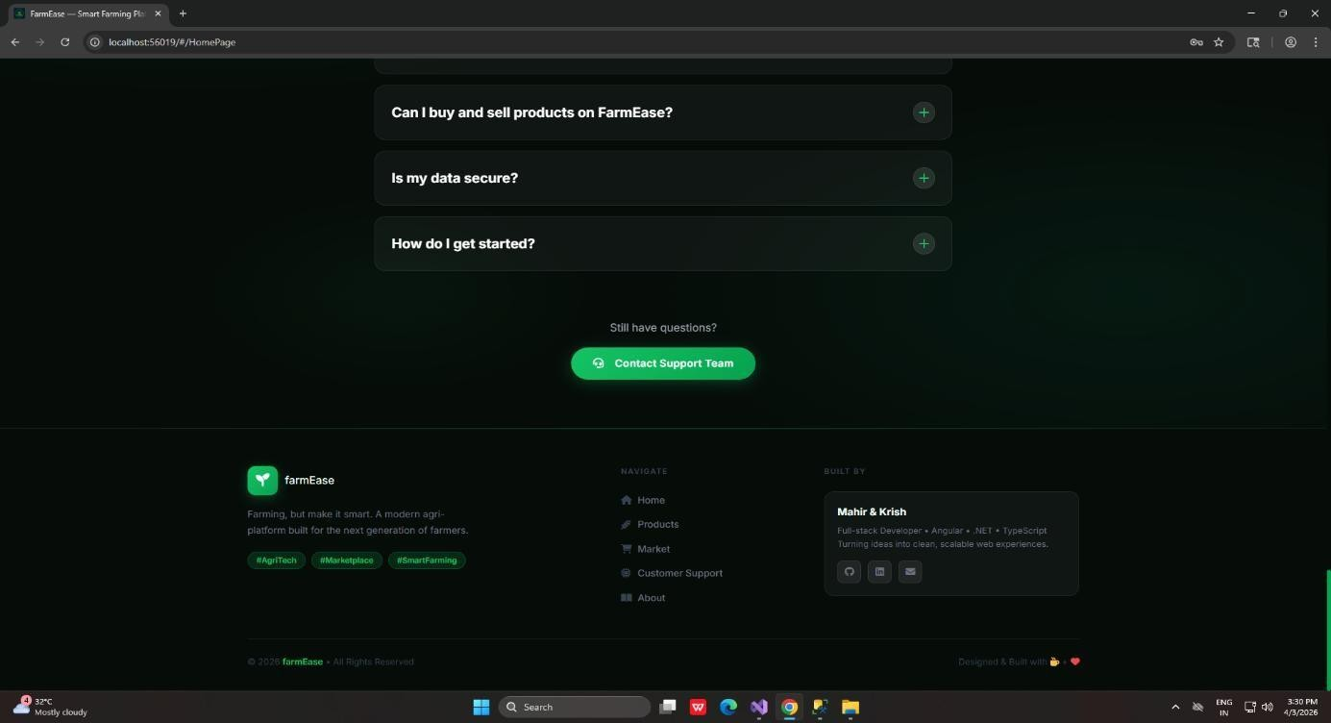
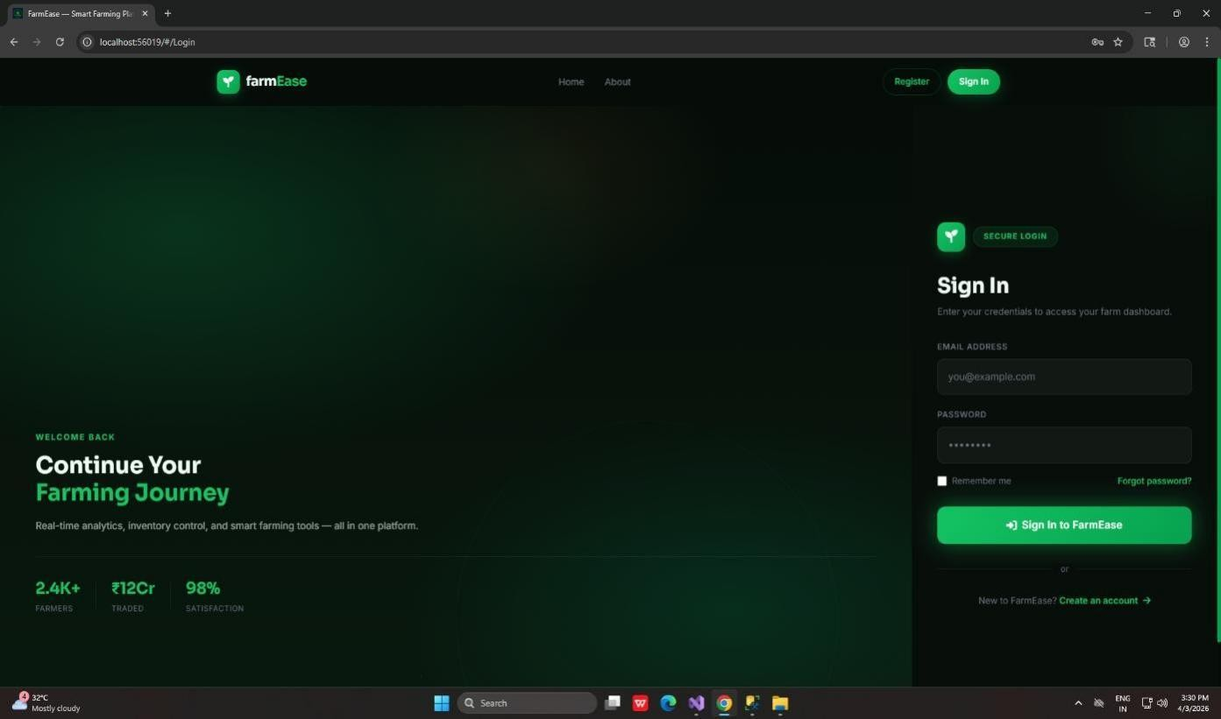

Footer:

Figure 30 Footer

Login:

Figure 31 Login Page

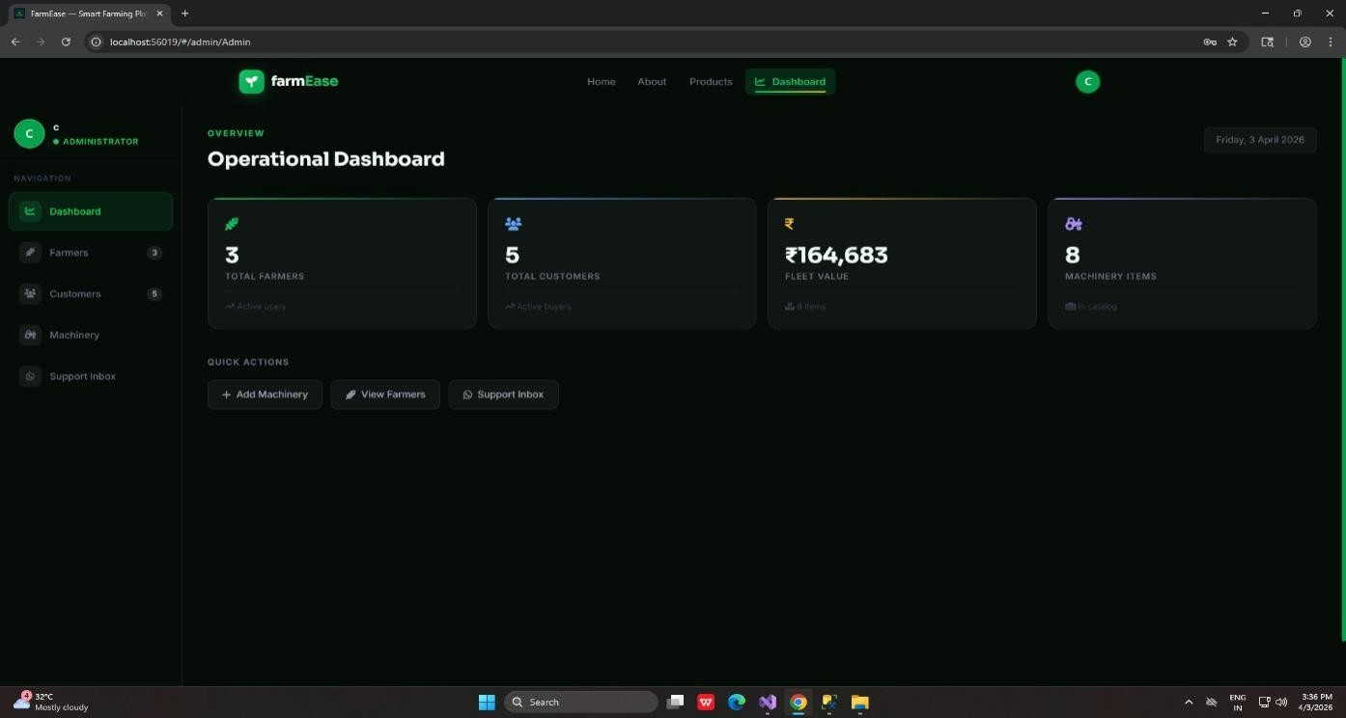
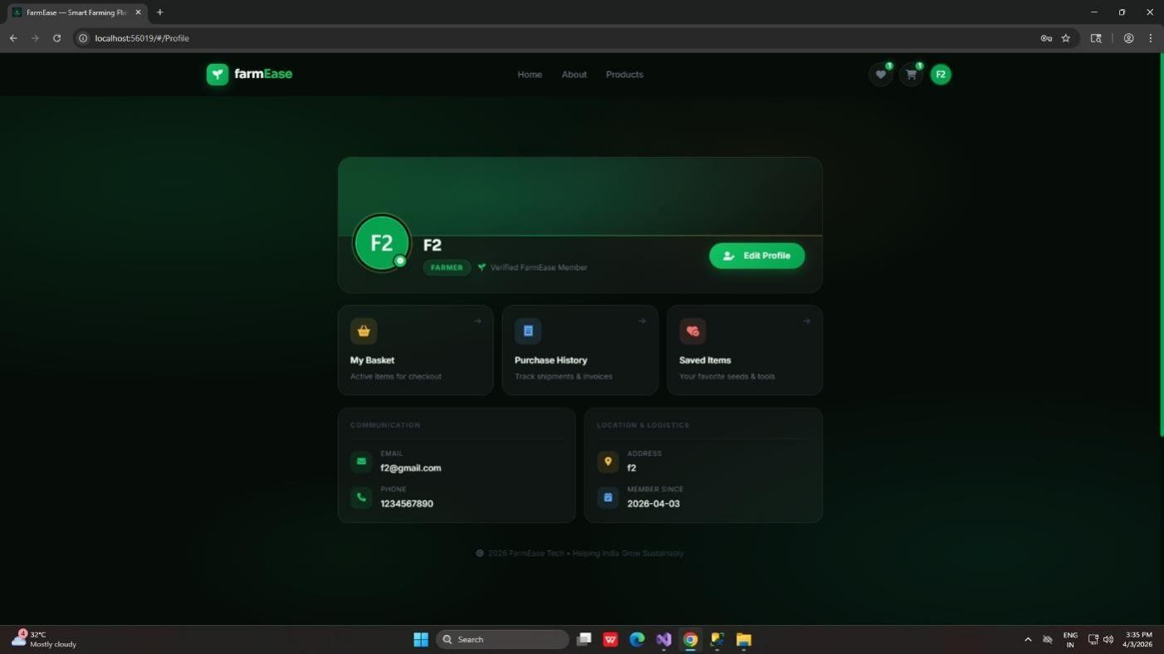

Admin Dashboard:

Figure 32 Admin Dashboard

User Profile:

Figure 33 User Profile

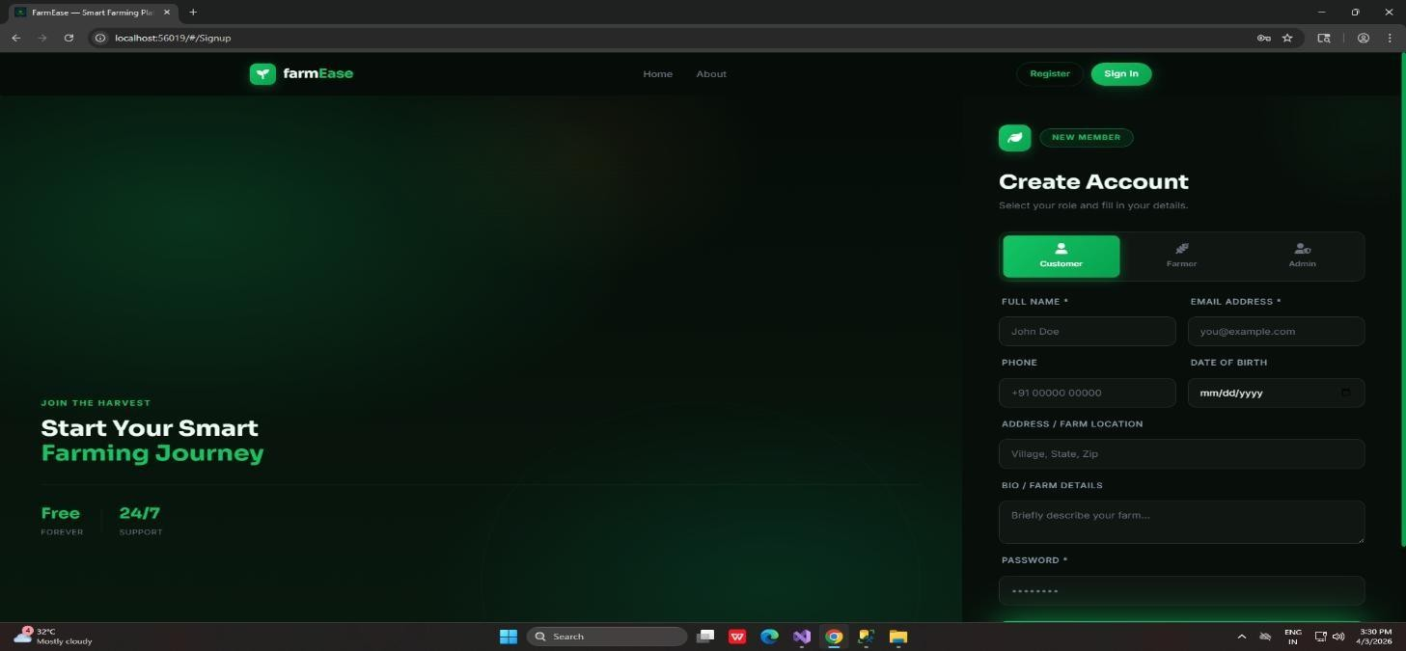
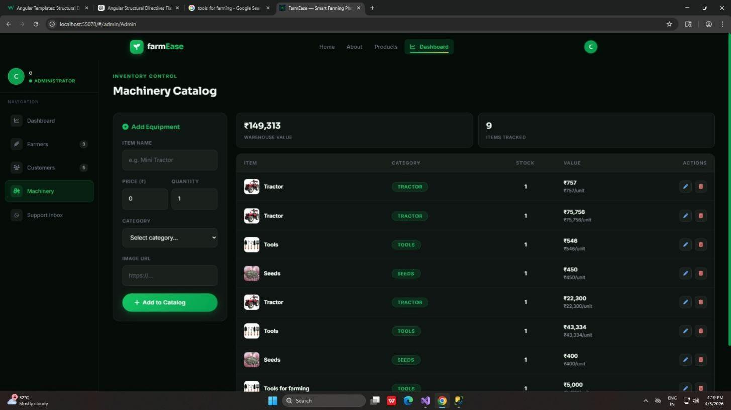

User Registration:

Figure 34 Register Page

Total Machinery :

Figure 35 Machinery

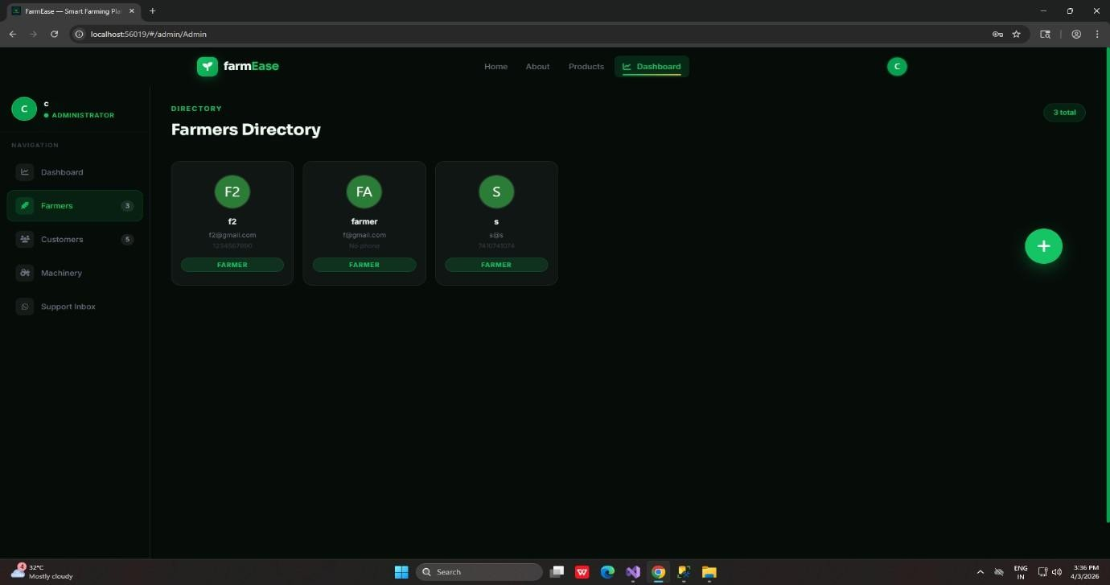
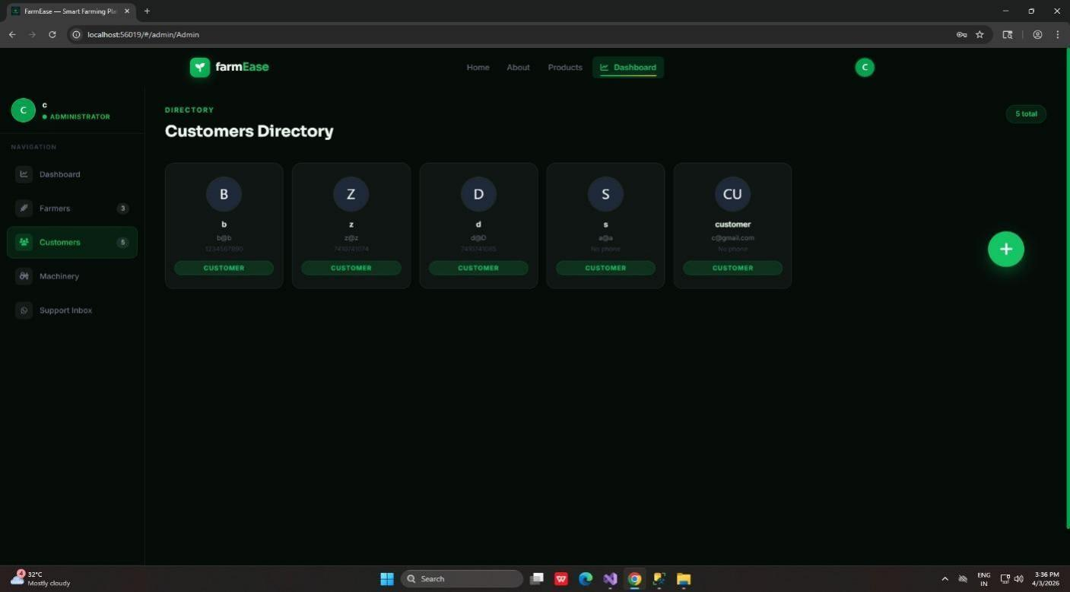

Total Farmers:

Figure 36 Total Farmers
Total Customers:

Figure 37 Total Customers


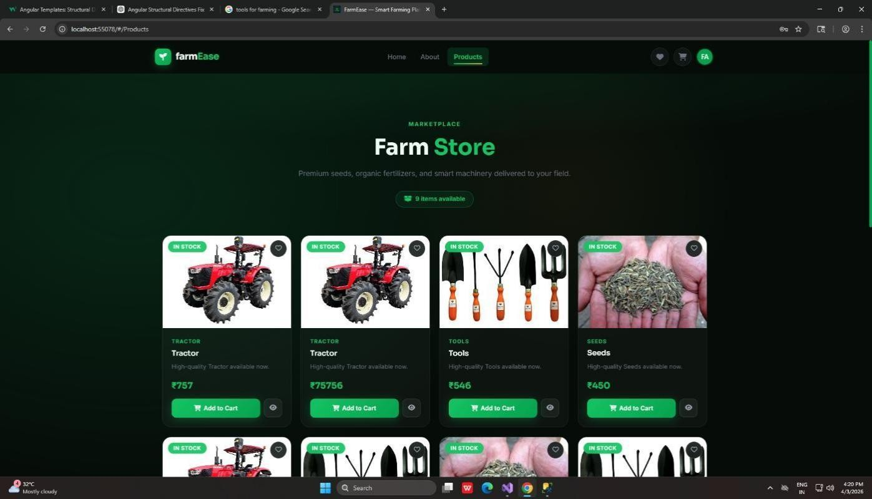
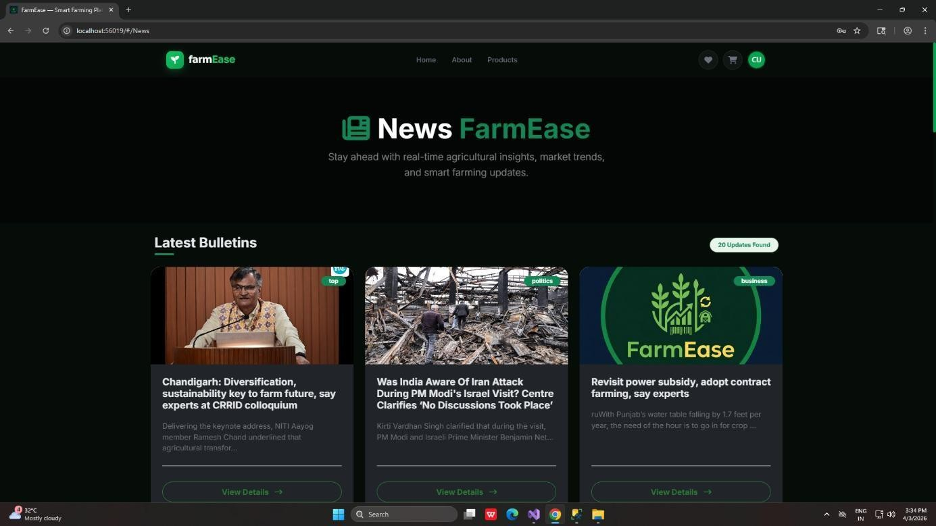
News Page :

Figure 38 News Page
Products Page :

Figure 39 Products Page

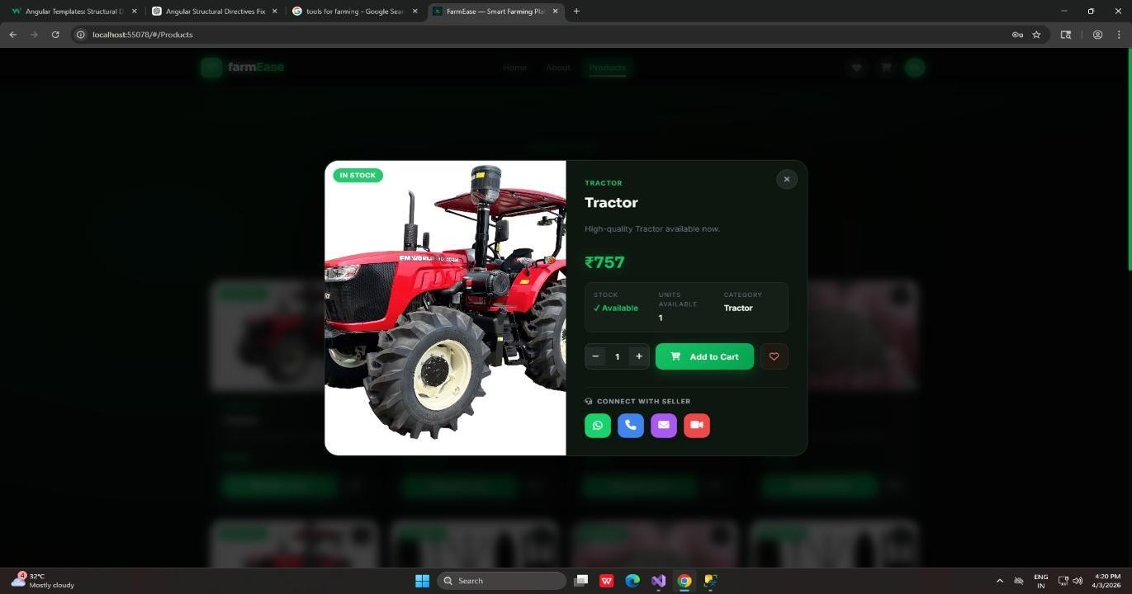
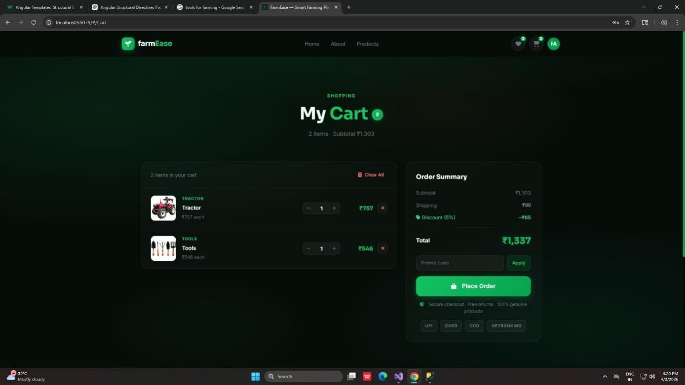
Product Modal:

Figure 40 Product Modal
Cart Page:

Figure 41 Cart Page

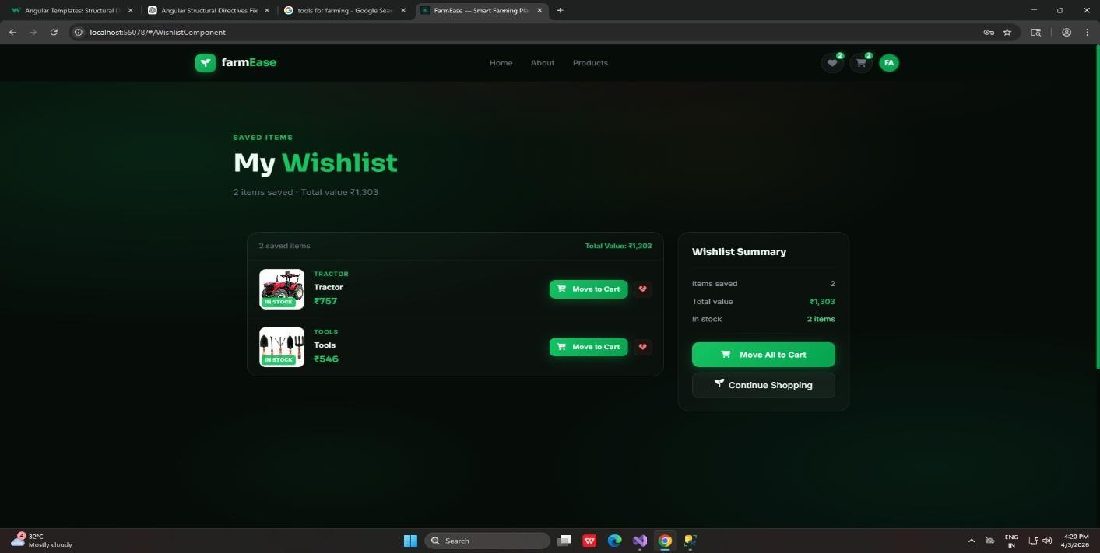
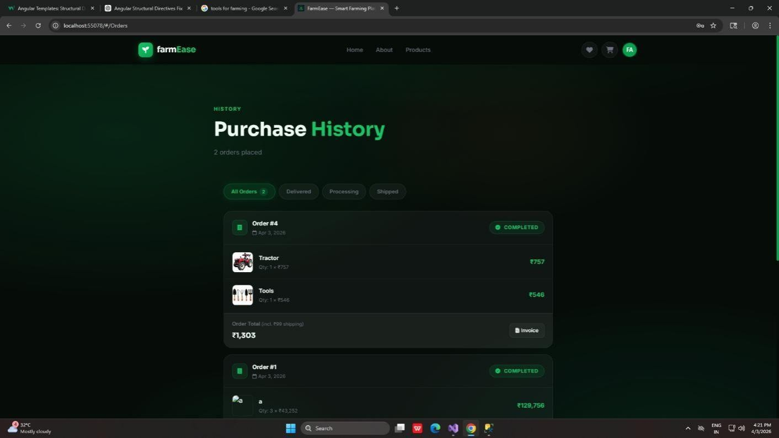

Wishlist Page:

Figure 42 Wishlist Page

Purchase Page:

Figure 43 Purchase History

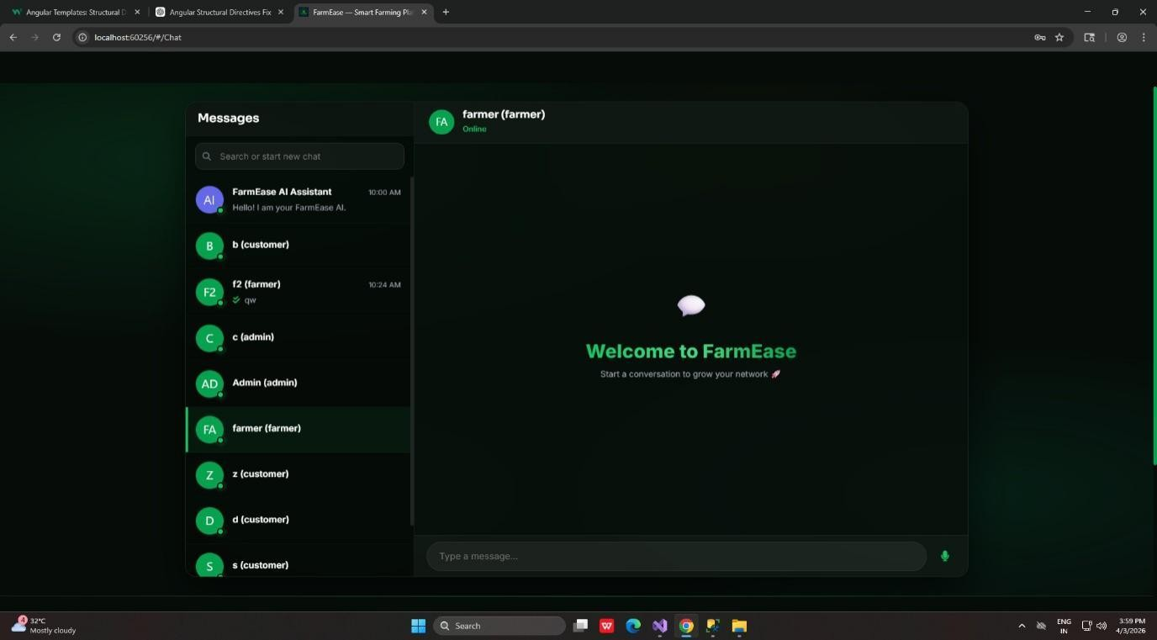
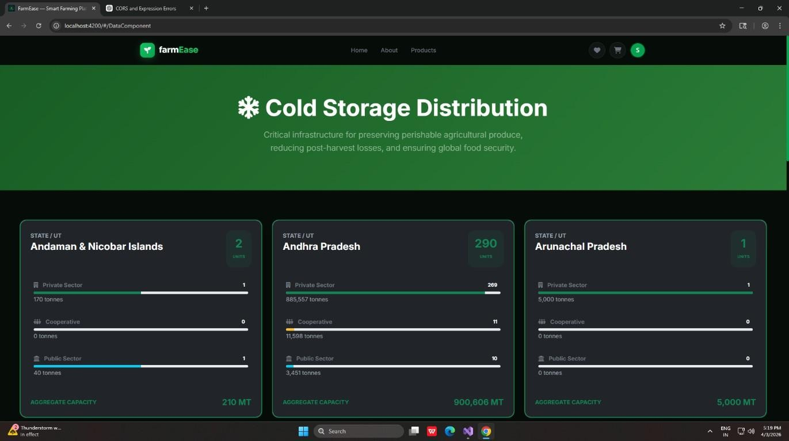

Messaging Page :

Figure 44 Chat Page
Cold Storage Data :

Figure 45 Cold Storage Page

CHAPTER 7

TESTING

TESTING PLAN
We are using white box testing because testers know the internal structure of software.
The development process repeats this testing sub-process a number of times for the following phases.
    - Unit Testing

    - Integration Testing

    - System Testing

    - User Acceptance Testing(UAT)
    - Performance Testing

Unit Testing
Unit testing is performed to test individual components or modules of the system. Each function or feature is tested separately to ensure it works correctly. In FarmEase, components like login, registration, and API functions are tested individually. This helps in identifying errors at an early stage. It improves code quality and reduces bugs in the system.

Integration Testing
Integration testing is done to check whether different modules of the system work together properly. For example, the frontend (Angular) is tested with backend APIs (.NET) to ensure smooth communication. It verifies data flow between components. This helps in detecting issues related to module interaction.

System Testing
System testing is performed on the complete system to ensure that all features work as expected. It checks the overall functionality of the application. In FarmEase, features like marketplace, weather updates, and user management are tested together. This ensures that the system meets all requirements.

User Acceptance Testing (UAT)
User Acceptance Testing is conducted to verify whether the system meets user expectations. Real users test the system and provide feedback. This helps in identifying usability issues. It ensures that the system is ready for deployment.

TEST CASES :

Table 9 Test Cases

Sr No. | Test Case | Inputs | Test Data | Expected Result | Actual Result | Pass/Fail
1 | User Login (Valid Data) | Enter Username & Password | farmer1, Farmer@123 | Login Successfully | Login Successfully | Pass
2 | Recover Password | Enter Email / Username | farmer1@gmail.com | Password Recovered Successfully | Password Recovered Successfully | Pass
3 | User Registration | Enter Name, Email, Contact, Password | Mahir, mahir@gmail.com, 9876543210,  Mahir@123 | User Registered Successfully | User Registered Successfully | Pass
4 | View Crop Information | Select Crop | Wheat | Crop Details Displayed | Crop Details Displayed | Pass
5 | Weather Information | Enter Location | Ahmedabad | Weather Data Displayed | Weather Data Displayed | Pass
6 | Add Product to Marketplace | Enter Product Name, Price, Quantity | Wheat, ₹2000, 50kg | Product Added Successfully | Product Added Successfully | Pass
7 | Buy Product | Select Product & Confirm  Purchase | Fertilizer Pack | Purchase Successful | Purchase Successful | Pass

8 | Expert Consultation | Enter Query | “Crop disease in wheat” | Query Submitted Successfully | Query Submitted Successfully | Pass
9 | Logout | Click Logout | — | Logout Successfully | Logout Successfully | Pass
10 | Invalid Login | Enter Username & Password | testUser, wrong@123 | Invalid Credentials, Login Failed | Login Failed | Fail

CHAPTER 8

Risk Management

RISK IDENTIFICATION

System Failure Risk
There is a possibility that the system may fail due to server issues, software bugs, or unexpected errors. This can affect the availability of the platform and interrupt user activities. If the system is not available, farmers will not be able to access important information. Identifying this risk helps in preparing backup and recovery strategies.

Data Loss Risk
Important data such as user information, crop details, and marketplace data may be lost due to technical failures or cyber-attacks. Data loss can lead to serious issues and reduce user trust. Proper data backup mechanisms are required to prevent this problem.

Security Risk
Unauthorized access to the system can lead to data breaches and misuse of information. Hackers may try to access user accounts or sensitive data. This risk highlights the importance of implementing strong security measures such as authentication and encryption.

Internet Connectivity Risk
Since FarmEase is a web-based system, it depends on internet connectivity. Poor or unstable internet can affect system performance and accessibility. This is especially important in rural areas where network issues are common.

User Adoption Risk
Some farmers may hesitate to use digital platforms due to lack of technical knowledge. This can reduce the effectiveness of the system. Proper training and a user-friendly interface can help overcome this risk.

Data Accuracy Risk
The system relies on external data sources like weather APIs. If the data provided is incorrect, it may lead to wrong decisions by farmers. Ensuring reliable data sources is important.

RISK ASSESSMENT

High Risk (Security & Data Loss)
Risks related to data security and data loss are considered high because they can cause serious damage to the system and user trust. If sensitive data is leaked or lost, it can affect many users. Therefore, strong preventive measures are required.

Medium Risk (System Failure & Internet Issues)
System crashes or internet problems are considered medium risks. These issues can temporarily affect system availability but can be managed with proper backup systems and error handling.

Low Risk (User Adoption)
User adoption is considered a low risk because it can be improved through training and awareness. Providing a simple interface also helps in reducing this risk.

Impact Analysis
Each risk is analyzed based on its impact on the system. High-impact risks require immediate attention, while low-impact risks can be managed gradually. This helps in prioritizing risk management efforts.

RISK MONITORING & CONTROL

Regular System Monitoring
The system should be continuously monitored to detect any errors or failures. Monitoring tools can help identify issues early and take corrective actions.

Data Backup and Recovery
Regular backups should be taken to prevent data loss. In case of failure, data can be restored quickly. This ensures system reliability.

Security Measures Implementation
Strong security practices such as authentication, authorization, and encryption should be implemented. Regular updates and patches should be applied to prevent vulnerabilities.

Performance Optimization
The system should be optimized to handle multiple users efficiently. Performance testing helps in identifying and fixing bottlenecks.

User Training and Support
Providing training and support to users helps improve system adoption. It also reduces errors caused by lack of knowledge.

Use of Reliable Data Sources
Only trusted APIs and data sources should be used to ensure accuracy. This reduces the risk of incorrect information.

CHAPTER 9

CONCLUSION

Project Summary
FarmEase is a web-based platform developed to simplify and modernize agricultural practices. It integrates multiple services such as crop information, weather updates, and marketplace functionality into a single system. This helps farmers access all necessary resources in one place. The system is designed to be user-friendly and accessible, making it suitable for users with basic technical knowledge.

Achievement of Objectives
The project successfully achieves its main objectives, such as providing a centralized platform for farmers, improving productivity, and enhancing decision-making. Farmers can now access reliable information and services easily. This reduces dependency on traditional methods and improves efficiency.

Benefits to Users
FarmEase provides several benefits to farmers, including better access to information, direct marketplace interaction, and expert consultation. It helps farmers increase their income by reducing dependency on intermediaries. The system also saves time and effort by providing all services in one place.

System Effectiveness
The system is efficient, reliable, and easy to use. It performs well in handling user requests and providing accurate information. Proper testing ensures that the system works as expected. The use of modern technologies improves overall performance.

Future Enhancements
The project can be further improved by adding advanced features such as AI-based crop recommendations, IoT integration for smart farming, and mobile application support. These enhancements will make the system more powerful and useful.

Final Outcome
Overall, FarmEase is a successful project that contributes to the digital transformation of agriculture. It helps farmers adopt modern techniques and improves their productivity and profitability. The system has the potential to grow and evolve with future technological advancements.

CHAPTER 10

REFERENCES

- Draw.io – Online Diagram Tool
https://app.diagrams.net/
- W3Schools – Web Development Tutorials
https://www.w3schools.com/
- C# Corner – .NET and Programming Resources
https://www.c-sharpcorner.com/
- Stack Overflow – Programming Q&A Community
https://stackoverflow.com/
- TutorialsPoint – Programming Tutorials
https://www.tutorialspoint.com/
- Javatpoint – Technical Tutorials and Guides
https://www.javatpoint.com/
- GitHub – Code Repository and Version Control
https://github.com/
- Microsoft Documentation – .NET and SQL Server
https://learn.microsoft.com/
- Angular Official Documentation
https://angular.io/

