


BUG TRACKING SYSTEM

A PROJECT REPORT

Submitted by

KALARIYA KARAN PRAVINBHAI

(220130116020)

AND

NAVAL ZALA (220130116075)

In partial fulfillment for the award of the degree of

BACHELOR OF ENGINEERING

In

Information Technology

Government Engineering College, Sector-28, Gandhinagar

Gujarat Technological University, Ahmedabad April, 2026




Government Engineering College, Sector-28, Gandhinagar

CERTIFICATE

This is to certify that the INTERNSHIP project entitled “Bug Tracking System” Have been carried out by KALARIYA KARAN PRAVINBHAI and NAVAL ZALA under my guidance in INFORMATION TECHNOLOGY (8-SEM) of Gujarat Technological University, Ahmedabad during the academic year 2025-2026.

Proff. PATEL SURESH B. Dr. Komal Anadkat

Internal Guide Head of the Department

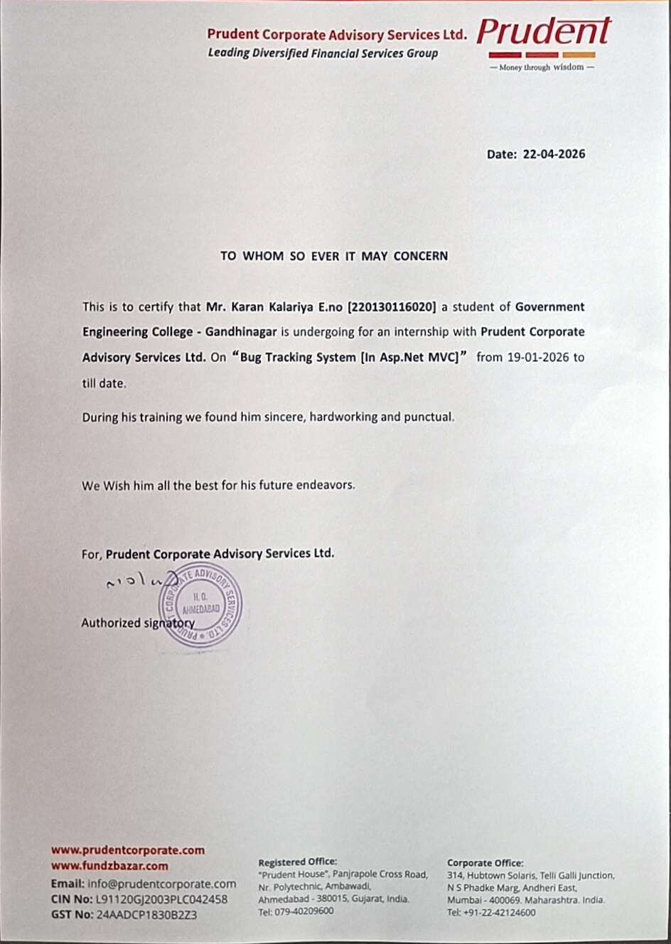





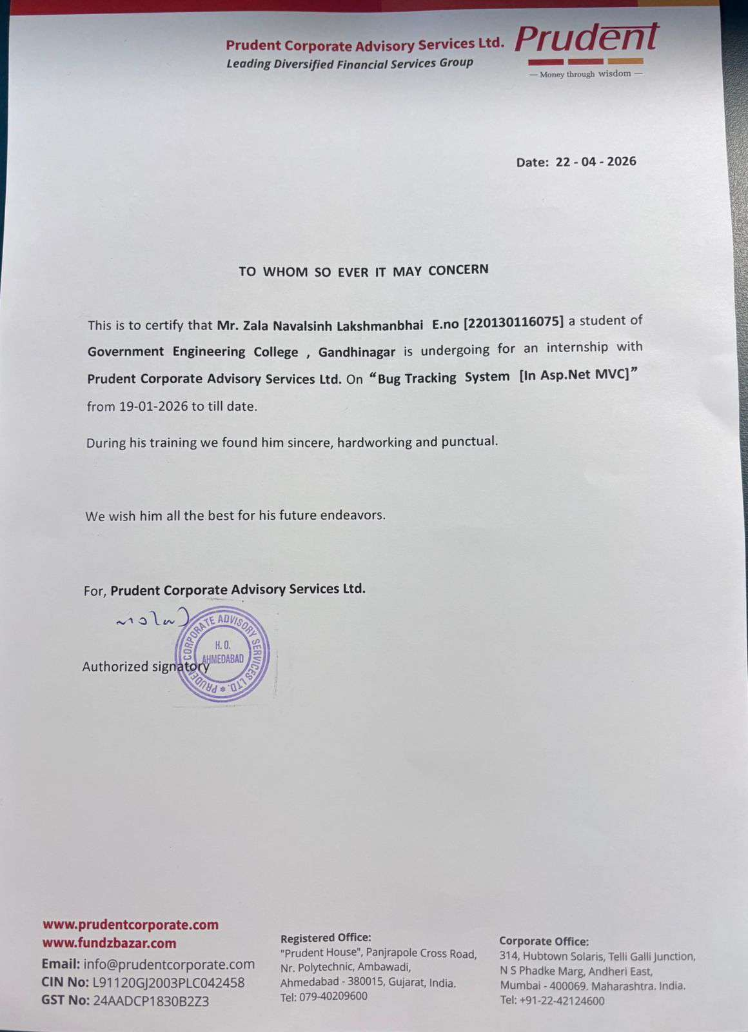



Government Engineering College,Sector-28, Gandhinagar

DECLARATION

We hereby declare that the Internship Project entitled Bug Tracking System submitted in partial fulfillment for the degree of Bachelor of Engineering in Information Technology to Gujarat Technological University, Ahmedabad, is a bonafide record of original project work carried out by me at PRUDENT CORPORATE ADVISORY SERVICE LTD. under the supervision of Meghna Shah and that no part of this report has been directly copied from any students reports or taken from any other source, without providing due reference.

Name of the Student Sign of Student

- Kalariya Karan

- Naval Zala

ACKNOWLEDGEMENT

- I would like to express my heartfelt gratitude to all those who contributed to the successful completion of my last year project on Bug Tracking System.

- I am also thankful to the faculty members of Government Engineering College,Sector-28, Gandhinagar for providing the necessary resources and creating an environment conducive to research and learning.

- I extend my sincere thanks to my classmates and friends for their encouragement, insightful discussions, and moral support during the various stages of this project.

- Furthermore, I am grateful to the developers and contributors of the open-source tools and libraries that formed the foundation of this project. Their dedication to advancing technology and sharing knowledge has been indispensable.

- Last but not least, I would like to express my gratitude to my family for their unwavering love, patience, and understanding throughout this endeavor.

- This project would not have been possible without the collective efforts of everyone mentioned above. Thank you all for your invaluable contributions.

ABSTRACT

- In the contemporary software development landscape, the management of bugs remains a critical aspect to ensure the quality and reliability of software products. This project aims to design and implement a robust bug tracking system tailored to the needs of software development teams.

- The proposed bug tracking system offers an intuitive user interface for logging, tracking, and resolving bugs efficiently. It incorporates features such as categorization of bugs based on severity and priority, assignment of tasks to respective developers, real-time notifications, and comprehensive reporting functionalities.

- Utilizing advanced technologies and methodologies, the system is designed to streamline the bug resolution process, thereby enhancing the overall productivity and effectiveness of software development projects. Moreover, the system's scalability and flexibility enable seamless integration with existing project management tools and workflows.

- Through the development and evaluation of this bug tracking system, this project contributes to the advancement of software engineering practices by providing a practical solution to effectively manage bugs in software development projects.

Kalariya Karan (220130116020)

Naval Zala (220130116075)

TABLE OF CONTENTS

Title Page No
Declaration………………………………………………………………….. I Acknowledgment…………………………………………………………… II
Abstract……………………………………………………………………... III
Table of Contents…………………………………………………………… IV
- Overview of Bug Tracking System 1
  - Introduction of Project………………………………………………. 2
  - Key Features & Main Objectives…………………………………… 2
  - Scope of the Project…………………………………………………. 4
- Background & Context 5
  - Importance of Bug Tracking System In Software Development……. 6
  - Current Challenges In Bug Tracking System……………………….. 7
  - Need for a Custom Bug Tracking System…………………………... 8
  - Users of the System…………………………………………………. 9
  - Project Planning…………………………………………………….. 9
- System Analysis 12
  - Hardware and Software Requirements……………………………… 13
  - Constraints………………………………………………………….. 13
  - Requirements of the System………………………………………... 13
    - System Requirements……………………………………… 13
    - Functional Requirements………………………...………… 14
    - Non-Functional Requirements…………………………….. 15
  - Project / Internship Scheduling (Gantt Chart)……………….…...…. 15
  - Software Requirement Specification (SRS)………………….…...…. 16

4. System Design 20

4.1 | Flow Chart Of The System……………………………….………… | 21

4.2 | Data Flow Diagram………………………………………………… | 22
4.3 | Unified Modeling Language ………………………………………. | 25
4.3.1 Use Case Diagram………………………………………… 25
4.3.2 Activity Diagram………………………………………….. 26
4.3.3 Sequence Diagram………………………………………… 27
4.4 | Entity-Relationship Diagram………………………………………. | 28
4.5 | Data Dictionary…………………………………………………….. | 30
- Implementation Planning And Details 36
  - Technologies Used for Bug Tracking System……………………… 37
  - Coding Standards…………………………………………………... 39
  - Development Environment Setup………………………………….. 40
  - Coding Screenshots………………………………………………… 41
  - Project Screenshots………………………………………………… 44
- Testing 52
  - Testing Plan………………………………………………………… 53
  - Test Cases………………………………………………………….. 54
- Risk Management 56
  - Risk Identification………………………………………………….. 57
  - Risk Assessment……………………………………………………. 58
  - Risk Monitoring & Control………………………………………… 60
- Conclusion………………………………………………………………….. 61
- References………………………………………………………………….. 63

CHAPTER 1

OVERVIEW OF BUG TRACKING SYSTEM

INTRODUCTION
The Bug Tracking System is a software application designed to manage and track issues, bugs, and enhancements throughout the software development lifecycle. It provides a centralized platform for users to report, prioritize, assign, track, and resolve issues efficiently. The system aims to streamline communication among team members and stakeholders, ensuring timely resolution of software defects and continuous improvement of product quality.

One of the key features of the BTS is its flexible workflow management capabilities. The system will enable project managers to define custom workflows tailored to their organization's specific needs, ensuring that bugs progress through stages such as triage, assignment, development, testing, and resolution in a systematic manner. Additionally, automated notifications and reminders will be integrated to keep stakeholders informed about the status and updates of their reported bugs, facilitating timely resolution.

KEY FEATURES AND MAIN OBJECTIVES
KEY FEATURES :

User-friendly Interface
Effective bug management hinges on the ability to prioritize issues based on severity, impact, and urgency. The Bug Tracking System will facilitate granular prioritization, allowing users to categorize bugs according to predefined severity levels (e.g., critical, major, minor) and allocate resources accordingly. Additionally, automated notifications and alerts will ensure timely escalation of critical issues, minimizing project delays and mitigating risks.

Issue Tracking
Central to the Bug Tracking System is its robust issue tracking functionality, which allows users to monitor the status and progress of reported bugs in real-time. From initial submission to resolution, stakeholders can track each bug's lifecycle, view updates, comments, and associated discussions, fostering transparency and accountability across the development team.

Prioritization and Severity Management
Effective bug management hinges on the ability to prioritize issues based on severity, impact, and urgency. The Bug Tracking System will facilitate granular prioritization, allowing users to categorize bugs according to predefined severity levels (e.g., critical, major, minor) and allocate resources accordingly. Additionally, automated notifications and alerts will ensure timely escalation of critical issues, minimizing project delays and mitigating risks.

Remove Closed Bug From the System
Here, You can Remove Closed Status Bug’s And also for further use the Closed bug Status File shared to all Active Users via Email in which the Excel and PDF Files are Attached. So, the User can review the bugs in future for any complications. Also the File Downloaded via System in which user can select Date From and Date To For Download the Files.

MAIN OBJECTIVES :

Security and Compliance
Implement robust security measures to protect sensitive data, ensure compliance with regulatory requirements, and maintain the integrity of the bug tracking system.

Feedback-Driven Development
Foster a culture of continuous improvement by soliciting feedback from users and stakeholders, incorporating user suggestions and feature requests into future iterations of the NuBug Tracking System.

Integration Flexibility
Offer seamless integration with a wide range of development tools and platforms, including version control systems, project management software, and continuous integration pipelines.

Scalability and Performance
Build a scalable and high-performance bug tracking system capable of handling large volumes of bug reports and supporting teams of various sizes and complexities.

SCOPE OF THE PROJECT

User Roles and Permissions
Different user roles (e.g., admin, developer, tester) should have distinct permissions and access levels within the system. Permissions should be granular, allowing administrators to control access to sensitive information and system functionalities.

Security and Data Protection
The system should prioritize security to protect sensitive data stored within the bug tracking system. Measures such as data encryption, access controls, and audit trails should be implemented to ensure data integrity and confidentiality.

Bug Reporting
Users should be able to easily report bugs encountered in the software.Bug reports should include details such as description, steps to reproduce, expected behavior, actual behavior, and severity.

Search and Filtering
Users should be able to search for specific bugs using keywords, filters, and advanced search criteria.Filter options may include bug status, severity, priority, assigned user, creation date, and last updated date.

CHAPTER 2

BACKGROUND & CONTEXT

IMPORTANCE OF BUG TRACKING SYSTEM IN SOFTWARE DEVELOPMENT
Early Detection of Issues : Bug tracking systems allow developers to identify issues early in the development process. By catching bugs before they escalate, teams can prevent larger problems down the line, saving time and resources.

Improved Communication : Bug tracking systems provide a centralized platform for communication among team members. This facilitates collaboration, allows for easy sharing of information, and ensures everyone is on the same page regarding bug status and resolution.

Efficient Issue Management : Bug tracking systems streamline the process of managing software issues. They allow teams to prioritize bugs based on severity and impact, assign tasks to appropriate team members, and track the status of bug fixes in real-time.

Enhanced Transparency : Bug tracking systems provide visibility into the status of software issues throughout the development lifecycle. This transparency helps stakeholders understand the progress of bug fixes, identify bottlenecks, and make informed decisions about project timelines and resource allocation.

Data-Driven Decision Making : Bug tracking systems generate valuable data and metrics that can be used to analyze bug trends, identify recurring issues, and assess the overall quality of software products. This data enables teams to make data-driven decisions to improve their development processes and prevent future issues.

Continuous Improvement : By tracking and analyzing software issues over time, bug tracking systems facilitate a culture of continuous improvement. Teams can learn from past mistakes, implement corrective actions, and refine their development processes to deliver higher quality software products with each iteration.

Customer Satisfaction : Detecting and fixing bugs promptly improves the overall quality and stability of software products. This, in turn, leads to higher levels of customer satisfaction, as users experience fewer issues and enjoy a smoother user experience.

Compliance and Auditing : In regulated industries, bug tracking systems provide documentation of software issues and their resolution. This documentation is essential for compliance with industry regulations and standards, as well as for auditing purposes.

CURRENT CHALLENGES IN BUG TRACKING SYSTEM
Integration Challenges : Integrating bug tracking systems with other development tools and systems, such as version control repositories and project management platforms, can be challenging. Incompatibilities or lack of interoperability may hinder seamless data exchange and workflow automation.

Incomplete or Inaccurate Bug Reports : Many bug reports lack essential information such as steps to reproduce, expected behavior, and actual behavior, making it challenging for developers to understand and resolve the issue.

Overwhelming Volume of Bug Reports : In large-scale software projects, the volume of bug reports can be overwhelming, making it difficult for teams to prioritize and address issues effectively.

Difficulty in Reproducing Bugs : Some bugs may be challenging to reproduce consistently, especially if they occur under specific conditions or in complex software environments. This makes it difficult for developers to diagnose and fix the underlying issues.

Poor Communication and Collaboration : Ineffective communication and collaboration among team members can lead to delays in bug resolution and misunderstandings regarding bug status and priority. Without clear communication channels, important information may be overlooked or lost.

NEED OF CUSTOME BUG TRACKING SYSTEM
A custom bug tracking system addresses the unique needs and challenges faced by development teams in their software development lifecycle. Off-the-shelf solutions may offer generic functionalities, but they often lack the flexibility to adapt to specific workflows, processes, and project requirements. By developing a custom bug tracking system, organizations can tailor the platform to their exact specifications, ensuring that it aligns seamlessly with their development practices and objectives.
The need for a custom bug tracking system arises from the unique requirements and complexities of software development projects within an organization. Off-the-shelf bug tracking solutions may lack the flexibility to adapt to specific workflows, processes, and integration requirements. A custom bug tracking system offers the opportunity to tailor the solution precisely to the organization's needs, ensuring seamless integration with existing tools and systems while accommodating unique development methodologies and practices.
Moreover, a custom bug tracking system empowers organizations to implement specialized features and functionalities that align with their development objectives and project requirements. By designing a system from the ground up, organizations can optimize bug tracking processes, enhance collaboration among team members, and improve overall productivity and efficiency.
Additionally, custom bug tracking systems provide greater control over security and data privacy, enabling organizations to implement robust measures to safeguard sensitive information and comply with regulatory requirements. Overall, a custom bug tracking system offers a tailored solution that enhances the effectiveness and success of software development projects within the organization.

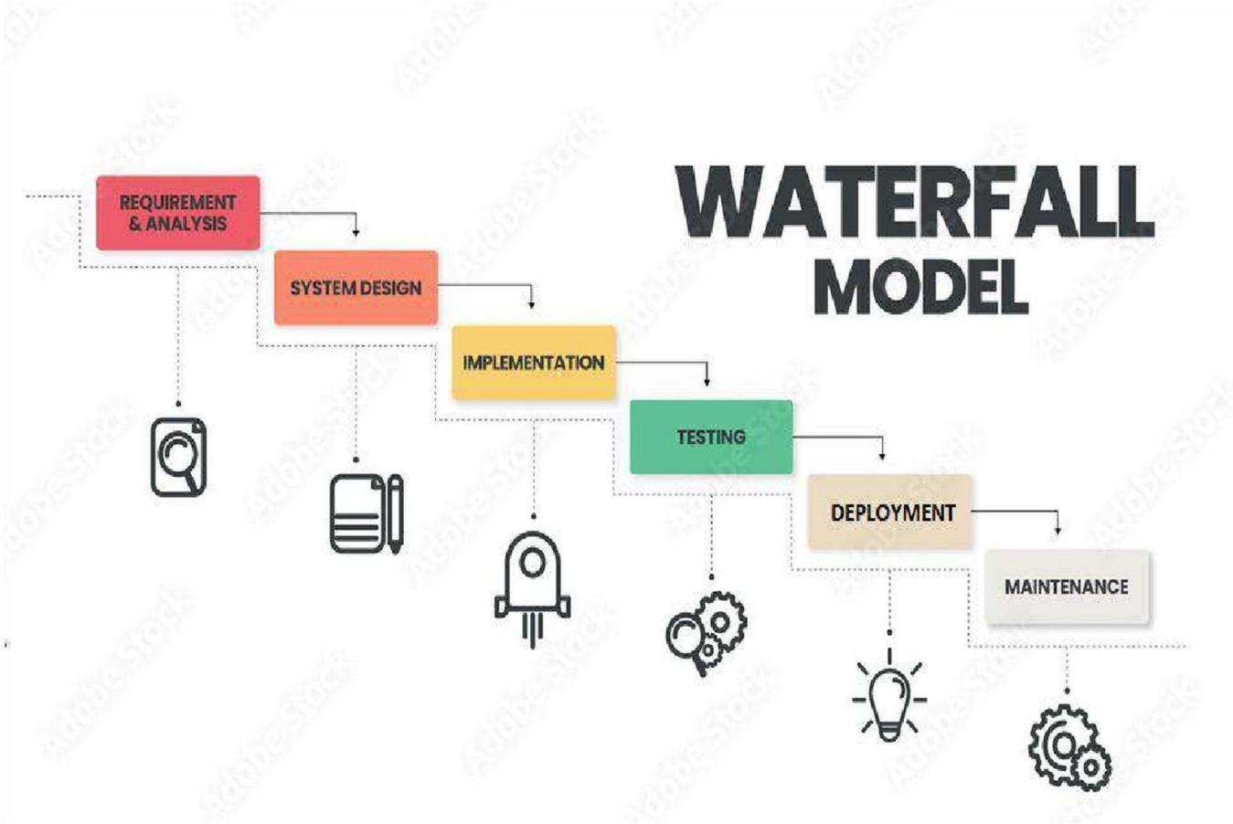

USERS OF THE SYSTEM

Admin User :
Admin User Can Add, Update And Activate Deactivate of User Registration and Also Admin User can change the All User’s Password. If Required

Developer & Tester :
Developer & Tester Can Add, Update And Delete the Project Details, Bug Details. Also Developer & Tester should Remove the Closed bug From the System And Download the File in PDF And Excel Format For Future Use.

PEOJECT PLANNING WATTERFALL MODEL

The waterfall model is a traditional software development methodology that follows a linear and sequential approach. In this model, the development process is divided into distinct phases, with each phase building upon the deliverables of the previous phase. The waterfall model typically consists of the following sequential phases :

- Requirements & Analysis : In this initial phase, requirements are gathered from stakeholders and documented in detail. This phase involves understanding the needs of the end-users and defining the scope of the project.
- System Design : Once the requirements are established, the system architecture and design are created. This phase involves translating the requirements into a technical blueprint
that outlines how the system will be structured and how different components will interact with each other.
- Implementation : With the system design in place, the actual coding and development of the software take place in this phase. Developers write the code according to the design specifications and guidelines.
- Testing : After the implementation phase, the software is rigorously tested to ensure that it meets the specified requirements and functions correctly. Testing includes various types such as unit testing, integration testing, system testing, and user acceptance testing.
- Deployment : Once the software passes testing and is deemed ready for release, it is deployed
to the production environment. This phase involves installing the software on the end-users' systems and making it available for use.
- Maintenance : After deployment, the software enters the maintenance phase, where it is monitored, updated, and modified as needed to address bugs, add new features, or accommodate changes in requirements.

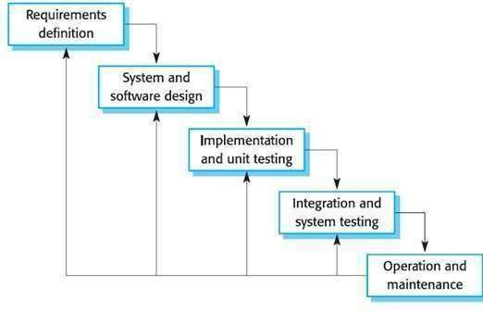

INCREMENTAL WATERFALL MODEL
I Used Incremental Model to Complete this Project. The increment model applies the waterfall model incrementally.The series of releases is referred to as “increment”,
with is increment providing more Functionality to the customer. After the first increment, a core product is delivered, which can already be used by the customer. Based on customer feedback, a plan is developed for next increments, and modifications are made accordingly.

This process continues, with increment being delivered until the complete product is delivered. With incremental development, each increment is tested individually before moving on to the next one. This ensures that any issues or bugs are caught early and can be addressed before they become bigger problems.

CHAPTER 3

SYSTEM ANALYSIS

HARDWARE & SOFTWARE REQUIREMENTS
HARDWARE REQUIREMENTS

- Standard PC
- Internet connection with enough speed
- At least 5000 MB Hard Disk space
- Smart mobile phone(if want to run on mobile)
- System type: 64-bit Operating System, x64 base processor or 32-bit
- Installed memory (RAM):128MB(At least)

SOFTWARE REQUIREMENTS
- Platform used: Mac OS, Linux, any windows like windows Vista, windows XP, windows 7, windows 8, windows 8.1, Windows 10.
- Web browser: any browser like Google, Internet Explorer, Mozilla Firefox, Safari.

  - CONSTRAINTS
Regularities Policy:
The application does demand much reliability and it is fully assured that the particular information about the users should be secured and flow is maintained and accessed according to the right.

Requirements of the System

System Requirements:
- Server : Sufficient processing power, memory, and storage capacity to host the Microsoft SQL Server database and handle web traffic.
- Client Devices : Standard computing devices with web browsing capabilities for accessing the SMS platform.
- Operating System : Compatible with Windows Server for hosting the database and web server.

- Database Management System: Microsoft SQL Server for storing and managing society data.
- Programming Languages : Utilize languages such as HTML, CSS, JavaScript, and backend frameworks (e.g., ASP.NET, Node.js) for website development.
- Development Tools : Integrated Development Environment (IDE) like Visual Studio for coding and testing.
- Development Tools : Integrated Development Environment (IDE) like Visual Studio for coding and testing.

Functional Requirement:

- User Authentication : The system shall provide a secure login mechanism for society members. Description: Users should be able to authenticate themselves using unique user IDs and passwords. Acceptance Criteria: Users can successfully log in using
valid credentials, and unauthorized access attempts are denied.
- Prioritization : Users should be able to prioritize bugs based on factors such as severity, impact on users, and urgency. This helps teams to focus on fixing the most critical issues first.
- Issue Tracking : The system should allow for the tracking of bugs throughout their lifecycle. This includes assigning statuses (e.g., open, in progress, resolved, closed) and assigning ownership to specific team members.
- Notifications : The system should provide notifications to relevant stakeholders when there are updates to bugs they are involved with (e.g., assigned to, commented on, status change).
- Security : The bug tracking system should have appropriate security measures in place to protect sensitive information and prevent unauthorized access or tampering.
- Search and Filtering : Users should be able to search for specific bugs based on various criteria (e.g., keywords, severity, status, assignee, creation date). Filtering options help users to focus on relevant issues.

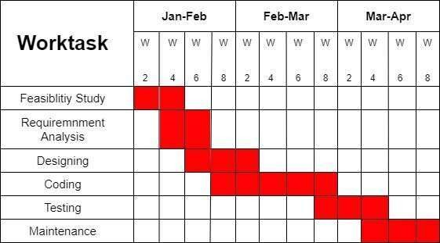

Non-Functional Requirement:
- Performance : The system should be responsive and able to handle concurrent users and a large volume of bug reports without significant degradation in performance. Response times for common operations should be within acceptable limits.
- Scalability : The system should be able to scale horizontally or vertically to accommodate increasing numbers of users, bug reports, and concurrent activities as the project grows.
- Reliability : The bug tracking system should be highly reliable, minimizing downtime and ensuring data integrity. It should have mechanisms in place to handle failures gracefully and recover quickly from errors.
- Availability : The system should be available for use whenever needed, with minimal planned downtime for maintenance activities. It should also have redundancy and failover mechanisms to 0321 ensure continued operation in case of hardware or network failures.

    - PEOJECT / INTERNSHIP SCHEDULING (GANTT CHART)

  - SOFTWARE REQUIREMENT SPECIFICATION
ADMIN

R :- Bug Tracking System [Admin Panel] R1 :- Log in
Input :- Enter Username and Password

Output :- Login Successfully

Process :- In this scenario if Username and Password is correct then Admin User will be Redirected to the Dashboard. Three Login Attempts Should be Considered if Password is incorrect.

R2 :- User Registration

R2.1 :- The Admin User should be Registered User

Input :- Admin Can Enter Basic Details Of User For Registration Process

Output :- User Registered Successfully.

Process :- Here, The Basic Details Of User should be added by Admin User
and the Account Activation Message is forwarded to Registered User via Email Address.

R2.2 :- Update And Deactivation of User

Input :- Admin User Should Be Enter Updated Details of User And also Deactivate the User Account

Output :- User Details Updated Successfully And also if Deactivated the User then Deactivated Successfully.

Process :- Here, Admin User Can Change Details Of User and Deactivated the User Account.

R3 :- Manage User Activation

R3.1 :- Activated User Account

Input :- Admin User Activated User Account

Output :- User account Activated Successfully.

Process :- Here, Deactivated User should be activated by Admin User.

R3.2 :- Change User Password

Input :- Admin User Can Update User Password

Output :- Password Changed Successfully.

Process :- Here, Admin User will changed the User password and the new Password is shared to user via Email Id.

R4 :- Submit Feedback

Input :- Give Rating and Submit Feedback Output :- Feedback Submitted Successfully Process :- Here Admin User can Submit Feedback. R5 :- Logout
Process :- Logout Successfully From the System.

DEVELOPER / TESTER

R :- Bug Tracking System [User Panel] R1 :- Log in
Input :- Enter Username and Password

Output :- Login Successfully

Process :- In this scenario if Username and Password is correct then Admin User will be Redirected to the Dashboard. Three Login Attempts Should be Considered if Password is incorrect.

R2 :- Add Project Details Input :- Enter Project Details
Output :- Project Details Added Successfully

Process :- Here, User should added Project Details Like Project Name, Domain Name, Completion Range, Remarks etc.

R3 :- Bug Tracker

R3.1 :- Add Bug Details Manually Input :- Add Bug Details
Output :- Bug Details Added Successfully

Process :- Here, Bug Details like Project Name, Page Name, Status, Priority, Severity, Bug Creation date, Bug Last Modified Date and Remarks Should be added Manually.

R3.2 :- Add Bug Details in Bulk Input :- Add Bug Details
Output :- Bug Details Added Successfully

Process :- Here, All Bug Information should be added via Excel File and Bulk of Bug Details should be Added in the System.

R3.3 :- Remove Unwanted Or Unused Bug Details Input

:- User Deleted Unwanted Or Unused Bug Details Output

:- Bug Details Deleted Successfully

Process :- Here, Used will Deleted Bug Details if not required

R3.4 :- Change Bug Details

Input :- User will Changes the Bug Details Manually

Output :- Bug Details Changed Successfully

Process :- Here, All Bug Information should be Updated like Project Name, Page Name, Status, Priority, Severity, Bug Creation date, Bug Last Modified Date and Remarks Manually.

R3.5 :- Remove Closed Bugs From the System Input :- Remove Closed Bugs From the System Output :- Bug Removed successfully
Process :- Here, User should Remove Closed Bugs From the system and the Closed Bug Details File Forwarded to All Activate User via Email Id.

R4 :- Show Closed Bug Details

Input :- Select Date From and Date To

Output :- Download Closed Bug Status File as a PDF And Excel Format

Process :- Here, User Selects the Date Field and Download the Closed Bug Status File.

R5 :- Submit Feedback

Input :- Give Rating and Submit Feedback Output :- Feedback Submitted Successfully Process :- Here User can Submit Feedback. R6

:- Logout

Process :- Logout Successfully From the System.

CHAPTER 4

SYSTEM DESIGN

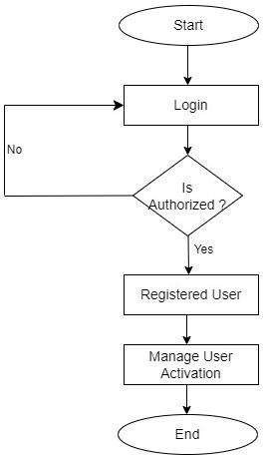

FLOW CHART OF THE SYSTEM
This flowchart provides a visual representation of the bug tracking process, outlining the steps involved from bug identification to resolution or closure.

ADMIN:

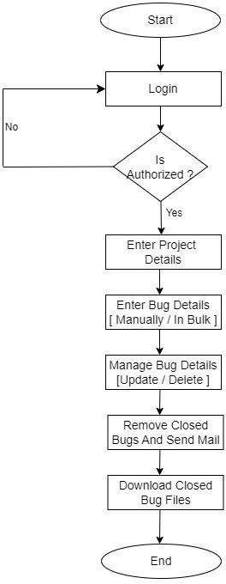
DEVELOPER / TESTER:

  - DATA FLOW DIAGRAM
This DFD outlines the main processes, data flows, data stores, and external entities involved in your bug tracking system. A Data Flow Diagram (DFD) depicts the flow of data within a system, illustrating how data is input, processed, and output.

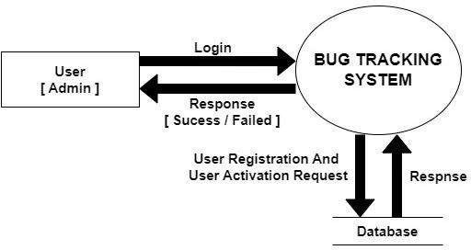
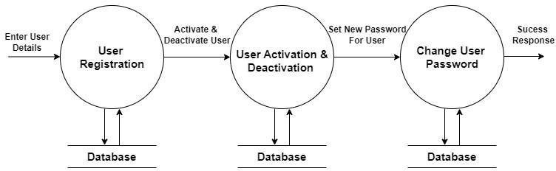

ADMIN:

LEVEL 0

LEVEL 1

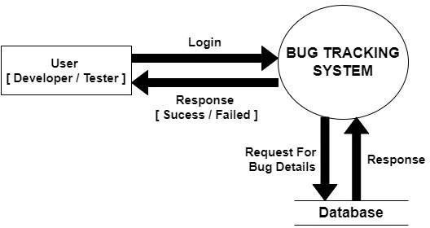
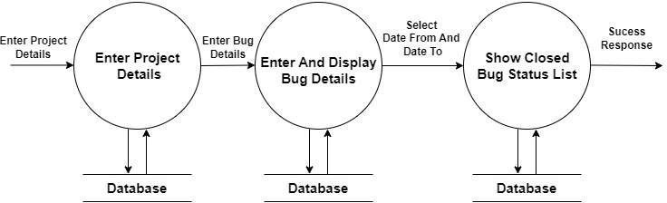

DEVELOPER / TESTER:

LEVEL 0

LEVEL 1

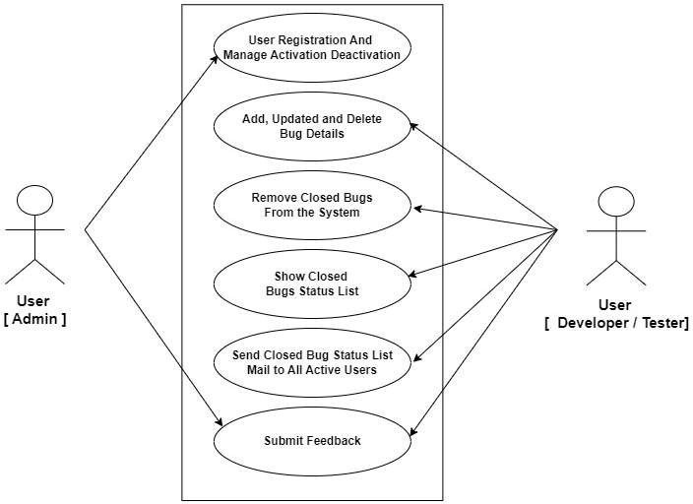

  - UNIFIED MODELING LANGUAGE
Unified Modeling Language (UML) is a standardized modeling language used in software engineering for visualizing, specifying, constructing, and documenting the artifacts of software systems. It provides a set of graphical notations for representing various aspects of a system's structure and behavior.

Use Case Diagram
A use case diagram in Unified Modeling Language (UML) is a type of diagram that represents the interactions between actors (users) and a system. It provides a high-level overview of the functionalities provided by the system and the actors involved in using those functionalities.

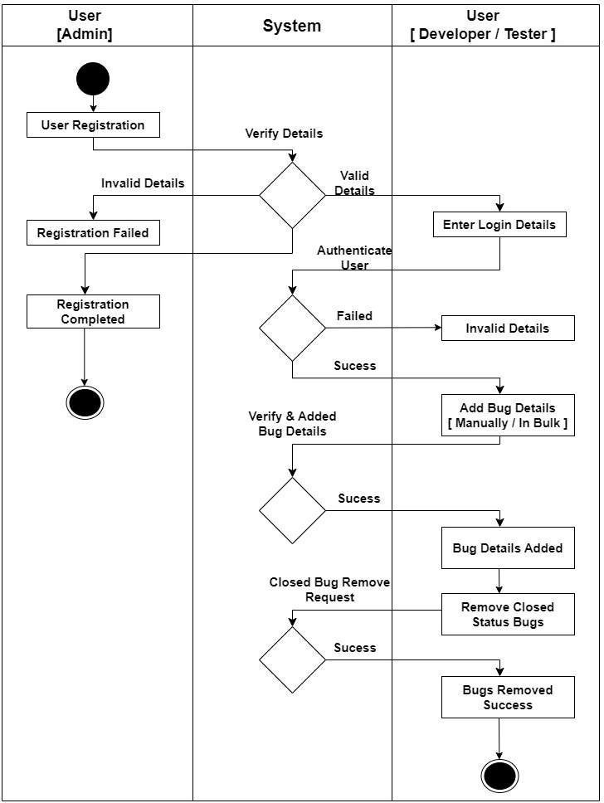

Activity Diagram

An activity diagram is a type of UML diagram that shows the workflow or flowchart of a system or process. It represents the steps, decisions, and activities involved in a process or workflow in a visual way, using symbols such as rectangles, diamonds, and arrows.
Activity diagrams are commonly used in business process modeling, software engineering, and project management to illustrate the steps involved in a complex process or workflow.

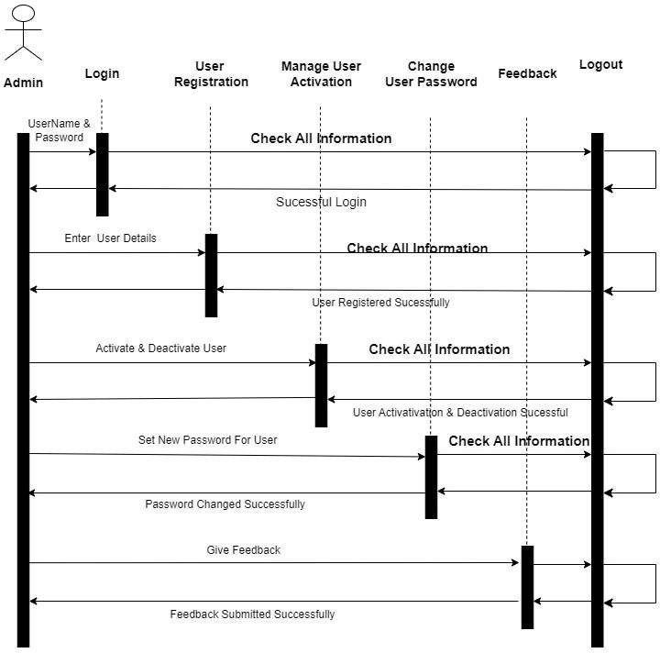

Sequence Diagram
A sequence diagram in Unified Modeling Language (UML) is a type of interaction diagram that illustrates the interactions and message exchanges between objects or components within a system over time.

ADMIN:

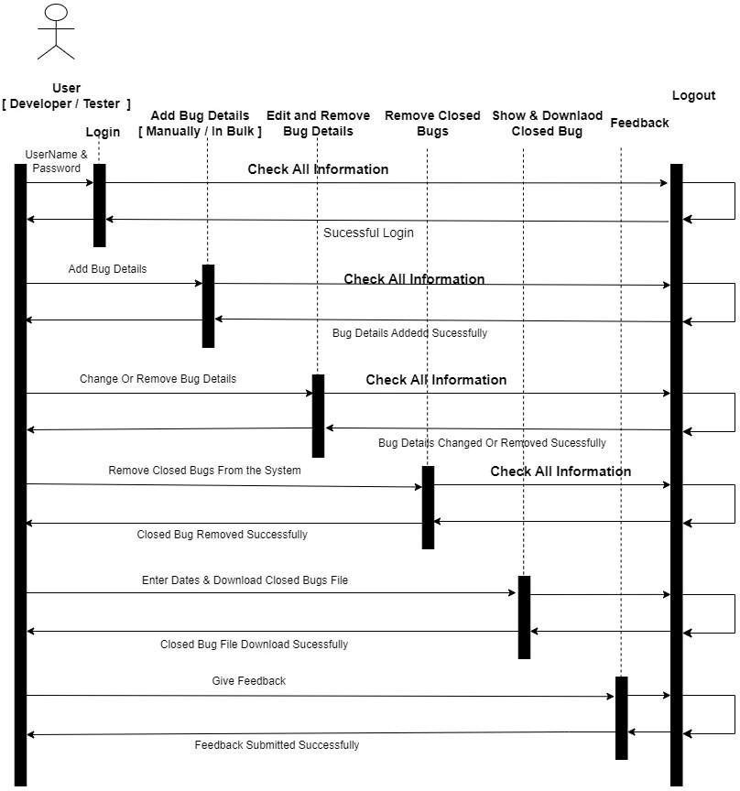
DEVELOPER / TESTER:

  - ENTITY-RELATIONSHIP DIAGRAM
Entity-Relationship (ER) diagrams are a type of visual representation used in database design to model the structure of a database.Entities represent real-world objects or concepts within the system being modeled. In an ER diagram, entities are depicted as rectangles, with each rectangle representing a specific entity type.

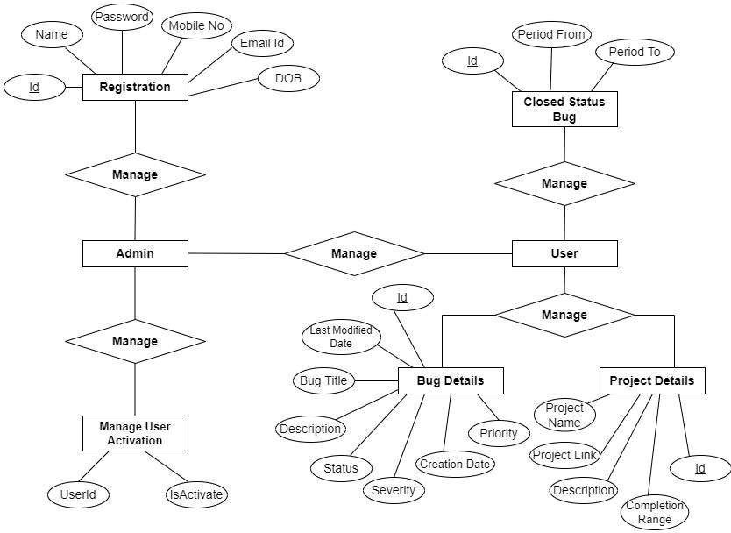

DATA DICTIONARY
- CLIENT_MASTER :

DATA FIELD | DATA TYPE | SIZE | CONSTRAINT | DESCRIPTION
Id | int | 4 | PRIMARY KEY | Login Id
UserId | varchar | 50 | NOT NULL | Unique User Name
FName | varchar | 50 | NOT NULL | First Name
LName | varchar | 50 | NOT NULL | Last Name
MName | varchar | 50 | NOT NULL | Middle Name
RoleId | int | 4 | FOREIGN KEY | Role Id
Encrypted_Pwd | varchar | 500 | NOT NULL | Encrypted Password
Encrypted_Salt | varchar | 500 | NOT NULL | Encrypted Salt
Address1 | varchar | 300 | NOT NULL | Address 1
Address2 | varchar | 300 | NOT NULL | Address 2
Address3 | varchar | 300 | NOT NULL | Address 3
CityId | int | 4 | FOREIGN KEY | City Id
StateId | int | 4 | FOREIGN KEY | State Id
PinCode | varchar | 6 | NOT NULL | Pincode
MobileNo | varchar | 15 | NOT NULL | Mobile No
EmailId | varchar | 300 | NOT NULL | Email Id
IsActive | int | 4 | NOT NULL | Is Active User
ProfileImage | varchar | 100 | - | Profile Image Name
Login_Attempts | int | 4 | NOT NULL | Login Attempts
Timest | datetime | 8 | NOT NULL | Date of Insert
UTimest | datetime | 8 | NOT NULL | Date of Update
IsFeedback | bit | 1 | - | Is Feedback Submitted
TwitterLink | varchar | 800 | - | Twitter Link

DATA FIELD | DATA TYPE | SIZE | CONSTRAINT | DESCRIPTION
FacebookLink | varchar | 800 | - | Facebook Link
InstagramLink | varchar | 800 | - | Instagram Link
LinkedinLink | varchar | 800 | - | Linkedin Link
- PINCODE MASTER :

DATA FIELD | DATA TYPE | SIZE | CONSTRAINT | DESCRIPTION
Id | int | 4 | PRIMARY KEY | Pincode Id
StateId | int | 4 | FOREIGN KEY | State Id
CityId | int | 4 | FOREIGN KEY | City Id
Pincode | varchar | 7 | NOT NULL | Pincode
AreaName | varchar | 100 | NOT NULL | Area Name
CityAreaName | varchar | 100 | NOT NULL | City Area Name
IsActive | bit | 1 | NOT NULL | Is Active Pincode
- CITY_MASTER :

DATA FIELD | DATA TYPE | SIZE | CONSTRAINT | DESCRIPTION
Id | int | 4 | PRIMARY KEY | City Id
StateId | int | 4 | FOREIGN KEY | State Id
CityName | varchar | 50 | NOT NULL | City Name
- CONTACT :

DATA FIELD | DATA TYPE | SIZE | CONSTRAINT | DESCRIPTION
Id | int | 4 | PRIMARY KEY | City Id

DATA FIELD | DATA TYPE | SIZE | CONSTRAINT | DESCRIPTION
Name | varchar | 100 | NOT NULL | User Name
EmailId | varchar | 300 | NOT ULL | Email ID

Subject | varchar | 300 | NOT NULL | Subject
Message | varchar | MAX | NOT NULL | Message
Timest | datetime | 8 | NOT NULL | Date of Insert

- FEEDBACK :

DATA FIELD | DATA TYPE | SIZE | CONSTRAINT | DESCRIPTION
Id | int | 4 | PRIMARY KEY | Id
LoginId | int | 4 | FOREIGN KEY | Login Id
Rating | int | 4 | NOT NULL | Rating
Feedback | varchar | MAX | NOT NULL | Feedback Message
Timest | datetime | 8 | NOT NULL | Date of Insert
- PROJECT_MASTER :

DATA FIELD | DATA TYPE | SIZE | CONSTRAINT | DESCRIPTION
Id | int | 4 | PRIMARY KEY | Project Id
ProjectName | varchar | 100 | NOT NULL | Project Name
ProjectLink | varchar | 500 | NOT NULL | Project Link
ProjectDescription | varchar | MAX | NOT NULL | Project Description
Completion | int | 4 | NOT NULL | Completion
IsActive | bit | 1 | NOT NULL | Is Active
Timest | datetime | 8 | NOT NULL | Date of Insert
UTimest | datetime | 8 | NOT NULL | Date of Update

- BUGTRACKER_MASTER :

DATA FIELD | DATA TYPE | SIZE | CONSTRAINT | DESCRIPTION
Id | int | 4 | PRIMARY KEY | Bug Id
ProjectId | int | 4 | FOREIGN KEY | Project Id
PageName | Varchar | 800 | NOT NULL | Page Name

BugTitle | varchar | 800 | NOT NULL | Bug Title
Priority | varchar | 5 | NOT NULL | Priority
Severity | varchar | 5 | NOT NULL | Severity
Status | varchar | 5 | NOT NULL | Status
CreationDate | datetime | 8 | NOT NULL | Creation Date
LastModifiedDate | datetime | 8 | NOT NULL | Last Modified Date
Description | varchar | MAX | NOT NULL | Description
LoginId | int | 4 | FOREIGN KEY | Login Id
ULoginId | int | 4 | FOREIGN KEY | Updated Login Id
Timest | datetime | 8 | NOT NULL | Date of Insert
UTimest | datetime | 8 | NOT NULL | Date of Update

- CLOSEDBUGTRACKER_MASTER :

DATA FIELD | DATA TYPE | SIZE | CONSTRAINT | DESCRIPTION
Id | int | 4 | PRIMARY KEY | Bug Id
ProjectId | int | 4 | FOREIGN KEY | Project Id
PageName | varchar | 800 | NOT NULL | Page Name
BugTitle | varchar | 800 | NOT NULL | Bug Title
Priority | varchar | 5 | NOT NULL | Priority
Severity | varchar | 5 | NOT NULL | Severity
Status | varchar | 5 | NOT NULL | Status

DATA FIELD | DATA TYPE | SIZE | CONSTRAINT | DESCRIPTION
CreationDate | datetime | 8 | NOT NULL | Creation Date
LastModifiedDate | datetime | 8 | NOT NULL | Last Modified Date
Description | varchar | MAX | NOT NULL | Description
LoginId | int | 4 | FOREIGN KEY | Login Id
ULoginId | int | 4 | FOREIGN KEY | Updated Login Id
RemvedByLoginId | int | 4 | NOT NULL | Removed By Login Id
Timest | datetime | 8 | NOT NULL | Date of Insert
- NOTIFICATION :

DATA FIELD | DATA TYPE | SIZE | CONSTRAINT | DESCRIPTION
Id | int | 4 | PRIMARY KEY | Id
UserId | int | 4 | FOREIGN KEY | Login Id
NotificationIcon | varchar | 100 | NOT NULL | Notification Icon
NotificationTitle | varchar | 100 | NOT NULL | Notification Title
Notification | varchar | 800 | NOT NULL | Notification Message
IsRead | bit | 1 | NOT NULL | Is Read
Timest | datetime | 8 | NOT NULL | Date of Insert
UTimest | datetime | 8 | NOT NULL | Date of Update
- MAIL_XML :

DATA FIELD | DATA TYPE | SIZE | CONSTRAINT | DESCRIPTION
Id | int | 4 | PRIMARY KEY | Id
MailSubject | varchar | MAX | NOT NULL | Mail Subject
MailBody | varchar | MAX | NOT NULL | Mail Body

DATA FIELD | DATA TYPE | SIZE | CONSTRAINT | DESCRIPTION
IsBodyHTML | bit | 1 | NOT NULL | Is HTML Body
IsActive | bit | 1 | NOT NULL | Is Active

CHAPTER 5

IMPLEMENTATION & PLANNING DETAILS

TECHNOLOGIES USED FOR BUG TRACKING SYSTEM FRONTEND TECHNOLOGIES :

HTML (Hypertext Markup Language) is the standard markup language for creating web pages. It provides the structure and content of a web page through a series of elements, such as headings, paragraphs, links, images, and forms. HTML elements are organized hierarchically and can be styled using CSS (Cascading Style Sheets) to control their appearance and layout.

CSS (Cascading Style Sheets) is a style sheet language used for describing the presentation of a document written in HTML. CSS separates the content of a web page from its visual presentation, allowing developers to control aspects such as colors, fonts, spacing, and positioning. CSS styles can be applied inline, embedded within HTML documents, or linked externally to apply styles consistently across multiple pages.

Bootstrap is a popular front-end framework for building responsive and mobile-first websites and web applications. It provides a collection of pre-designed components, such as navigation bars, buttons, forms, and grids, along with CSS and JavaScript plugins, to streamline the process of building modern and visually appealing user interfaces. Bootstrap's grid system and responsive design features make it easy to create layouts that adapt to different screen sizes and devices.

JavaScript is a versatile programming language used for adding interactivity and dynamic behavior to web pages. It allows developers to manipulate the content and structure of a web page in response to user actions, events, and input. JavaScript can be used to validate form data, create animations, handle user interactions, fetch data from servers asynchronously, and more. JavaScript is supported by all modern web browsers and is essential for building interactive web applications.

jQuery is a fast, small, and feature-rich JavaScript library that simplifies the process of traversing and manipulating HTML documents, handling events, and performing AJAX (Asynchronous JavaScript and XML) requests. jQuery provides a concise and easy-to-use API for common tasks, allowing developers to write less code and achieve more in a shorter amount of time. It abstracts away many of the complexities of JavaScript, making it accessible to developers of all skill levels.

Ajax (Asynchronous JavaScript and XML) is a technique for making asynchronous HTTP requests from a web page to a server without requiring a full page refresh. With Ajax, web applications can retrieve data from a server in the background and update parts of a web page dynamically, without interrupting the user's workflow. This allows for a more seamless and responsive user experience, as only the relevant portions of the page need to be updated in response to user actions or events. Ajax is commonly used in conjunction with JavaScript and jQuery to create interactive and dynamic web applications.

BACKEND TECHNOLOGIES :

C# (pronounced "C sharp") is a powerful and versatile programming language developed by Microsoft. It is widely used for building a variety of software applications, including web applications, desktop applications, mobile apps, games, and more. C# is part of the .NET framework and provides features such as strong typing, object-oriented programming, asynchronous programming, and support for generics, LINQ (Language Integrated Query), and dynamic programming. C# is known for its simplicity, readability, and robustness, making it a popular choice for developers across different domains.

MVC (Model-View-Controller) is a software architectural pattern commonly used for designing and implementing web applications. MVC separates the application into three main components:

Model : The model represents the data and business logic of the application. It encapsulates the application's data structure, performs data manipulation and validation, and interacts with the database or other external data sources.

View : The view represents the user interface (UI) of the application. It presents the data to the user in a visually appealing and interactive manner. Views are responsible for rendering HTML markup, handling user input, and displaying dynamic content.
Controller : The controller acts as an intermediary between the model and the view. It receives user input from the view, processes requests, invokes appropriate actions on the model, and selects the appropriate view to display the response. Controllers handle routing, request processing, and application logic.
MVC promotes separation of concerns, modularity, and code reusability, making it easier to maintain and extend web applications over time. It provides a structured approach to organizing code and facilitates collaboration among developers working on different parts of the application.

Microsoft SQL Server is a relational database management system (RDBMS) developed by Microsoft. It provides a secure, scalable, and reliable platform for storing, retrieving, and managing structured data. SQL Server supports a wide range of features, including transaction processing, data warehousing, business intelligence, and analytics. It offers tools and services for database development, administration, and performance optimization, as well as integration with other Microsoft technologies such as Visual Studio and .NET framework.

CODING STANDARDS

    - Use descriptive names for variables, functions, classes, and other identifiers
    - Follow camelCase naming conventions for variables and functions.
    - Use meaningful prefixes or suffixes for variables to indicate their type or purpose (e.g., "btn" for buttons).
    - Provide clear and concise descriptions of parameters, return values, and side effects.
    - Follow best practices for error handling, exception handling, and logging.
    - Use consistent and clear formatting for code blocks, braces, and parentheses.
    - Avoid unnecessary or excessive comments, but include comments to explain complex logic, algorithms, or non-obvious code.

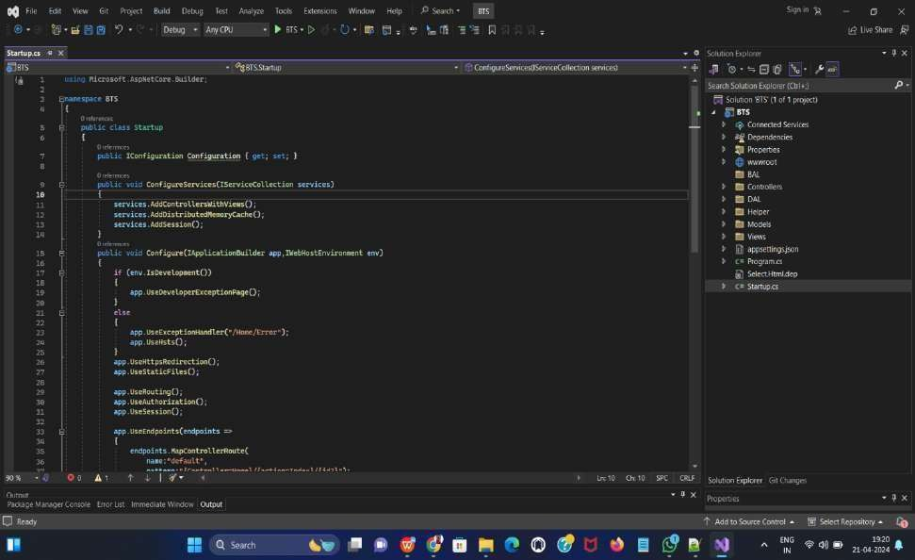

DEVELOPMENT ENVIRONMENT SETUP

Microsoft Visual Studio 2022 :
Microsoft Visual Studio 2022 is a comprehensive integrated development environment (IDE) designed to support a wide range of software development activities, including web development, desktop application development, mobile app development, cloud-based development, and more. With a powerful set of tools, features, and services, Visual Studio 2022 enables developers to build, debug, test, and deploy applications efficiently and effectively.

Microsoft SQL Server 2019 :
Microsoft SQL Server 2019 is a powerful and feature-rich relational database management system (RDBMS) developed by Microsoft. It provides a robust platform for storing, managing, and analyzing structured and unstructured data, enabling organizations to build scalable and high-performance data-driven applications.

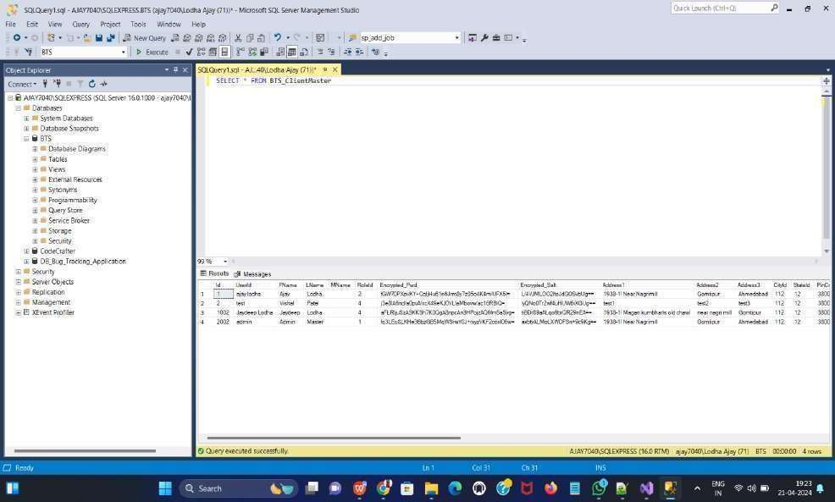
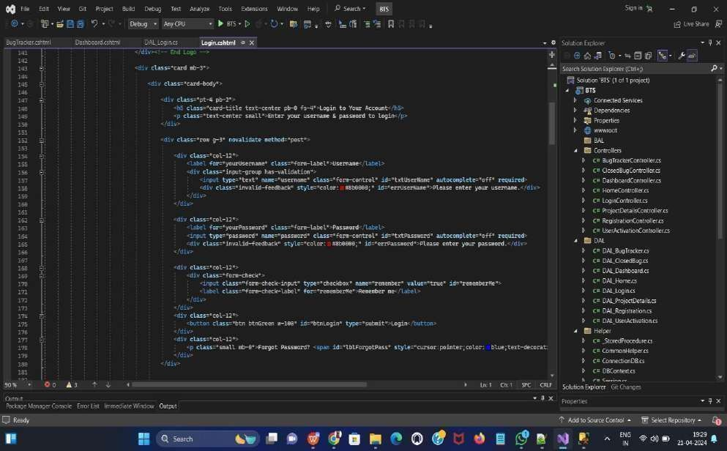

CODING SCREENSHOTS
Login :

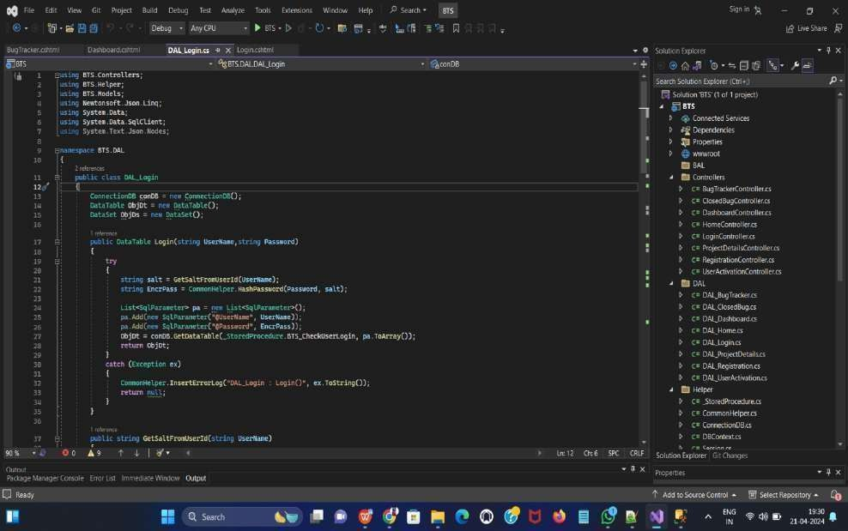
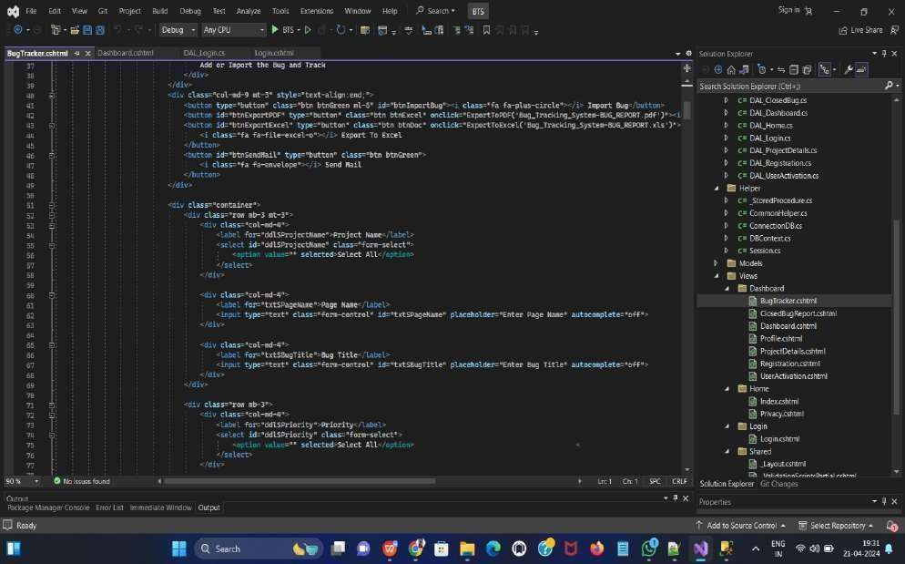

BugTracker :

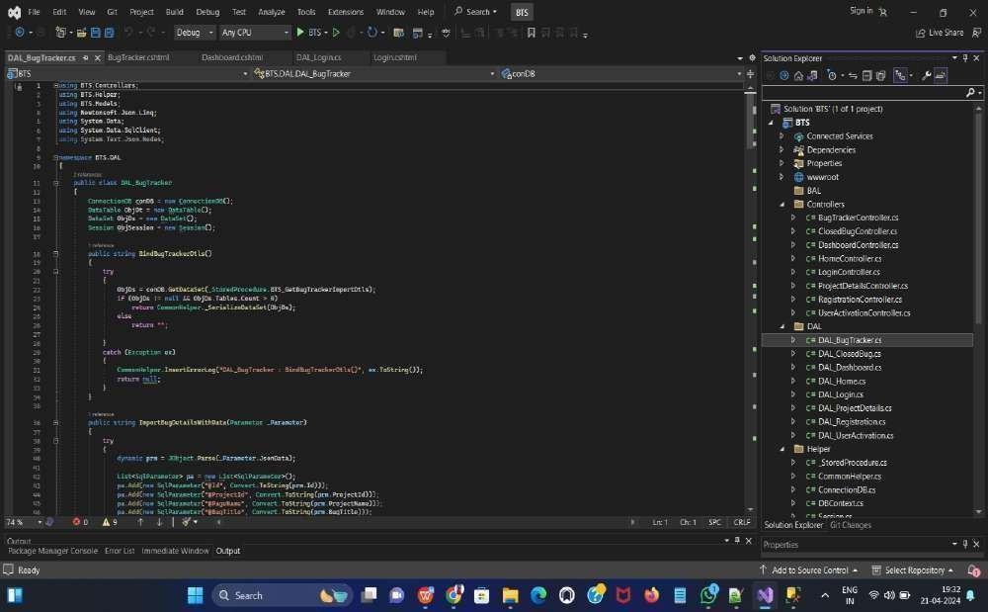
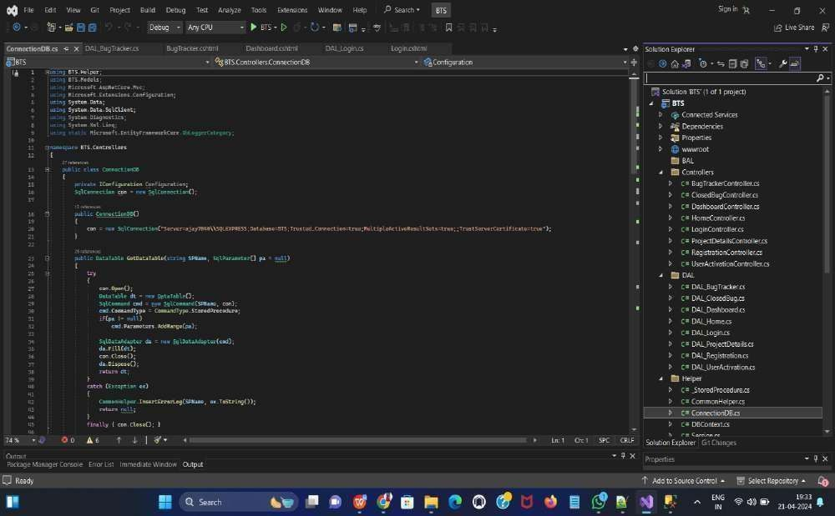

ConnectionDB :

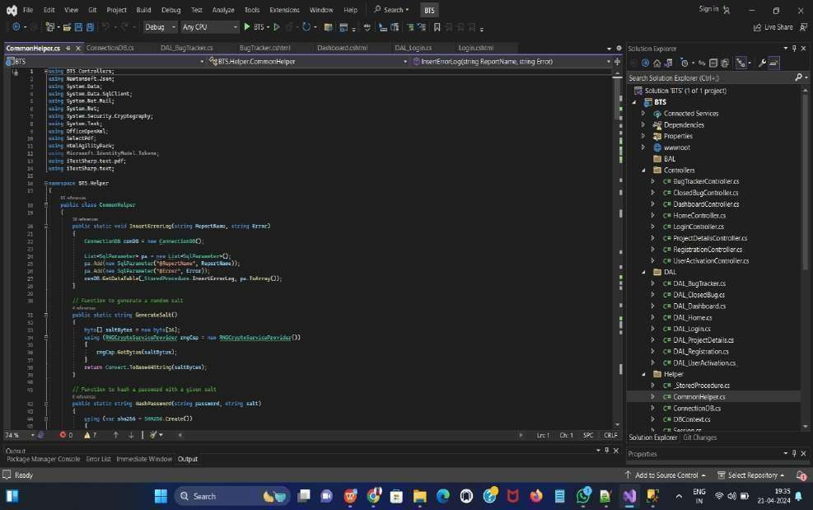
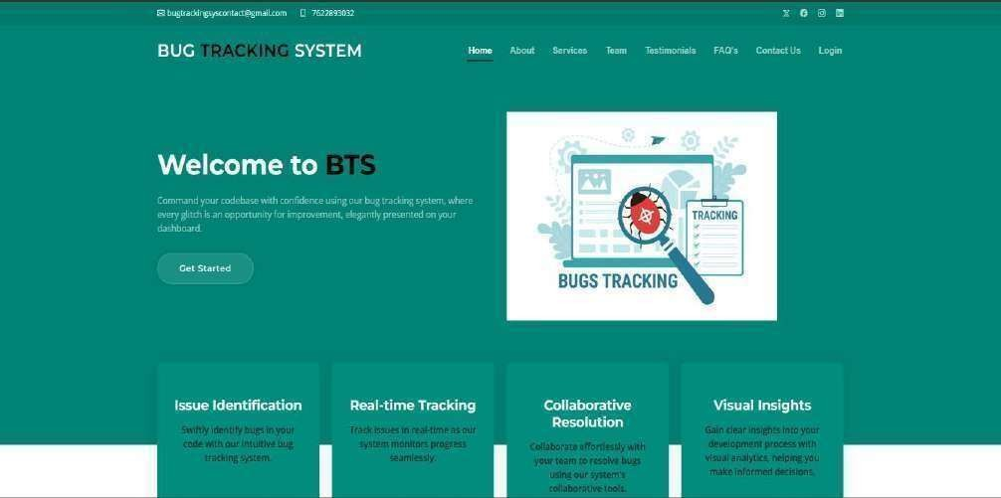
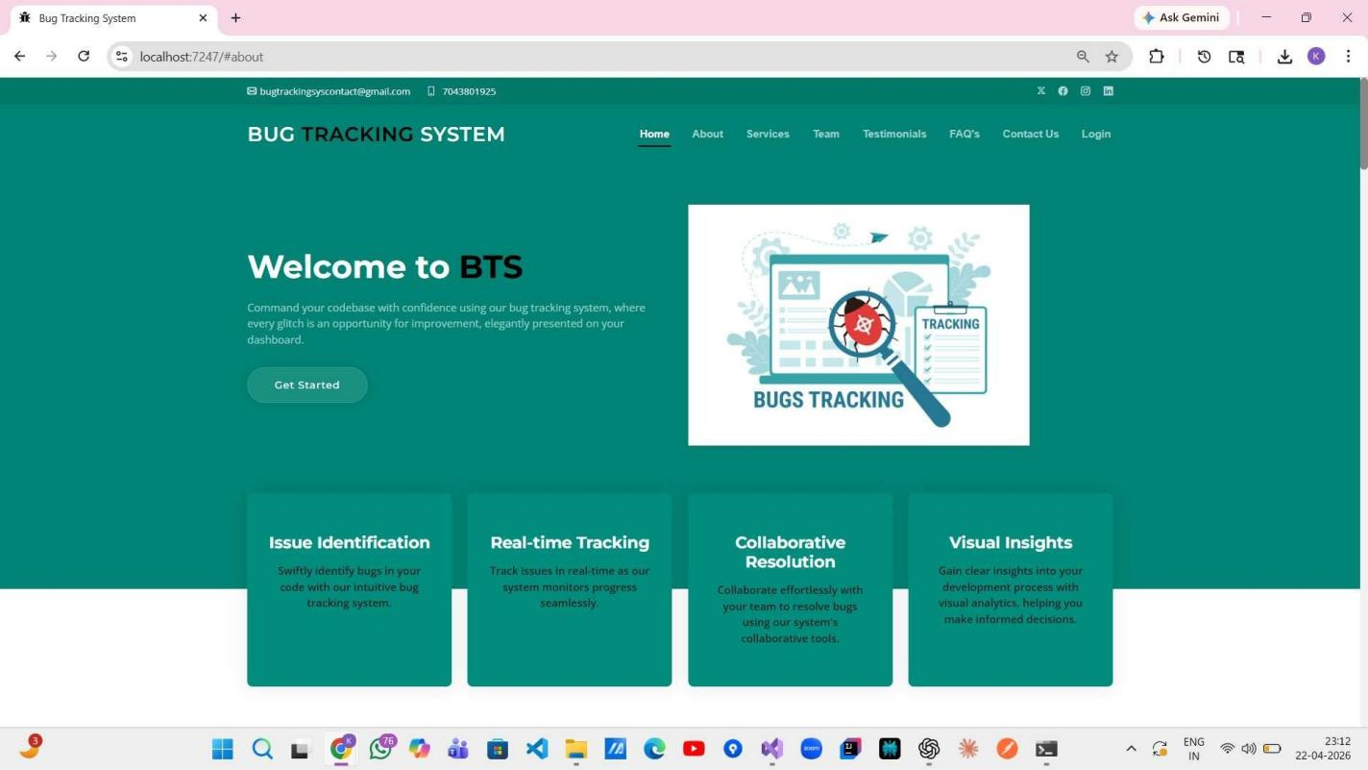
CommonHelper :

PROJECT SCREENSHOTS
Home Page :

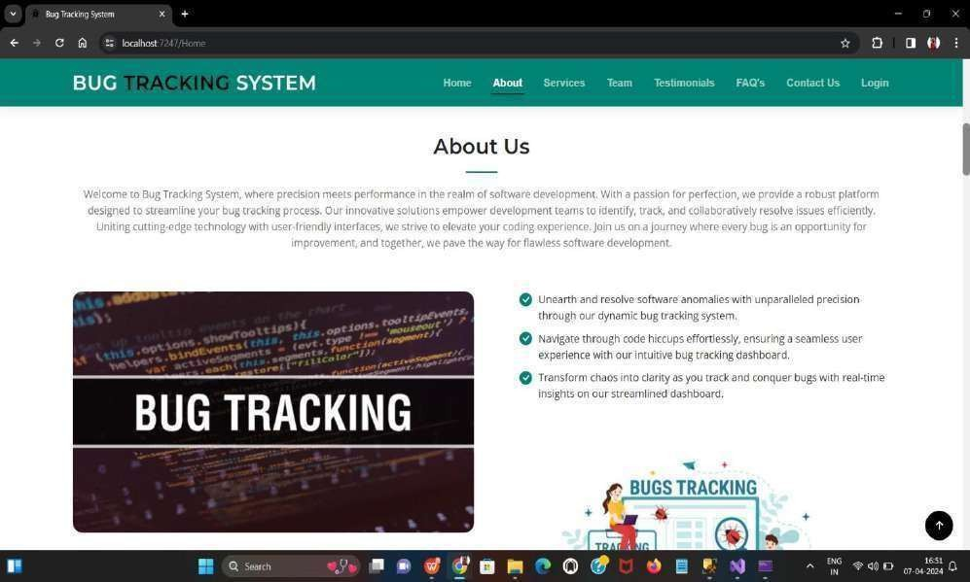
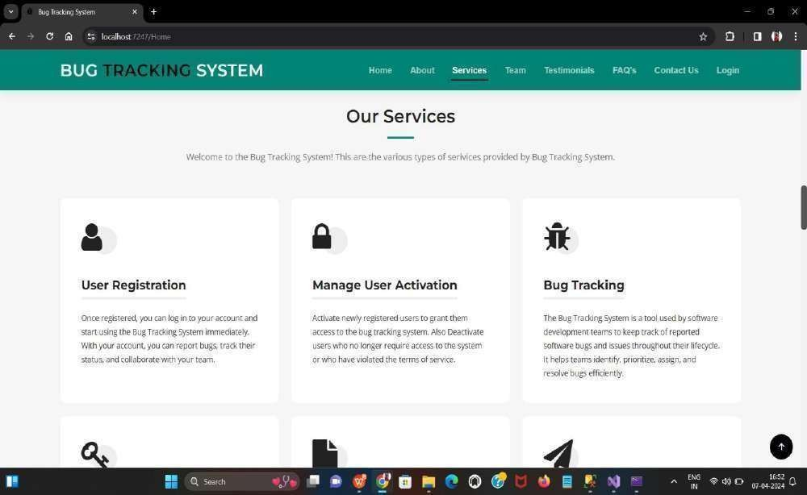
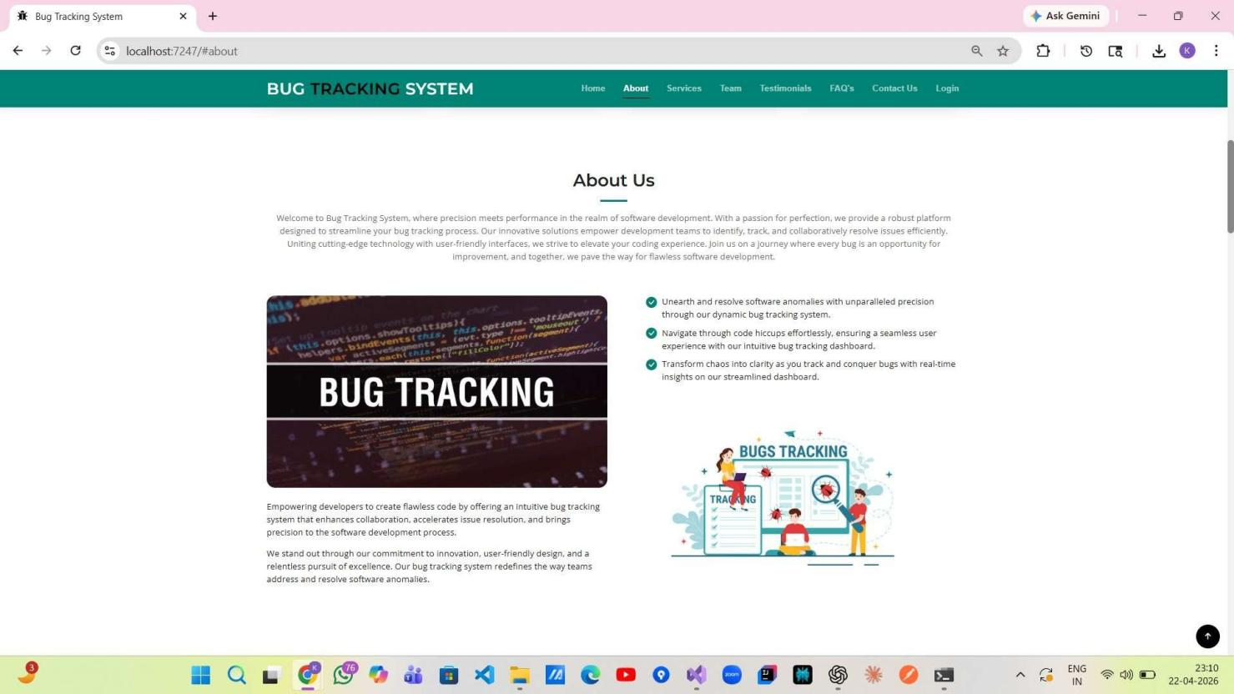
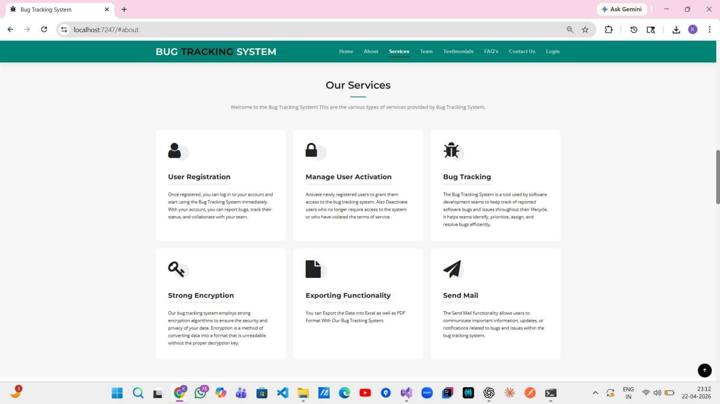
About Us

Our Services :

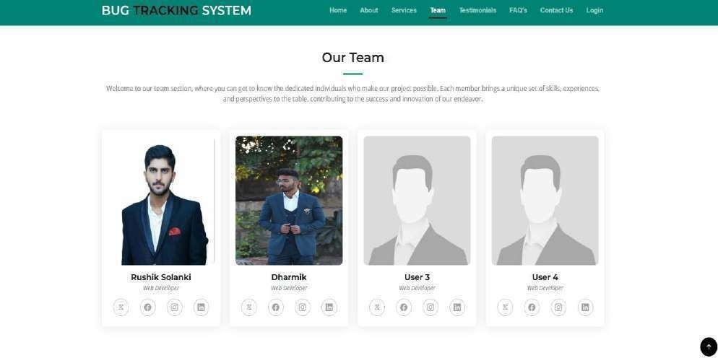

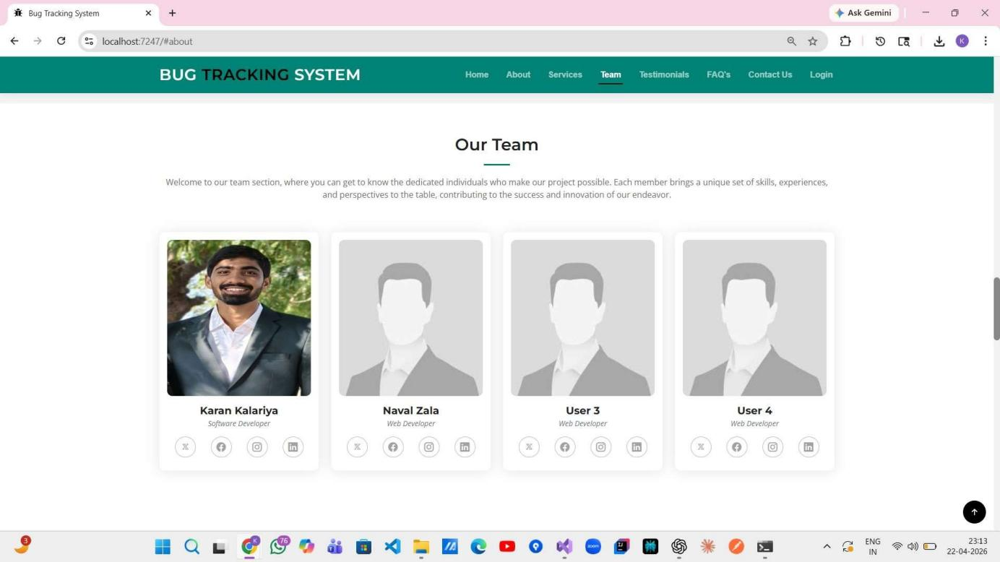

Our Team :

Testimonials :

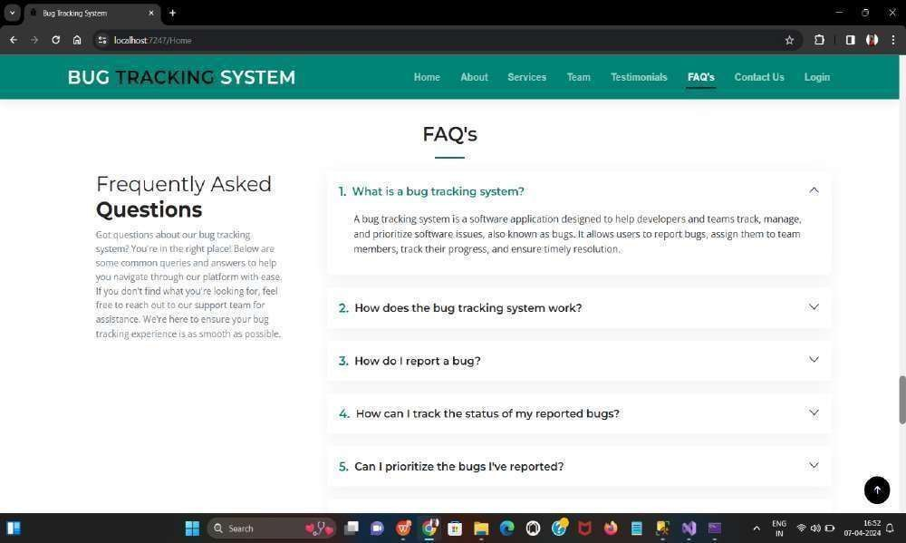
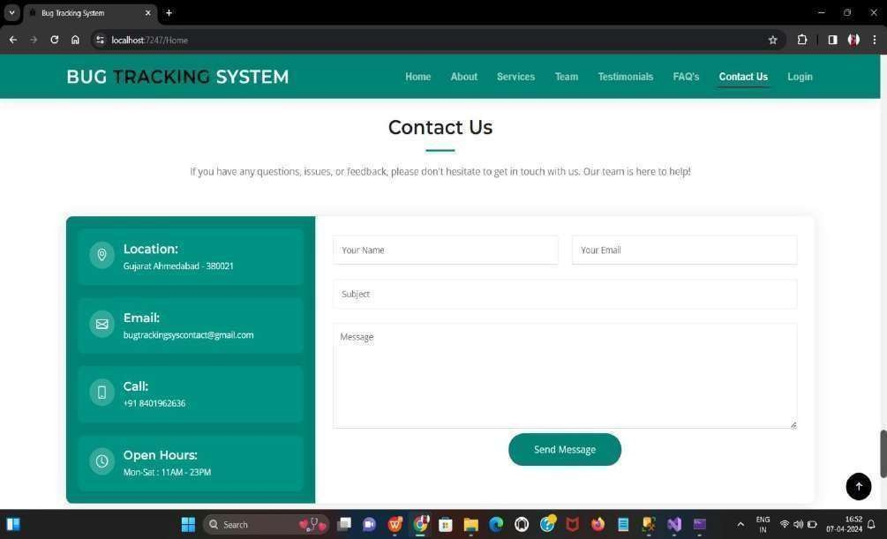
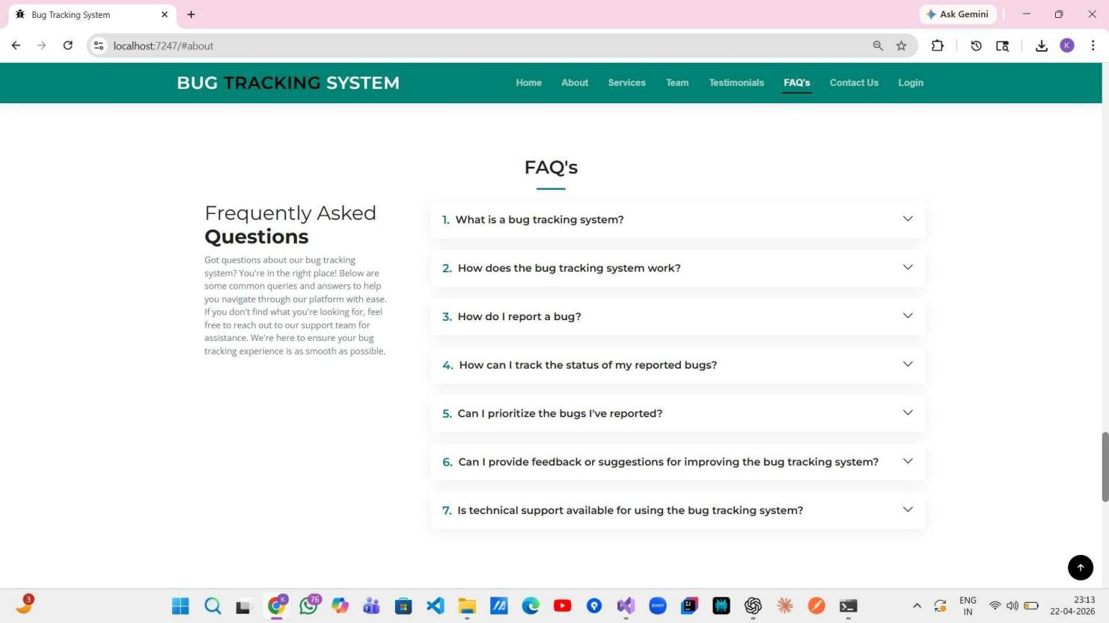
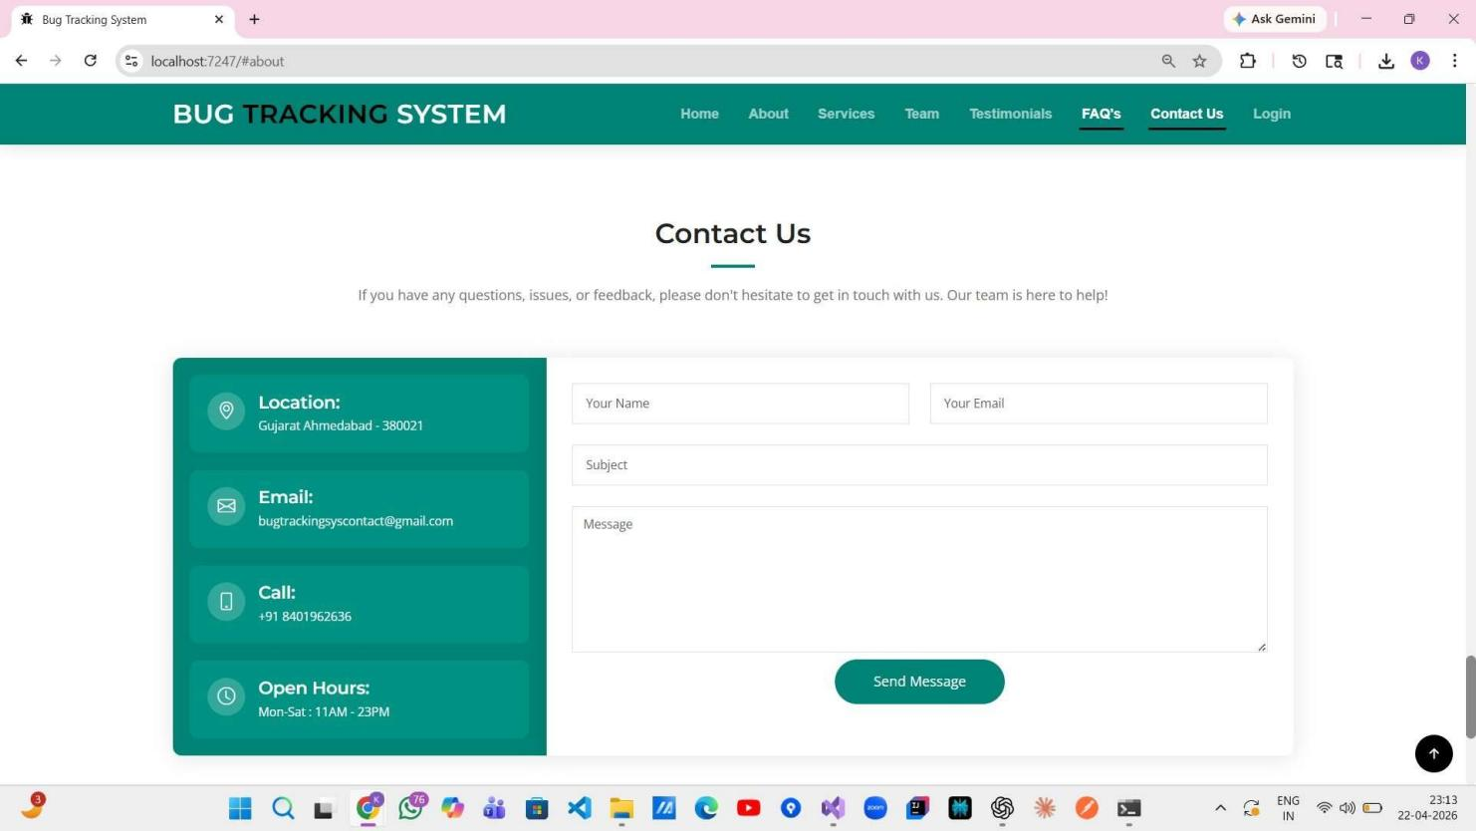
FAQ’s :

Contact Us :

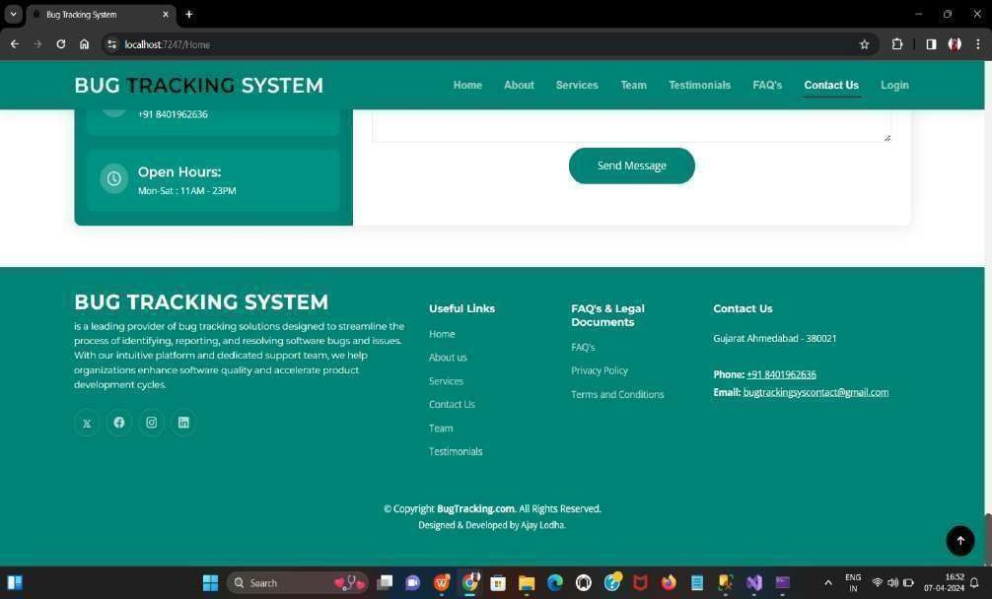
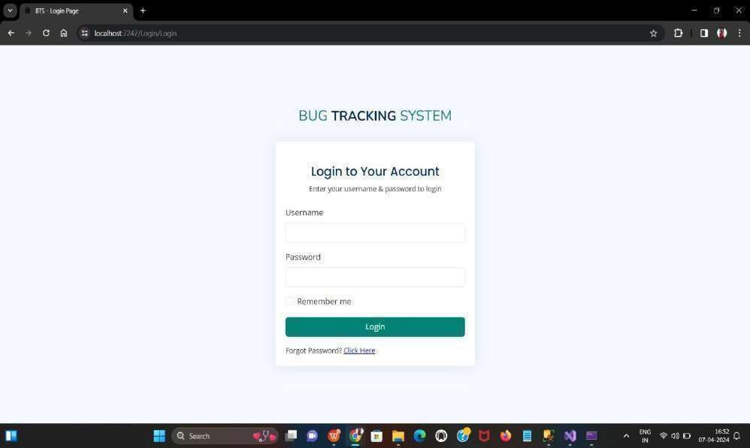
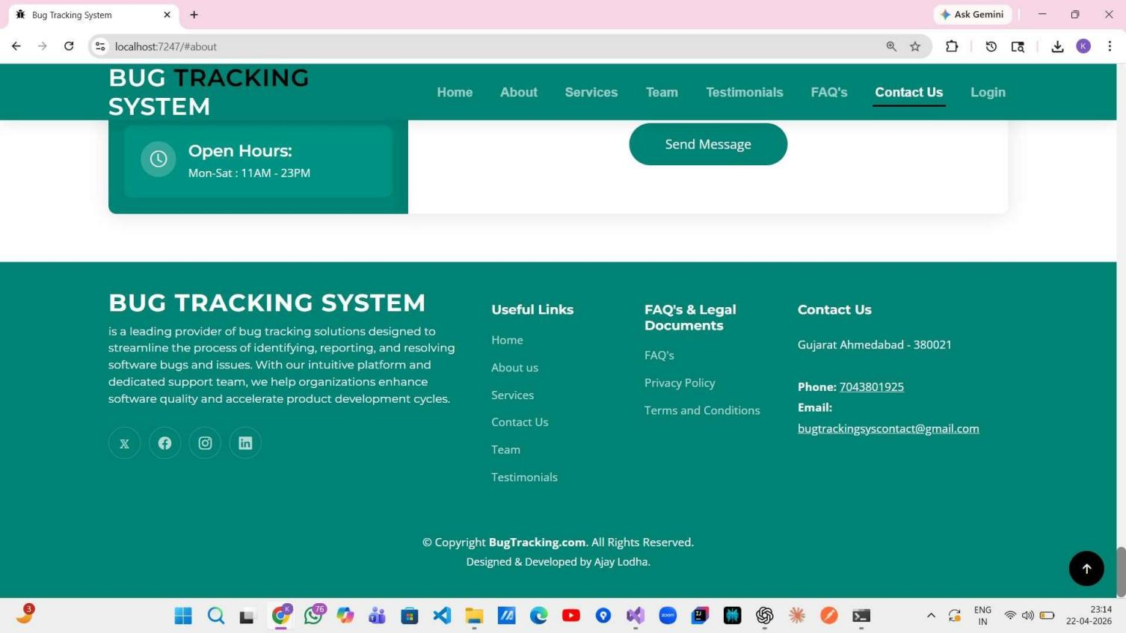
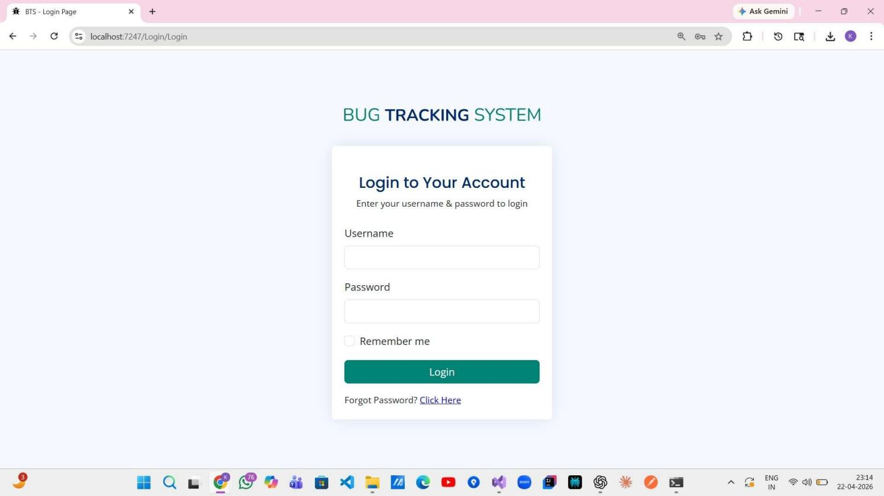
Footer :

Login :

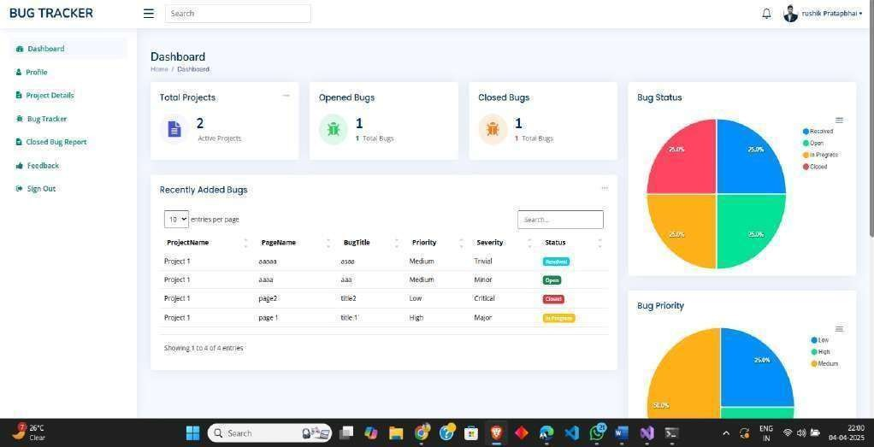
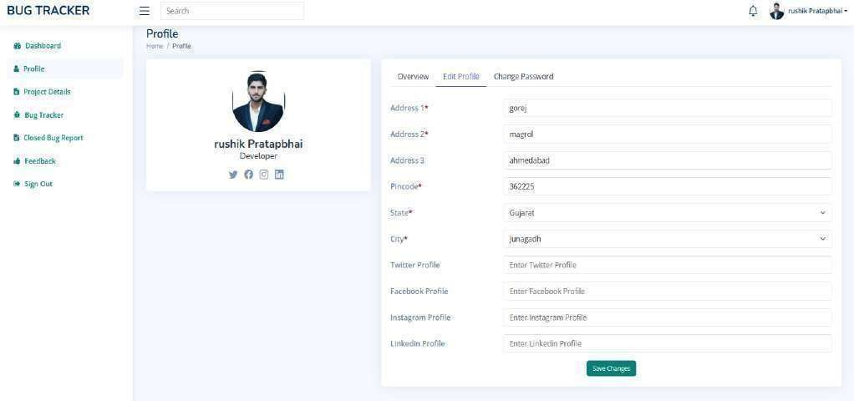
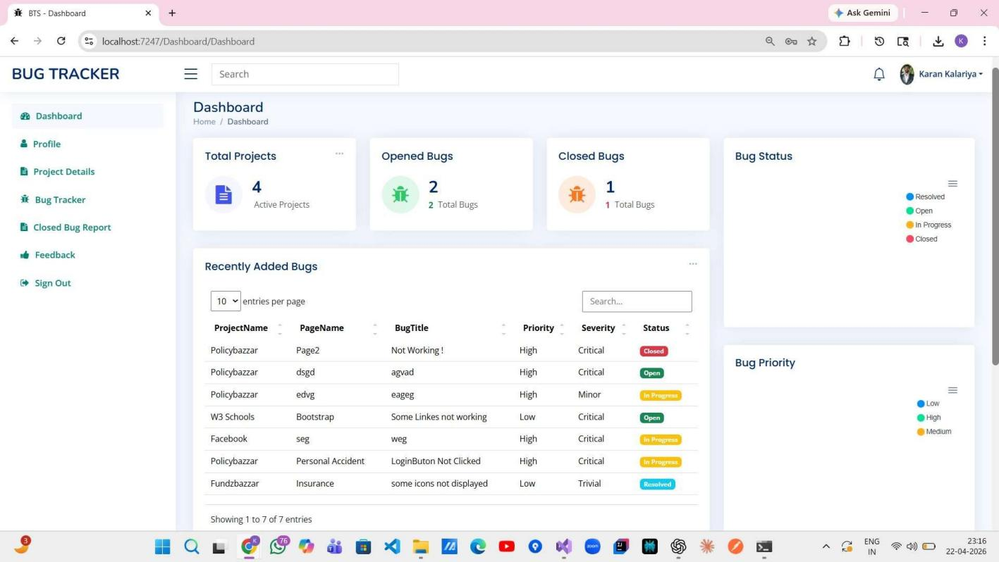
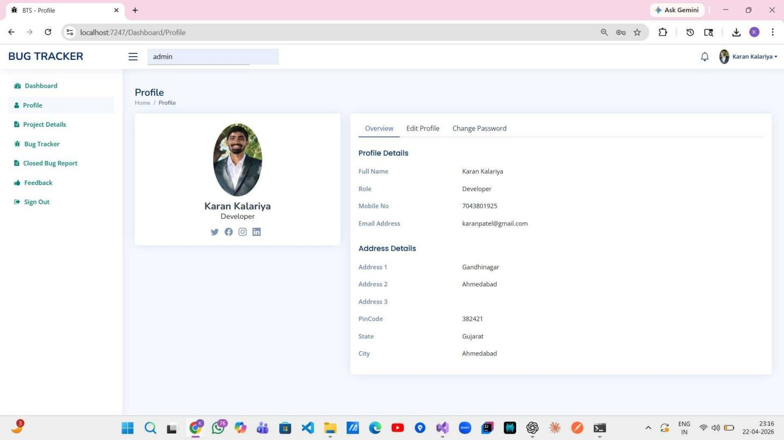
Dashboard :

User Profile :

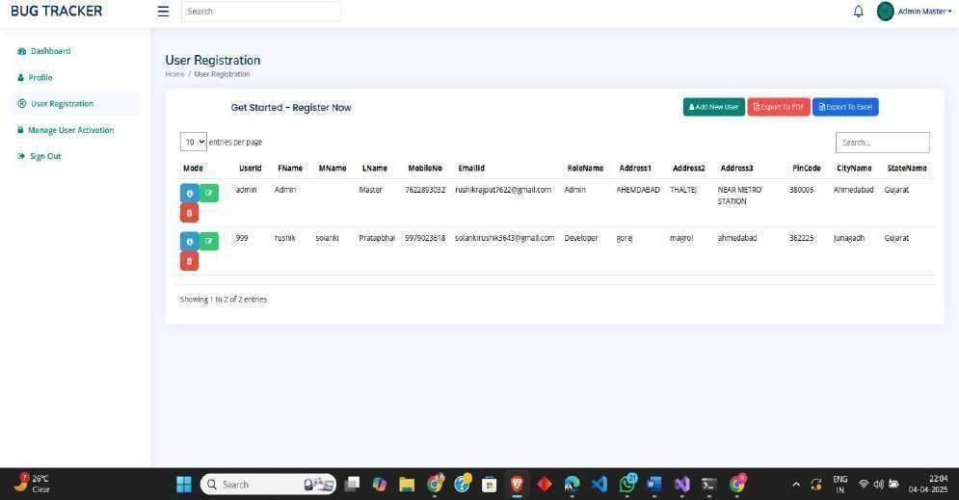
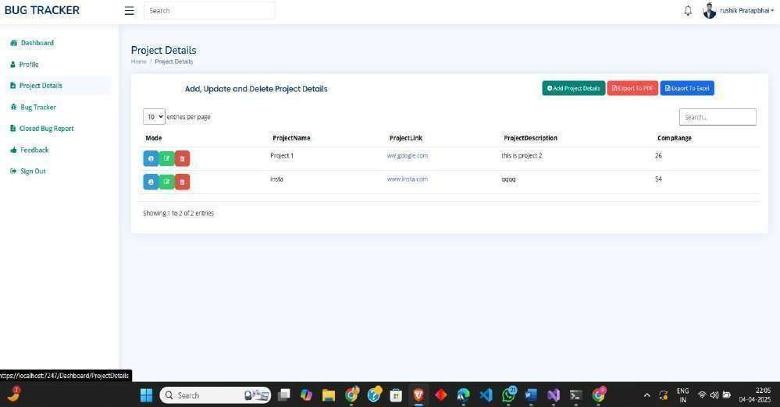
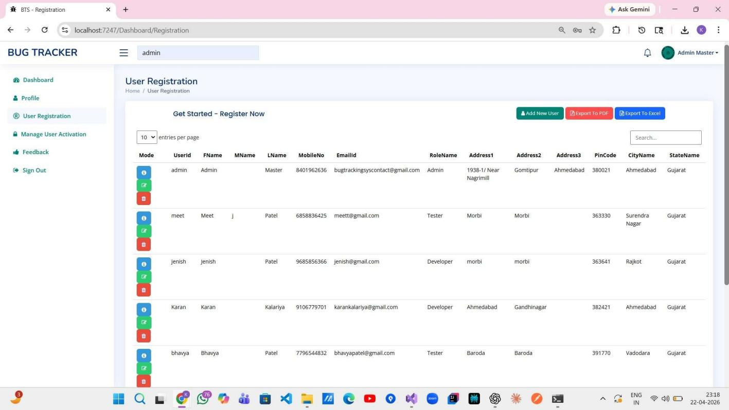
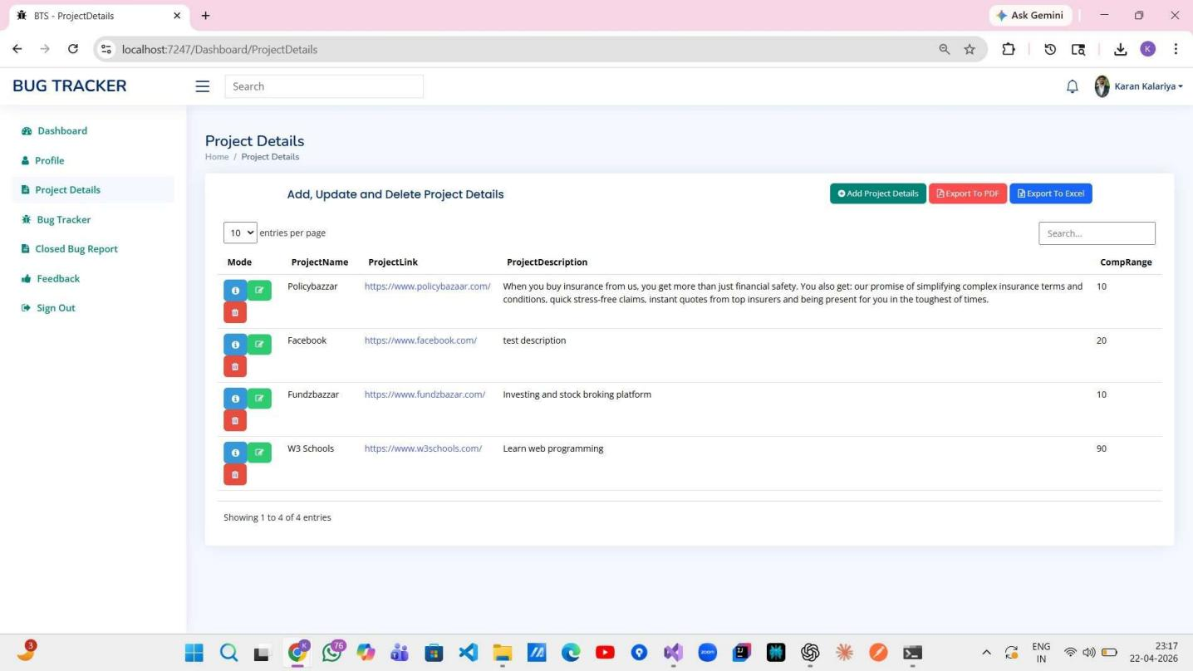

User Registration :

Project Details :

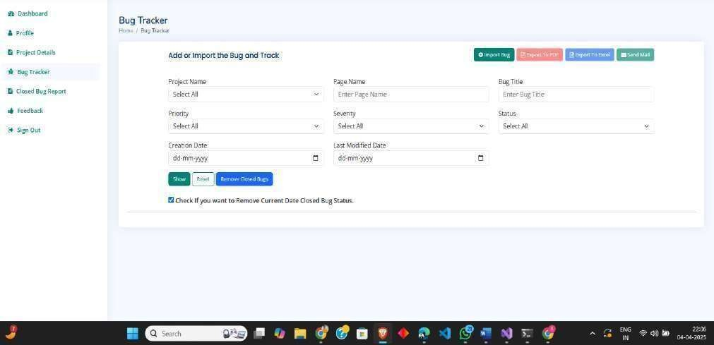
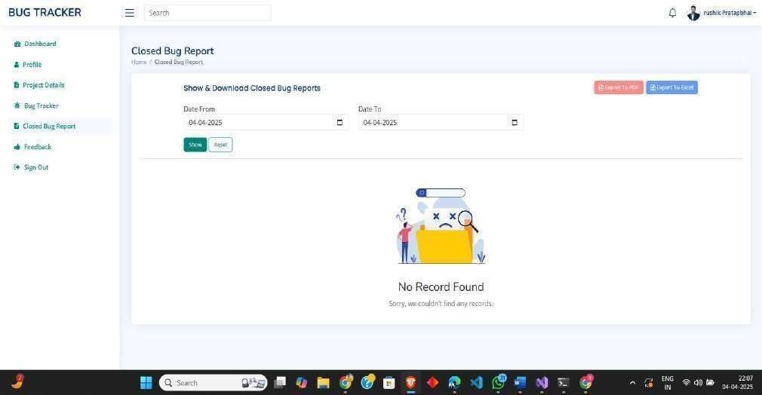
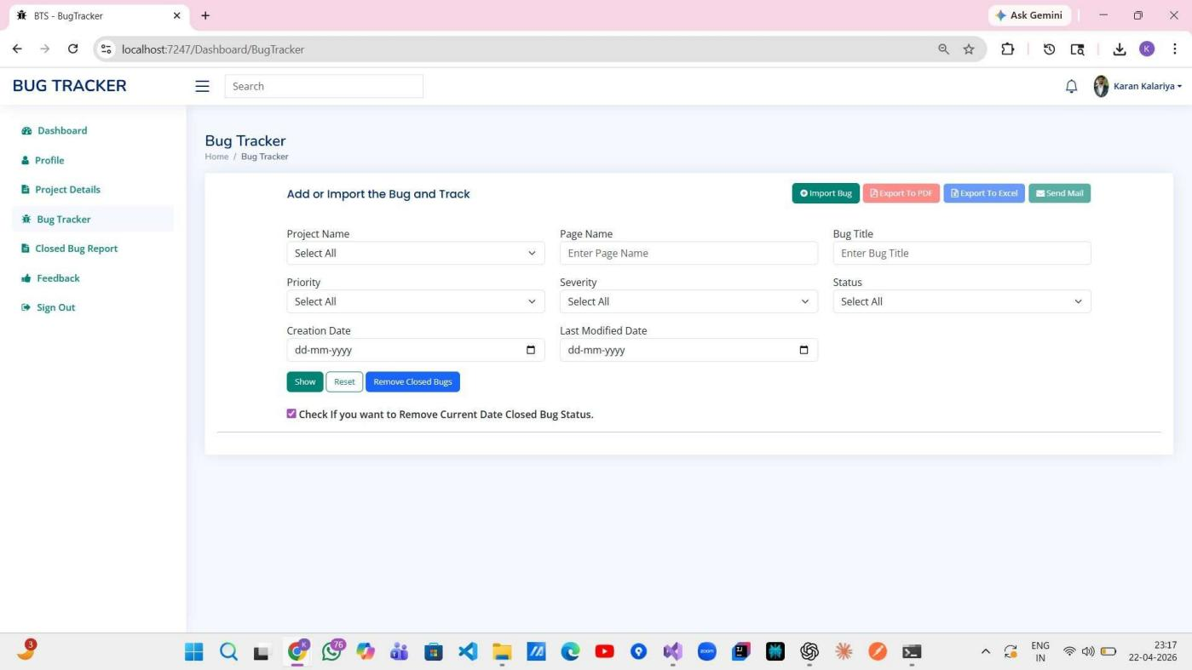
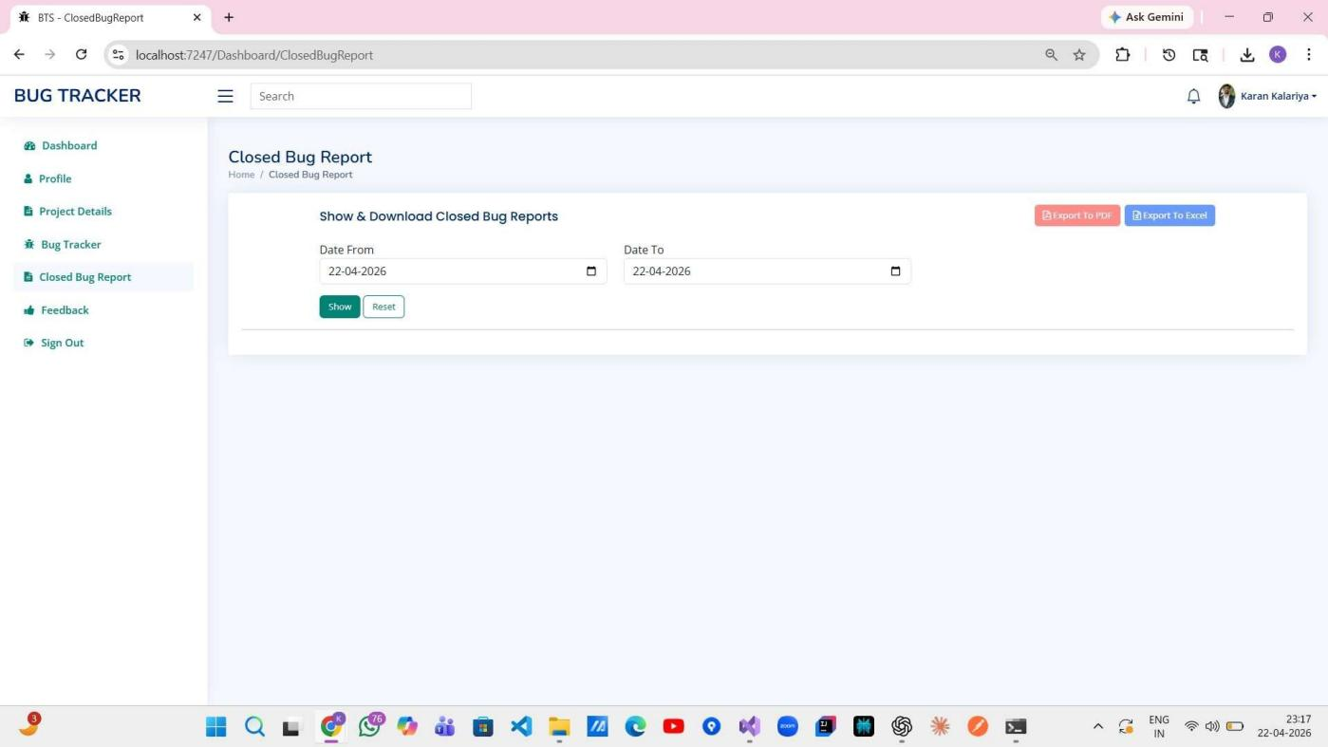
Bug Tracker :

Closed Bug Report :

CHAPTER 6

TESTING

TESTING PLAN
We are using white box testing because testers know the internal structure of software.
The development process repeats this testing sub-process a number of times for the following phases.

    - Unit Testing
    - Integration Testing
    - System Testing

Unit Testing : In unit testing for your bug tracking system, individual components, modules,
or classes are tested in isolation to verify that they function correctly and produce the expected results. Test cases are designed to cover various scenarios and edge cases, ensuring that each
unit behaves as intended and handles different inputs and conditions appropriately. Mock objects
or test doubles may be used to simulate dependencies and isolate the unit under test. Unit testing helps identify defects early in the development process, promotes code quality and maintainability, and facilitates refactoring and code reuse.

System Testing : System testing involves testing the entire bug tracking system as a whole to verify that all components work together seamlessly and meet the specified requirements and objectives. Test cases are designed to validate the system's functionality, performance, usability, security, and other quality attributes under realistic usage scenarios and conditions. System testing encompasses end-to-end testing of all system features, integration points, and user interactions, ensuring that the software behaves as expected from the user's perspective. It helps uncover defects, inconsistencies, and deficiencies in the overall system design and implementation, enabling stakeholders to make informed decisions and improvements before deployment.

Integration Testing : Integration testing focuses on testing the interactions and interfaces between different modules, components, or subsystems of the bug tracking system to ensure
that they integrate and function correctly together. Test cases are designed to validate data flow, communication protocols, and dependencies between integrated components, detecting any integration errors, interface mismatches, or compatibility issues. Integration testing may involve

various techniques such as top-down, bottom-up, and incremental integration, depending on the system architecture and development approach. It helps identify and resolve integration problems early in the development lifecycle, ensuring smooth integration and interoperability of system components.

TEST CASES :

Sr No. | Test Case | Inputs | Test Data | Expected Result | Actual Result | Pass OR  Fail
1. | Validate Login Form | Enter UserName & Password | Admin, Admin@22456 | Login Successfully | Login Successfully | Pass
2. | Recover Password | Enter UserName | Admin@22456 | Password Recover Successfully | Password Recover Successfully | Pass
3. | Enter Project Details | Enter ProjectName, ProjectLink, Description & Completion Range | Policybazzar, https://www.policybazaar.com/, Purchase Policy,  45% | Project Details Added Successfully | Project Details Added Successfully | Pass
4. | Enter Bug Details | Enter ProjectName, PageName, BugTitle, Priority, Severity, Status, CreationDate, LastModifiedDate, Description | Policybazzar, Health Insurance, Some Images Not Loaded, Medium, Trivial, Open,  27-03-2024, 27-03-2024, Please  Resolve ASAP | Bug Details Added Successfully | Bug Details Add Successfully | Pass
5. | Enter Bug Details [In Bulk] | Import Bug Details File which contains All Bug Inputs | All Bug Details Inputs | File Imported Successfully | File Imported Successfully | Pass
6. | Show Closed Bug Data | Enter Date From & Date To | 01-03-2024, 31-03-2024 | Show Details | Show Details | Pass
7. | Validate Login Form | Enter UserName & Password | testUser, test$3426 | Invalid UserId. So, Login Failed | Login Failed | Fail

Sr No. | Test Case | Inputs | Test Data | Expected Result | Actual Result | Pass OR  Fail
8. | Enter Bug Details [In Bulk] | Import Bug Details File which contains All Bug Inputs | All Bug Details Inputs [ If Any Data Missing in Excel or Something Is Invalid ] | File Imported Successfully | File Importing Failed | Fail
9. | Remove Closed Bug From the System | Check Checkbox, If you want to Remove the Current Date Closed Bugs | - | Bug Details Removed Successfully | Bug Details Removed Successfully | Pass
10. | Remove Closed Bug From the System | Check Checkbox, If you want to Remove the Current Date Closed Bugs | - | Bug Details Removed Failed Because Not Found Any Bug that’s in Closed Status | Bug Details Removed Failed | Fail

CHAPTER 7

Risk Management

RISK IDENTIFICATION
    - Scope Creep : This happens when the project keeps growing without clear boundaries. Imagine you're building a house, but suddenly people keep adding more rooms and features, and it becomes a mansion. It can make the project take much longer and cost more than originally planned.

    - Poor Requirements Gathering: If you don't understand exactly what the bug tracking system needs to do, it's like trying to bake a cake without a recipe. You might end up with something nobody wants to eat!

    - Technological Challenges: Sometimes the tools or technology you're using might not work well together, like trying to fit a square peg in a round hole. This can cause delays and frustration.

    - Lack of User Involvement: If the people who will actually be using the bug tracking system aren't involved in its development, you might end up building something that doesn't meet their needs. It's like designing a car without asking anyone who's going to drive it what they want.

    - Data Security Concerns: Imagine you're guarding a treasure chest, but you forget to lock it. Data security risks are like leaving that treasure chest wide open for anyone to take from.

    - Integration Issues: If the bug tracking system needs to work with other software or systems, like sending emails or connecting to a database, and they don't work well together, it's like trying to speak two different languages without a translator.

    - Resource Constraints: Sometimes you might not have enough people, time, or money to do everything you want. It's like trying to build a sandcastle with only a teaspoon and a bucket.
Lack of Testing: Not testing the bug tracking system thoroughly is like driving a car without brakes. You might not notice anything wrong until it's too late!

    - Change Management: When things change during the project, like new requirements or team members leaving, it can be like trying to steer a ship in a storm without a compass. You might end up going in circles.

    - User Adoption Challenges: Even if you build a great bug tracking system, if people don't want to use it, it's like buying a fancy new toy that nobody wants to play with.

RISK ASSESSMENT

Scope Creep :
  - Likelihood: Moderate
  - Impact: High
  - Assessment: Scope creep could occur if additional features are requested during development, leading to delays and increased costs.

Poor Requirements Gathering :
  - Likelihood: Low
  - Impact: High
  - Assessment: Inadequate understanding of user needs could result in a bug tracking system that doesn't meet expectations, causing rework and dissatisfaction.

Technological Challenges :
  - Likelihood: Moderate
  - Impact: Moderate
  - Assessment: Integrating different technologies and tools may present challenges, potentially causing delays in development.

Lack of User Involvement :
  - Likelihood: Moderate
  - Impact: High

  - Assessment: Without continuous input from end-users, the bug tracking system may not align with their needs, leading to decreased adoption and effectiveness.

Data Security Concerns :
  - Likelihood: Low
  - Impact: High
  - Assessment: Failure to address data security adequately could result in data breaches, compromising sensitive information and damaging trust.

Integration Issues :
  - Likelihood: Moderate
  - Impact: Moderate
  - Assessment: Difficulties in integrating the bug tracking system with existing tools or systems may disrupt workflows and reduce efficiency.

Resource Constraints :
  - Likelihood: High
  - Impact: High
  - Assessment: Limited resources in terms of time, budget, or personnel could lead to compromised quality, missed deadlines, or incomplete functionality.

Lack of Testing :
  - Likelihood: Moderate
  - Impact: High
  - Assessment: Inadequate testing may result in undetected bugs and errors, diminishing the reliability and usability of the bug tracking system.

Change Management :
  - Likelihood: Moderate
  - Impact: Moderate
  - Assessment: Changes in project requirements, team composition, or external factors may disrupt the development process, requiring adjustments and potentially causing delays.

User Adoption Challenges :
  - Likelihood: Moderate
  - Impact: High
  - Assessment: Resistance from users or inadequate training may impede the adoption of the bug tracking system, reducing its effectiveness in managing and resolving issues.

RISK MONITORING & CONTROL
- Regular Reviews and Updates : Set up regular meetings or check-ins to review the project's progress and any new risks that may have emerged. It's like checking the weather forecast before going on a picnic to make sure you're prepared for any unexpected rain.

- Risk Response Plans : Develop clear plans for how to deal with each identified risk if it occurs. It's like having a fire escape plan in case of emergencies - you hope you never need it, but it's there just in case.

- Communication Channels : Ensure open communication channels among team members and stakeholders so that everyone can quickly raise any concerns or new risks they notice. It's like having a group chat where everyone can share updates and ask questions.

- Track Progress : Keep track of how risks are being managed and whether the actions taken are effective. It's like keeping score in a game to see if your team's strategy is working or if you need to change tactics.

- Adaptability : Be prepared to adjust plans and strategies as needed based on changing circumstances or new information. It's like being a chef who tastes the soup as it cooks and adds more seasoning if needed to make sure it tastes just right.

CHAPTER 8

CONCLUSION

In conclusion, the development and implementation of the Bug Tracking System (BTS) have been a significant endeavor aimed at enhancing the efficiency, transparency, and quality of software development processes. Through meticulous planning, collaboration, and execution, the project has successfully delivered a robust platform that addresses the critical need for systematic bug tracking and management.

As the Bug Tracking System is deployed and integrated into the software development ecosystem, it is imperative to maintain a proactive approach to support, monitoring, and enhancement. Regular feedback loops, performance evaluations, and iteration cycles will enable the BTS to evolve in response to changing requirements, technological advancements, and user needs, ensuring its continued relevance and effectiveness in facilitating efficient bug tracking and resolution.

In essence, the Bug Tracking System project represents a significant milestone in the pursuit of excellence in software development practices. By leveraging technology, collaboration, and best practices, the BTS not only mitigates risks and accelerates bug resolution but also fosters a culture of innovation, learning, and continuous improvement, driving organizational success in delivering superior software products to customers.

CHAPTER 9

REFERENCES

- Draw.io : https://app.diagrams.net/
- W3 Schools : https://www.w3schools.com/
- C# Corner
https://www.c-sharpcorner.com/
- Stack Overflow https://stackoverflow.com/
- Tutorials Point https://www.tutorialspoint.com/index.htm
- Javatpoint https://www.javatpoint.com/
- GitHub https://github.com/

