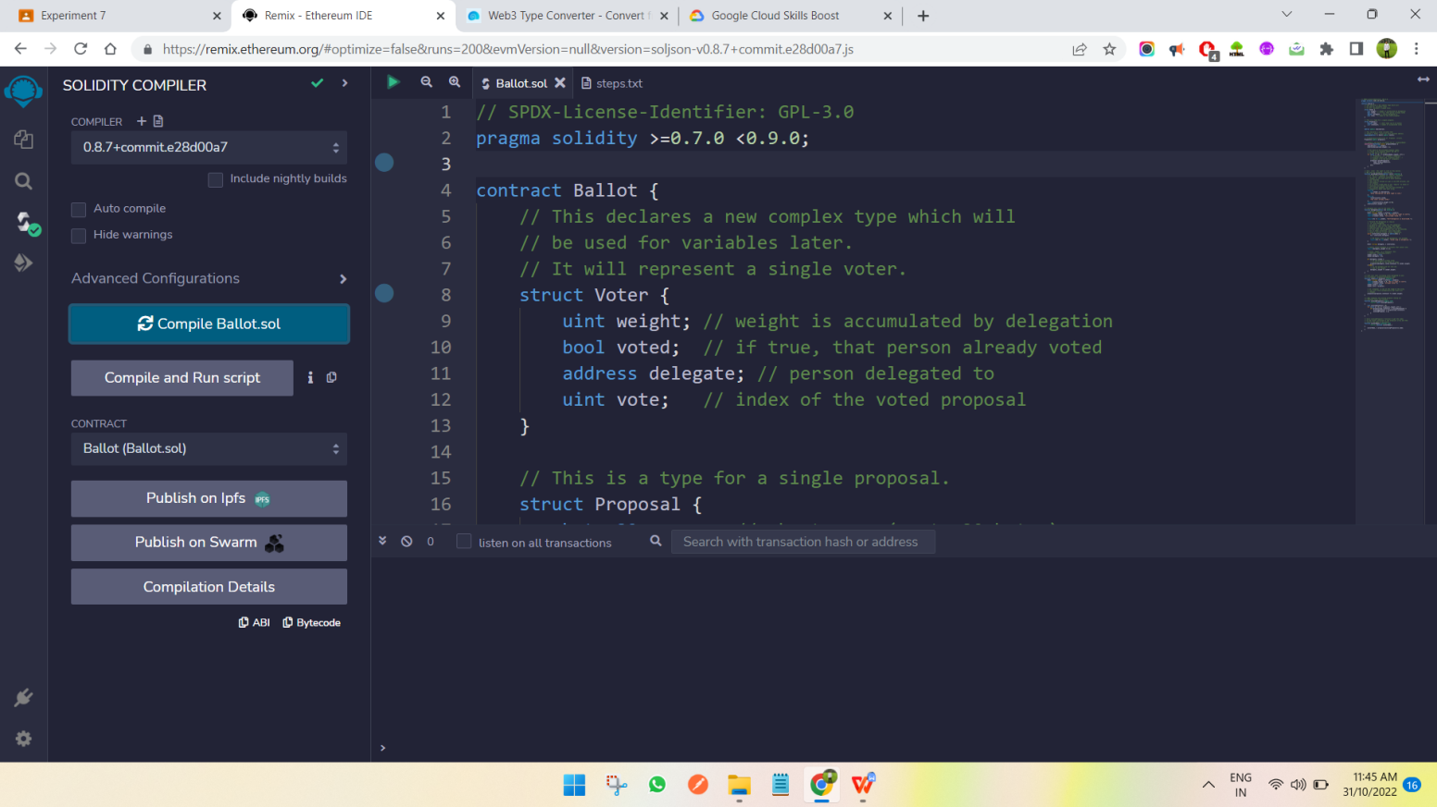

Figure 7.1 : First complie the smart contract in remix id.

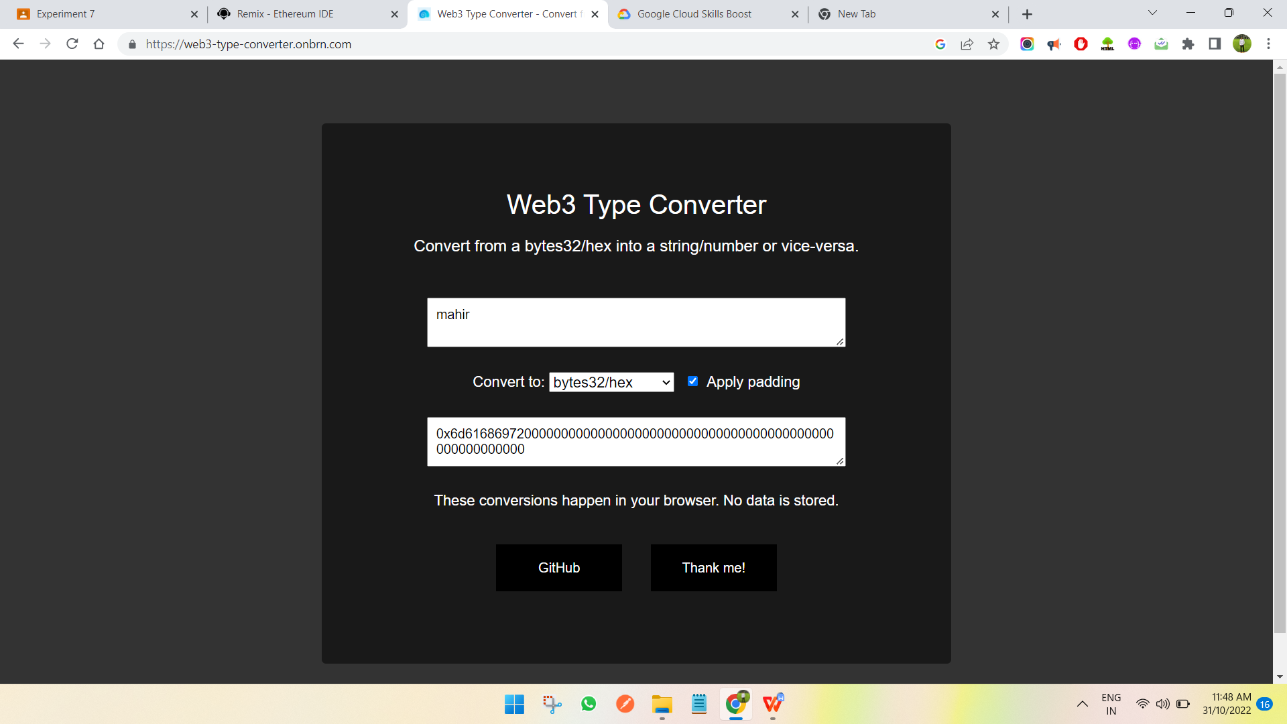

Figure 7.2 : Now convert the string into byte32 address because we have described input format as byte32 inside the smart contract.

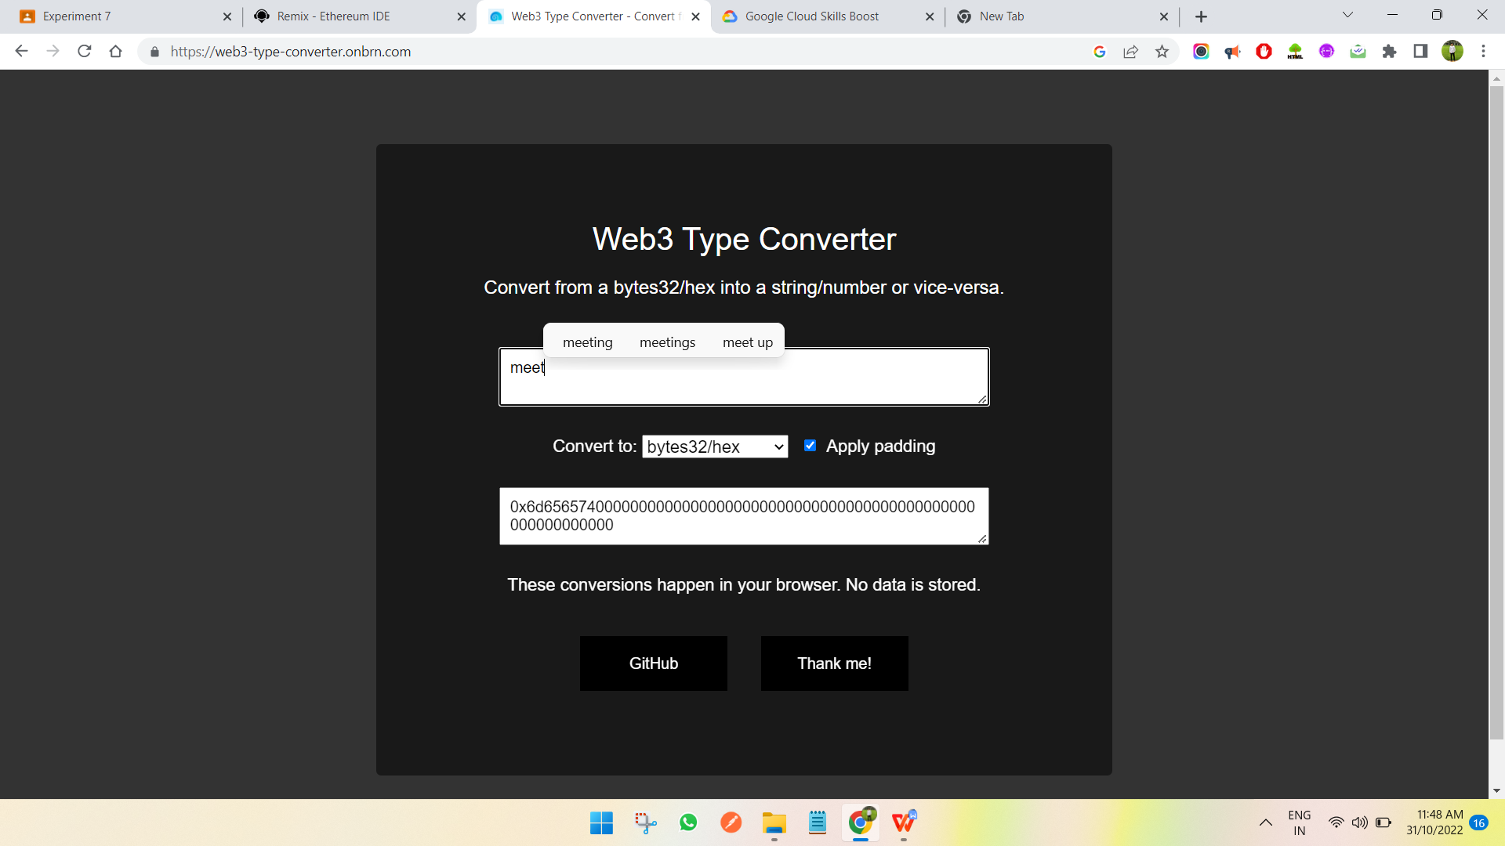

Figure 7.3 : Next, this is one more voter in the evoting system.

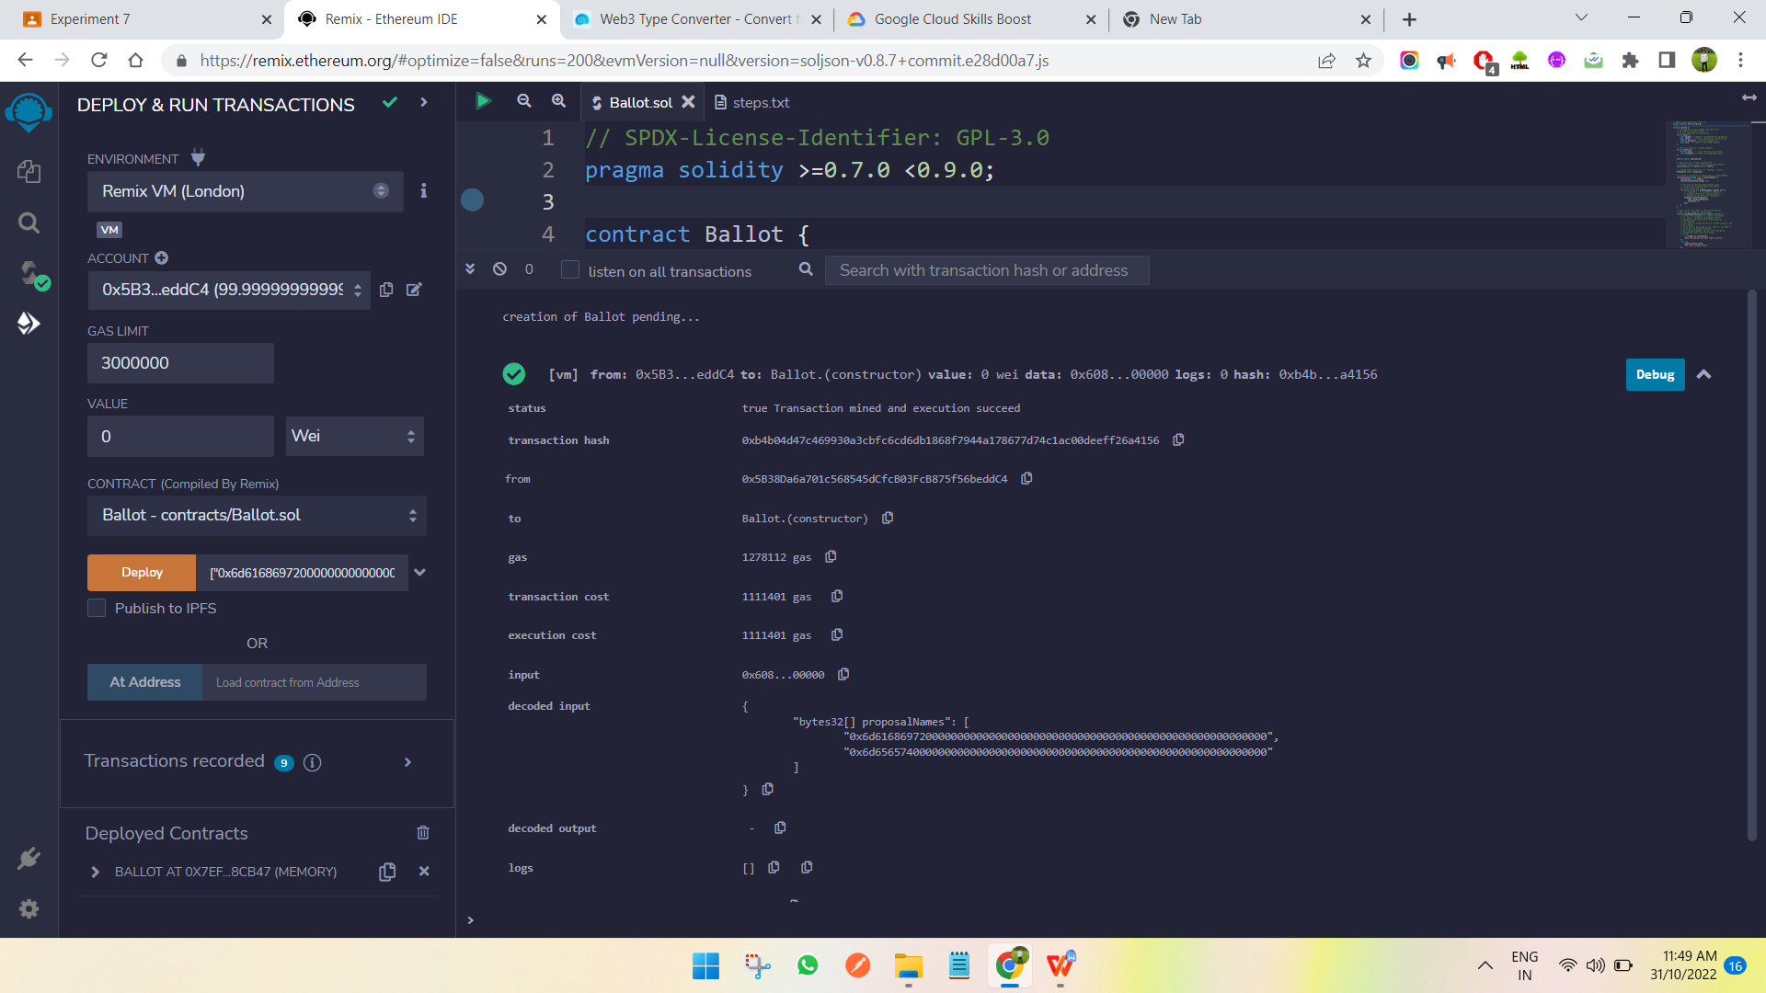

Figure 7.4 : Enter both the address into the blank box near deploy button then click the deploy button and it will deploy the smart contract.

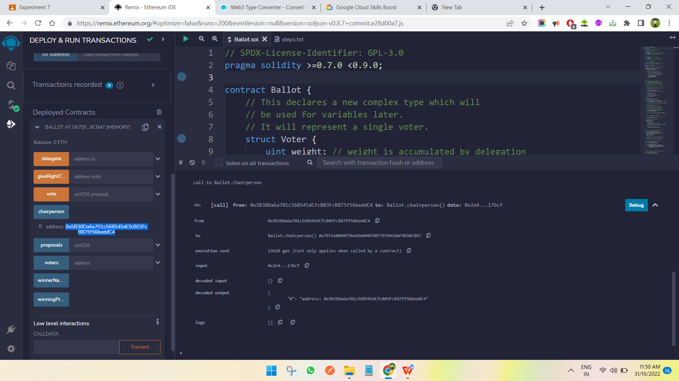

Figure 7.5 : Now call the chairman function as shown above. It will give you the address of chairman.

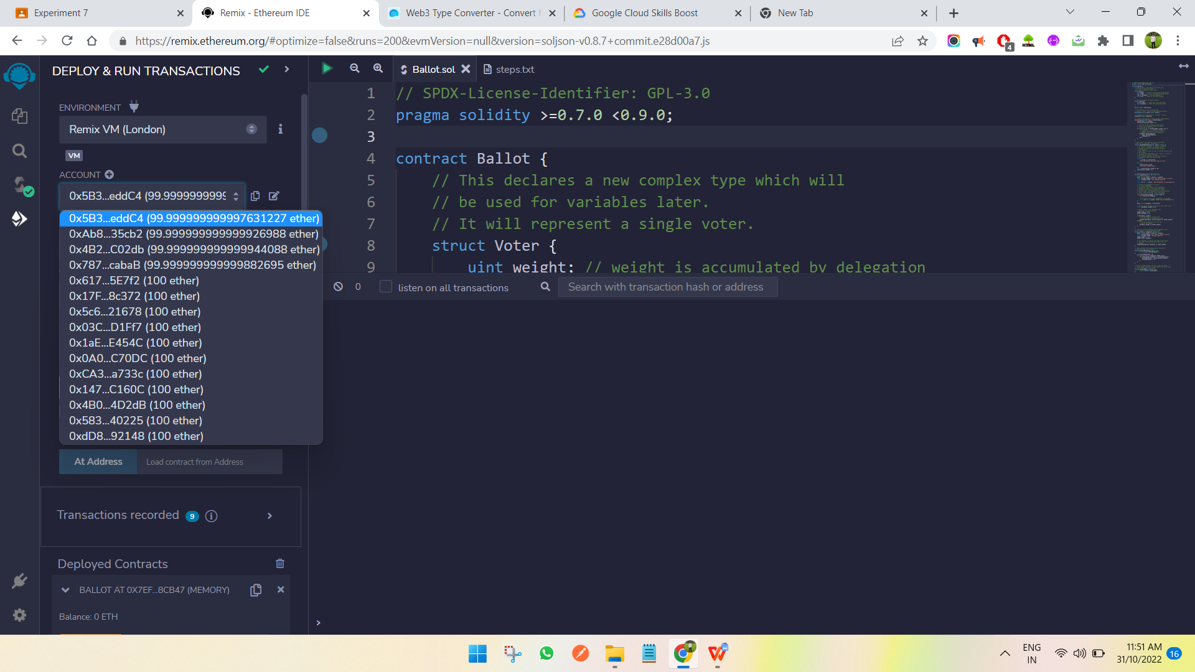

Figure 7.6 : Here is the list of accounts in the remix id. First one is the chairman. Now we will give authority to next 3 accounts to vote.

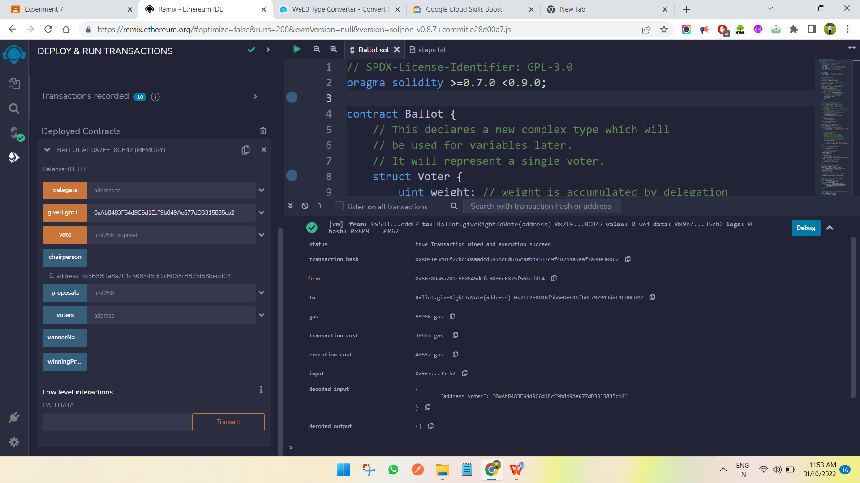

Figure 7.8 : Here we have given the authority for voting to 2nd account by entering the account address into the box and click giverighttovote button. Only chairman can giv the authority. Repeat the same process for 3rd and 4th account.

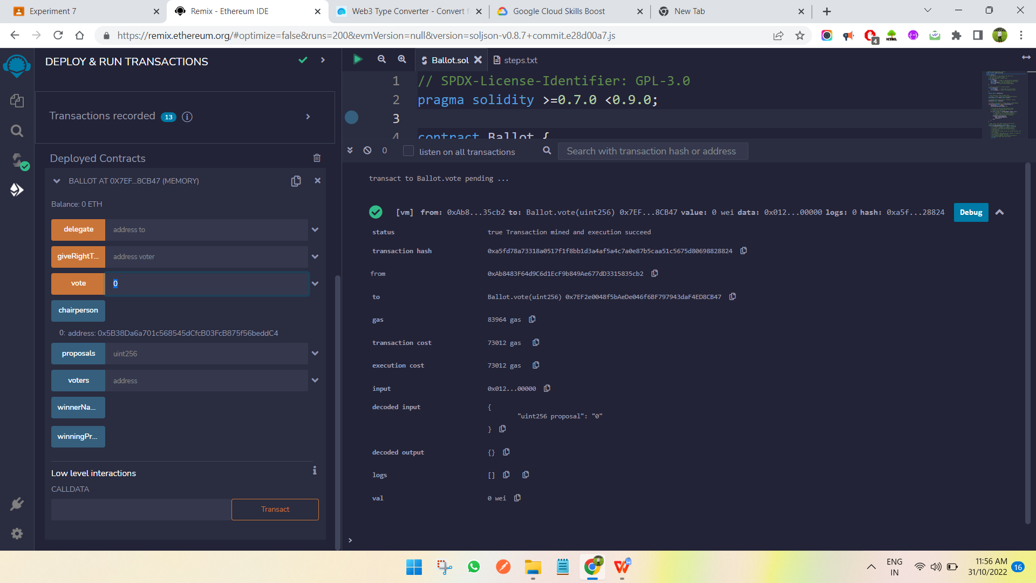

Figure 7.9 : Now switch to 2nd account and enter 0(‘mahir’) inside the blank box near vote button and click the vote button it will initiate the transaction to vote for that candidate.

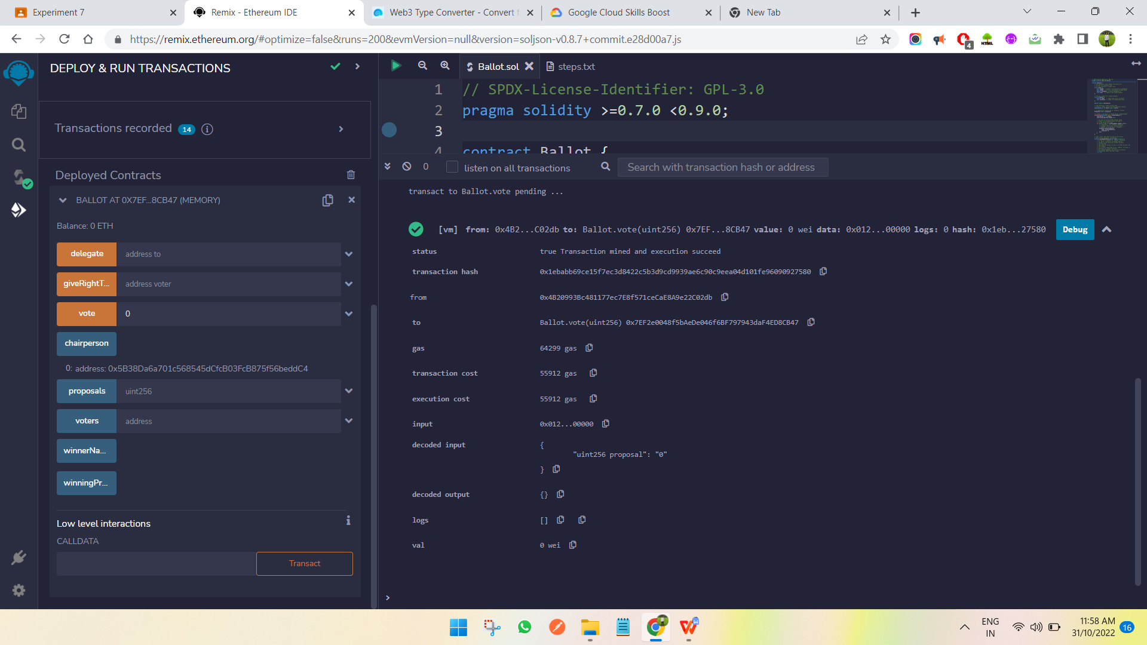

Figure 7.10 : Now switch to 3rd account and vote for 0.

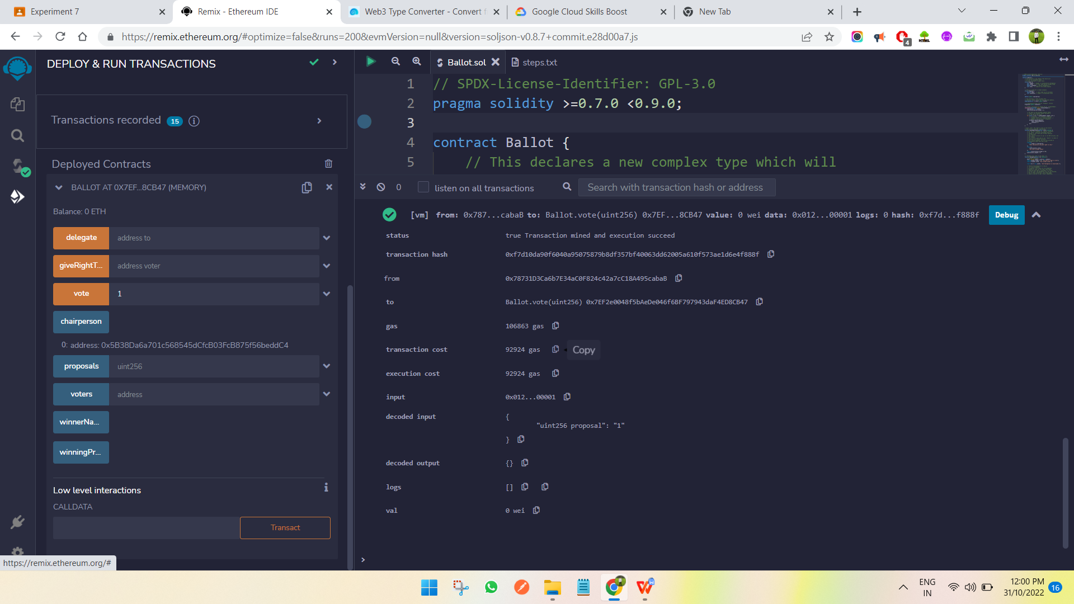

Figure 7.11 : Lastly switch to 4th account and enter 1(‘meet’) and vote it.

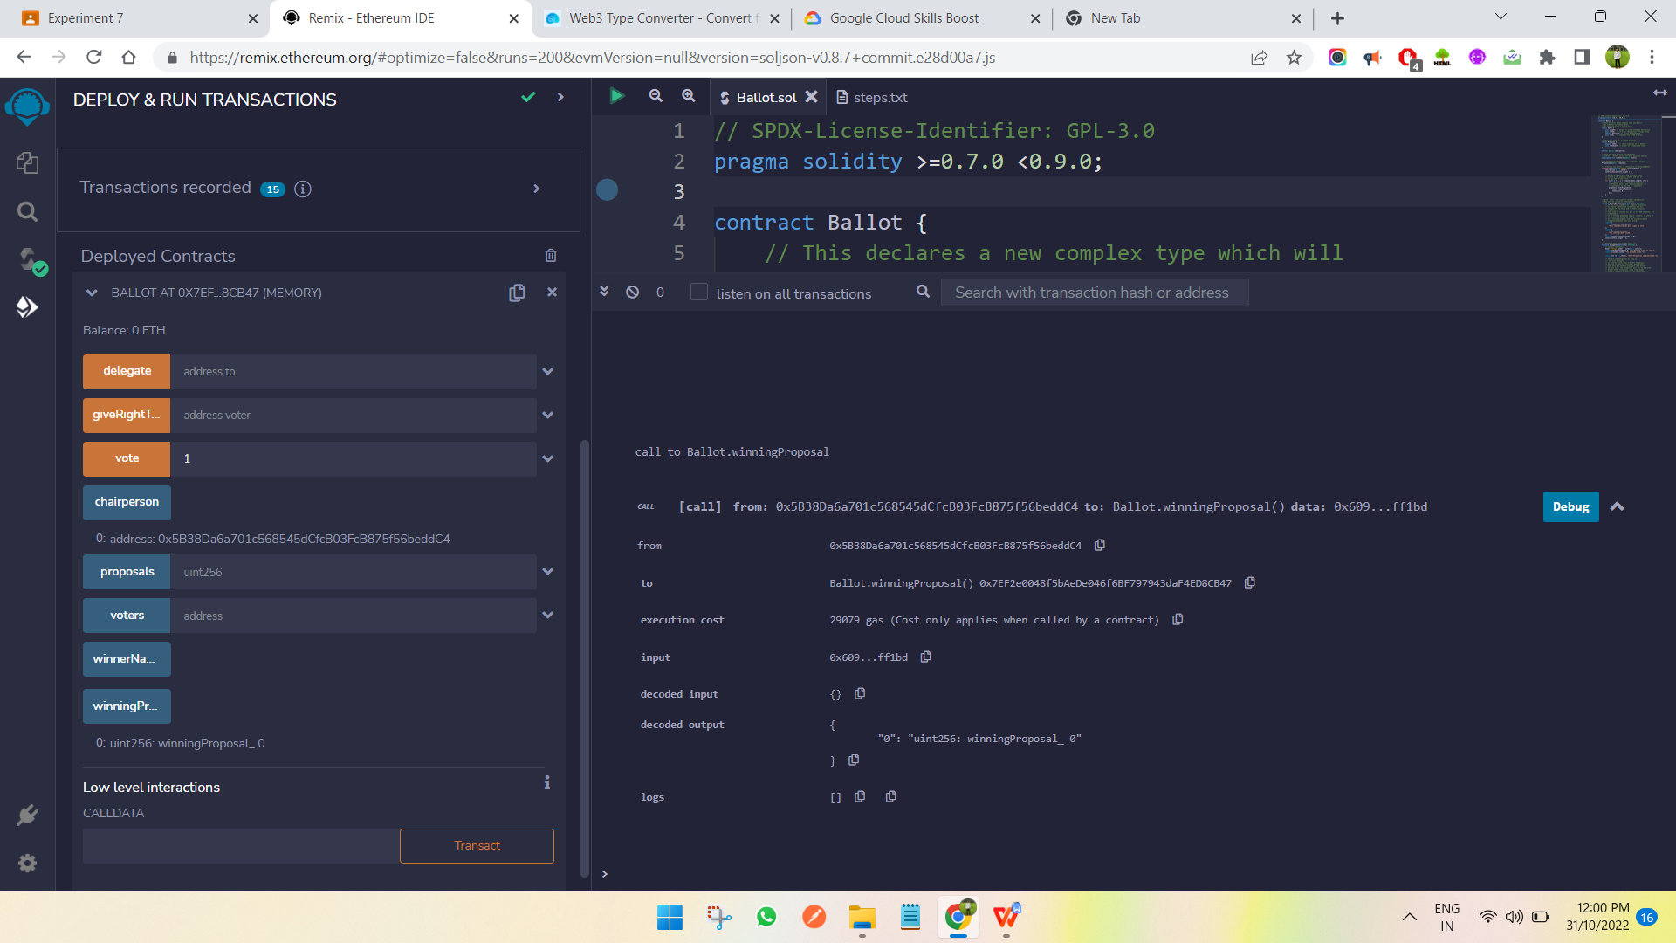

Figure 7.12 : Now call the winning function to see who won.

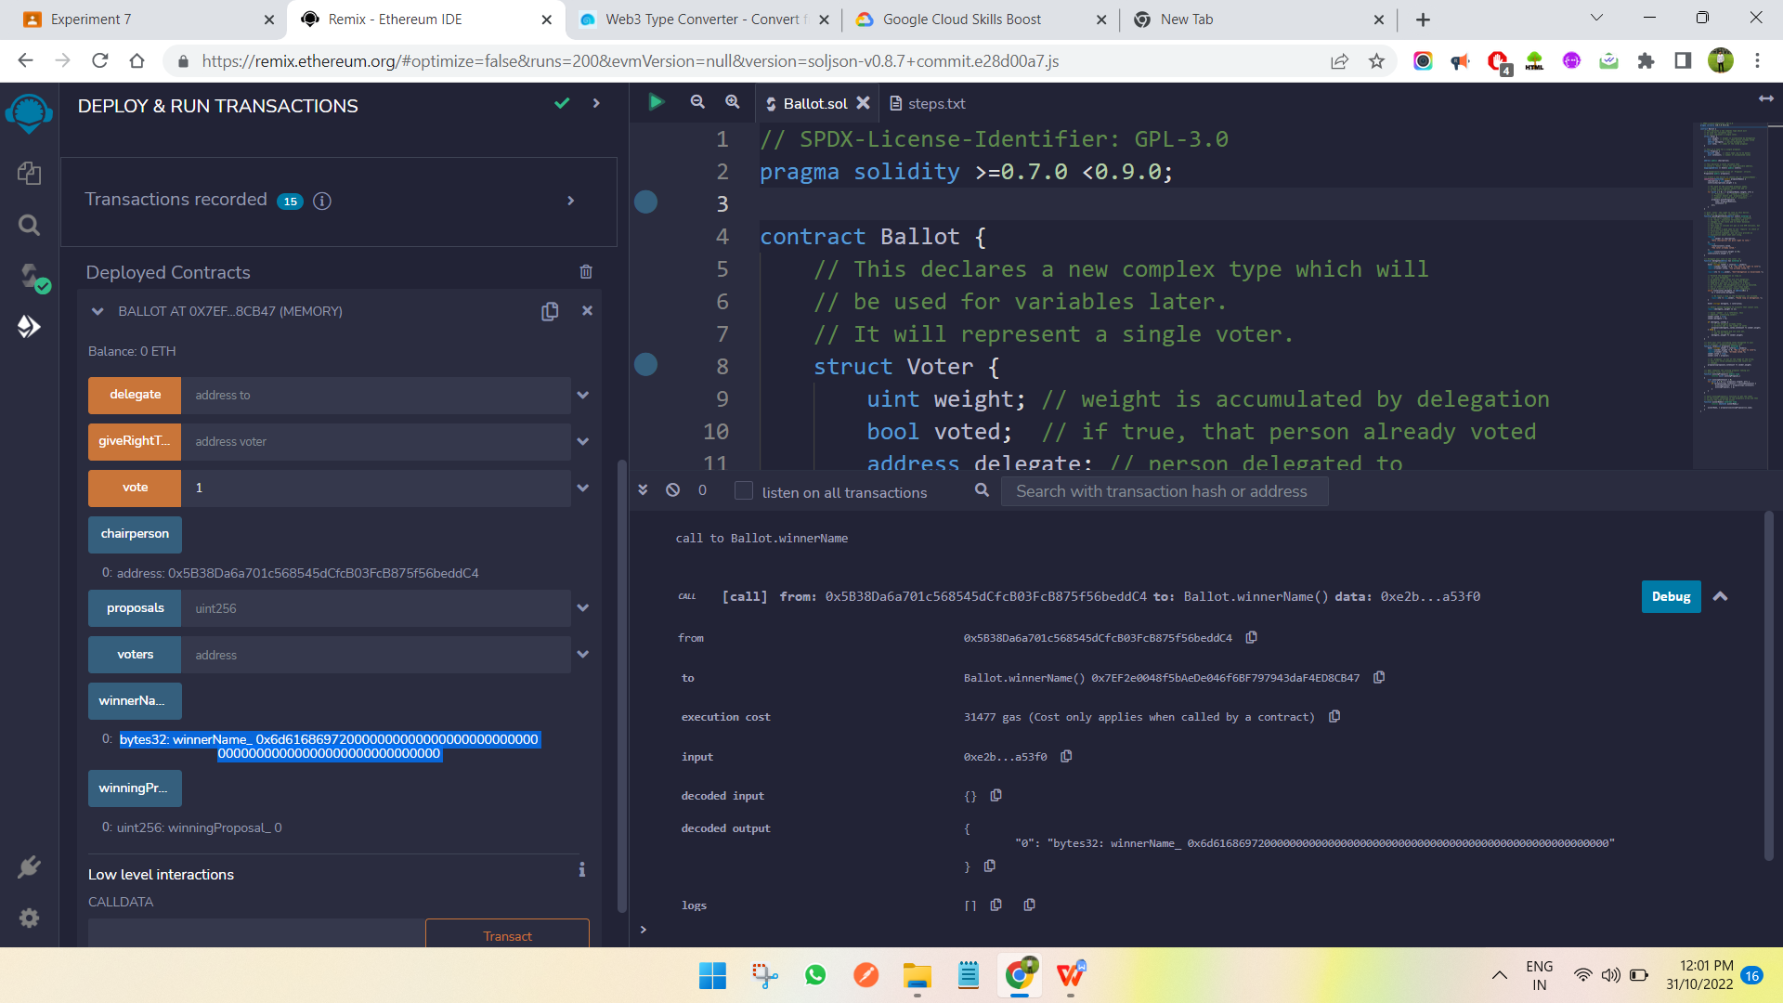

Figure 7.13 : Finally call the winning name function to see the name(byte32) of the person who won.