Members:

1) Name: Ananta Akash Podder

Registration No.: 2016331102

2) Name: Md. Mahir Labib

Registration No.: 2016331031

Screenshots:

 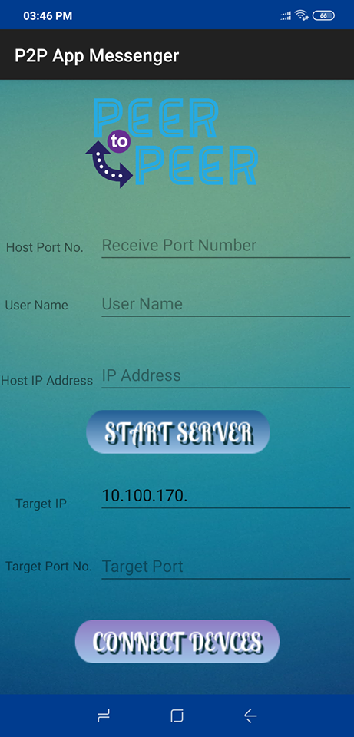

**Splash Screen Server&Client**

**Interface**

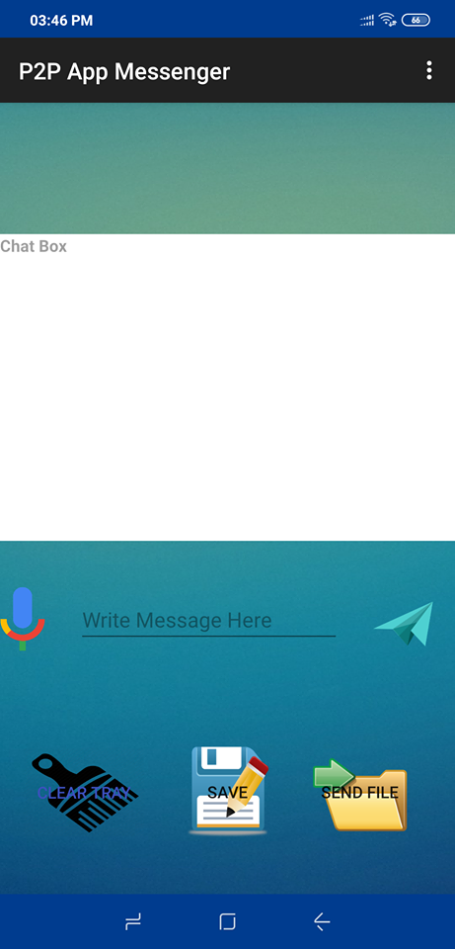 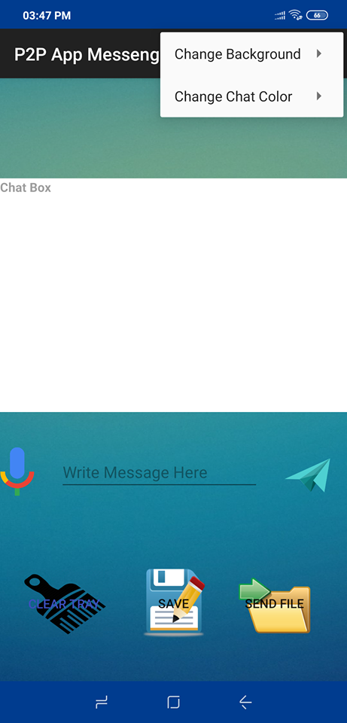

**Chat Interface Menu Options**