1. Datatypes

Code:

using System;

namespace Application

{

    class Program

    {

        static void Main(string[] args)

        {

          Console.WriteLine("Integer: \n");

          snippet0();

          snippet1();

          snippet2();

          snippet3();

          snippet4();

          snippet5();

          Console.WriteLine("\nDouble: \n");

          snippet6();

          snippet7();

          snippet8();

          Console.WriteLine("\nDecimal: \n");

          snippet9();

          snippet10();

          snippet11();

          snippet12();

        }

        static void snippet0(){

          int a = 1, b = 10,c = a+b;

          Console.WriteLine("Add: " + c);

          c = a-b;

          Console.WriteLine("Subtract: " + c);

          c = a\*b;

          Console.WriteLine("Multiply: " + c);

          c = a/b;

          Console.WriteLine("Divide: " + c);

        }

        static void snippet1(){

        //showing BODMAS

          int a = 1, b = 10,c = 4,d = a+b\*c;

          Console.WriteLine($"Snippet1: {d}");

        }

        static void snippet2(){

          int a = 1, b = 10,c = 4,d = (a+b)\*c;

          Console.WriteLine($"Snippet2: {d}");

          d = (a + b) / c;

          Console.WriteLine($"Snippet2: {d}");

        }

        static void snippet3(){

          int a = 1, b = 10,c = 4,d = (a+b)/c,e = (a+b)%3;

          Console.WriteLine($"The Quotient is: {d}");

          Console.WriteLine($"The Remainder is: {e}");

        }

        static void snippet4(){

          Console.WriteLine($"The minValue for int is: {int.MinValue} & the maxValue for int is: {int.MaxValue}");

        }

        static void snippet5(){

          int max = int.MaxValue;

          int overflowbydumbmachine = max + 3;

          Console.WriteLine($"The Value for int is: {overflowbydumbmachine}");

        }

        static void snippet6(){

          double a = 1, b = 10,c = 4,d = (a+b)/c;

          Console.WriteLine($"Double ans: {d}");

        }

        static void snippet7(){

          Console.WriteLine($"The minValue for double is: {double.MinValue} & the maxValue for double is: {double.MaxValue}");

        }

        static void snippet8(){

          double third = 1.0 / 3.0;

          Console.WriteLine(third);

        }

        static void snippet9(){

          Console.WriteLine($"The minValue for Decimal is: {decimal.MinValue} & the maxValue for Decimal is: {decimal.MaxValue}");

        }

        static void snippet10(){

          Console.WriteLine("Double : " + 1.0 / 3.0);

          Console.WriteLine("Decimal : " + 1.0M / 3.0M);

        }

        static void snippet11(){

          //calculate the area of circle by using PI in math

          double radius = 2.5;

          Console.WriteLine($"The Area of Circle is {Math.PI\*radius\*radius} cm2\n");

        }

        static void snippet12(){

        }

    }

}

Output:

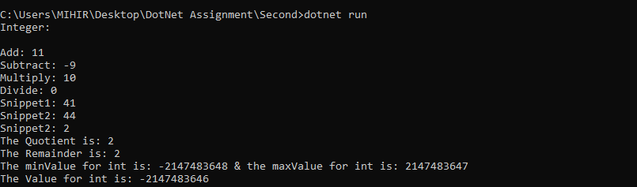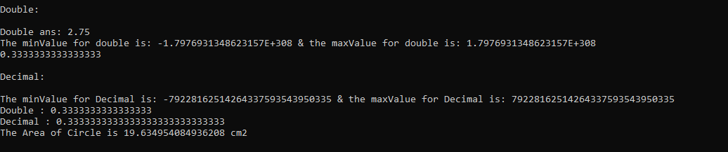

2) Loops and conditional Statements

Code:

using System;

namespace Application

{

    class Program

    {

        static void Main(string[] args)

        {

          snippet0();

          snippet1();

          snippet2();

          snippet3();

          snippet4();

          snippet5();

          snippet6();

          snippet7();

        }

        static void snippet0(){

          int a = 5;

          int b = 1;

          if (a + b > 10)

            Console.WriteLine("The answer is greater than 10.");

        }

        static void snippet1(){

          int a = 5;

          int b = 1;

          if (a + b > 10)

            Console.WriteLine("The answer is greater than 10.");

          else

            Console.WriteLine("The answer is smaller than or equal to 10");

        }

        static void snippet2(){

          int a = 5,b = 10 ,c = 10;

          if((a+b+c > 10) || (b == c)){

            Console.WriteLine("The summation is larger than 10 or b equals c");

          }

          else{

            Console.WriteLine("The summation is smaller than 10 and b not equals c");

          }

        }

        static void snippet3(){

          int counter = 0;

          while(counter < 10){

            Console.WriteLine($"While loop I am! The Counter is {counter}");

            counter++;

          }

        }

        static void snippet4(){

          //run and then checks the condition

          int counter = 0;

          do{

            Console.WriteLine($"Do while I am! The Counter is {counter}");

            counter++;

          }while(counter < 10);

        }

        static void snippet5(){

          for(int counter = 0; counter < 10; counter++)

          {

            Console.WriteLine($"For loop I am! The Counter value is {counter}");

          }

        }

        static void snippet6(){

          //nested loops

          int row = 5,col = 2;

          for(int i = 0; i < row; i++){

            for(int j = 0; j < col; j++){

              Console.WriteLine("The row and col: " + i + " " + j);

            }

          }

        }

        static void snippet7(){

          //  find the sum of all integers 1 through 20 that are divisible by 3

          int sum = 0;

          for(int i = 1; i <= 20; i++){

            if(i%3 == 0){

              sum += i;

            }

          }

          Console.WriteLine("The Sum is : " + sum);

        }

    }

}

Output:

