1. Intro

Input:

Console.WriteLine("Hello World!");

Ouptut:



1. Strings

Input:

Console.WriteLine("Hello Mihir!");

Ouptut:

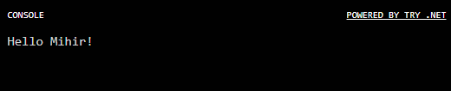

1. Variables

Input:

var name = "Mihir";

Console.WriteLine("Hello " + name + "!");

Ouptut:



1. String Interpolation

Input:

var name = "Mihir";

Console.WriteLine($"Hello {name} !");

Ouptut:



1. Methods

Input:

var name = "Mihir";

Console.WriteLine($"Hello {name.ToUpper()}!");

Ouptut:



1. Collections

Input:

var names = new[] {"Mihir", "XXX", "YYY", "ZZZ"};

foreach(var name in names){

Console.WriteLine($"Hello {name.ToUpper()}!");

}

Ouptut:

