It seems that the temperature has been recorded in KELVIN. As the mean temperature of 281.2 does not belong to either of the traditional scales.
The lowest recorded temperature is 0 kelvin which is impossible, and so likely an error. The lowest recorded temperature was -60 degree Fahrenheit (-51.1 celsius) in Minnesota.
As such we will discard all the = which have temperature below 220 kelvin.
Before performing any operation, I want to make sure I have backup. However, I have the option to do rollback by using my Github as such we will only commit after every change instead of manually doing backups.
After this operation, the lowest temperature is 243.3900
Since rain, snow, and clouds can be 0.000 which does make logical sense I will not do any changes to them.
Moving towards the maximum values, the rain on 1 hour has a maximum value of 9831 mm which does not make sense. The maximum rain that occurred in 24-hours in Minnesota in history was 384 mm, in Hokah on August 18-19, 2007.
I will now perform an operation to fix this issue. Similarly to what we did with temps we will remove all values above 380 mm.
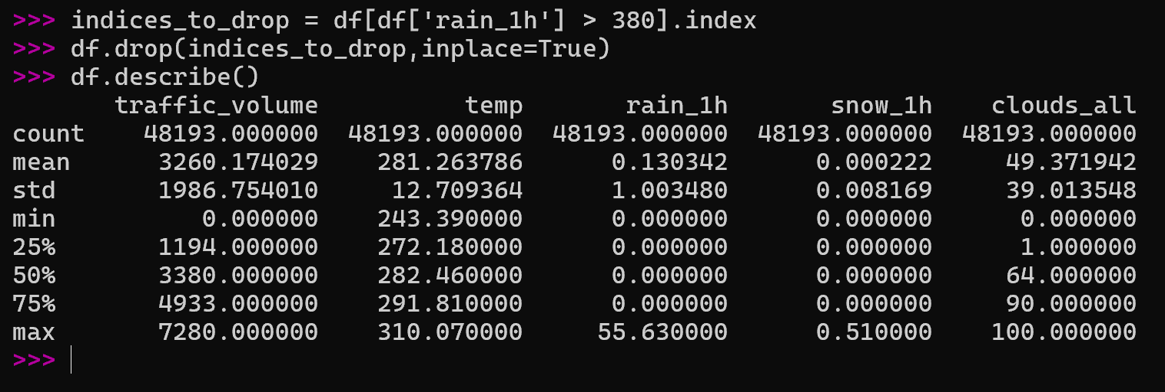

Note: I am using the terminal python3 as it is easier to modify the file instead of manually typing it in an IDE and then clicking save and run.
The max rain issue has now been fixed. The maximum snow in mm in Minnesota was much higher than 0.51. I will have to investigate what the data is describing for snow. As such I will use the command print((df[df['snow_1h']> 0.001].head(10)).sort_values(by='snow_1h'))

It seems that there are 63 days where there are days with snow, and I have also found out that some days have rain/snow/mist and are 3 rows for the same time/day which is not good.
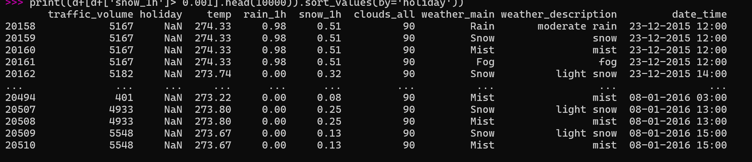
I used the command
pd.set_option(‘display.max_rows’, None)
and then printed. The data which was revealed shows that the snow data where is greater than 0.00 is only from 23-12-2015 to 06-01-2016.
I now double-checked using >>> data = df[df['weather_main'] == "Snow"] and then print(data). However, it seems like that whenever the weather was snow the snow was usually always 0.00. Intrigued by this, I also checked the same for rain. Although there are some days which have 0.00 rain mm while the day’s weather_main being rain, the majority of the days with weather_main being rain did have some mm rain recorded into them.
Based upon my recent findings, I am excluding snow days from the model entirely. I am also excluding days which have weather_main = rain but have no rain recorded.
Commands used:
>> >>> df.drop(df[df.weather_main == "Snow"].index, inplace=True)
df = df.loc[~((df['weather_main']=="Rain") & (df['rain_1h'] == 0.00))]

After this we removed duplicates by df.drop_duplicates(inplace=True)

