

American International University-Bangladesh (AIUB)
Department of Computer Science
Faculty of Science & Technology (FST)

Project Title: Amar Khata
Semester: Fall 25-26

Group:08 |  | Section: T
SL | Student Name | Student ID
1 | JANNATUL FERDOUS | 23-50756-1
2 | SHAIKH ZARIF SHAHRIAR | 23-50770-1
3 | MAHIR MAHMUD SIAM | 23-50773-1
4 | MOZAMMEL HOSSAIN MAHIM | 22-49086-3
5 | SABRINA RAHAMAN | 23-55365-3

Table of Contents

1. Project Proposal xx
1.1 Background to the Problem xx
1.2 Selection of Process Model xx
2. Software Requirements Specification (SRS) / PRD xx
2.1 Scopes and Features xx
2.2 User Story Table xx
2.3 Requirements Traceability Matrix xx
2.3.1 Functional Requirements xx
2.3.2 Non-Functional Requirements xx
3. Software Design xx
3.1 System Deisgn xx
3.2 UI Deisgn using Figma xx
4. Git Workflow xx
5. Software Testing xx
6. Conclusion xx

1. PROJECT PROPOSAL

The Amar Khata system connects three separate roles. The roles are the Business Owner, the Driver, and the Admin. The roles help to coordinate a thorough financial management workflow. As the strategic observer, the business owner uses advanced analytical tools to examine 12-month transaction trends, filter historical logs by particular keywords or dates, and break down income by category to identify top revenue sources. They also use a powerful dashboard to quickly visualize critical financial health indicators, such as total income, total expenses, and calculated net profit. Additionally, they keep complete control over reporting by creating and downloading comprehensive financial summaries in common formats, such as PDF or Excel, for external audits. They also control the security of their individual accounts and interface preferences by changing their passwords and customizing themes. In order to maintain accountability, the driver simultaneously manages the operational data entry and is in charge of growing the fleet by adding new cars to the system and entering vital driver information like name, NID, and phone number. As they choose particular vehicles to record income or expense entries, they play a crucial role in keeping accurate financial records. They make sure that every transaction is carefully classified with exact amounts, income types, dates, and optional notes for future reference. Lastly, the administrator maintains the integrity and security of the platform by using high-level privileges to monitor User Logs for suspicious activity by tracking IP addresses and timestamps, confirming the success or failure status of individual payment transactions to settle disputes, and using authority to manage the user base by suspending, banning, or reactivating accounts to enforce platform policies.

  - Background to the Problem
Financial tracking in Bangladesh remains mainly manual and fragmented in the transportation and vehicle management sector. Most of the vehicle owners and fleet operators use traditional paper notebooks (khatas) or disjointed spreadsheets to record daily trips, fuel consumption, and maintenance costs. As a result this backdated process creates a "financial blind spot," where data is prone to human error, physical damage, or loss. Besides, there is a significant disconnect between vehicle owners and drivers. Owners often lack real-time visibility into daily operations, leading to delayed accountability and an inability to calculate the accurate Net Profit until the end of the month. At present, digital solutions are available but sometimes too complicated, such as needing big app downloads, or don't support Bangla as a native language or work offline. This makes them useless for drivers who work in locations with unreliable internet connections.

  - Selection of Process Model
We used the Scrum model for the Amar Khata project because it made it possible for us to work in a flexible, organized, and collaborative manner all of which were crucial for creating a system with numerous user roles, real-time data handling, and intricate business logic. Scrum was the best development methodology for this project because it required frequent adjustments, gradual feature development, and ongoing feedback.

Financial tracking is still mostly done manually in Bangladesh's transportation and vehicle management industries. Traditional Khatas or dispersed spreadsheets are used by many car owners to keep track of daily income, expenses, and maintenance information. This results in a lack of real-time financial visibility, inconsistent data, human error, and information loss. Additionally, it is challenging to accurately track operations and compute net profit due to the communication gap between drivers and business owners. Due to these difficulties, our project needed a system that could continuously adjust to user needs while evolving gradually. We were able to divide this difficult issue into manageable development cycles thanks to Scrum, which guaranteed adaptability and frequent project improvements.
Project Planning and Execution:
We submitted a formal project proposal to specify our development direction at the start of the project and recorded all system features and workflows in a Product Requirement Document (PRD). Three people made up the team at first, and then two more joined. Scrum facilitated this team's growth by enabling cooperative planning and dynamic task distribution.
We used an incremental and iterative approach instead of building the entire system at once. For instance, we worked on backend logic, system flow, and feature enhancement on some days and UI/UX design using Figma on others. We were able to lower risks, validate concepts early, and continuously enhance system quality thanks to this methodical approach.
Project Management and Collaboration:
We used Trello to manage tasks efficiently, where we clearly defined:
- What tasks needed to be completed.
- Who was responsible for each task.
- Which tasks were high priority.
Team members were held accountable and transparent as a result. Additionally, we used Notion as a shared workspace, which made it possible for everyone to work together, record ideas, and maintain alignment throughout the project. Our team had a designated leader who made sure the project's objectives were met while fostering a collaborative team atmosphere. Every time a problem emerged, we talked about it and collaborated to find workable solutions. We continued to collaborate using Microsoft Teams outside of lab sessions, which greatly enhanced productivity and communication.
Why Scrum Was the Best Choice:
Scrum was especially suitable for this project because:
- It allowed us to work in manageable iterations rather than building everything at once.
- It supported continuous improvement based on feedback and testing.
- It encouraged team collaboration and accountability.
- It enabled quick adaptation to new ideas, requirement changes, and team expansion.
- It helped deliver features efficiently while maintaining quality and consistency.
In conclusion, Scrum turned out to be the best development model for the Amar Khata project. Scrum enabled us to maintain flexibility, clarity, and productivity throughout the development process despite the system's complexity, the requirement for real-time data handling, and the involvement of several user roles, including Business Owner, Driver, and Admin. As a result, we were able to create a scalable, user-focused, and well-organized solution that tackles actual financial management issues in the transportation industry.

2. SOFTWARE REQUIREMENTS SPECIFICATIONS (SRS) / PRODUCT REQUIREMENTS DOCUMENT (PRD)

2.1 Scopes and Features
- Feature1: Auth Feature.
- Signup [admin] [User]
- Sign in [admin] [User]
- Feature2: Dashboard & Analytics.
- Menu [User]
- Dashboard [Business Owner]
- Transaction Logs [Business Owner]
- Net Profit View [Business Owner]
- Reports [Business Owner]
- Feature3: Vehicle & Driver Management.
- Vehicle Inventory [Business Owner]
- Add Vehicle & Driver [Driver]
- Feature4: Financial Operations.
- Add Transaction [Driver/Owner]
- Feature5: Account Management.
- Profile Settings [Driver/Owner]
- Feature6: Admin Administrations.
- User Logs [Admin]
- Transaction Oversight [Admin]
- User Management [Admin]

2.2 User Story Table
- Feature1: Auth Feature.
Signup [admin] [User]:
As an Admin or User, the system allows account registration using required personal and role-based information so that a secure account is created and role-specific access is enabled.
Sign in [admin] [User]:
As an Admin or User, the system enables secure login using valid credentials so that
authorized access to role-based dashboards and features is granted.

- Feature2: Dashboard & Analytics.
Menu [User]:
As a logged-in user, I want to open the main menu from anywhere in the app so that I can quickly navigate between features without restarting the app.
Dashboard [Business Owner]:
As a Business owner I want to Access dashboard, See total income, See total expense, See last 12 months transaction So that operational metrics are visible in one place. The business owner can quickly monitor overall revenue and track total outgoing costs.,"1. Dashboard loads with all key metrics and navigation options.

Transaction Logs [Business Owner]:
As a Business owner I want to Filter transaction logs, Check income by category, Specific transactions can be found and analyzed rapidly. The owner understands which sources generate the most revenue.

Net Profit View [Business Owner]:
As a Business owner I want to Check net profit So that I know the actual profit after all expenses.

Reports [Business Owner]:
As a Business owner I want to Check reports, Download reports So that financial documents can be stored, shared, or printed for audits.

- Feature3: Vehicle & Driver Management.
Vehicle Inventory [Business Owner]:
As a Business owner I want to Check vehicle list So that all vehicles in the fleet are accounted for.

Add Vehicle & Driver [Driver]:
As a Driver I want to Add Vehicle, Add Driver Name, Add NID, Add Phone, Add Status So that the fleet can be expanded and tracked.

- Feature4: Financial Operations.
Add Transaction [Driver/Owner]:
As a Driver I want to Add a new income or expense record for a vehicle So that all financial transactions are tracked accurately by vehicle.

- Feature5: Account Management.
Profile Settings [Driver/Owner]:
As a Driver/Owner I want to Change password, Change user name, Change theme So that account privacy is protected and dashboard can be customized.

- Feature6: Admin Administrations.
User Logs [Admin]:
As an Admin I want to Check User logs So that system security is maintained and suspicious activities can be traced.

Transaction Oversight [Admin]:
As an Admin I want to check transaction So that financial discrepancies can be investigated.

User Management [Admin]:
As an Admin I want to manage users So that user account issues (like locked accounts) can be resolved quickly.
2.3 Requirements Traceability Matrix

2.3.1 Functional Requirements

Functional Requirement | Why
User Signup for Admin and User | Defines a core system action: creating an account
User Sign in (authentication) | Specifies login behavior and access control
Role-based dashboard access | System behavior changes based on user role
View dashboard metrics (income, expense, transactions) | Describes system-provided functionality
Filter transaction logs | Specifies a data-processing capability
View net profit | System calculates and displays profit
Generate and download reports | Describes report creation and export
View vehicle inventory | System displays stored vehicle data
Add vehicle and driver details | System allows data input and storage
Add income/expense transactions | Core financial operation of the system
Update profile settings (password, username, theme) | System allows account customization
View user logs (Admin) | System provides monitoring functionality
Transaction oversight (Admin) | System allows review of transactions
User management (Admin) | Admin controls user accounts

2.3.2 Non-Functional Requirements

Non-Functional Requirement | Why
Secure password rules | Defines security quality, not a feature
Data confidentiality and encryption | Describes system security standards
Role-based access enforcement | Defines access control policy and constraints
System performance (fast dashboard loading) | Concerns speed and responsiveness
System availability and reliability | Describes uptime expectations
Audit trail for user actions | Defines compliance and traceability
Error handling and validation messages | Describes usability and robustness
Account lock after multiple failed logins | Security and safety constraint
Scalability for multiple users | Performance under increased load
UI theme customization | Usability and user experience quality

3. SOFTWARE DESIGN
3.1 System Design: Draw the system design for your project using Draw.io or LucidChart.
- Prepare a Use Case Diagram by first defining all users (actors) and their roles. Show each actor’s interactions with the system through use cases inside a system boundary. Include relationships like include or extend where needed.
- Prepare a Class Diagram by identifying the main classes from your project. Add attributes and operations for each class, and show associations, generalizations, aggregations, or compositions between them.
- Prepare an Activity Diagram that visually represents the workflow of a system or process.

Use Case Diagram
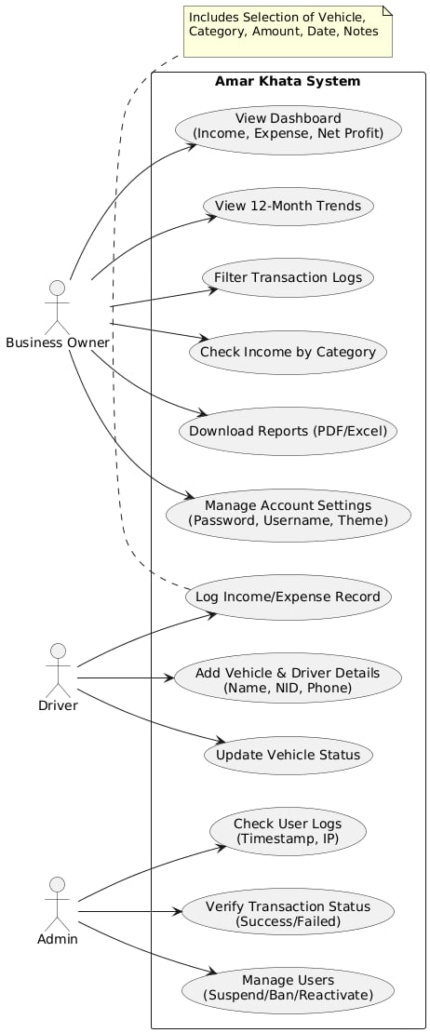

Class Diagram
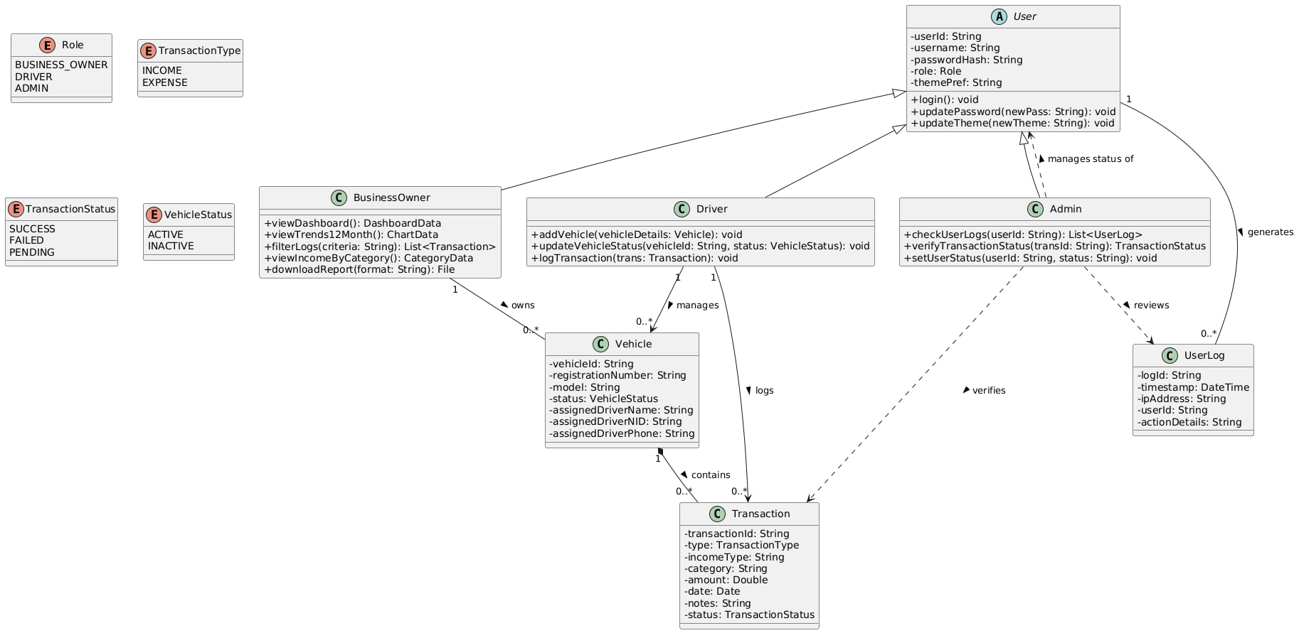

UI / Wireframe Design using Figma
- Build the wireframes directly from your SRS. Each functional requirement defined in the SRS should have a corresponding screen or component in the UI.
- Use the Trello user board (or equivalent task board) as a reference to decide which features and user flows need to be represented in the prototype.
- Create clickable wireframes that connect the main screens together, showing how a user will navigate through the system.
- Ensure the wireframe matches the actors, roles and functionalities described in the SRS and system design diagrams.
- Export the prototype and include screenshots or a link to your design as part of the report submission.

Signup [admin] [User]:
As an Admin or User, the system allows account registration using required personal and role-based information so that a secure account is created and role-specific access is enabled.

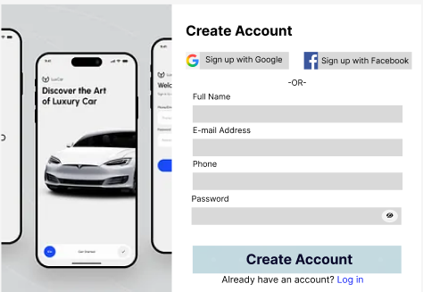

Sign in [admin] [User]:
As an Admin or User, the system enables secure login using valid credentials so that
authorized access to role-based dashboards and features is granted.

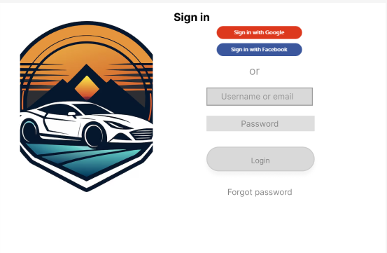

Dashboard [Business Owner]:
As a Business owner I want to Access dashboard, See total income, See total expense, See last 12 months transaction So that operational metrics are visible in one place. The business owner can quickly monitor overall revenue and track total outgoing costs.,"1. Dashboard loads with all key metrics and navigation options.
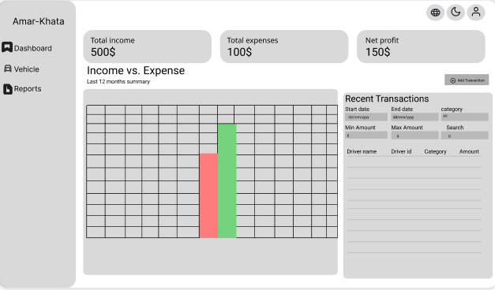

Admin Dashboard:
This is an admin dashboard that lets you manage the users and transactions on a platform. It shows overall stats (total users, system health, pending tickets), lets the admin manage user status (active, suspended, banned), and provides a transaction oversight section to search and review individual transactions with their status and options like viewing or investigating them.

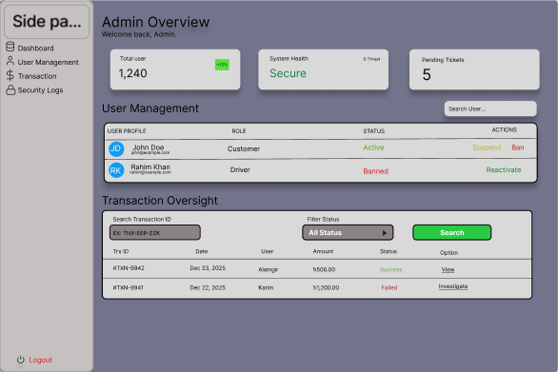
Vehicles:
This is a fleet vehicle management table listing drivers with their NID, phone number, current active status, and an action column for further management options.

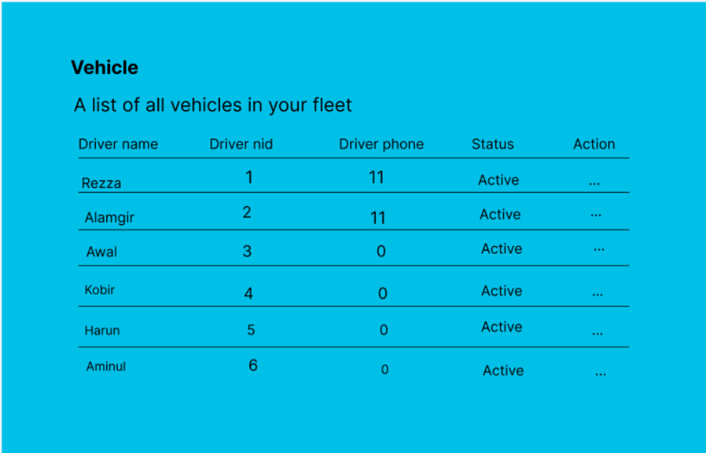

Add Vehicle:
This is a "Add Vehicle" form for managing a fleet. It has fields for the driver's name (for example, Rezul Karim), NID (for example, 1234567890), phone (for example, 0172345678), status (Active), and a Save button.

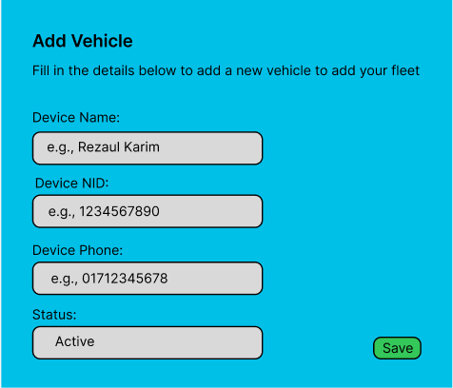

Reports:

This is a Weekly Report dashboard for fleet vehicles. It lets you choose a date range (start and end dates) and export to CSV. There is a table for each vehicle that shows Total Income, Total Expenses, and Net Profit (for example, Rez (1): all 0.00). A summary row shows the total for all vehicles (for example, all 0.00). Here is a table that shows the monthly totals for income, expenses, and profit. For example, in November 2025, income was $700.00, expenses were $250.00, and profit was $450.00.

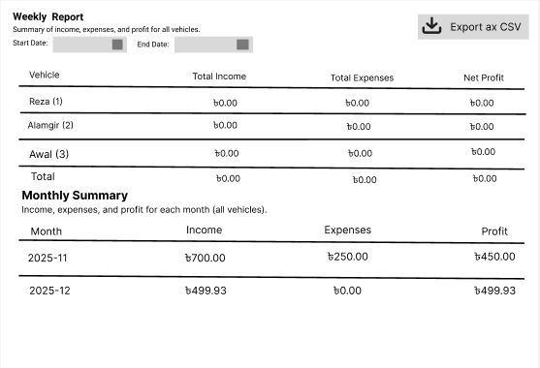

Settings:
This is the user settings page. It has a sidebar menu with options like Dashboard, Amar-Khata, and more. The main area has two parts: "Update Profile," which has fields for Full Name, Phone Number, and Email (note: changing your email requires verification and re-login), and a "Save" button. Next to it is "Change Password," which has fields for "Current Password," "New Password," "Confirm New Password," and a "Save" button for added security.

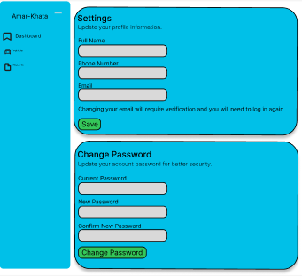

4. GIT WORKFLOW
- Create a central repository for the project on GitHub and set the master (or main) branch as the primary branch for integration.
- Each member should clone the repository and create their own feature branches for assigned tasks. Work on new features or fixes within these branches.
- Add files, stage them and commit changes with clear messages that describe the purpose of each update.
- Push commits from the feature branches to the remote repository so other members can see progress.
- Use pull to fetch and integrate changes from the remote repository into local copies, ensuring everyone stays updated.
- Merge feature branches into the master/main branch only after the work is tested and reviewed, resolving any conflicts that occur.
- Show evidence of collaboration by maintaining a clear commit history (using logs) with multiple commits, merges and contributions from all group members.
- Keep the repository organized with a clean history that tracks the project workflow from initialization to completion.
Member Jannatul:
Member Siam:
Member Zarif:
Member Mozammel:
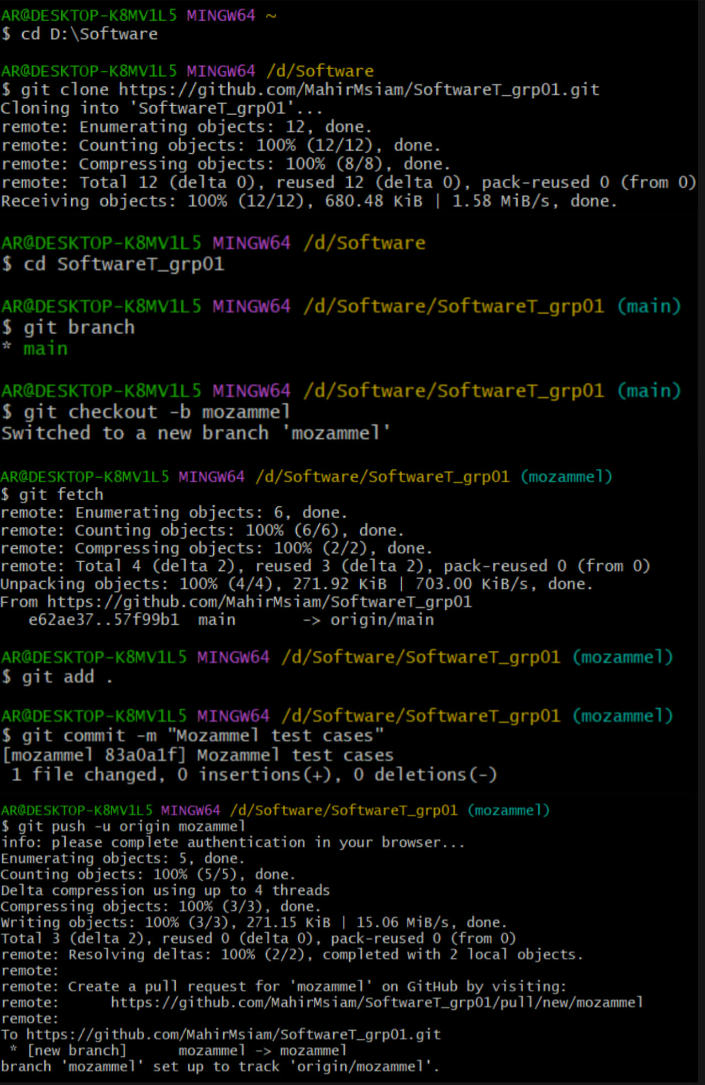
Member Sabrina:
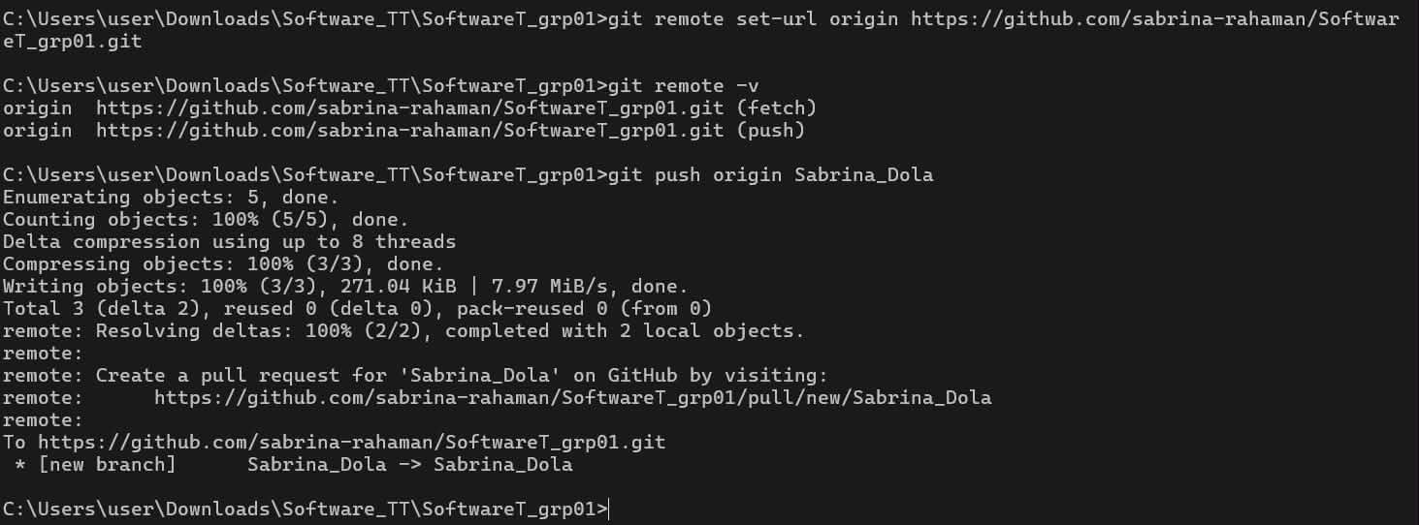
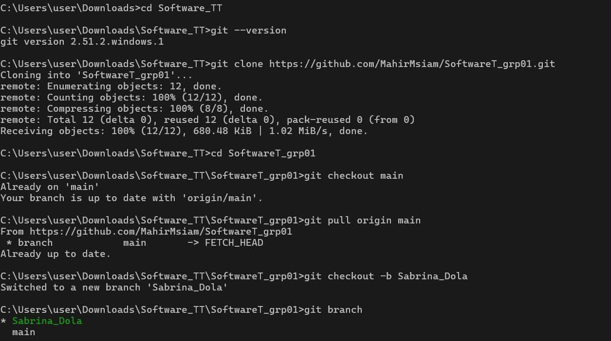

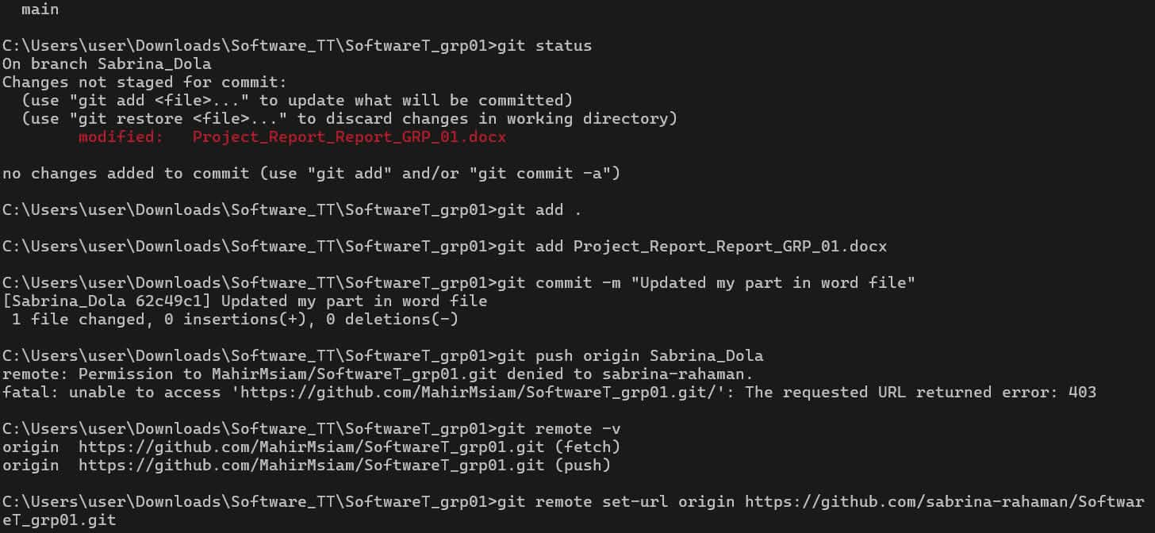

5. SOFTWARE TESTING
- Identify some testing methods that you want to use in the testing phase later for your project.
- Prepare 3 test cases using a manual test case template which template taught you in the class. Suppose if you have total 4 members, then the total test cases will be 12.

Project Name: Amar Khata |  |  | Test Designed by: Jannatul Ferdous
Test Case ID: TC_1 |  |  | Test Designed date:06/01/2026
Test Priority (Low, Medium, High): High |  |  | Test Executed by: Jannatul Ferdous
Module Name: Login Session (Signup) |  |  | Test Execution date: 06/01/2026
Test Title: Verify create account with valid username and password or login with google or facebook
Description: Create an account for login
Preconditions: The user and admin have to create an account with valid username and password
Dependencies: Valid username and password
Test Steps | Test Data | Expected Result |  | Actual Results | Status (Pass/Fail)
1.Go to the site  2.Enter Full Name  3.Enter Email  4.Enter Phone  5.Enter Password  6.Click Create Account | Username: jannat01  Email: jannat@gmail.com Phone:  018XXXXXXXX | The user should sing up in to the application successfully |  | As expected | Pass

Project Name: Amar Khata |  |  | Test Designed by: Jannatul Ferdous
Test Case ID: TC_2 |  |  | Test Designed date: 13/01/2026
Test Priority (Low, Medium, High):High |  |  | Test Executed by: Jannatul Ferdous
Module Name: Login Session (Sign in) |  |  | Test Execution date: 13/01/2026
Test Title: Verify the account with valid username and password for sign in
Description: Sign in to the account
Preconditions: Valid username and password
Dependencies: Successfully Signup the account
Test Steps | Test Data | Expected Result |  | Actual Results | Status (Pass/Fail)
1. Go to the site  2.Enter username or email  3.Enter Password  4.Click Login Button | Username: jannat01  Email: jannat@gmail.com | The user should log in the application |  | As expected | Pass

Project Name: Amar Khata |  |  | Test Designed by: Jannatul Ferdous
Test Case ID: TC_3 |  |  | Test Designed date: 20/01/2025
Test Priority (Low, Medium, High): High |  |  | Test Executed by: Jannatul Ferdous
Module Name: Navigation Menu |  |  | Test Execution date: 20/01/2025
Test Title: Main Menu Navigation Access
Description: Verify business owner can access and navigate using main menu
Preconditions: Logged in as Business Owner
Dependencies: Authentication Module, Dashboard Module
Test Steps | Test Data | Expected Result |  | Actual Results | Status (Pass/Fail)
1.Open application Business owner account - Menu icon visible on header.  2. Login to system credentials.  3.Tap menu icon - Dashboard option.  - Transactions option.  - Reports option.  - Settings option.  - Logout option.  4. Select Dashboard | Menu icon visible on header.  Menu opens on tap.  Dashboard visible.  Transactions option visible.  Reports option visible.  Settings option visible.  Logout option visible.  Redirected to Dashboard screen | Everything is visible as we want. |  | As expected. | Pass.

Project Name: Amar Khata |  |  | Test Designed by: Mahir Mahmud Siam
Test Case ID: 04 |  |  | Test Designed date: 06/01/2026
Test Priority (Low, Medium, High): high |  |  | Test Executed by: Mahir Mahmud Siam
Module Name: Dashboard & Analytics |  |  | Test Execution date: 06/01/26
Test Title: Dashboard
Description: Verify Dashboard Layout Loading
Preconditions: Logged in as Business owner
Dependences: Transactions
Test Steps | Test Data | Expected Result |  | Actual Results | Status (Pass/Fail)
1.Go to the page  2.Log in  3.Access dashboard | Business owner credential | - Total Income Card  - Total Expense Card  - Net Profit Card  - 12-Month Transaction Chart  - Navigation Sidebar |  | - Total Income Card  - Total Expense Card  - Net Profit Card  - 12-Month Transaction Chart  - Navigation Sidebar | Pass

Project Name: Amar Khata |  |  | Test Designed by:
Test Case ID: |  |  | Test Designed date:
Test Priority (Low, Medium, High): |  |  | Test Executed by:
Module Name: |  |  | Test Execution date:
Test Title:
Description:
Preconditions:
Dependencies:
Test Steps | Test Data | Expected Result |  | Actual Results | Status (Pass/Fail)

Project Name: Amar Khata |  |  | Test Designed by:
Test Case ID: |  |  | Test Designed date:
Test Priority (Low, Medium, High): |  |  | Test Executed by:
Module Name: |  |  | Test Execution date:
Test Title:
Description:
Preconditions:
Dependencies:
Test Steps | Test Data | Expected Result |  | Actual Results | Status (Pass/Fail)

Project Name: Amar Khata |  |  | Test Designed by:
Test Case ID: TC_7 |  |  | Test Designed date:
Test Priority (Low, Medium, High):Low |  |  | Test Executed by:
Module Name: Deshboard & Analystics |  |  | Test Execution date:
Test Title:Report[Business Owner]

Description:
Preconditions:
Dependencies:
Test Steps | Test Data | Expected Result |  | Actual Results | Status (Pass/Fail)

Project Name: Amar Khata |  |  | Test Designed by:
Test Case ID: |  |  | Test Designed date:
Test Priority (Low, Medium, High): |  |  | Test Executed by:
Module Name: |  |  | Test Execution date:
Test Title:
Description:
Preconditions:
Dependencies:
Test Steps | Test Data | Expected Result |  | Actual Results | Status (Pass/Fail)

Project Name: Amar Khata |  |  | Test Designed by:
Test Case ID: |  |  | Test Designed date:
Test Priority (Low, Medium, High): |  |  | Test Executed by:
Module Name: |  |  | Test Execution date:
Test Title:
Description:
Preconditions:
Dependencies:
Test Steps | Test Data | Expected Result |  | Actual Results | Status (Pass/Fail)

Project Name: Amar Khata |  |  | Test Designed by: Mozammel Hossain Mahim
Test Case ID: TC_SIGNIN_08 |  |  | Test Designed date: 15/01/2026
Test Priority (Low, Medium, High): High |  |  | Test Executed by: Mozammel Hossain Mahim
Module Name: Login Session (Sign in) |  |  | Test Execution date: 15/01/2026
Test Title: Verify sign in with invalid password
Description: Check system behavior when incorrect password is used.
Preconditions: User/Admin account exists
Dependencies: Valid username/email
Test Steps | Test Data | Expected Result |  | Actual Results | Status (Pass/Fail)
1. Go to login page  2. Enter valid email  3. Enter valid password  4. Click Login | Email: mozammel67@gmail.com  Password: User@123 | User should be redirected to role-based dashboard successfully |  | System shows error message and does not redirect to dashboard | Fail

Project Name: Amar Khata |  |  | Test Designed by: Mozammel Hossain Mahim
Test Case ID: TC_SIGNIN_ 9 |  |  | Test Designed date: 15/01/2026
Test Priority (Low, Medium, High): High |  |  | Test Executed by: Mozammel Hossain Mahim
Module Name: Login Session (Sign in) |  |  | Test Execution date: 15/01/2026
Test Title: Login Session (Sign in)
Description: Check whether user/admin can successfully sign in using valid credentials.
*Preconditions: User/Admin account already exists
*System is online
Dependencies: Successful signup
Test Steps | Test Data | Expected Result |  | Actual Results | Status (Pass/Fail)
1. Go to login page  2. Enter valid email  3. Enter valid password  4. Click Login | Email: mozammel67@gmail.com  Password: User@123 | User should be redirected to role-based dashboard successfully |  | User is redirected to the correct role-based dashboard successfully | Pass

6. CONCLUSION
- Write a conclusion within 180 to 200 words.

Instructions:
- Minimum of 3 members and Maximum of 5 members per group.
- Font: Times New Roman ; Size: 12; Justify the para [Ctrl + J].
- Delete the highlighted part after completing this project report.
- The completed report should be within the range of 40 to 50 pages.

- Submission: Bring a hard copy of this report [per group] on the project evaluation day. Also, you will need to upload the soft copy later.

