Homework 3
Name: Mahir Nagersheth, Sanath Mahesh Kumar
AndrewID: mnagersh, sanathk

Problem 1(a)-(c) | Construction cost only
Total demand is 1,000 + 3,000 + 3,000 + 1,000 + 4,000 = 12,000 cars. The facility data used in all three models are:
Plant | Fixed cost ($) | Cost/car ($) | Minimum | Capacity
1 | 2,100,000 | 380 | 2,000 | 5,000
2 | 2,800,000 | 165 | 3,000 | 7,000
3 | 2,400,000 | 155 | 4,000 | 8,000
4 | 2,700,000 | 170 | 2,500 | 6,000

(a) Integer programming formulation
Let y_i = 1 if Plant i is built, and 0 otherwise, for i = 1, 2, 3, 4. Let F_i and U_i denote the fixed cost and maximum capacity in the table.
Minimize Z = Σ_{i} F_{i} y_{i}
= 2,100,000y₁ + 2,800,000y₂ + 2,400,000y₃ + 2,700,000y₄
Subject to: 5,000y₁ + 7,000y₂ + 8,000y₃ + 6,000y₄ ≥ 12,000
y_{i} ∈ {0,1} for every plant i.
This first model selects sufficient installed capacity. It does not choose production quantities, so minimum production and variable costs do not enter this model.

(b)-(c) Solver result and recommendation
Build Plants 1 and 3. The minimum construction cost is $4,500,000. Their combined capacity is 13,000 cars, leaving capacity for 1,000 cars beyond forecast demand. Do not build Plants 2 and 4.
No single plant can meet demand. Plants 1 and 3 form the least costly feasible pair, and every three-plant combination costs more.
Problem 1: Min B27; change B22:B25 (binary); B29 >= 0.
C22=B22*E5; D22=B22*B5, copied down to row 25.
B27=SUM(D22:D25); B28=SUM(C22:C25); B29=B28-D28; D28=B17.

Problem 1(b) | Excel evidence
Actual Excel worksheet, Solver Parameters, and Solver Results screenshots. The formulas and settings are documented in the workbook and on the preceding solution page.
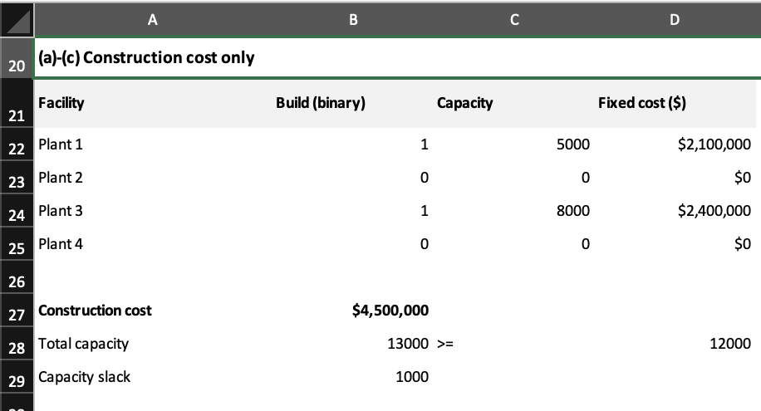
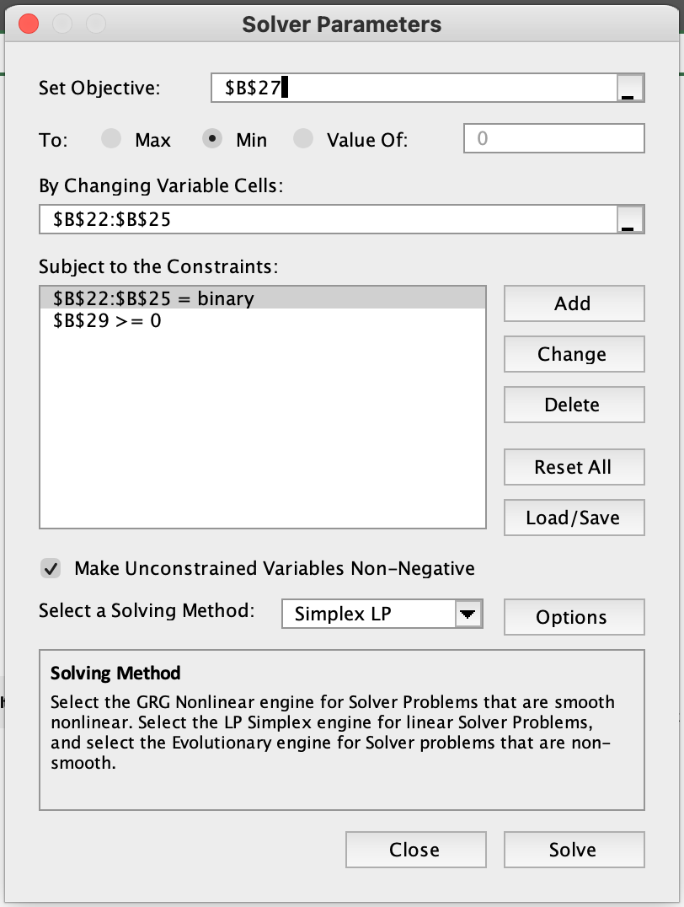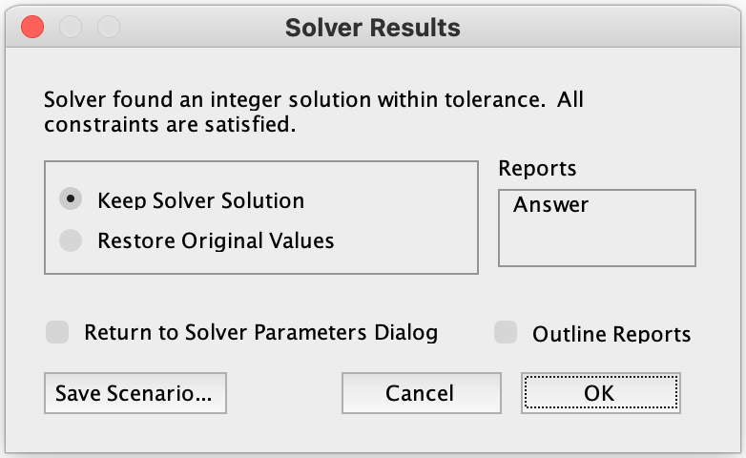

Problem 1(d)-(f) | Construction and production

(d) Integer programming formulation
Let y_i be the binary build decision defined in part (a), and let q_i be the nonnegative integer number of cars produced at Plant i. Let c_i and L_i denote production cost per car and minimum production if built.
Minimize Z = Σ_{i} F_{i} y_{i} + Σ_{i} c_{i} q_{i}
Subject to: Σ_{i} q_{i} ≥ 12,000
L_{i} y_{i} ≤ q_{i} ≤ U_{i} y_{i} for i = 1, 2, 3, 4
y_{i} ∈ {0,1}; q_{i} ∈ {0,1,2,...}.
The linking constraints force production to zero at an unbuilt plant and enforce both production limits at a built plant. All production costs are positive, and this optimum produces exactly 12,000 cars.

(e)-(f) Solver result and recommendation
Plant | Build? | Cars produced | Production cost
1 | No | 0 | $0
2 | No | 0 | $0
3 | Yes | 8,000 | $1,240,000
4 | Yes | 4,000 | $680,000
Build Plants 3 and 4. Produce 8,000 cars at Plant 3 and 4,000 at Plant 4. Construction costs are $5,100,000 and production costs are $1,920,000, for a minimum total cost of $7,020,000.
Plant 3 meets its 4,000-car minimum and reaches its 8,000-car capacity. Plant 4 produces between its 2,500-car minimum and 6,000-car capacity. Total unused capacity is 2,000 cars.

Excel implementation
Min B43; change B38:C41. B38:B41 binary; C38:C41 integer.
Constraints: H38:I41 >= 0; B47 >= 0; nonnegative variables.
D38=B38*D5; E38=B38*E5; F38=B38*B5; G38=C38*C5.
H38=C38-D38; I38=E38-C38. Copy through row 41.
B43=SUM(F38:G41); B46=SUM(C38:C41); B47=B46-D46.
D46=B17, where B17=SUM(B16:F16)=12000.
H and I are the lower-bound and capacity slacks. Requiring both to be nonnegative implements the linking constraints exactly.

Problem 1(e) | Excel evidence
Actual Excel worksheet, Solver Parameters, and Solver Results screenshots. The formulas and settings are documented in the workbook and on the preceding solution page.
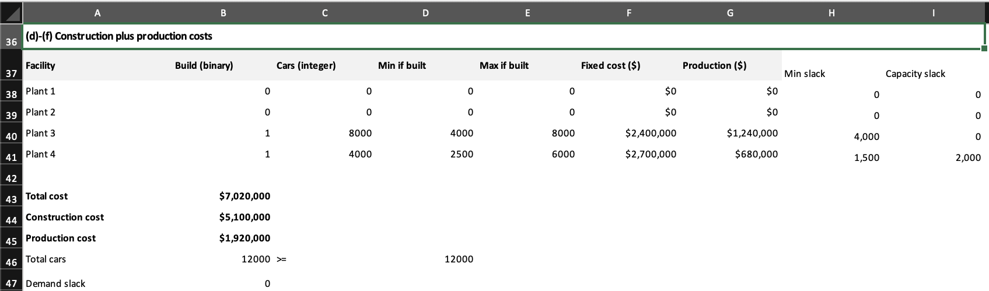
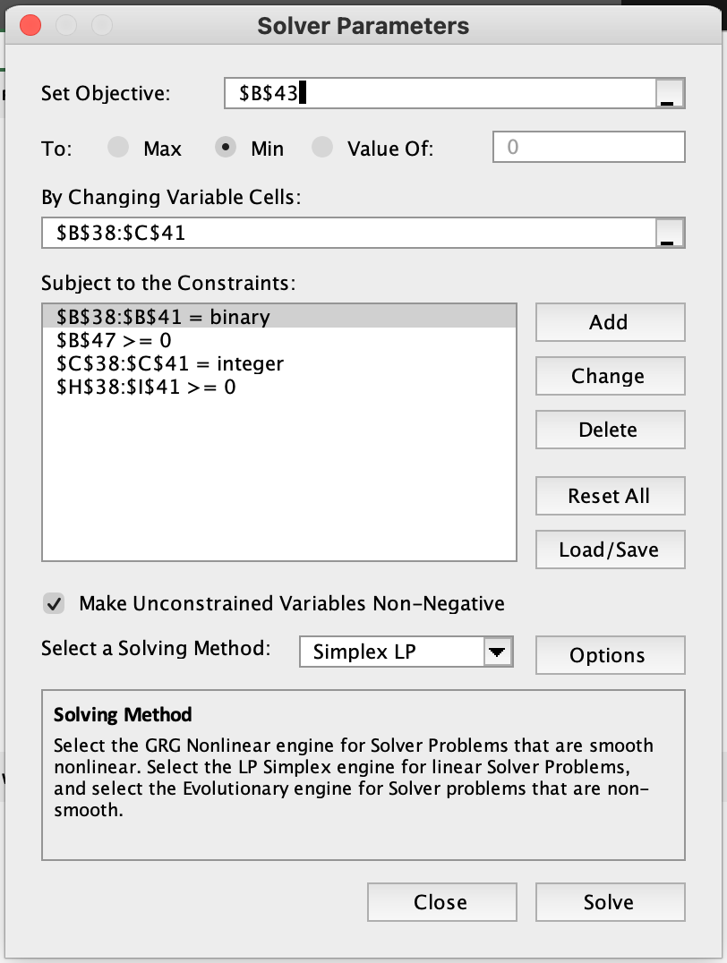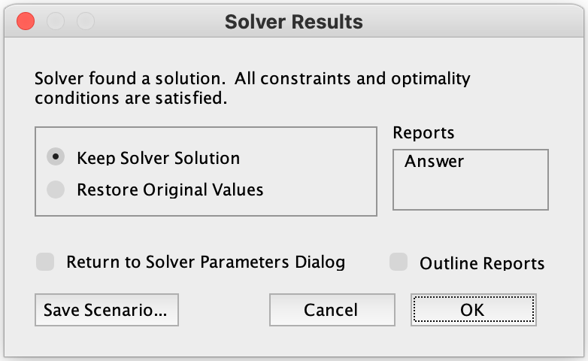

Problem 1(g) | Full cost model
Let x_ij be the nonnegative integer number of cars shipped from Plant i to city j. Retain the build decisions y_i and production quantities q_i. Each produced car is shipped to one of the five cities.
$/car | Pittsburgh | Chicago | New York | D.C. | Boston
Plant 1 | 18 | 35 | 50 | 30 | 20
Plant 2 | 15 | 10 | 12 | 10 | 12
Plant 3 | 40 | 50 | 30 | 35 | 25
Plant 4 | 32 | 25 | 20 | 25 | 40
Demand | 1,000 | 3,000 | 3,000 | 1,000 | 4,000
Let t_ij be the transportation cost in the table and d_j the demand of city j. The city order is Pittsburgh, Chicago, New York, Washington, D.C., Boston.
Minimize Z = Σ_{i} F_{i} y_{i} + Σ_{i} c_{i} q_{i} + Σ_{i} Σ_{j} t_{ij} x_{ij}
Subject to: Σ_{i} x_{ij} = d_{j} for every city j
q_{i} = Σ_{j} x_{ij} for every plant i
L_{i} y_{i} ≤ q_{i} ≤ U_{i} y_{i} for every plant i
y_{i} ∈ {0,1}; q_{i} and x_{ij} are nonnegative integers.
City constraints meet each demand exactly. The production balances ensure that a plant produces what it ships. In Excel, q_i is calculated as the row sum of shipments, so it does not need a separate changing cell.

Excel implementation for part (h)
Min B66; change B57:G60. B57:B60 binary; C57:G60 integer.
Constraints: K57:L60 >= 0; C64:G64 = 0; nonnegative variables.
H57=SUM(C57:G57); I57=B57*D5; J57=B57*E5.
K57=H57-I57; L57=J57-H57. Copy through row 60.
C62=SUM(C57:C60); C63=B16; C64=C62-C63.
Copy the city formulas across through column G.
B67=SUMPRODUCT(B57:B60,B5:B8)
B68=SUMPRODUCT(H57:H60,C5:C8)
B69=SUMPRODUCT(C57:G60,B12:F15)
B66=SUM(B67:B69)

Problem 1(h)-(i) | Full cost solution
Build Plants 2 and 3. Produce 7,000 cars at Plant 2 and 5,000 cars at Plant 3. The minimum total cost is $7,339,000.
From | Pittsburgh | Chicago | New York | D.C. | Boston
Plant 1 | 0 | 0 | 0 | 0 | 0
Plant 2 | 1,000 | 3,000 | 2,000 | 1,000 | 0
Plant 3 | 0 | 0 | 1,000 | 0 | 4,000
Plant 4 | 0 | 0 | 0 | 0 | 0
Total | 1,000 | 3,000 | 3,000 | 1,000 | 4,000

Cost calculation
Construction = 2,800,000 + 2,400,000 = $5,200,000
Production = 7,000(165) + 5,000(155) = $1,930,000
Plant 2 transport = 1,000(15) + 3,000(10) + 2,000(12) + 1,000(10)
= $79,000
Plant 3 transport = 1,000(30) + 4,000(25) = $130,000
Total = 5,200,000 + 1,930,000 + 209,000 = $7,339,000
All city demands are met. Plant 2 uses its full 7,000-car capacity. Plant 3 produces above its 4,000-car minimum and has 3,000 cars of unused capacity. Plants 1 and 4 are not built and have zero production and shipments.

Recommendation to the company
Use the full cost model for the final facility decision. Plants 2 and 3 cost $100,000 more to build and $10,000 more to operate than Plants 3 and 4 at their production-only optimum, but Plant 2 has much lower shipping costs. Optimizing all costs together selects Plants 2 and 3.
The three reported objective values cover different cost categories. They should not be compared as if they were three estimates of the same total cost.

Problem 1(h) | Excel evidence
Actual Excel worksheet, Solver Parameters, and Solver Results screenshots. The formulas and settings are documented in the workbook and on the preceding solution page.
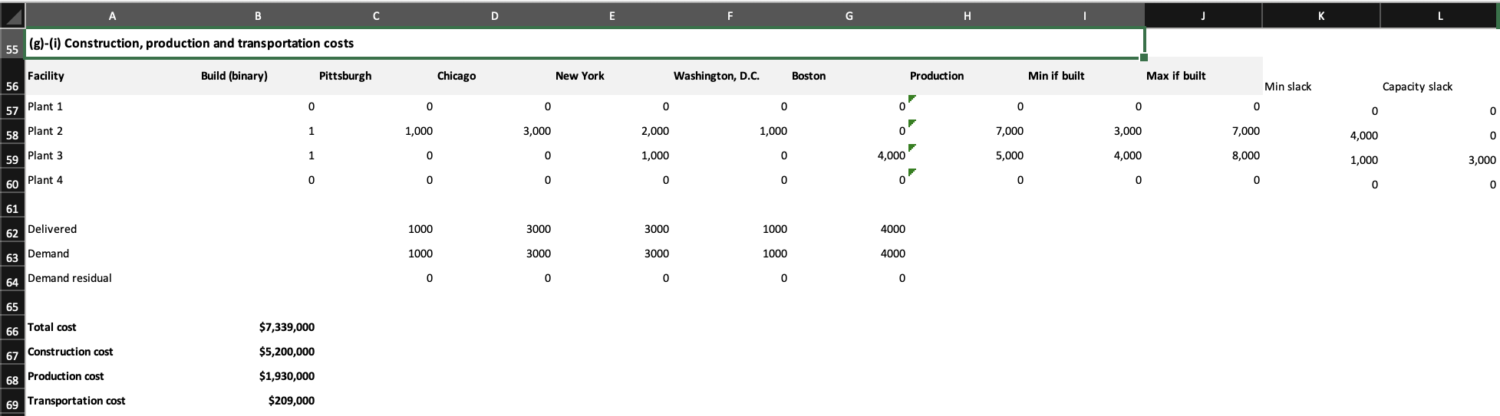
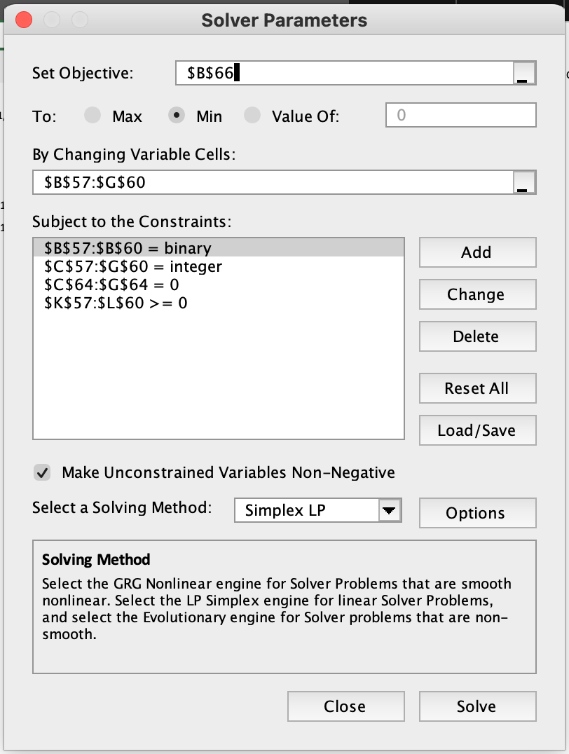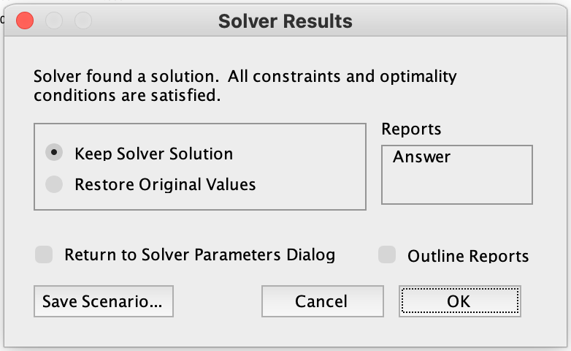

Problem 2(a) | Match scheduling model
Use the assignment’s hypothetical group and visibility data. Let M = {1,...,6} be the matches and D = {1,...,14} be the available days. Match numbers identify pairings; they do not require chronological order.
Match | Pairing
1 | Colombia vs. Germany (C-G)
2 | Colombia vs. Philippines (C-P)
3 | New Zealand vs. Germany (NZ-G)
4 | New Zealand vs. Philippines (NZ-P)
5 | Colombia vs. New Zealand (C-NZ)
6 | Germany vs. Philippines (G-P)
Define x_md = 1 if match m is scheduled on day d, and 0 otherwise. Let v_md be its visibility score. For each team t, M_t is the set of matches involving that team:
M_{C} = {1,2,5}; M_{NZ} = {3,4,5}; M_{G} = {1,3,6}; M_{P} = {2,4,6}.
Maximize V = Σ_{m} Σ_{d} v_{md} x_{md}
Σ_{d} x_{md} = 1 for every match m [play each match exactly once]
Σ_{m} x_{md} ≤ 2 for every day d [at most two matches per day]
Σ_{(m ∈ M_t)} x_{md} ≤ 1 for every team t and day d
Σ_{m} x_{m,14} = 2 [exactly two matches on the last day]
x_{md} ∈ {0,1} for all matches and days.
The team constraints make the two day-14 matches disjoint, so every team plays once on the final day. Give those two matches the same kickoff time. Since this model selects days only, their common kickoff time is an operational requirement rather than a separate day-assignment variable.
“All matches should be played on the 14 days” is interpreted as scheduling all six matches within days 1 through 14. It cannot mean that each of the 14 days must contain a match.

Problem 2(b)-(c) | Optimal schedule
Day | Match | Visibility
5 | New Zealand vs. Philippines | 177
9 | Colombia vs. Germany | 192
13 | Colombia vs. New Zealand | 188
13 | Germany vs. Philippines | 181
14 | Colombia vs. Philippines | 150
14 | New Zealand vs. Germany | 150
Maximum visibility = 177 + 192 + 188 + 181 + 150 + 150 = 1,038.
Recommend the schedule above. Both day-14 games must begin at the same time. No matches are scheduled on the other days. Every match appears once, each team plays three matches, no team plays twice on one day, and no day has more than two games.
Colombia and Germany play on days 9, 13 and 14. New Zealand and the Philippines play on days 5, 13 and 14. Thus, all four teams play on consecutive days 13 and 14. This is allowed in parts (a)-(c), but motivates the added constraint in part (d).

Excel implementation
Problem 2: Max B43; change B24:G37 (binary).
B39:G39 = 1; H24:H37 <= 2; I24:L37 <= 1; H37 = 2.
H24=SUM(B24:G24)
I24=B24+C24+F24; J24=D24+E24+F24
K24=B24+D24+G24; L24=C24+E24+G24
Copy these daily formulas through row 37.
B39=SUM(B24:B37)
B40=SUMPRODUCT($A$24:$A$37,B24:B37)
B41=SUMPRODUCT(B6:B19,B24:B37)
Copy these match formulas across through column G.
B43=SUMPRODUCT(B6:G19,B24:G37)
The visibility input matrix occupies B6:G19. The binary decision matrix uses the same day and match order in B24:G37. The workbook also includes a three-day-window check for part (d).

Problem 2(b) | Excel evidence
Actual Excel worksheet, Solver Parameters, and Solver Results screenshots. The formulas and settings are documented in the workbook and on the preceding solution page.
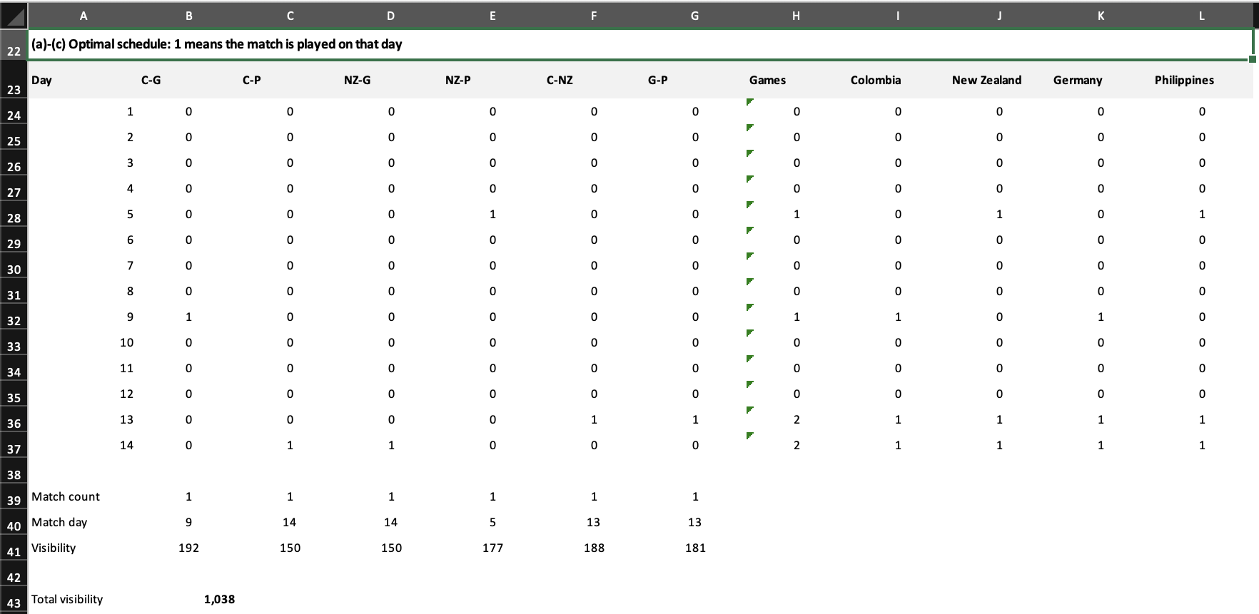
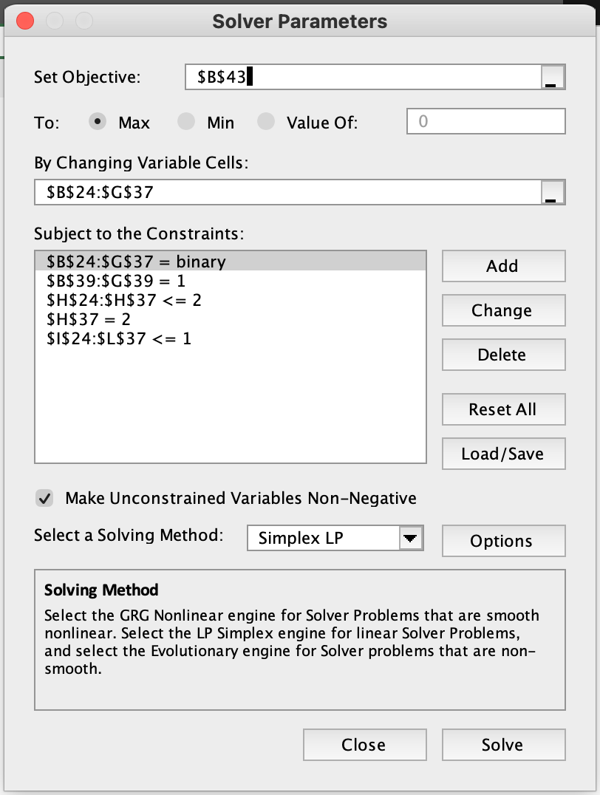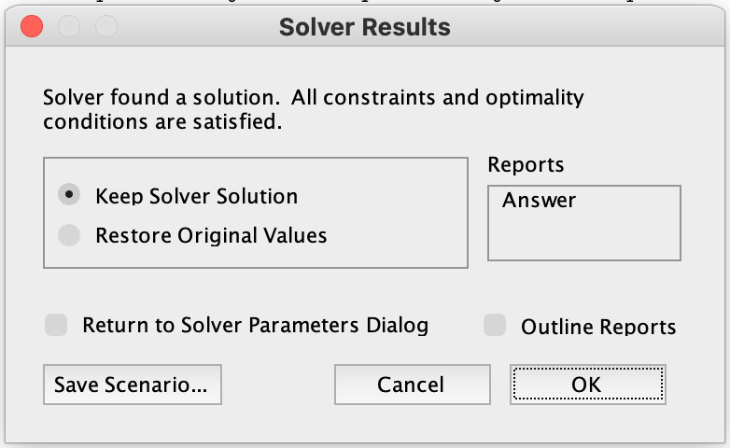

Problem 2(d) | At least two days of rest
Add the following rolling three-day-window constraint for every team t and every starting day k = 1,...,12:
Σ_{(m ∈ M_t)} [x_{m,k} + x_{m,k+1} + x_{m,k+2}] ≤ 1.
A team may play at most one match in any three consecutive days. Therefore, a match on day 1 excludes days 2 and 3, and the next match can occur on day 4 or later. This is a linear constraint in the original binary variables and requires no new decision variables.

Examples
For Colombia, k = 1:
(x_{1,1} + x_{2,1} + x_{5,1}) + (x_{1,2} + x_{2,2} + x_{5,2})
+ (x_{1,3} + x_{2,3} + x_{5,3}) ≤ 1.
For k = 12, the constraint covers days 12, 13 and 14. Since every team plays on day 14, no team can play on day 12 or 13 under the new rule. The original optimal schedule is therefore infeasible once this rest requirement is added.

Excel implementation
B61=SUM(I24:I26), copied across through E61 and down through row 72.
Add B61:E72 <= 1 to the existing Problem 2 Solver model.
Columns I:L contain each team’s daily match count. The 12 rows of the rest check represent windows 1-3, 2-4, ..., 12-14. Part (d) asks for the mathematical constraint, so the workbook retains the requested base optimum for parts (b)-(c).

Problem 2 | Visibility data and source notes
Day | C-G | C-P | NZ-G | NZ-P | C-NZ | G-P
1 | 185 | 170 | 183 | 168 | 178 | 175
2 | 130 | 125 | 125 | 120 | 125 | 125
3 | 110 | 120 | 115 | 125 | 115 | 120
4 | 138 | 140 | 138 | 140 | 140 | 140
5 | 175 | 170 | 182 | 177 | 177 | 175
6 | 120 | 125 | 125 | 130 | 125 | 125
7 | 110 | 110 | 110 | 110 | 110 | 110
8 | 144 | 142 | 142 | 140 | 142 | 142
9 | 192 | 183 | 177 | 168 | 175 | 185
10 | 130 | 130 | 130 | 130 | 130 | 130
11 | 120 | 120 | 120 | 120 | 120 | 120
12 | 156 | 153 | 153 | 150 | 153 | 153
13 | 180 | 175 | 182 | 175 | 188 | 181
14 | 150 | 150 | 150 | 150 | 150 | 150

