Recitation W5
  - Problem 1: Community garden planning

(a) Integer programming formulation
Let F be the 10 foods below, H = {basil, cilantro, parsley}, and V = F \ H (all fruits and vegetables, using the categories in the assignment).
For each food i, let xᵢ = 1 if it is planted and 0 otherwise. Let yᵢ be the number of plants. Thus xᵢ ∈ {0, 1} and yᵢ ∈ ℤ≥₀.
Parameters: sᵢ is square feet per plant, mᵢ is the minimum quantity if selected, and eᵢ is expected harvest in pounds per plant. Following the faculty model, use M = 100 in the selection linking constraints.
Food | Category | sᵢ | mᵢ | eᵢ | M
Tomato | Vegetable | 4 | 4 | 10 | 100
Bell pepper | Vegetable | 2 | 6 | 5 | 100
Carrot | Vegetable | 0.5 | 20 | 0.25 | 100
Lettuce | Vegetable | 1 | 10 | 1.5 | 100
Strawberry | Fruit | 1 | 12 | 1 | 100
Cucumber | Fruit | 4 | 3 | 8 | 100
Zucchini | Vegetable | 9 | 2 | 12 | 100
Basil | Herb | 1 | 4 | 1 | 100
Cilantro | Herb | 0.5 | 6 | 0.5 | 100
Parsley | Herb | 0.5 | 4 | 0.6 | 100

Objective
Maximize Z = ∑ᵢ∈F eᵢyᵢ
Equivalently, maximize 10y_T + 5y_B + 0.25y_Ca + 1.5y_L + y_S + 8y_Cu + 12y_Z + y_Ba + 0.5y_Ci + 0.6y_P. Subscripts follow the food names in the table.
The faculty solution is the primary reference for the formulation. Tomatoes are optional. If tomatoes are selected, at least two herb types must also be selected; no separate constraint forces tomatoes to be planted.

(a) Constraints
Space. Total planting area cannot exceed 100 square feet.
∑ᵢ∈F sᵢyᵢ ≤ 100
Selection and minimum quantities. Unselected foods have zero plants. Selected foods meet their minimum quantities.
mᵢxᵢ ≤ yᵢ ≤ 100xᵢ for every i ∈ F
Variety. Plant at least four different types of food.
∑ᵢ∈F xᵢ ≥ 4
Herbs require another category. Whenever an herb is selected, at least one fruit or vegetable is selected.
3∑ᵢ∈V xᵢ − ∑ₕ∈H xₕ ≥ 0
Tomatoes and companion herbs. If tomatoes are selected, include at least two distinct herb types.
x_Ba + x_Ci + x_P ≥ 2x_T
At least two specified foods. Choose at least two of tomato, bell pepper, and zucchini.
x_T + x_B + x_Z ≥ 2
Zucchini excludes tomatoes. Zucchini and tomatoes cannot both be selected.
x_T + x_Z ≤ 1
Tomato threshold and lettuce. If y_T > 30, the first inequality forces x_L = 1; the second then requires at least 10 lettuce plants.
y_T ≤ 30 + 100x_L; y_L ≥ 10x_L
Variable domains. Plant counts are nonnegative integers; selections are binary.
xᵢ ∈ {0, 1}; yᵢ ∈ ℤ≥₀ for every i ∈ F
The tomato threshold is redundant for this garden: 4y_T ≤ 100 implies y_T ≤ 25. Consequently, more than 30 tomato plants is impossible. The threshold constraint is retained to explicitly represent the stated rule; the lettuce minimum also appears in the general linking constraints.

(b) Excel Solver solution
In the Harvest worksheet, maximize D33 by changing C21:D30. Set C21:C30 to binary and D21:D30 to integer. Use Simplex LP, retain nonnegativity, and set Integer Optimality (%) to 0. Apply the linking constraints and the LHS/RHS checks shown in the screenshots.
Excel Solver returned: “Solver found a solution. All constraints and optimality conditions are satisfied.” An independent integer optimization check gives the same objective value. The table reports the faculty’s selected optimal plan.
Food | Plant? xᵢ | Plants yᵢ | Area (sq. ft.) | Harvest (lb.)
Tomato | 1 | 4 | 16 | 40
Bell pepper | 1 | 39 | 78 | 195
Cilantro | 1 | 6 | 3 | 3
Parsley | 1 | 6 | 3 | 3.6
Other six foods | 0 | 0 | 0 | 0
Total | 4 | 55 | 100 | 241.6
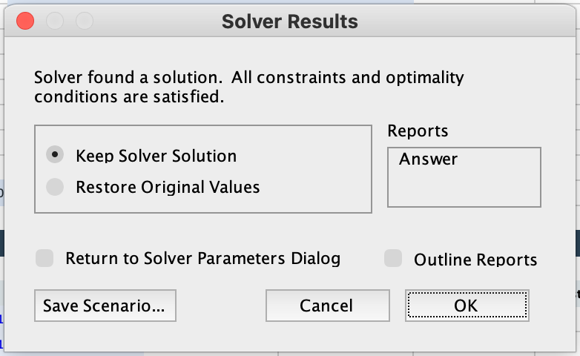
Figure 1. Actual Excel Solver completion dialog for the final model.

(c) Recommendation to the gardening club
Plant 4 tomatoes, 39 bell peppers, 6 cilantro, and 6 parsley. This plan uses all 100 square feet and produces an expected harvest of 241.6 pounds. It includes four food types, supplies the two herbs required by tomatoes, and selects two of the specified foods. Every selected food meets its minimum quantity. Zucchini is excluded, and the lettuce condition is not triggered.
Alternative optima exist. Our rerun also found 20 tomatoes, 7 bell peppers, 6 cilantro, and 6 parsley, yielding the same 241.6 lb. The table and worksheet display the faculty’s plan.

Spreadsheet evidence: parameters and solution
Actual Excel screenshot showing all parameters, both decision-variable columns, the quantity bounds, and the maximized objective value. Space is measured in square feet; expected harvest is in pounds.
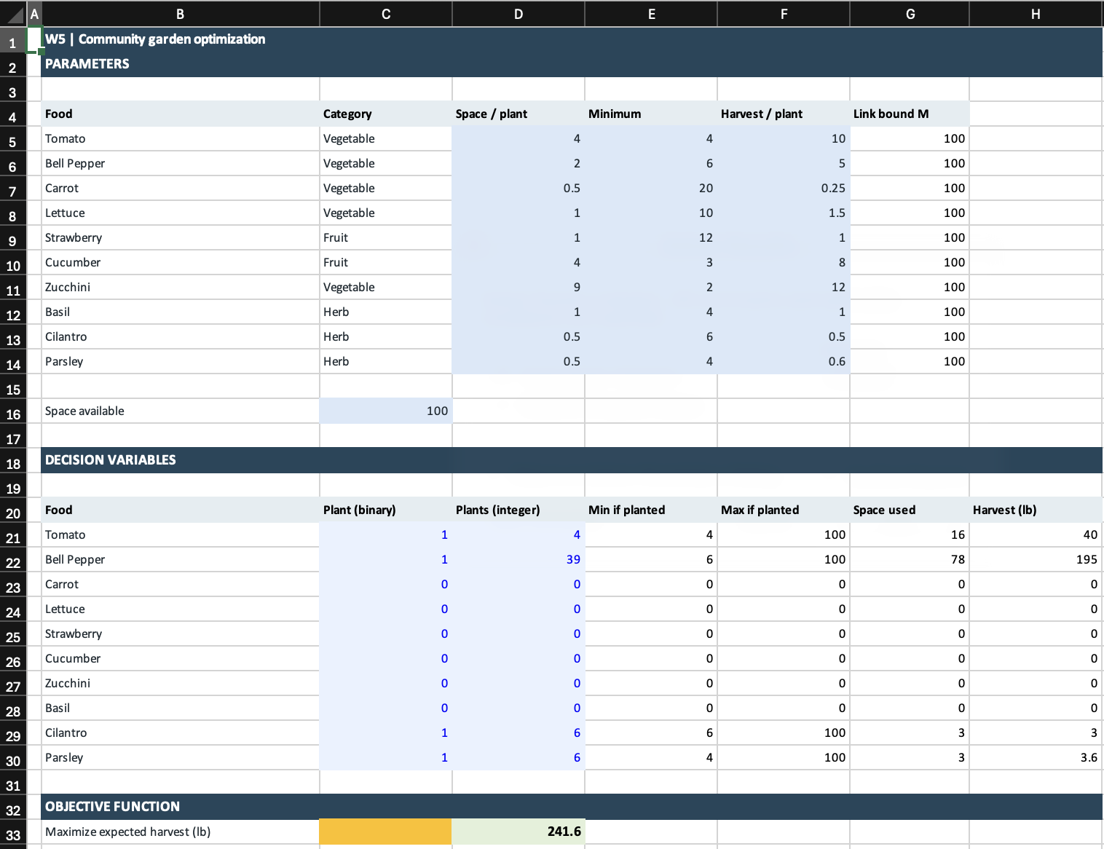
Figure 2. Harvest worksheet, rows 1 through 33.

Key spreadsheet formulas
G5:G14 contains M = 100, matching the faculty’s linking bound. For the tomato row, E21 = E5*C21 and F21 = G5*C21 give the selected minimum and maximum. G21 = D5*D21 calculates area; H21 = F5*D21 calculates harvest. Copy these formulas through row 30. D33 = SUM(H21:H30) is the objective.
The template label “Minimize cost” was corrected to “Maximize expected harvest (lb)” to match the assignment.

Spreadsheet evidence: constraints and Solver
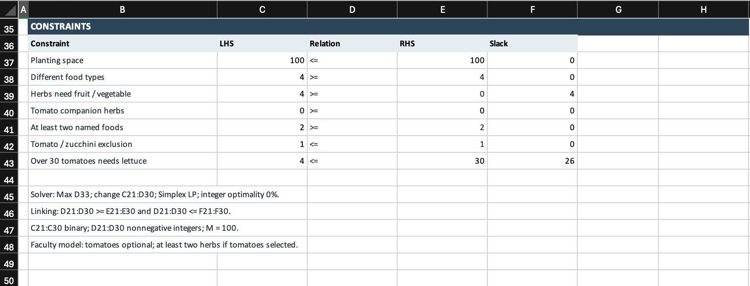
Figure 3. Every displayed constraint is satisfied. The rowwise quantity bounds appear in Figure 2.
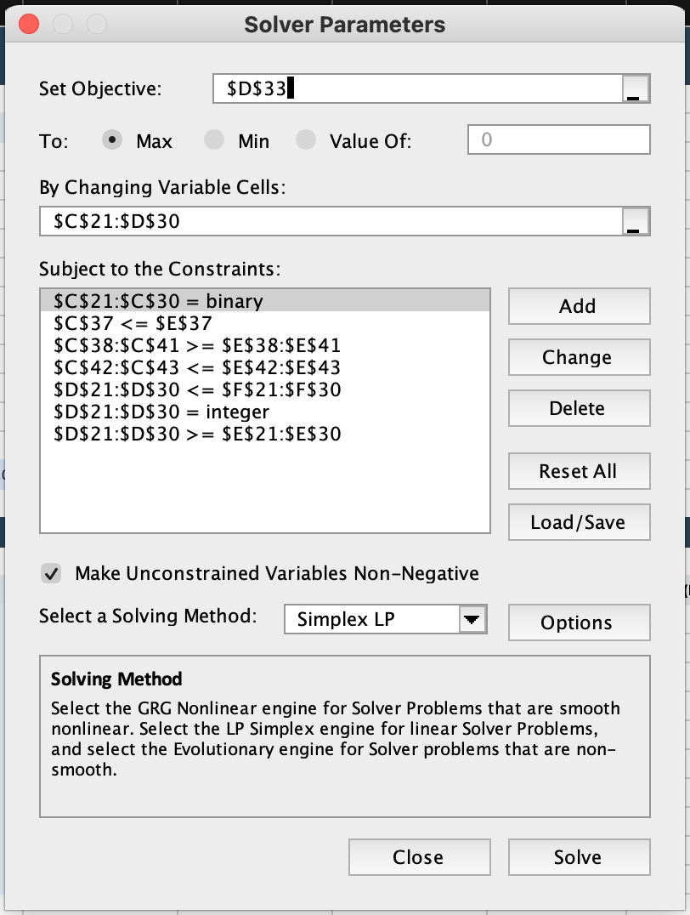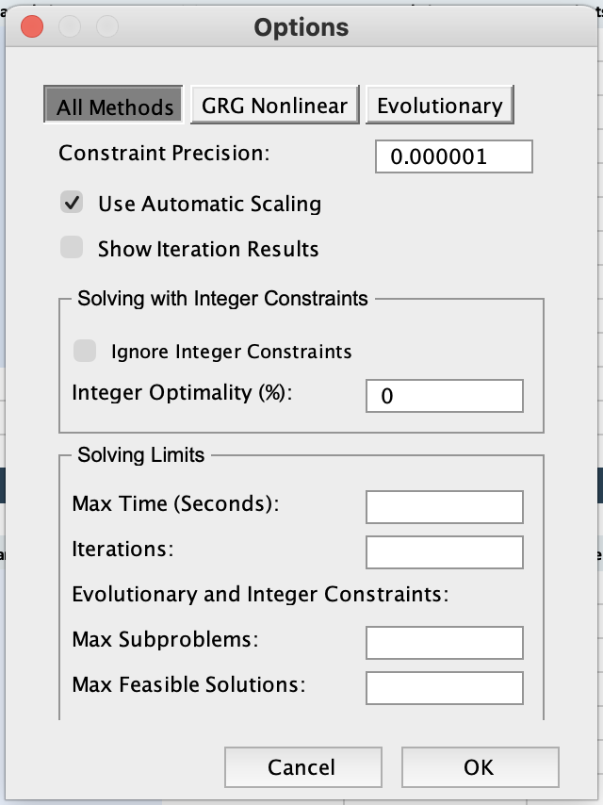
Figure 4. Actual Solver Parameters and Options dialogs. Integer Optimality is 0%. Tomatoes are optional; the conditional companion-herb requirement is retained.
Primary reference: faculty Recitation W5 Sol.xlsx, Harvest worksheet. Additional sources: RS W5.pdf, Problem 1, and Recitation W5.xlsx.

