**C Programm:**

**A. Check for balance parenthesis in arithmetic expression and tokenize it.**  
**Code:**

#include <iostream>

#include <stack>

#include <string>

using namespace std;

bool isMatchingPair(char opening, char closing)

{

    return (opening == '(' && closing == ')') || (opening == '{' && closing == '}') || (opening == '[' && closing == ']');

}

bool isBalanced(const string expr)

{

    stack<char> s;

    for (char ch : expr)

    {

        if (ch == '(' || ch == '{' || ch == '[')

        {

            s.push(ch);

        }

        else if (ch == ')' || ch == '}' || ch == ']')

        {

            if (s.empty() || !isMatchingPair(s.top(), ch))

            {

                return false;

            }

            s.pop();

        }

    }

    return s.empty();

}

void tokenize(const string expr)

{

    cout << "Tokens: ";

    for (char ch : expr)

    {

        if (ch != ' ')

        {

            cout << ch << " ";

        }

    }

    cout << endl;

}

int main()

{

    string expr;

    cout << "Enter an expression: ";

    getline(cin, expr);

    tokenize(expr);

    if (isBalanced(expr))

    {

        cout << "Balanced Parentheses." << endl;

    }

    else

    {

        cout << "Unbalanced Parentheses." << endl;

    }

    return 0;

}

**Output:**

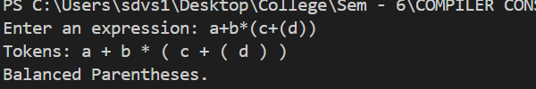

**Lex:**

**A. Check for balance paranthesis in arithmetic expression and tokenize it.  
Code:**

%{

#include <stdio.h>

%}

%%

"<"[^>]+">"   { printf("HTML Tag: %s\n", yytext); }

.|\n       ;

%%

int main() {

    yylex();

    return 0;

}

int yywrap() {

    return 1;

}

**Output:**

