Use this links for setup Jenkins on Kubernets cluster by using the below Git Url

<https://github.com/Mahisakapal/jenkins-on-kubernetes>

Also check Jenkins-server.yaml if you have a secrets than add that or I have commited that

Once your Jenkins is ready then we have to install kubernets plugin to use manage dynamic agent

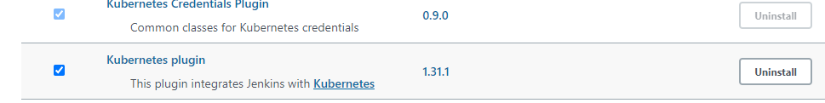

After this you can see configure clouds option like below. at manage Jenkins > manage node >

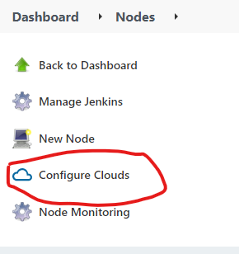

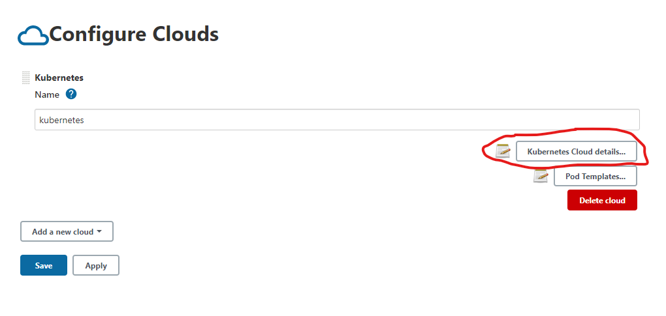

Select kubernets cloud details

Select secret file in kind and in file choose file you have to upload kube config file or just copy your config file and and save in your local path five same name and upload it

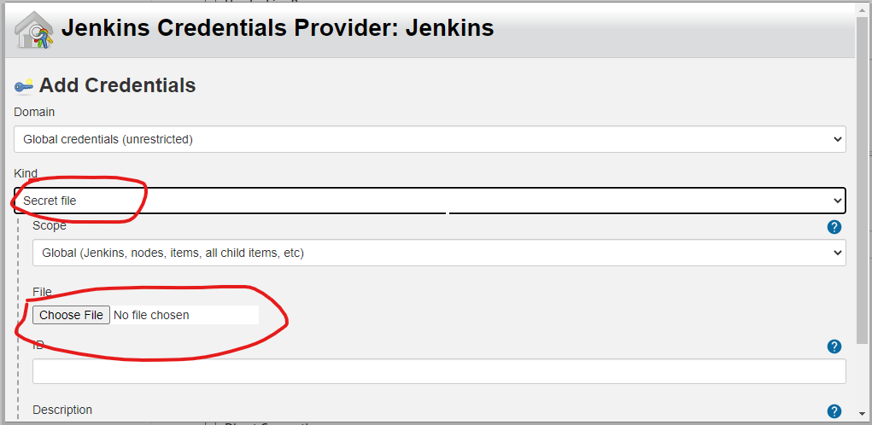

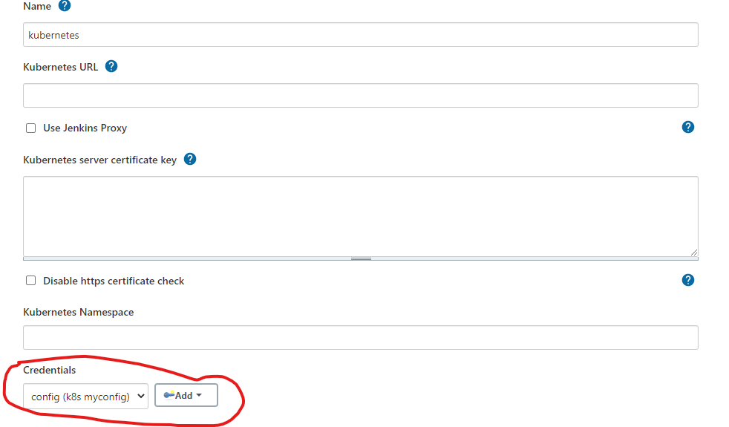

Now you don’t have give path and all you can test it bcoz we have url and all in our config file

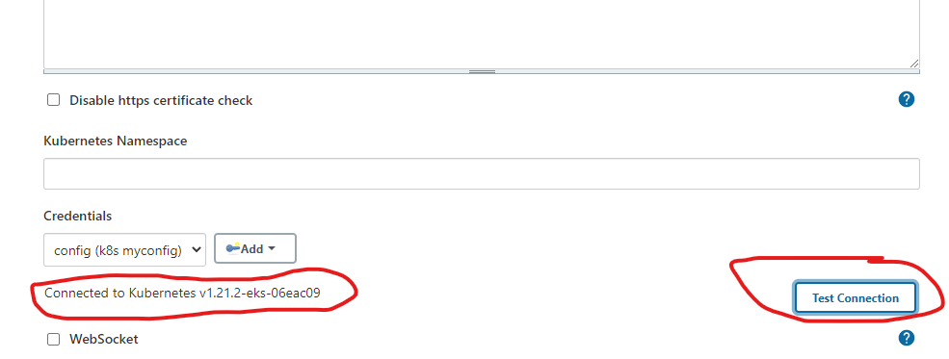

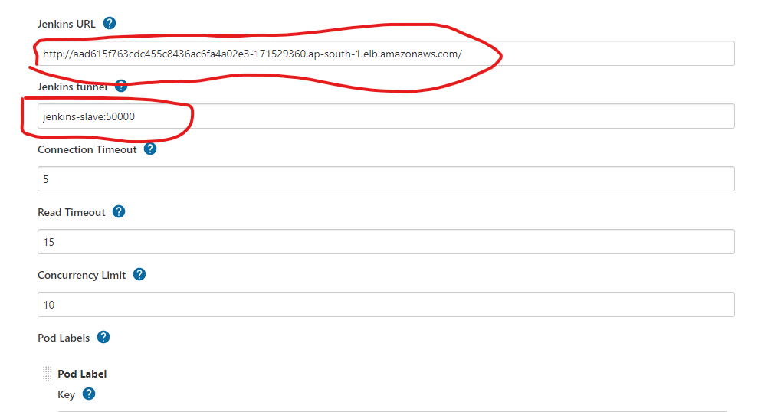

Give URL of Jenkins which is hosted on kubernets if we have that on aws eks we will load balancer as shown in image.

And Jenkins turnel you can check give your of your Jenkins with port : 50000.crosscheck by

kubectl get svc –A # we will all services by this cmd

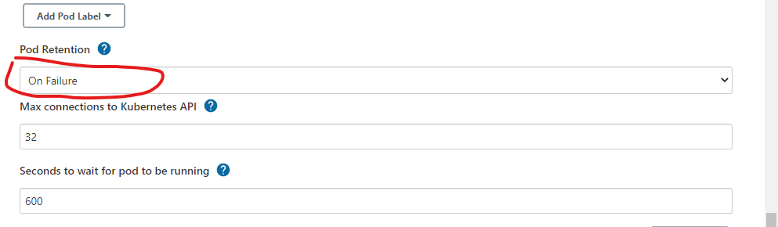

If we want to retain pod to check output we have use always or if we don’t want we can use never but if we want only on failure that we have to select appropriate one

Add pod label like this and we have one more label for there also we can save give name This label refer to agent label for Jenkins job

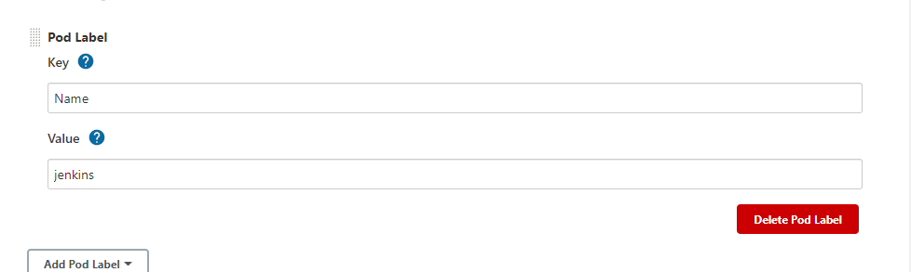

Now we have a pod templet to setup

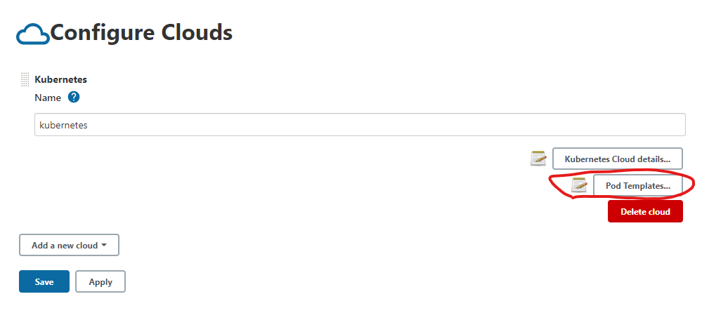

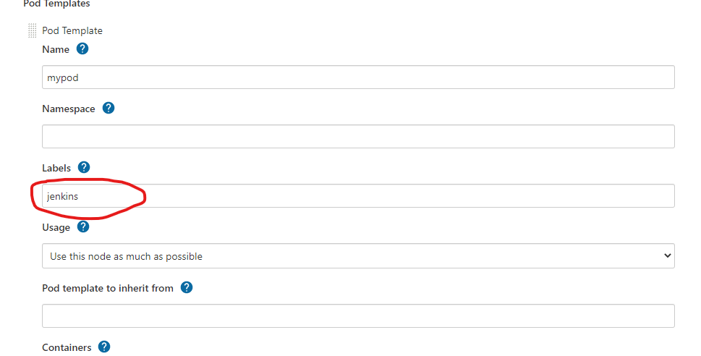

This label refers to agent label for Jenkins job

And use this as much as possible

Give image name as it is if your don’t have spacifice job to run

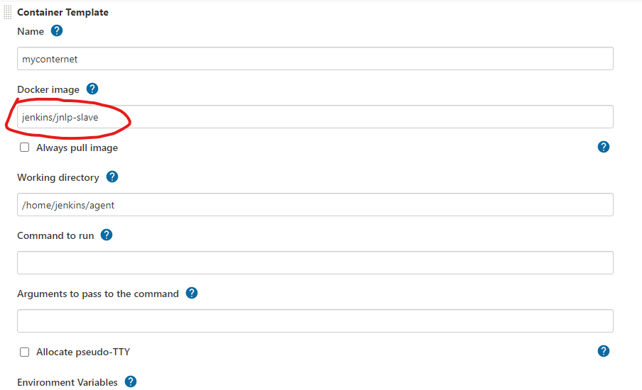

Save and apply

Now create one project add restrict agent like below

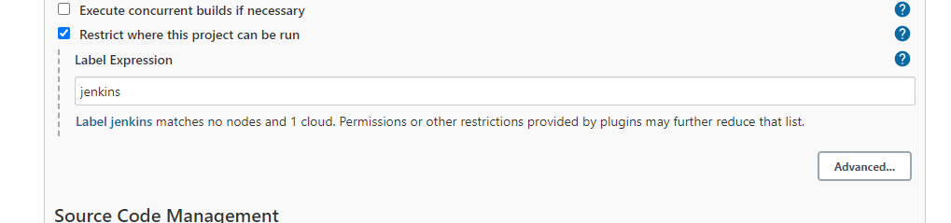

See this same name what we given in for labels

If you have any issue than u can refer this blog

<https://devopscube.com/jenkins-build-agents-kubernetes/>

<https://medium.com/vivid-seats-engineering/how-to-kubernetes-pods-as-jenkins-build-agents-a726d3886861>