INTRODUCTION

The Vehicle Management System is an application for the automotive industry. It supports, in the area of sales and services, the business processes that you require as vehicle importer when dealing with your original equipment manufacturers and your dealers in new and used vehicle sales.

* 1. OVERVIEW

Vehicle management systems created by SCAND are designed to help our clients to keep track of the vehicles in real-time, plan, execute, and optimize their transportation processes through GPS and data collection.

* 1. PURPOSE
* Utilization calculation of fleet’s movement
* Vehicle allocation
* Web analytics visualization

USES

* Tracking in real-time
* Low fuel consumption
* Safe and secure
* GPS vehicle tracking through mobile app
* Driver safety and management

1. PROBLEM DEFINITION AND DESIGN THINKING

2.1 EMPATHY MAP

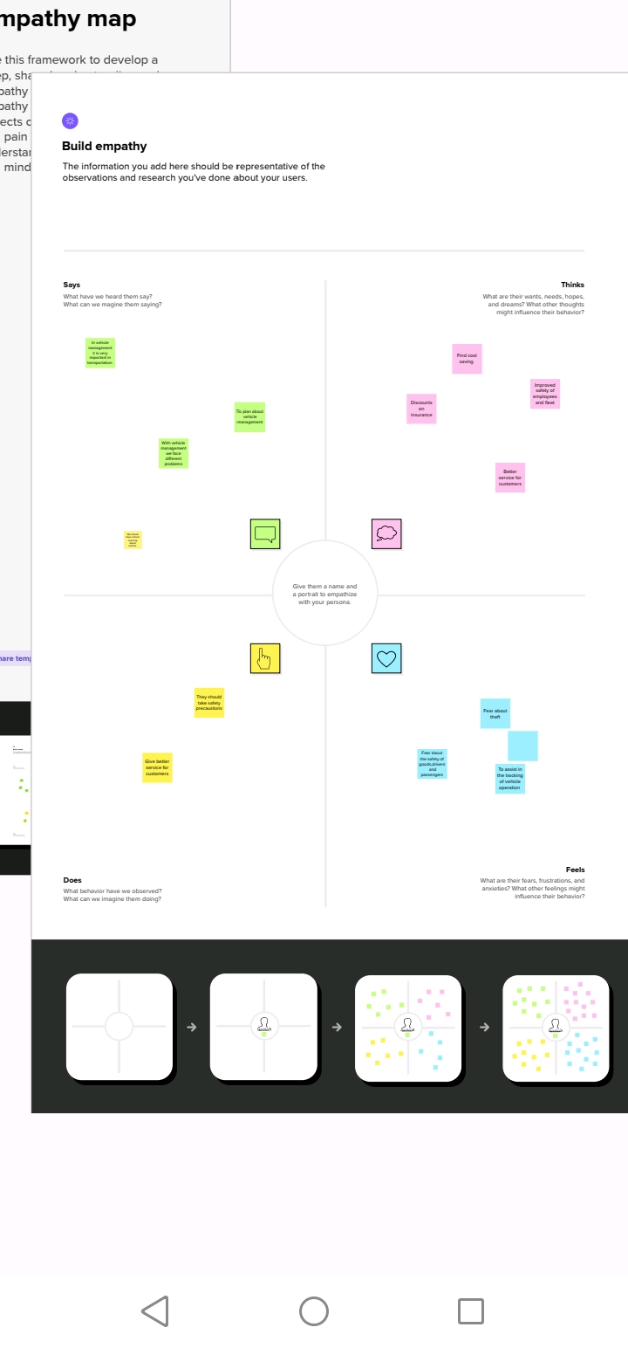

2.2 IDEATION & BRAINSTORMING MAP

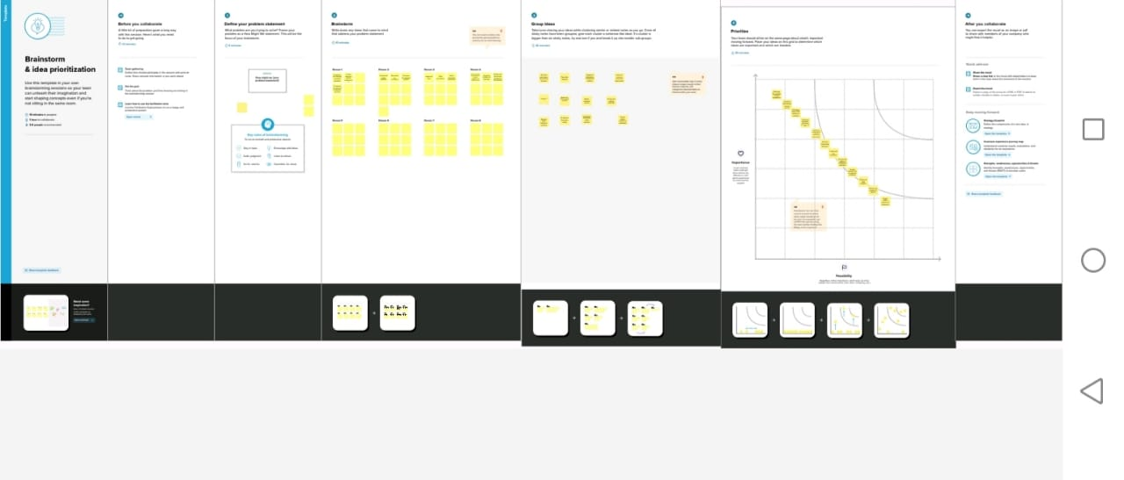

1. RESULT
   1. DATA MODEL

|  |  |
| --- | --- |
| Objective name | Fields in the object |
| obj 1  Vehicle | |  |  | | --- | --- | | Field label | Data type | | Vehicle name | text | | Vehicle number | text | |
| obj 2  Driver | |  |  | | --- | --- | | Field label | Data type | | Driver name | text | | Licence number | text | |

* 1. ACTIVITY & SCREENSHOT

ACTIVITY 1

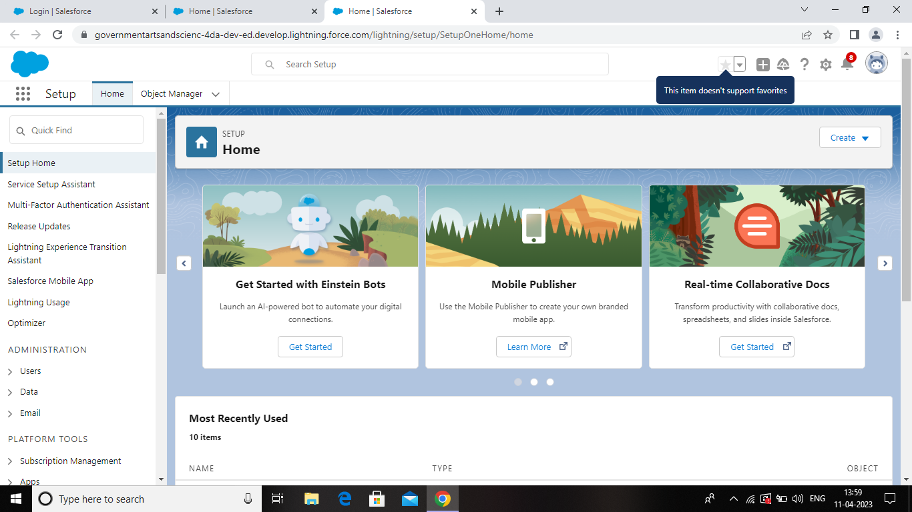

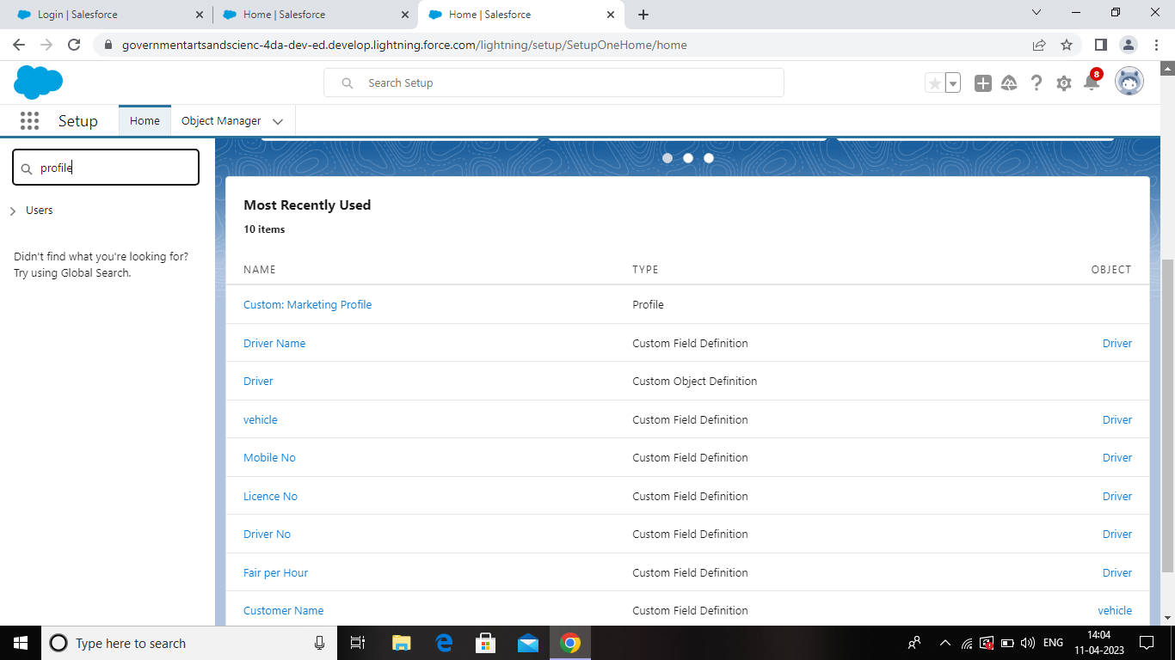

ACTIVITY 2

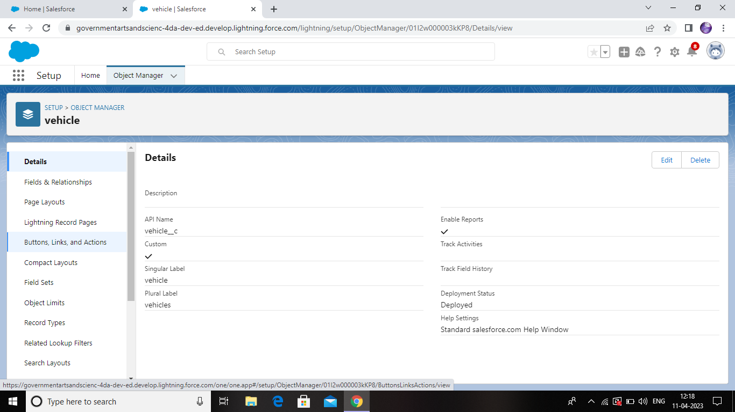

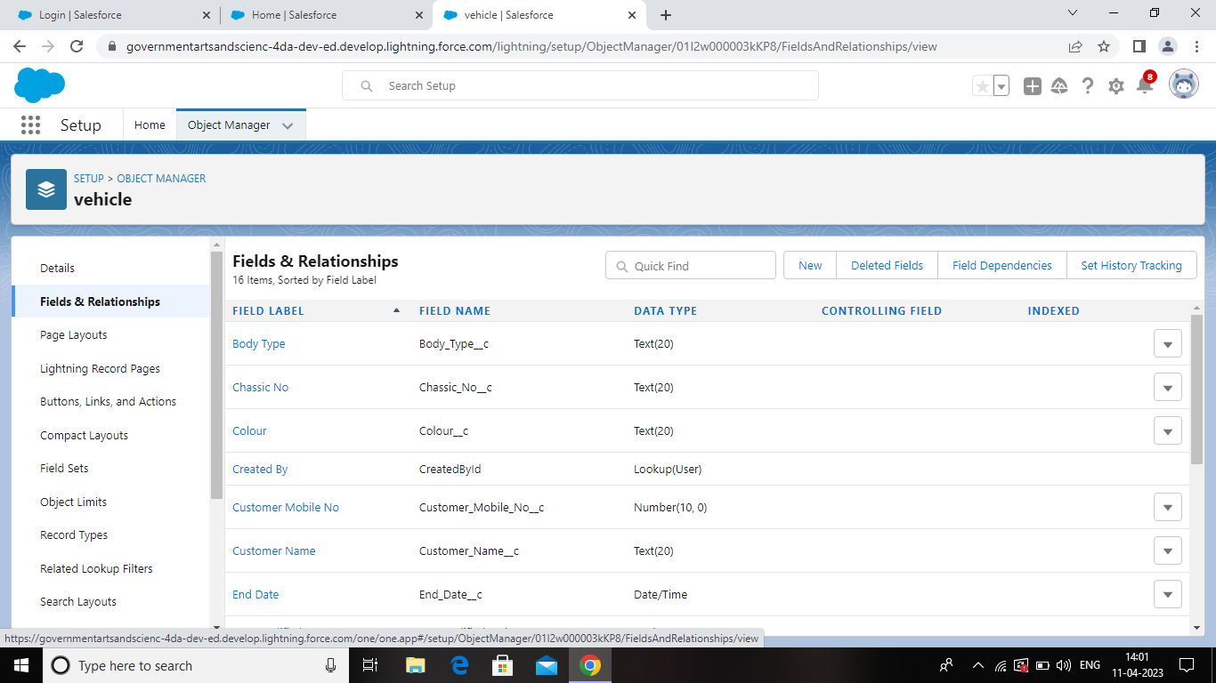

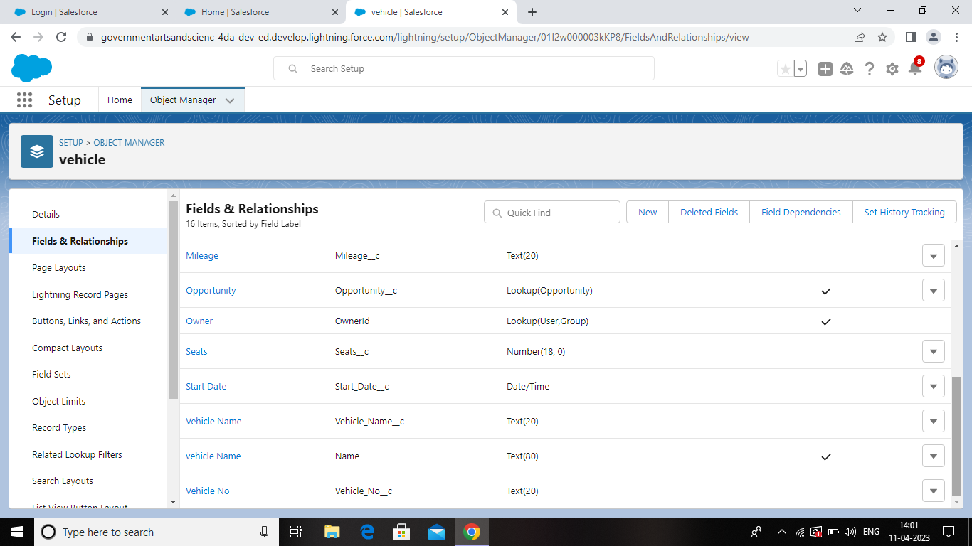

ACTIVITY 3

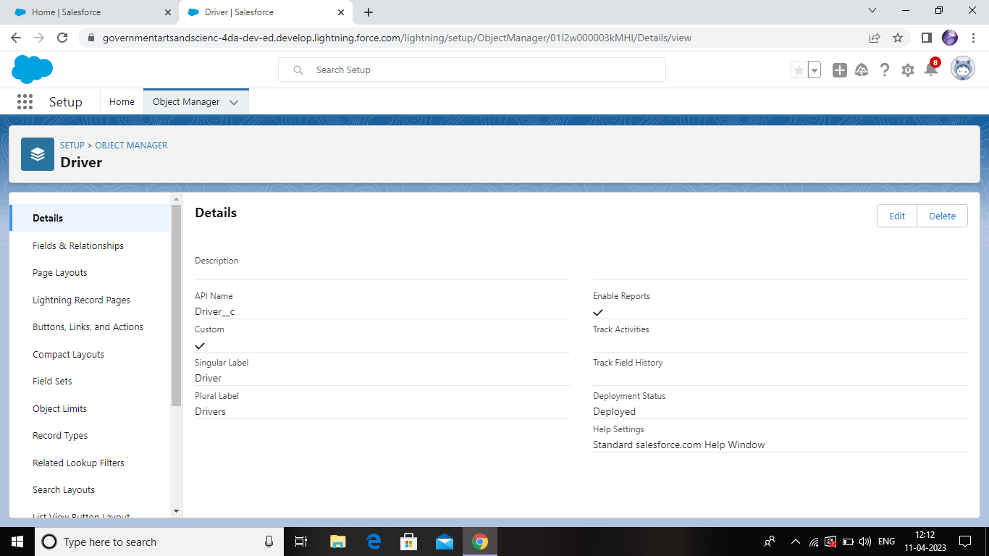

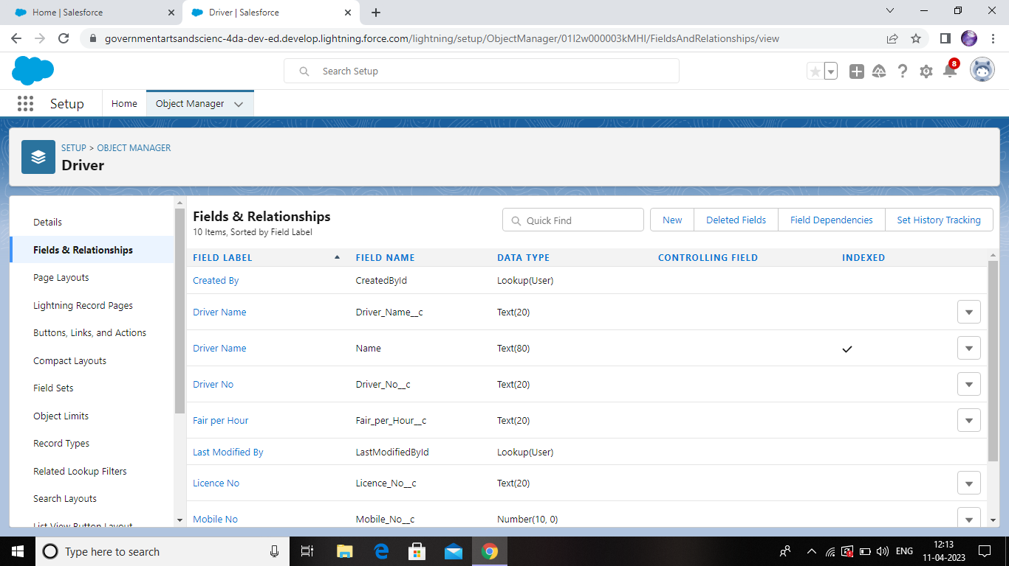

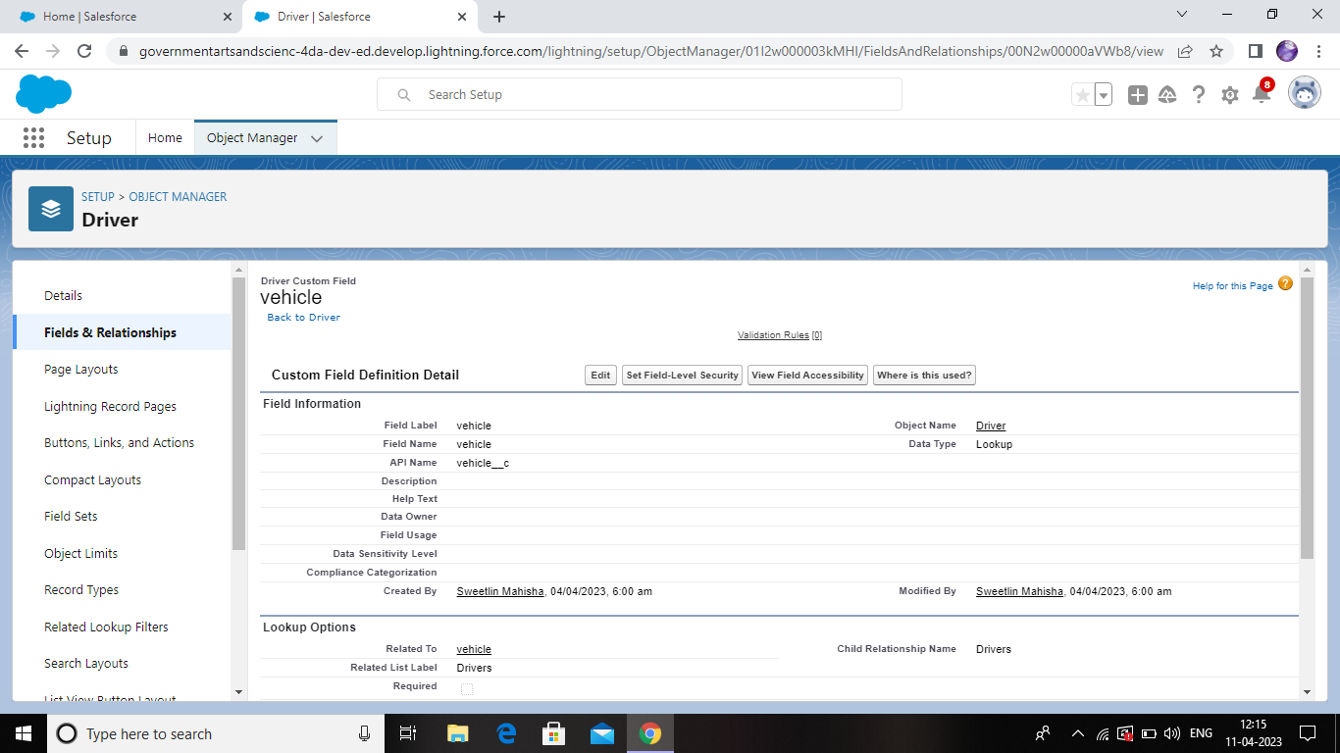

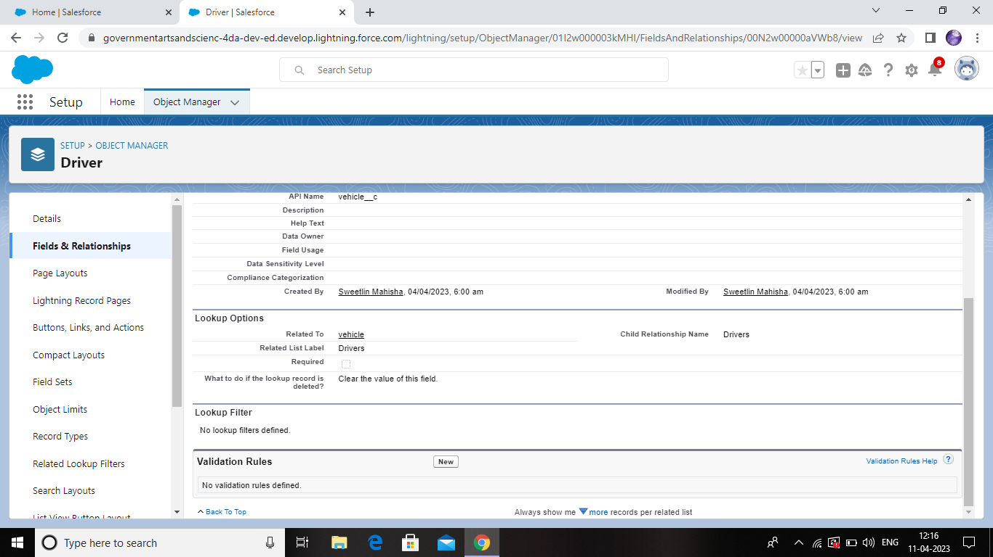

ACTIVITY 4

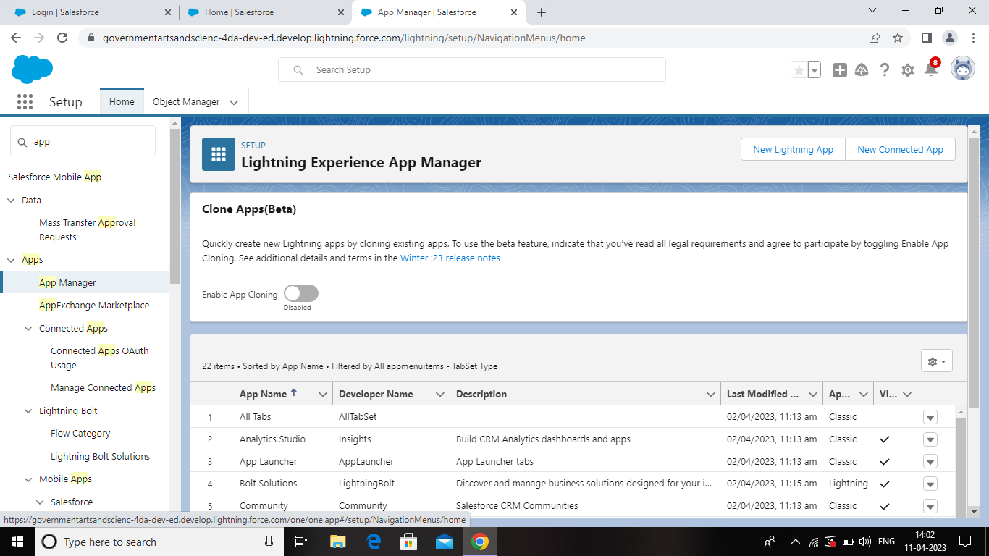

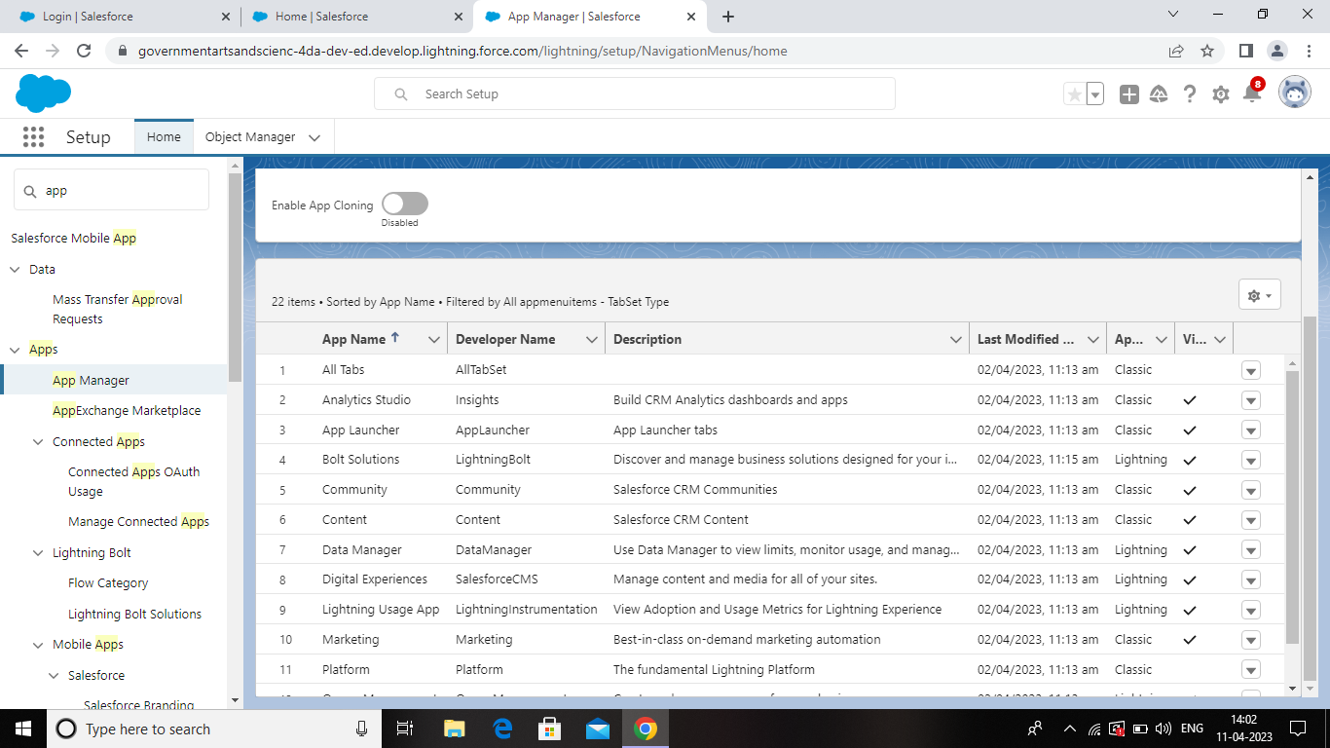

ACTIVITY 5

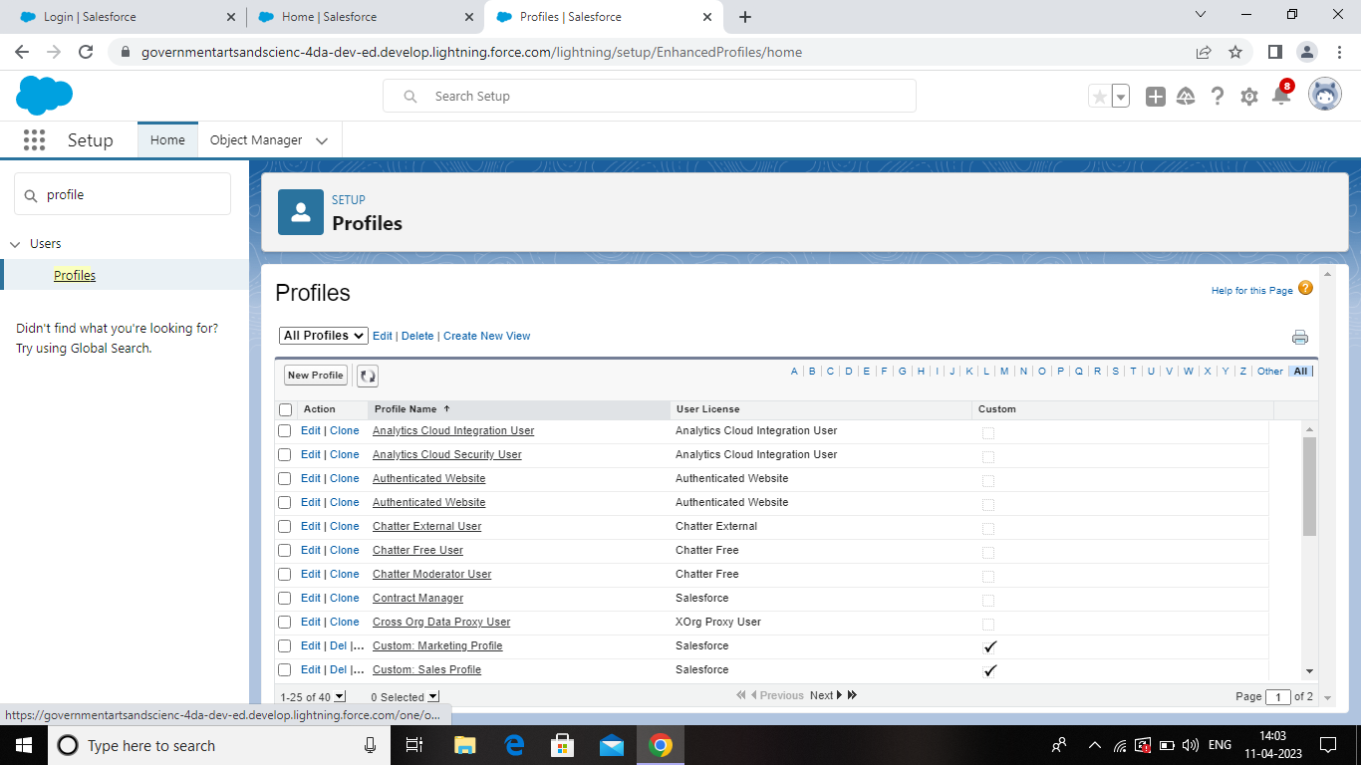

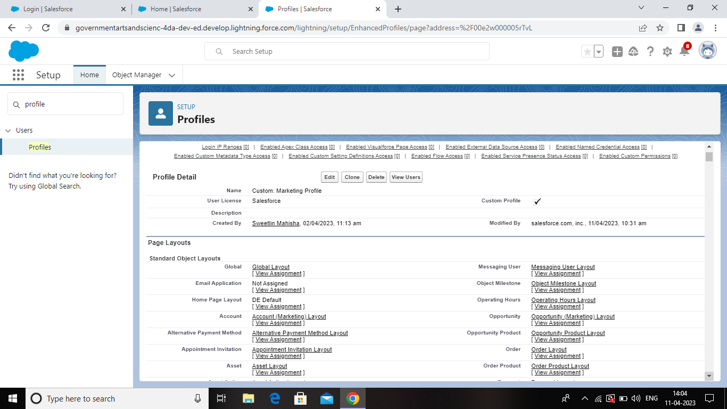

ACTIVITY 6

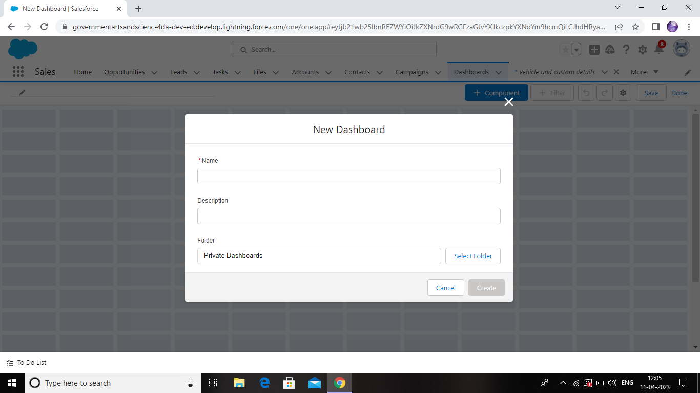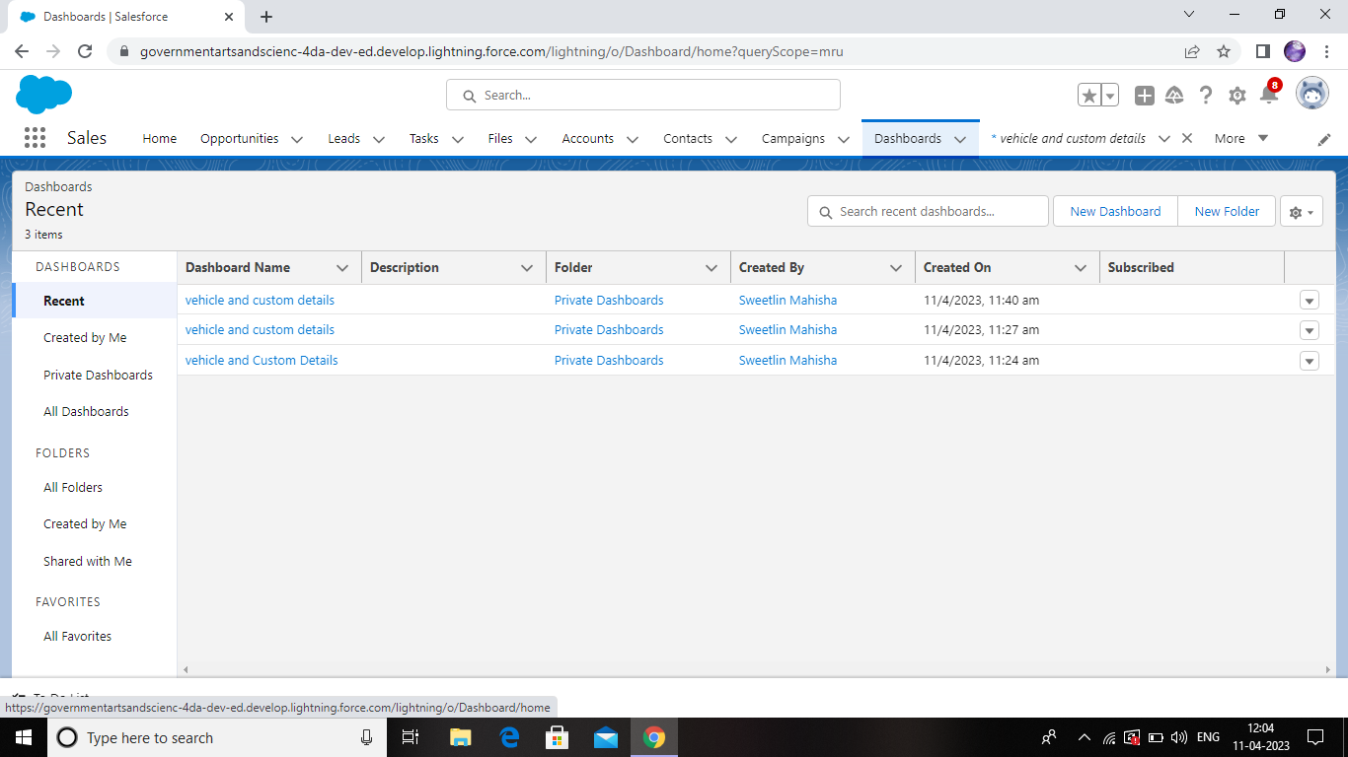

1. TRAILHEAD PROFILE PUBLIC URL

Team Head-<https://trailblazer.me/id/imahisham>

Team member 1- <https://trailblazer.me/id/maths38>

Team member 2- <https://trailblazer.me/id/ashar3936>

Team member 3- <https://trailblazer.me/id/ii35t>

1. ADVANTAGES & DISADVANTAGES

Advantages

* Improve fleet safety and working conditions
* Improve the behavior and performance and drivers and beat unsafe driving
* Schedule shifts and work hours
* Leverage driver retention
* Track vehicles, assets or professional equipment
* Schedule routine maintenance
* Manage fuel efficiency
* Keep track of malfunctions
* Track mileage and manage deductible expenses
* Produce individualized reports for all parties involved

Disadvantages

* Active tracking based vehicle management requires monthly subscription charges and data usage charges
* It is difficult to manage and maintain vehicle management system due to use of multiple technologies such as cloud servers, cellular wireless systems, vehicle management software etc.
* It requires skilled resources to maintain such system. This increase maintenance costs.

APPLICATION

* Schools
* Colleges
* Offices
* Industries
* Whole world wide

7 CONCLUSION

This application is applicable for all the students and candidates. It can be give a new way to handle a Internals results and marks. Everyone can use this application.

8 FUTURE SCOPE

* We can add printer in future.
* We can give more advance software for vehicle management system including more facilities.
* We will host the platform on online servers to make it accessible worldwide.
* Integrate multiple load balancers to distribute the loads of the system.