1. Introduction
This lab work aims to demonstrate how Generative AI (GAI) can be integrated into the TypeScript Dependency Analysis Tool developed as part of my master’s thesis. The tool analyzes TypeScript projects to detect and visualize dependencies, generate Dependency Structure Matrices (DSM), and identify architecture violations. In this task, UML diagrams were created using PlantUML to illustrate how GAI services can be embedded into the workflow to enhance developer support, explain analysis results, and provide intelligent recommendations.
2. Selected Company: GitHub (Microsoft)
The company that best suits the integration of the developed solution is GitHub, owned by Microsoft. GitHub offers a perfect environment for integrating the dependency analysis tool due to its strong connection with the TypeScript ecosystem and VS Code, GitHub Actions for continuous integration (CI/CD), and integration with Copilot, which uses large language models (LLMs) to provide natural-language explanations, refactoring advice, and code quality insights. The ability to display analysis results as part of pull request checks improves developer collaboration and code health.
3. System Description
The proposed solution includes several main modules:
- Quick Import Scan - detects direct dependencies among files.
- Semantic Analyzer - performs detailed inspection using the TypeScript Compiler API.
- Graph Builder and DSM Generator - constructs dependency graphs and DSM matrices.
- Policy Engine - checks architectural rules and dependencies between modules.
- GAI Orchestrator - communicates with a Large Language Model (LLM) to interpret analysis results and generate human-readable feedback.
- Report Generator - compiles both technical and AI-augmented reports for developers.
The integration of GAI allows the tool to provide advanced functionalities such as:
- Explaining dependency cycles and module violations in natural language.
- Suggesting architectural refactors and new dependency policies.
- Generating project documentation based on code structure.
4. UML Diagrams
Several UML diagrams were created using PlantUML to visualize the system’s structure and AI integration:
1. Component Diagram - shows how the analyzer, GitHub, and GAI components interact.
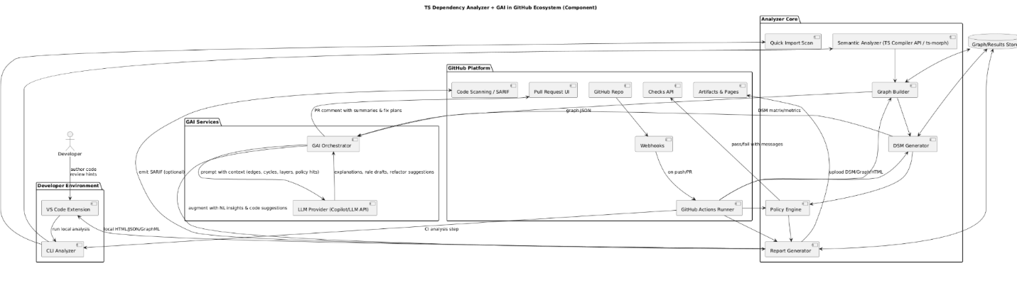
2. Sequence Diagram - illustrates the CI workflow during a pull request, including LLM-based feedback.
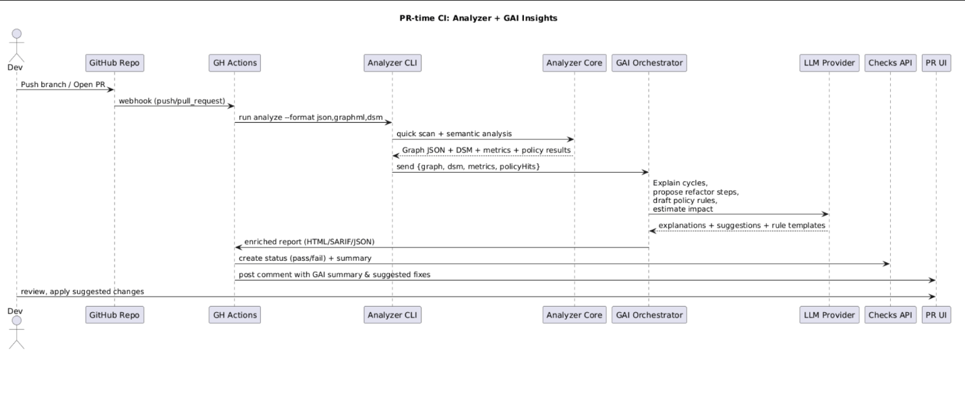
3. Class Diagram - represents the internal class relationships within the analyzer and GAI client.
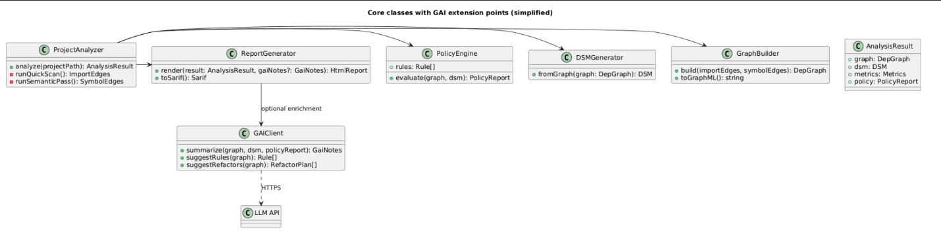
4. Deployment Diagram - shows how the system is deployed across the developer environment, GitHub Actions, and cloud-based GAI services.
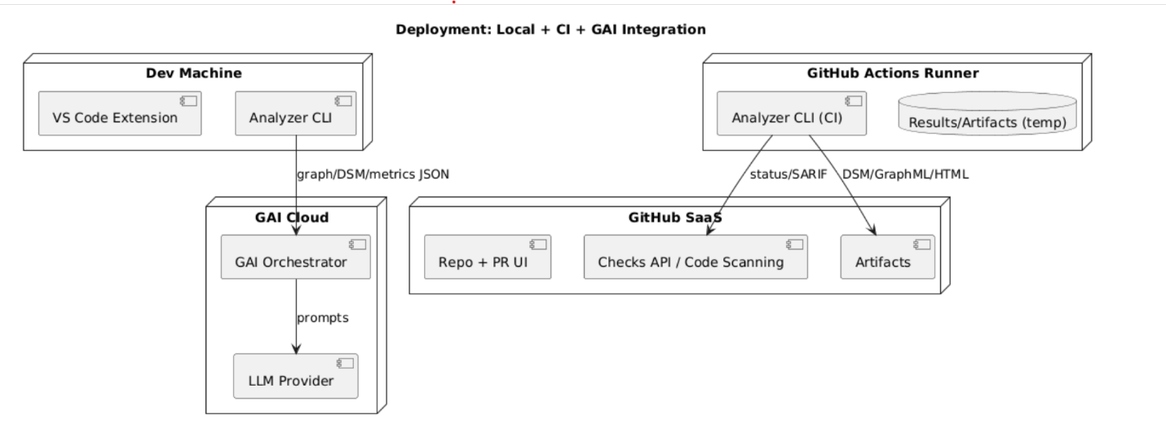
5. Conclusion
Through this integration, the tool not only performs static analysis but also provides intelligent, AI-driven explanations and recommendations. GitHub’s ecosystem offers the ideal environment for deploying such an AI-augmented tool, making the development and review process more efficient and insightful.

