-- 1. Register New User (registerUser)
INSERT INTO users (fullname, username, email, phone_number, user_type, max_borrow_limit, user_status, password, age)
VALUES ('marie','mak', 'maro@email.com', '012344655', 'Student', 3, 'Active', '232322', 20);
-- 2. User Login (userLogin)
SELECT user_id, username, password, user_status
FROM users
WHERE username = 'Dr.Ahmed';
-- 3. Get User Info (getUserInfo)
SELECT user_id, fullname, username, email, phone_number, user_type, max_borrow_limit, user_status, age
FROM users
WHERE user_id = 3;
-- 4. Check if User Can Borrow (canUserBorrow)
SELECT u.user_status, u.max_borrow_limit, COUNT(bp.process_code) AS current_borrowings
FROM users u
LEFT JOIN borrowing_process bp ON u.user_id = bp.user_id AND bp.status IN ('Borrowed', 'Overdue')
WHERE u.user_id = 3
GROUP BY u.user_id;
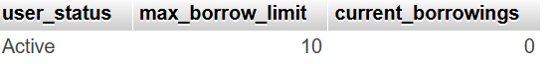
-- 5. Staff Login (staffLogin)
SELECT staff_id, username, password, staff_status, position
FROM staff_member
WHERE username = 'mary';

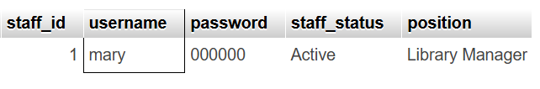
-- 6. Get Staff Info (getStaffInfo)
SELECT staff_id, member_name, email, phone_num, position, hire_date, salary, staff_status, age
FROM staff_member
WHERE staff_id = 2;

-- 7. Get Active Staff (getActiveStaff)
SELECT staff_id, member_name, email, position, hire_date, staff_status
FROM staff_member
WHERE staff_status = 'Active'
ORDER BY position, member_name;

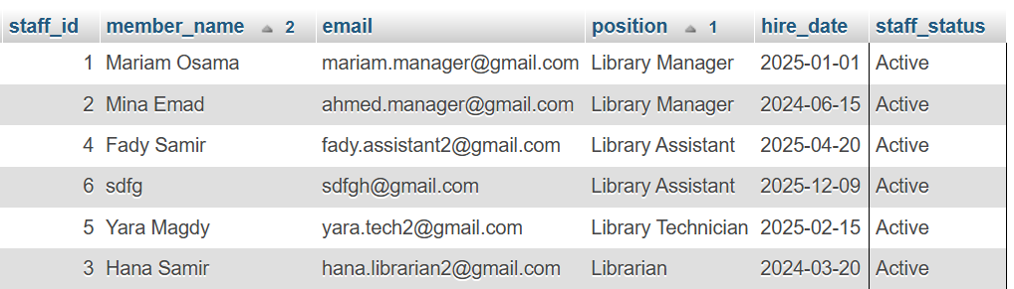

-- 8. Get Available Books (getAvailableBooks)
SELECT book_id, book_name, author_name, release_year, available_copies, book_description, book_language, total_pages
FROM book
WHERE available_copies > 0
ORDER BY book_name;
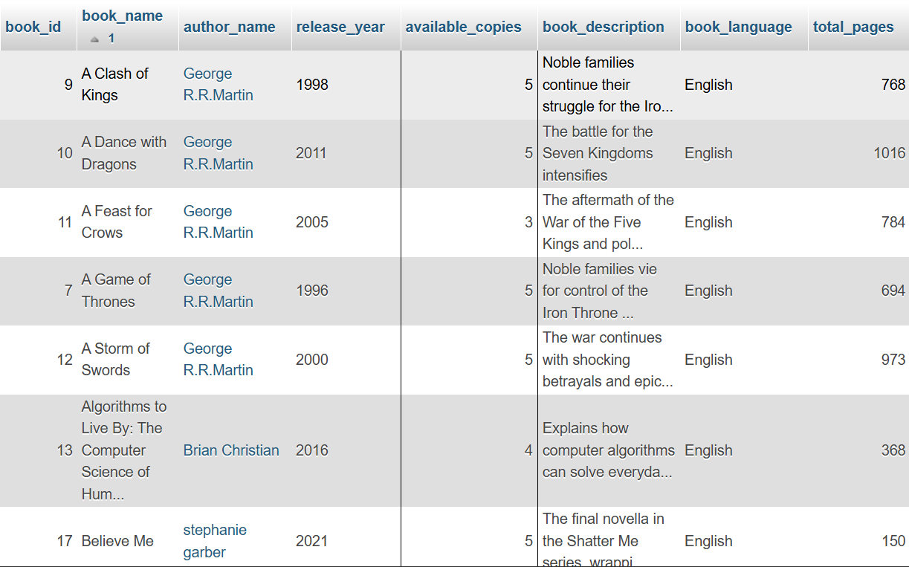
-- 9. Get All Books (getAllBooks)
SELECT book_id, book_name, author_name, release_year, available_copies, book_description, book_language, total_pages
FROM book
ORDER BY book_name;
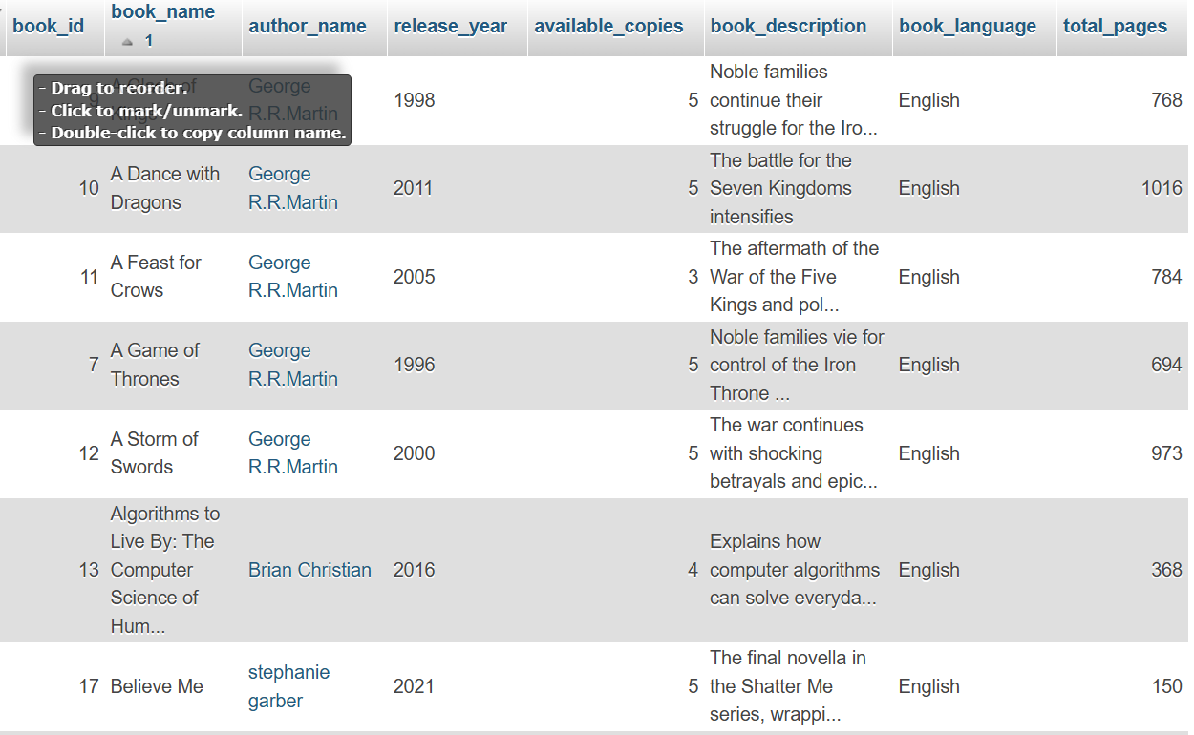
-- 10. Get Book By ID (getBookById)
SELECT *
FROM book
WHERE book_id = 5;

-- 11. Get Book Cover (getBookCover)
SELECT book_cover
FROM book
WHERE book_id = 4;
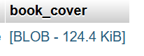
-- 14. Check Book Availability (isBookAvailable)
SELECT available_copies
FROM book
WHERE book_id = 5;
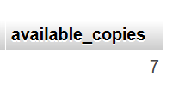
-- 17. Return Book - Get Borrowing Info (returnBook)
SELECT *
FROM borrowing_process
WHERE process_code = 1764795768;

-- 20. Get User Borrowings (getUserBorrowings)
SELECT bp.process_code, b.book_name, b.author_name, bp.process_date, bp.due_date, bp.return_date, bp.status,
DATEDIFF(CURDATE(), bp.due_date) AS days_overdue
FROM borrowing_process bp
INNER JOIN book b ON bp.book_id = b.book_id
WHERE bp.user_id = 2
ORDER BY bp.process_date DESC;
-- 22. Get User Activity Summary
SELECT u.user_id, u.fullname, u.user_type,
COUNT(bp.process_code) AS total_borrowed,
SUM(CASE WHEN bp.status = 'Borrowed' THEN 1 ELSE 0 END) AS currently_borrowed,
SUM(CASE WHEN bp.status = 'Returned' THEN 1 ELSE 0 END) AS returned_books
FROM users u
LEFT JOIN borrowing_process bp ON u.user_id = bp.user_id
GROUP BY u.user_id
ORDER BY total_borrowed DESC;

