Mahi Berhanu

Lab 4 - Out - Of - Lab

1. egrep -w 'Towns|Union' /home/mberhanu2/Lab4/mountainList.txt
2. grep 'R​​abun' mountainList.txt | wc -l
3. grep -c 'Rabun' mountainList.txt
4. 1. 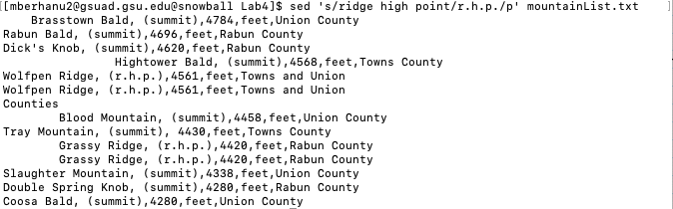
   2. 
   3. -n is used to suppress automatic printing of pattern space.
   4. It only displayed lines that were printed out twice when we used only sed and replaced all the ridge high points with r.h.p.
5. sed -e 's/^[ \t]\*//' mountainList.txt
6. sed -e 's/^[ \t]\*//' mountainList.txt > newList.txt
7. sed -n 's/^[ \t]//p' mountainList.txt
8. sed '/Union County/d' mountainList.txt
9. sed 's/,[^,]\*,[^,]\*,[^,]\*,/,/' mountainList.txt
10. awk -F',' 'BEGIN{OFS=","}{print $1,$5}' mountainList.txt
11. sed -i '1i Table: Eleven highest mountains in Georgia' mountainList.txt
12. sort -t "," -k 1,1 mountainList.txt
13. sort -t"," -r -nk 3,3 mountainList.txt
14. 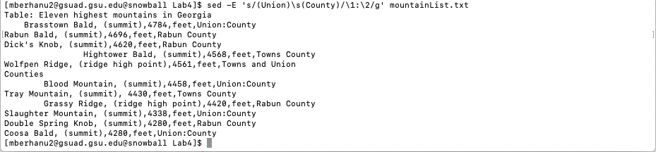
15. sed -E 's/,.\*,/,/' mountainList.txt