Mahi Berhanu

Lab 7 Post Lab

1.

a. Source Code:

#include <stdio.h>

int main() {

int x;

int y;

int z;

printf("Enter a phone number [(999)999-999]: ");

scanf("(%d)%d-%d", &x,&y,&z);

printf("You entered: %d-%d-%d", x,y,z);

}

b. Output Screenshot:

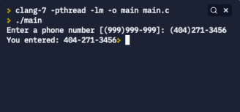

2.

a. Source Code:

#include <stdio.h>

int main() {

float number, price, total;

int month, date, year, quantity;

printf("Enter item number: ");

scanf("%f",&number);

printf("Enter unit price: ");

scanf("%f",&price);

printf("Enter quantity: ");

scanf("%d",&quantity);

printf("Enter purchase date (mm/dd/yyyy): ");

scanf("%d/%d/%d",&month,&date,&year);

total=price\*quantity;

printf("Item \t");

printf("QTY \t");

printf("Purchase Date \t");

printf("Unit Price \t");

printf("Total Amount \t \n");

printf("%f \t",number);

printf("%d \t",quantity);

printf("%d/%d/%d \t \t",month,date,year);

printf("$ %f \t \t",price);

printf("%f \t",total);

return 0;

}

b. Output Screenshot:

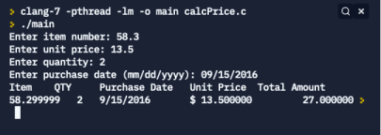

Part 2:

