# GitHub Logos and Usage · GitHub SUMMARY REPORT ON GIT AND GITHUB

### GIT: Git is a free and open-source version control system, means that we can save the initial version of our code and then update it anytime and save it again in Git. We can track all our changes that we have done in our project through git.

### 

### Terms Used:

1. Directory 🡪 Folder
2. Github 🡪 A website to host our repositories online
3. CLI 🡪 Command Line Interface
4. Cd 🡪 Change Directory
5. Repository 🡪 Our project or the place where our project is stored

### Basic Git Commands:

1. **clone:** Bring a repository that is hosted somewhere like on github into a folder which is present on our local machine

**git clone [url]**

1. **add:** This command is used to track the files and change it in git

**git add [file]**

1. **commit:** Saves the file or changes in git

**git commit -m “[ Type in the commit message]”**

1. **push:** This command uploads the git commits into the remote repo

**git push [variable name] master**

1. **pull:** Download changes from remote repo to our local machine

**git pull [Repository Link]**

1. **Git Status:** This command is used to check the status of the project

**git status**

**Readme** is the basic text file in every project that gives the description of the project. Each commits always has a unique identifier and also git help us to see what changes were done in the project at what point of time. To check installation git on the local machine we need to type a command as **“git - -version”**

When we clone a project or create a project folder through git than **“.git”** is a hidden file which is being created and which saves all our commits or changes of code. It has all of the changes recorded in the history of the project folder.

### Github Workflow

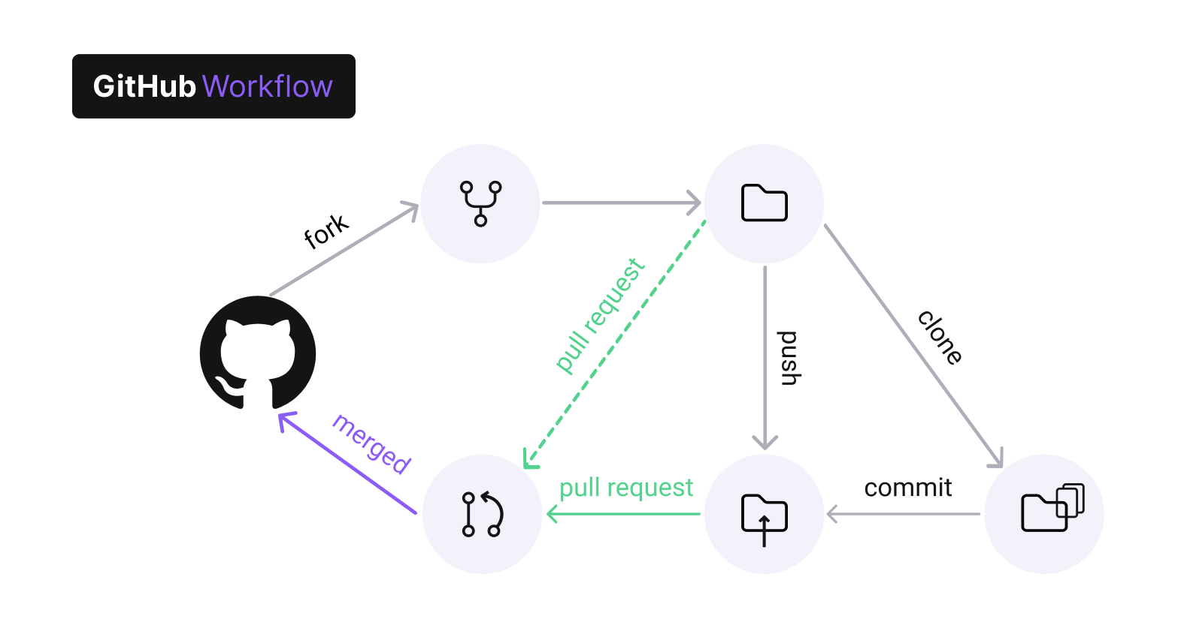

### Git Branching

In git we have a default branch as “**Master Branch”**. The git branch command lets us create, list, rename, and delete branches.

To list all the branch in our repository we use the command git - - list branch

To create a new branch we use the command git branch -d <branch>

To delete a git branch we use the command git branch -D<branch>

To create a new branch we use the command git branch [branch name]

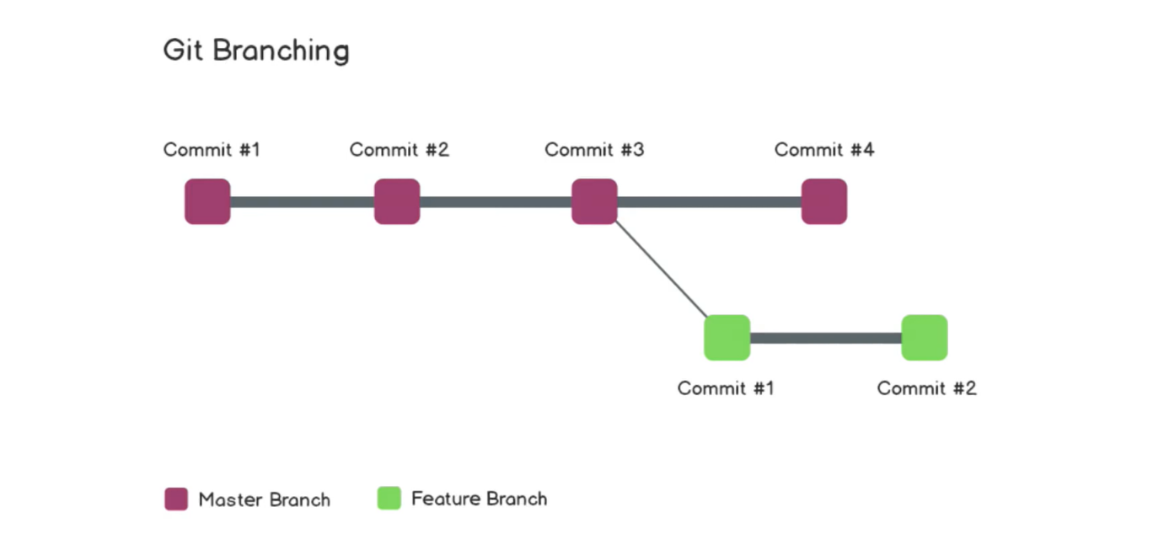

Thus we can say that the git branch operations are inexpensive and frequently used. This flexibility enables powerful [Git workflow](https://www.atlassian.com/git/tutorials/comparing-workflows) customization.

### Undoing in Git

In git we can undo our changes which we don’t want to make in our project, for this purpose the command used is “**reset”.** If certain commits are needed to be undone than we write the command as “**git reset HEAD~1**” where, the head is pointing to the last commit. In git all commits are stored in **reverse chronological order.**

### Forking in Git

Forking is the concept of taking another’s persons repo into our own local machine so that we can modify it and update the changes accordingly. The Fork button on github allow us to do so. The main advantage of the Forking Workflow is that contributions can be integrated without the need for everybody to push to a single central repository.

**Reported Submitted By**

**Mahima Churi**