**MCAS SMARTHELPER BOT / AI CHAT BOT**

***A report submitted in partial fulfillment of the requirements for the***

***Award of Degree of***

*BACHELOR OF COMPUTER APPLICATION*

**Submitted by**

**MAHITH S**

**(REGISTER NUMBER: 21MUCA1084)**

*Guided by*

**Ms.N.PADMAPRIYA M.Sc., M. Phil., B.Ed.,**

**Assistant Professor, Computer Application**

**Muthayammal collage of arts and Science (AUTONOMOUS)**



**DEPARTMENT OF COMPUTER APPLICATION**

*MUTHAYAMMAL COLLEGE OF ARTS AND SCIENCE (AUTONOMOUS)*

Affiliated to Periyar University, Salem,

Accredited by NAAC with an 'A' grade,

Recognized by UGC under Section 2 (F) & 12(B), Rasipuram-637 408, Namakkal District, Tamil Nadu.

*APRIL-2024*

**MUTHAYAMMAL COLLEGE OF ARTS AND SCIENCE** **(AUTONOMOUS)**



***CERTIFICATE***

This is to certify that the **“MCAS SMARTHELPER BOT / AI CHAT BOT “submitted** **by**

**MAHITH S (21MUCA1084)** is work done by his and submitted during 2024-2025 academic year, in partial fulfillment of the requirements for the award of the degree of **BACHELOR OF COMPUTER APPLICATION** at **License Plate Detection and Recognition (LPDR)**

**Project Coordinator (College)**

**HEAD OF THE DEPARTMENT**

DR.V. VIJAYADEEPA

Submitted for the viva- voce examination held on

**Internal Examiner External Examiner**

**ACKNOWLEDGEMENT**

**ACKNOWLEDGEMENT**

I wish to express my profound thanks to people who have helped me to make the application reality. It is my pleasure to acknowledge the help of all individuals.

I am delighted to thank our **Chairman Thiru. K.P.RAMASWAMY, Thiru.R.MUTHUVEL, Secretary, Dr. R.SELVAKUMARAN., Director-Academics, Vanetra Muthayammal Institution**, for having sufficient infrastructure to execute my project work successfully.

I Would like to express my sincere thanks to, **Dr. S.P.VIJEIKUMAR M.Sc.,( Ph.D)., Principal, Dr. A. STELLABABY, M.A., M.Phil., Ph.D., Vice Principal**, **Muthayammal College of Arts and Science** for giving me an opportunity to carry out this project.

I wish to extend my gratitude to **Dr. V.VIJAYADEEPA M.C.A., M.Phil., (Ph.D).,Head Department of Computer Application & Data Science,** for her moral support.

I wish to extend my gratitude to **Mrs.N.PADMAPRIYA M.Sc., M.Phil., B.Ed.,** **Assistant Professor, Computer Application** and my project guide for his courageous support and guidance on various stages of this project.

I wish to thank all other faculty members of Department of Computer Applications, Muthayammal College of Arts and Science, Rasipuram. It is my privilege to thank my parents for their support at all level of this project work.

Finally, I thank my friends and well-wishers for the constant moral support in the successful completion of this project work.

**(MAHITH S)**

**CONTENT**

|  |  |  |
| --- | --- | --- |
| **S.NO** | **PARTICULARS** | **PAGE NO.** |
| **1** | **Introduction to MCAS SmartHelper Bot** |  |
| **2** | **Botpress for MCAS** |  |
| **3** | **Botpress** |  |
| **4** | **Functionality and Modules of the College Bot** |  |
| **5** | **Menu Selection** |  |
| **6** | **Key Features** |  |
| **7** | **Benefits** |  |
| **8** | **Edit Studio** |  |
| **9** | **Bot Information** |  |
| **10** | **Webchat Settings** |  |
| **11** | **Agents & Knowledge Base** |  |
| **12** | **Botpress: Building and Configuring Chatbots** |  |
| **13** | **Advanced Styler: Customizing Web Chat CSS Properties** |  |
| **14** | **Logs Panel** |  |
| **15** | **Conversations feature** |  |
| **16** | **Analytics** |  |
| **17** | **Chat page** |  |
| **18** | **Overview of MCAS** |  |
| **19** | **References** |  |
| **20** | **Conclusion** |  |

**1.Introduction to MCAS SmartHelper Bot**

**Content**:

* Brief overview of the College Bot and its purpose.
  + The College Bot is an AI-powered conversational agent designed to provide timely and accurate information to students, faculty, and staff of the college.
  + Its primary purpose is to streamline communication channels, facilitate access to essential resources, and enhance overall user experience within the college ecosystem.
* Introduction to Botpress Studio as the development platform.
  + Botpress Studio is an open-source conversational AI platform that offers a comprehensive suite of tools for building, deploying, and managing chatbots and virtual assistants.
  + It provides an intuitive interface, extensive customization options, and seamless integration capabilities, making it an ideal choice for developing sophisticated conversational agents like the College Bot.
* Explanation of the importance of the bot for college communication and information dissemination.
  + With the growing reliance on digital communication channels, the College Bot serves as a centralized hub for accessing information, resolving queries, and completing administrative tasks efficiently.
  + By leveraging AI technology, the bot can handle a wide range of inquiries and tasks autonomously, reducing the burden on human resources and improving overall productivity within the college community.

**2.Introduce the project, stating that it involves the development of a chatbot using Botpress for MCAS (Muthayammal College of Arts & Science).**

This project involves the development of an advanced chatbot utilizing Botpress technology tailored specifically for Muthayammal College of Arts & Science (MCAS). The aim of this endeavor is to enhance the efficiency of communication and provide comprehensive assistance to students, faculty, and visitors within the MCAS community. With the integration of Botpress, MCAS endeavors to offer an intuitive and user-friendly interface that streamlines access to essential information, services, and resources available within the institution.

The implementation of a chatbot within the MCAS ecosystem aligns with the institution's commitment to embracing technological advancements to improve overall user experience. By harnessing the capabilities of Botpress, the chatbot will serve as a virtual assistant capable of addressing a wide range of inquiries, facilitating smoother navigation through various campus facilities, and offering timely assistance to users.

Through this project, MCAS seeks to revolutionize the way stakeholders interact with the institution, providing them with a seamless and personalized experience that caters to their individual needs and preferences. The development of this chatbot marks a significant step towards modernizing communication channels at MCAS and fostering a more connected and engaged campus community.

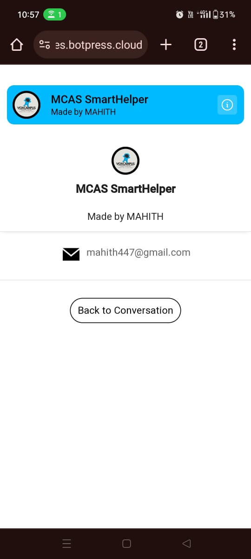This page serves as the main interface for the MCAS SmartHelper bot, designed and developed by MAHITH. The bot is named VOXCAMPUS and aims to assist users with various inquiries and tasks related to Muthayammal College of Arts & Science (MCAS). Users can interact with the bot to obtain information, ask questions, and receive assistance on a wide range of topics.

he presence of the email address ([mahith447@gmail.com](mailto:mahith447@gmail.com)) provides users with a direct means of contacting the bot creator for reporting issues or providing feedback. By clicking on the email address, users can report any issues they encounter while interacting with the bot, ensuring continuous improvement and troubleshooting

This page represents the chat interface with the MCAS SmartHelper bot. Users can initiate conversations with the bot to seek assistance, ask questions, or engage in interactive dialogues. The bot is programmed to provide relevant information, answer queries, and guide users through various processes related to Muthayammal College of Arts & Science.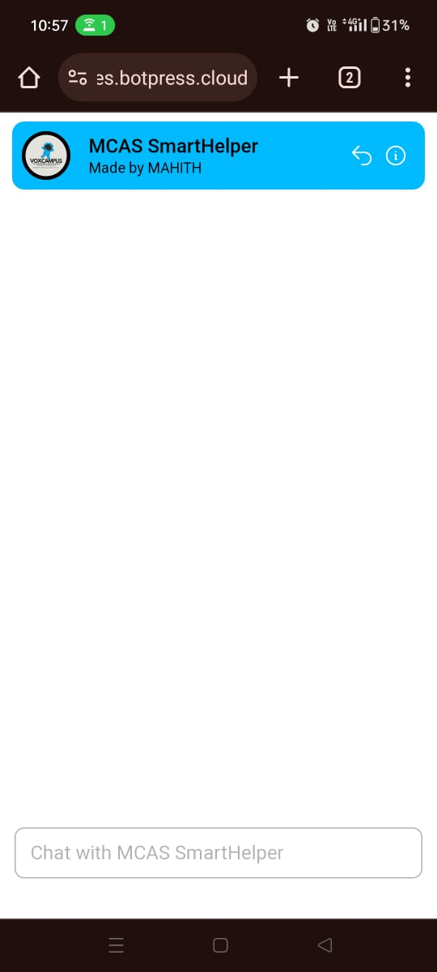

This interface provides a user-friendly platform for students, faculty, and staff of MCAS to interact with the SmartHelper bot and access its functionalities seamlessly.

**3.Botpress**

Botpress is like a toolbox for building and managing chatbots, such as the MCAS SmartHelper Bot. It provides easy-to-use tools and features that help you create a smart assistant that can chat with users. With Botpress, you can design how your bot responds to different questions and tasks. It also helps you integrate your bot with websites or messaging apps so people can talk to it. Additionally, Botpress gives you insights into how your bot is performing so you can make improvements over time. Overall, it's a helpful tool for beginners to create their own chatbots without needing to know complex coding.

**4.Functionality and Modules of the College Bot**

**Content**:

* **Description of main functionalities such as:**
  + Providing information about courses, schedules, faculty, and academic resources.
  + Answering frequently asked questions (FAQs) related to admissions, events, facilities, and campus life.
  + Assisting in administrative tasks such as appointment scheduling, form submissions, and resource booking.
* **Segmentation of modules:**
  + Information retrieval module:
    - Utilizes structured data sources and APIs to fetch accurate and up-to-date information on courses, schedules, faculty profiles, etc.
  + FAQ handling module:
    - Employs natural language understanding (NLU) and predefined question-answer pairs to address common queries effectively.
  + Administrative task module:
    - Implements conversational workflows and backend integrations to facilitate tasks like appointment scheduling, form submissions, and resource booking seamlessly.

**Information Retrieval Module:**

Enables users to query information about MCAS, including academic programs, faculty details, campus facilities, events, and policies.

Provides accurate and relevant responses to user inquiries using natural language processing.

**Guidance and Assistance Module:**

Offers guidance and assistance on academic matters, administrative procedures, campus policies, and other relevant topics.

Provides step-by-step instructions to help users navigate through various processes within the college.

**Interactive Q&A Module:**

Facilitates interactive question-and-answer sessions, allowing users to address specific queries or concerns.

Utilizes advanced natural language understanding to interpret user queries and deliver precise responses.

**Event Management Module:**

Manages and promotes college events and activities.

Provides information about upcoming events, schedules, registration procedures, and logistical details.

**Feedback and Support Module:**

Allows users to submit feedback, report issues, or seek technical support.

Facilitates communication between users and administrators for issue resolution and service improvement.

**Resource Access Module:**

Helps users access educational resources such as online libraries, academic journals, study materials, and digital learning platforms.

Provides direct links or instructions for accessing these resources efficiently.

**Transportation and Logistics Module:**

Assists users in planning transportation options, including bus routes, schedules, and commuting logistics to and from the college campus.

**Notification and Announcement Module:**

Disseminates important notifications, announcements, and updates to users regarding academic deadlines, campus events, and policy changes.

Ensures timely communication and keeps users informed of relevant information.

**Integration with Campus Systems:**

Integrates with existing campus systems and databases to fetch real-time information such as student records, course schedules, exam timetables, and financial transactions.

Enhances the accuracy and reliability of information provided by the bot.

**Customization and Personalization:**

Allows users to customize their experience by setting preferences, receiving personalized recommendations, and accessing tailored services based on individual needs and interests.

This comprehensive set of functionalities and modules enables the MCAS SmartHelper bot to serve as a valuable resource for the MCAS community, offering convenience, efficiency, and accessibility in accessing college-related information and services.

* The College Bot offers a comprehensive suite of functionalities tailored to the specific needs of the college community.
* Segmenting functionalities into distinct modules ensures efficient handling of different types of queries and tasks, enhancing user experience and operational efficiency.

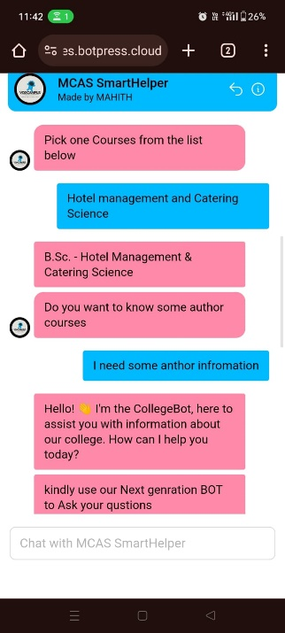

**Start:**

The conversation begins with a greeting message welcoming the user to the College Bot interface.

**5.Menu Selection:**

The user is presented with a list of menu options to choose from, including:

1. Student Help Corner
2. About the College
3. Academics Course
4. Admission
5. Contacts / Location
6. Text Inquiry

**Student Help Corner:**

* If the user selects this option, the bot prompts them to pick a course from a list.
* Upon selecting a course, the user is further prompted to choose their academic year and semester.
* After selecting the academic details, the bot provides information about classes, courses, and related materials.
* Additionally, the bot offers assistance from an AI helper if the user needs further clarification or assistance.
* About the College:
* If the user selects this option, they are presented with topics such as Vision-Mission-History, Chairman's Message, etc.
* Upon selecting a specific topic, the bot provides relevant information about the college based on the user's choice.

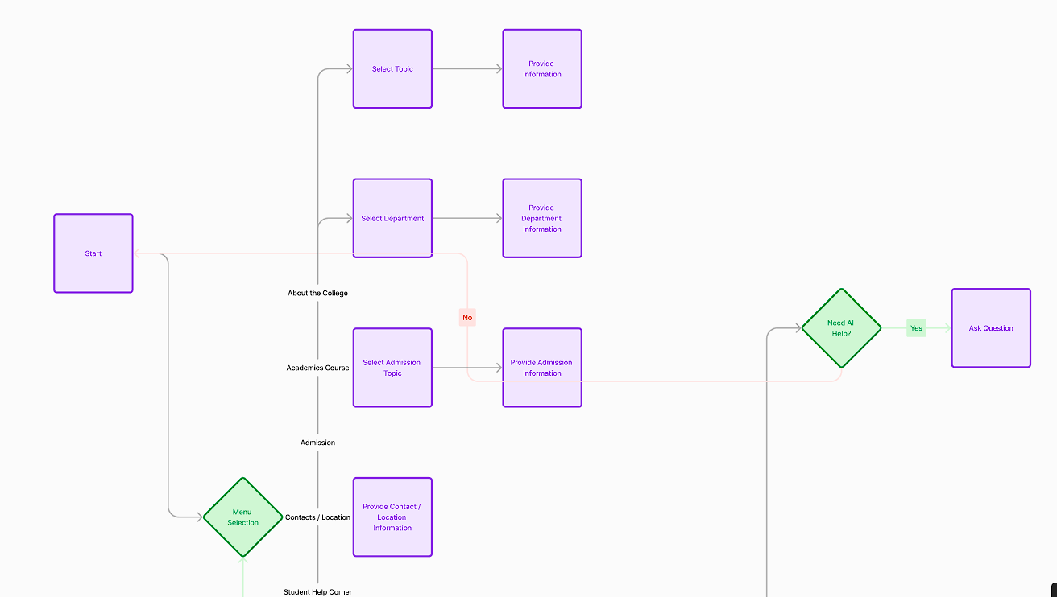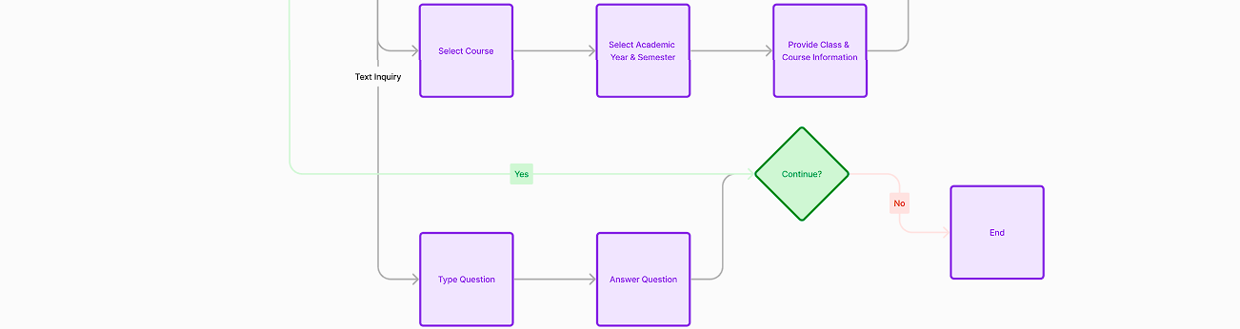

**Student Support Hub**

1. User selects "Student Help Corner."
2. Bot prompts the user to pick a course from the list.
3. Bot provides options for different years (I, II, III) based on the course.
4. Upon selecting a year, the bot presents options for different semesters.
5. If the user selects a semester, the bot shows available classes and courses.
6. If the user chooses a specific course, the bot provides relevant information.
7. If the user needs help with "Al" (Assisted Learning), the bot asks if they have any questions. If not, the conversation ends.

**6.Key Features:**

Conversational Interface: The bot employs a natural language interface, allowing users to interact with it just like they would with a human assistant.

24/7 Availability: Users can access support and information anytime, anywhere, reducing dependence on traditional support channels with limited availability.

Personalized Assistance: Through advanced algorithms, the bot delivers personalized responses and recommendations tailored to individual user needs and preferences.

Task Automation: Routine tasks such as accessing course schedules, submitting forms, and retrieving study materials are automated, saving users valuable time and effort.

Integrations: Seamlessly integrated with the MCAS platform, the bot retrieves real-time data and updates, ensuring accuracy and relevancy in its responses.

**7.Benefits:**

Enhanced User Experience: By providing instant and personalized assistance, the bot enhances user satisfaction and engagement.

Improved Efficiency: Automation of repetitive tasks frees up valuable resources, allowing users to focus on more strategic activities.

Scalability and Accessibility: The bot's accessibility across devices and platforms ensures that all users, regardless of technical expertise, can benefit from its capabilities.

Data Insights: Through analytics and reporting features, the bot provides valuable insights into user interactions and preferences, enabling continuous improvement and optimization.

**About the College:**

* If the user selects this option, they are presented with topics such as Vision-Mission-History, Chairman's Message, etc.
* Upon selecting a specific topic, the bot provides relevant information about the college based on the user's choice.

**Discover Our Story**

1. User selects "About the College."
2. Bot presents options for Vision-Mission-History, Chairman's Message, or going back.
3. Based on the user's choice, the bot provides relevant information.

**Academics Course:**

* Upon selecting this option, the user is prompted to choose a department from a list of available departments.
* After selecting a department, the bot provides information about courses, programs, and academic offerings within that department.

**Academic Pathways**

1. User selects "Academics Course."
2. Bot provides a list of course options.
3. Depending on the user's selection, the bot provides information about that course.

**Admission:**

* If the user selects this option, they are presented with admission-related topics such as Application, Admission Contact, etc.
* Upon selecting a specific topic, the bot provides information and guidance related to the admission process.

**Admission Gateway**

1. User selects "Admission."
2. Bot provides options like Application, Admission Contact, Academic Scholarship, or Admission Pre-Registration.
3. Based on the user's choice, the bot provides relevant information.

**Contacts / Location:**

* If the user chooses this option, the bot provides contact details and location information about the college.

**Connect with Us**

1. User selects "Contacts."
2. Bot provides contact information or other relevant details.

**Locate Us**

1. User selects "Location."
2. Bot provides information about the college's location.

**Text Inquiry:**

* If the user selects this option, the bot prompts them to ask a question.
* The user can type their question, and the bot attempts to provide a relevant response.
* If the bot cannot answer the question, it notifies the user and offers assistance from an AI helper.

**Curious Minds**

1. User selects "Text here to get some another information."
2. Bot asks if the user has any questions.
3. If the user asks a question, the bot tries to respond. If it doesn't have an answer, it informs the user.

**Continuation:**

* After each interaction, the bot asks if the user wants to continue the conversation or if they have any more questions.
* If the user chooses to continue, they are taken back to the menu selection to choose another option.
* If the user indicates they are finished, the conversation ends, and the bot bids farewell.

**8.Edit Studio:**  
Edit Studio is a key component of the MCAS SmartHelper project, providing a user-friendly interface for managing and customizing the bot's behavior and content. Within Edit Studio, users can create and modify conversation flows, which represent the paths that users can take during interactions with the bot. The flow chart visually depicts these paths, including decision points, user inputs, and bot responses. Users can easily navigate and edit the flow chart to refine the bot's dialogue, add new features, or troubleshoot issues. Edit Studio streamlines the bot development process, empowering users to create dynamic and engaging conversational experiences.

**9.Bot Information:**

**Bot Name:** MCAS SmartHelper

**Description:** Made by MAHITH

**Avatar URL:** [URL to the avatar image]

**Email Address:** [mahith447@gmail.com](mailto:mahith447@gmail.com)

**10.Webchat Settings:**

The webchat feature in Botpress allows you to integrate a chatbot directly into your website or web application, providing users with a convenient way to interact with your bot without leaving your site

**Composer Placeholder:** "Chat with MCAS SmartHelper"

**Bot Conversation Description:** "Made by MAHITH"

**Theme Name:** Prism

**Bot Name:** MCAS SmartHelper

**Avatar URL:** [URL to the avatar image]

**Email Address:** mahith447@gmail.com

**Stylesheet URL:** [URL to the stylesheet]

**Shareable URL:** [URL for sharing the bot]

**Embedded Webchat Code:**

The embedded webchat code is provided for integrating the bot into webpages.

It includes various configuration parameters such as composer placeholder, bot name, avatar URL, email address, stylesheet URL, etc.

**Bot development** **components Here's a breakdown of some key functionalities:**

**Send Messages:**

1. Text
2. Image
3. Audio
4. Video
5. File
6. Card
7. Carousel
8. Location

**Execute:**

1. Execute code
2. Get Record
3. Insert Record
4. Update Record
5. Delete Record
6. Find Records
7. Conversation Management:
8. Start Conversation
9. Configure Webchat
10. Show Webchat
11. Toggle Webchat
12. Get User Data
13. Send Custom Messages
14. Hide Webchat

**Flow Logic:**

1. Intent
2. Expression
3. AI Tasks
4. Capture Information
5. Events

**11.Agents & Knowledge Base:**  
  
In this project, agents serve as intelligent entities that handle various tasks and interactions. The Summarizer Agent condenses lengthy text or conversations into concise summaries, making information more digestible for users. The Translator Agent facilitates communication by translating messages between different languages, enabling seamless multilingual interactions. Lastly, the Knowledge Aggregator Agent gathers and organizes information from various sources to provide accurate and relevant responses to user queries, enhancing the overall effectiveness of the bot.

**Enabled Agents:**

1. Summary Agent
2. Translator Agent
3. Knowledge Agent

**Disabled Agents:**

1. Personality Agent
2. HITL Agent

**Utilities:**

1. Comment
2. Image
3. Video

**Knowledge Base:**

The KB (Knowledge Base) serves as a centralized repository of information and resources accessible to users. It includes various features such as links, documents, tables, and a search function to facilitate easy navigation and retrieval of information. Users can access relevant articles, documents, and data tables stored within the KB to find answers to their queries or gain insights on specific topics. The text editor allows for easy editing and updating of content within the KB, ensuring that information remains up-to-date and relevant to users' needs.

**12.Botpress: Building and Configuring Chatbots:**

Introduction: Botpress is a versatile tool for developing chatbots that can perform various tasks and interact with users across different messaging channels. It offers a wide range of features and capabilities to create customized chatbot solutions.

**Creating a Chatbot:**

* Prerequisites: To get started, users need to create an account on Botpress Cloud.
* Creating a Bot: Once logged in, users can create a new bot and begin editing it in the Cloud Studio interface.
* Editing and Testing: Botpress provides an intuitive interface for editing and testing chatbots, including a built-in chat emulator.
* Publishing: Once the chatbot is ready, users can publish it to make it available to users.

**Botpress Features:**

* SDK: Provides utility functions for user custom code.
* Security: Includes audit logs, encryption, rate limits, and SSO.
* CI/CD: Supports one-click publishing to production.
* Multi-Channel Support: Allows instant delivery of bots on major messaging channels.
* Botpress Webchat: Customizable chat interface with support for multiple simultaneous conversations.
* Community Support: Access to forums, community, and live support.
* Conversational AI Management: Includes managed NLU engine, intent classification, entity extraction, and more.
* FAQ/Q&A: Ability to create, manage, and access frequently asked questions.
* Human in the Loop (HITL): Integration with third-party HITL platforms.
* Analytics & Continuous Training: Tools for capturing and improving user engagement and chatbot accuracy.
* Chatbot Privacy: Features for obfuscating sensitive data and selective data persistence.
* Javascript IDE: Integration with internal systems and third parties, with code autocompletion and debugging tools.

**Enterprise-Specific Features:**

* Enhanced Enterprise Security: Identity transmission, RBAC, and Single-Sign On (SSO).
* Scalability: Botpress adapts to user growth seamlessly.
* Monitoring: Direct message monitoring with alerts and message traffic tracking.
* Enterprise Support: Advanced technical support with different service levels.
* Integrations: Botpress supports a wide range of integrations, including Facebook Messenger, Microsoft Teams, Twilio, WhatsApp, and more.
* Collaboration: Real-time collaboration features allow multiple developers to work on chatbots simultaneously within workspaces.

**Knowledge Base:**

* Enabling the Knowledge Base Agent: Users can enable the Knowledge Base feature to manage and access organizational knowledge.
* Creating a Knowledge Base: Users can create knowledge bases, organize information, and provide descriptions for easy access.
* Knowledge Sources: Botpress supports various knowledge sources, including documents, web pages, web search, text documents, and tables.
* Limitations: The amount of information that can be stored in the Knowledge Base is limited by the storage quota.
* Debugging: Users can debug chatbots by checking logs and emulator answers to refine queries and content.

**13.Advanced Styler: Customizing Web Chat CSS Properties:**

Below is the CSS code for customizing the appearance of the Web Chat using Botpress **Styler:**

/* Default font size */

html {

font-size: 16px;

}

/* Text direction */

p,

.bpw-from-bot > div,

#input-message {

direction: ltr;

}

/* Input message text color */

#input-message {

color: #000000;

}

/* New message indicator */

.bpw-new-messages-indicator {

background-color: #f5f5f5;

color: #ffffff;

}

/* Chat header container */

.bpw-header-container {

margin: 10px;

background: #6675fa;

border-radius: 10px;

position: relative;

overflow: hidden;

border: 1px solid #ffffff; /* Added border */

color: #ffffff;

}

/* Header name color */

.bpw-header-name{

color: #ffffff;

}

/* Typing bubble background */

.bpw-typing-bubble {

background: #000000;

}

/* Chat bubble content */

.bpw-chat-bubble-content {

background-color: #f5f5f5;

border-radius: 3px;

border: 1px transparent;

}

/* Date container, header name, header subtitle color */

.bpw-date-container,

.bpw-header-name,

.bpw-header-subtitle {

color: #ffffff;

}

/* Chat bubble layout */

.bpw-layout {

width: 360px !important;

height: 60vh;

border-radius: 10px;

right: 10px;

bottom: 5px;

border: 1px solid #ffffff; /* Added border */

}

/* Responsive design */

@media screen and (max-device-width: 767px) {

.bpw-layout {

width: 100% !important;

height: 100%;

right: 0;

bottom: 0;

border-radius: 0;

}

}

/* Header icon color */

.bpw-header-icon,

.bpw-header-icon svg,

.bpw-header-icon svg path {

fill: #ffffff !important;

}

/* Input message placeholder color */

#input-message::placeholder {

color: rgba(0,0,0,.30);

}

/* Composer textarea outline and focus */

.bpw-composer textarea {

outline: none !important;

border: 1px solid rgba(0,0,0,.15);

}

.bpw-composer textarea:focus {

outline: none !important;

border: 1px solid rgba(0,0,0,.30);

}

/* Keyboard single choice background color */

.bpw-keyboard-single-choice {

background-color: #ffffff;

border: none;

}

/* Button styling */

.bpw-button,

.bpw-button-alt {

background-color: #dcdcdc;

color: #000000;

border-radius: 10px;

border: none;

}

/* Button hover effect */

.bpw-button:hover,

.bpw-button-alt:hover {

background-color: #f5f5f5;

}

/* Hyperlink color */

a {

color: #ffffff;

text-decoration: underline;

}

/* Chat container styling */

.bpw-chat-container {

background-color: #ffffff;

scrollbar-width: thin;

scrollbar-color: #f5f5f5 #ffffff;

border: none;

}

/* Bot chat bubble content color */

.bpw-from-bot .bpw-chat-bubble .bpw-chat-bubble-content {

background-color: #f5f5f5;

color: #000000;

}

/* User chat bubble content color */

.bpw-from-user .bpw-chat-bubble .bpw-chat-bubble-content {

background-color: #6675fa;

color: #ffffff;

}

/* Composer section background */

.bpw-composer {

background-color: #ffffff;

border-top: none;

}

/* Chat container scrollbar */

.bpw-chat-container::-webkit-scrollbar,

.bpw-chat-container::-moz-scrollbar {

width: 10px;

background-color: #ffffff;

border: none;

}

/* Bot avatar styling */

.bpw-bot-avatar img,

.bpw-bot-avatar svg {

background: #000000;

border: 3px solid #ffffff;

}

/* General scrollbar styling */

::-webkit-scrollbar {

width: 0.5rem;

}

/* General scrollbar thumb styling */

::-webkit-scrollbar-thumb,

.bpw-chat-container::-webkit-scrollbar-thumb,

.bpw-chat-container::-moz-scrollbar-thumb {

background-color: #ffffff;

border-radius: 1rem;

border: 0.5rem solid transparent;

}

/* Floating button icon color */

.bpw-floating-button i svg path {

fill: #6675fa;

}

/* Powered by section styling */

.bpw-powered {

text-align: center;

padding: 10px;

color: #000000;

background: #ffffff;

font-size: 14px;

border-bottom-right-radius: 10px;

border-bottom-left-radius: 10px;

}

/* Powered by section hyperlink color */

.bpw-powered a {

color: #000000;

text-decoration: underline;

}

/* Powered by section hyperlink hover effect */

.bpw-powered a:hover {

text-decoration: underline;

}

/* Send button background color */

.bpw-send-button{

background: #6675fa;

}

/* Change Bot Widget Icon */

.bpw-widget-btn {

border-radius: 50%;

background: #6675fa;

}

.bpw-floating-button::before {

background: url("data:image/svg+xml,%3Csvg xmlns='http://www.w3.org/2000/svg' fill='none' viewBox='0 0 24 24' stroke-width='1.5' stroke='white' class='w-6 h-6'%3E%3Cpath stroke-linecap='round' stroke-linejoin='round' d='M8.625 12a.375.375 0 11-.75 0 .375.375 0 01.75 0zm0 0H8.25m4.125 0a.375.375 0 11-.75 0 .375.375 0 01.75 0zm0 0H12m4.125 0a.375.375 0 11-.75 0 .375.375 0 01.75 0zm0 0h-.375M21 12c0 4.556-4.03 8.25-9 8.25a9.764 9.764 0 01-2.555-.337A5.972 5.972 0 015.41 20.97a5.969 5.969 0 01-.474-.065 4.48 4.48 0 00.978-2.025c.09-.457-.133-.901-.467-1.226C3.93 16.178 3 14.189 3 12c0-4.556 4.03-8.25 9-8.25s9 3.694 9 8.25z' /%3E%3C/svg%3E");

background-repeat: no-repeat;

background-position: center;

background-size: contain;

height: undefinedpx !important;

width: undefinedpx !important;

}

.bpw-floating-button {

box-shadow: none !important;

}

.bpw-floating-button:hover {

box-shadow: none !important;

}

This CSS code includes customization for various aspects of the Web Chat interface, such as font size, text direction, colors, layout, button styling, scrollbar appearance, and more. Adjust the values as needed to achieve the desired look and feel for your chatbot interface.

**Chat Widget:**

* Widget Color: #6675fa
* Image URL: [Provide the URL of the image you want to use as the chatbot widget launcher icon]
* Widget Size: 30px

**Chat Container:**

* Header Background: #6675fa
* Chat Background Color: #ffffff
* Bot Avatar Color: #000000
* Bot Bubble Color: #f5f5f5
* Bot Bubble Text Color: #000000
* User Bubble Color: #6675fa
* User Bubble Text Color: #ffffff

**Chat Layout:**

* Border Radius: 10%
* Move Vertical: 5%
* Move Horizontal: 10%
* Height: 60%
* Width: 360px
* Right-to-Left Direction: [Enable if needed for languages such as Arabic or Hebrew]

You can use these customization options to tailor the appearance of your Web Chat to suit your branding or design preferences. Once you've configured the settings according to your preferences, you can generate the stylesheet URL to apply the changes to your chat interface.

**14.Logs Panel:**

The logs panel serves as a vital tool for monitoring and analyzing the activity and performance of the MCAS SmartHelper Bot. It provides a comprehensive overview of user interactions, system events, and error messages, allowing administrators and developers to gain insights into how the bot is being used and how it is functioning.

With the logs panel, administrators can track user engagement metrics such as the number of interactions, session durations, and popular queries. They can also identify patterns and trends in user behavior, helping to inform decisions about bot improvements and optimizations.

Additionally, the logs panel facilitates troubleshooting by providing detailed information about errors and exceptions encountered during bot operation. Developers can use this information to diagnose issues, debug code, and address any technical challenges that arise.

Overall, the logs panel serves as a valuable resource for ensuring the effectiveness, reliability, and performance of the MCAS SmartHelper Bot, ultimately contributing to a seamless and satisfying user experience for students, faculty, and staff at Muthayammal College of Arts & Science.  
  
**15.Conversations feature:**

The Conversations feature in the MCAS SmartHelper Bot enables users to engage in dialogues with the bot, allowing them to ask questions, seek assistance, and receive relevant responses. This feature facilitates real-time communication between users and the bot, creating a seamless and interactive experience.

**Key aspects of the Conversations feature include:**

* **Dialogues:** Users can initiate conversations with the bot by typing messages or prompts into the chat interface. The bot then processes these inputs using natural language understanding (NLU) techniques to understand user intent and context.
* **Responses:** Based on the user's inputs, the bot generates appropriate responses to provide information, answer questions, or assist with tasks. These responses may include text messages, images, links, or interactive elements, depending on the bot's capabilities and configuration.
* **Contextual Understanding:** The Conversations feature allows the bot to maintain context throughout the dialogue, enabling it to remember previous interactions and tailor responses accordingly. This contextual understanding enhances the user experience by providing more personalized and relevant assistance.
* **Multi-turn Interactions:** Users can engage in multi-turn conversations with the bot, where they ask follow-up questions or provide additional information related to the ongoing dialogue. The bot dynamically adjusts its responses based on the evolving conversation flow, ensuring a fluid and natural interaction experience.

Overall, the Conversations feature empowers users to interact with the MCAS SmartHelper Bot in a conversational manner, enabling them to access information, receive support, and accomplish tasks efficiently and effectively.

**16.Analytics:**

Analytics refers to the process of collecting, measuring, analyzing, and interpreting data to understand and optimize the performance of a system or process. In the context of the MCAS SmartHelper Bot project, analytics involves tracking and analyzing various metrics related to user interactions, system usage, and performance to gain insights and make data-driven decisions.

For the MCAS SmartHelper Bot, analytics may include tracking metrics such as:

1. Total Users: The total number of unique users who interact with the bot over a specific period.

2. New Users: The number of users who interact with the bot for the first time during a specified timeframe.

3. Returning Users: The number of users who have interacted with the bot previously and return to use it again within a defined time period.

4. Sessions: The total number of sessions initiated by users, where a session represents a period of continuous interaction with the bot.

5. User Messages: The total number of messages sent by users to the bot, including queries, requests, and commands.

Analyzing these metrics can provide valuable insights into user engagement, behavior patterns, popular queries, and overall bot performance. This information can help optimize the bot's functionality, improve user experience, and identify areas for enhancement.

By leveraging analytics, the MCAS SmartHelper Bot project can continuously monitor and evaluate its performance, ensuring that it meets the needs of its users effectively and efficiently.

**17.Chat page:**

The chat page serves as the primary interface where users interact with the MCAS SmartHelper Bot in real-time. It provides users with a platform to ask questions, seek assistance, and receive automated responses from the bot. The chat page is designed to be user-friendly, with intuitive features and a clean layout that make it easy for users to engage with the bot.

Key components of the chat page may include:

1. Messaging Interface: The messaging interface is where users can type their messages and send them to the bot. It typically includes a text input field where users can enter their queries or prompts.

2. Bot Responses: Upon receiving a message from the user, the bot processes the input and generates an appropriate response. These responses are displayed within the chat interface, allowing users to view the bot's answers and engage in a conversation.

3. User Feedback Options: The chat page may include options for users to provide feedback on their interactions with the bot. This could include rating the bot's responses, reporting issues, or leaving comments.

4. Additional Features: Depending on the specific requirements of the project, the chat page may include additional features such as buttons for navigating predefined options, multimedia support for sending images or files, and integration with other services or platforms.

Overall, the chat page plays a crucial role in facilitating communication between users and the MCAS SmartHelper Bot. It provides a convenient and accessible platform for users to access information, receive assistance, and engage in meaningful interactions with the bot.

**18.Overview of MCAS**:

Provide a brief overview of MCAS, including its location, facilities, and services offered.

Muthayammal College of Arts & Science (MCAS) is an esteemed educational institution located in Rasipuram, Namakkal District, Tamil Nadu, India. Established in 1994, MCAS has emerged as a leading center for academic excellence, offering a wide range of undergraduate and postgraduate programs across various disciplines.

MCAS boasts state-of-the-art facilities and infrastructure designed to cater to the diverse needs of its students, faculty, and staff. The campus provides modern amenities, including well-equipped classrooms, laboratories, libraries, and sports facilities, ensuring an enriching learning environment conducive to holistic development.

In addition to academic programs, MCAS offers a plethora of services aimed at enhancing the overall student experience. These services encompass hostel accommodations, transportation facilities, library resources, sports facilities, and extracurricular activities. The institution is committed to providing comprehensive support to its stakeholders, fostering a vibrant and inclusive campus community.

With its commitment to academic excellence, innovation, and inclusivity, MCAS continues to strive towards nurturing future leaders and contributing to societal development through quality education and holistic learning experiences.  
  
**Hostel Rules and Regulations**:

Detail the rules and regulations for hostel accommodation at MCAS, including requirements for ID cards, silence hours, leave procedures, etc.

At Muthayammal College of Arts & Science (MCAS), the hostel accommodation is governed by a set of rules and regulations aimed at ensuring the safety, security, and well-being of all residents. These rules are designed to foster a conducive environment for academic pursuits and personal growth. Below are the detailed guidelines for hostel accommodation:

**1.ID Card Requirement:** All students residing in the hostel must keep their identity cards with them at all times. This measure helps in maintaining security within the hostel premises.

**2. Silence Hours:** Silence must be observed during specific hours to facilitate a conducive environment for studying and rest. The designated silence hours are as follows:

- Morning: 6:00 am to 7:00 am

- Evening: 8:30 pm to 10:00 pm

During these hours, students are expected to engage only in academic activities and refrain from unnecessary noise or disturbances.

**3. Leave Procedures:** Hostellers availing leave on working days are required to follow the designated leave procedures. They must submit a leave letter to the hostel coordinator, duly signed by the class incharge concerned. This process helps in maintaining accountability and tracking the whereabouts of hostel residents.

**4. Attendance:** Upon entering the hostel premises, students are required to register their attendance using biometric or face recognition systems. This ensures accurate attendance records and enhances security measures.

**5. Stay Within Premises:** Except during class hours, all hostel inmates are expected to stay within their respective rooms or within the hostel premises at all times. This measure is in place to ensure the safety and security of students.

**6. Internet Usage:** Hostel residents are provided with Wi-Fi and internet facilities. However, internet usage is regulated, with a specified bandwidth allocation of 1 Mbps per person. Additionally, internet access for non-academic purposes may incur additional costs. Students are expected to use the internet responsibly and refrain from accessing unnecessary or inappropriate content.

**7. Meal Timings and Regulations:** Meals are served at designated timings, and residents are not allowed to carry food to their rooms. The hostel provides both vegetarian and non-vegetarian options, and any changes to the menu are decided by the mess committee. Furthermore, guests, including day scholars, are not permitted to dine in the hostel mess.

**8.Visitors and Parental Visits:** Visitors, including parents/guardians, are required to adhere to specific visiting hours and guidelines. They are only allowed to wait in designated areas and are not permitted to enter the rooms. Overnight stays by visitors are strictly prohibited, except under genuine circumstances with prior approval from the hostel coordinator.

**9.Prohibited Activities:** Smoking, gambling, consumption of alcohol or prohibited substances, and any other form of indisciplinary behavior are strictly prohibited within the hostel premises. Violation of these rules may result in expulsion from the college.

**10.Timely Return and Permissions:** Hostel residents must adhere to specified timings for returning to the hostel after holidays or outings. In case of any delays, prior intimation to the coordinator is mandatory. Additionally, overnight stays outside the hostel premises require written permission from the coordinator and consent from parents.

**11.Safety and Security:** Hostel residents are responsible for the safety of their personal belongings and are advised to keep their rooms locked during class hours. Any damages caused to hostel property will incur financial liabilities, either individually or collectively.

**12.Disciplinary Measures:** Any instances of misconduct or indisciplinary behavior will be dealt with strictly by the college authorities. The principal's decision on disciplinary matters is final.

**Transportation Options**:

Present the transportation options available for students and staff, including routes and schedules for different districts.

**Transportation Options at MCAS**

Muthayammal College of Arts & Science (MCAS) recognizes the importance of providing convenient transportation options for students and staff residing in various districts. The college facilitates transportation services to ensure accessibility and connectivity. Below are the transportation options available, including routes and schedules for different districts:

**Library Facilities:**

Describe the resources and services available at the MCAS library, including the collection size, subscriptions, and sections.

**Library Facilities at MCAS**

The library at Muthayammal College of Arts & Science (MCAS) serves as a vital resource hub for students, faculty, and staff, providing access to a wide range of academic materials and services. Here's an overview of the resources and services available at the MCAS library:

**1. Collection Size:**

- The library boasts an extensive collection of academic resources, including books, journals, periodicals, reference materials, and electronic resources.

- The collection covers diverse subject areas, catering to the academic needs of various departments and programs offered at MCAS.

- The library continually updates its collection to ensure relevance and comprehensiveness.

**2. Subscriptions:**

- The library subscribes to leading academic journals, magazines, and newspapers, both in print and electronic formats.

- Subscriptions are carefully curated to support the research and learning objectives of students and faculty across different disciplines.

- Online databases and digital repositories are also accessible to facilitate research and scholarly activities.

**3. Sections:**

- Reference Section: Houses encyclopedias, dictionaries, handbooks, and other reference materials for quick access to background information and facts.

- Circulation Section: Contains the main collection of books available for borrowing by students and faculty for a specified period.

- Periodicals Section: Provides access to academic journals, magazines, and newspapers for browsing and reference purposes.

- Digital Section: Equipped with computer terminals and access to online databases, e-journals, e-books, and other digital resources.

- Special Collections: Includes rare books, thesis papers, project reports, and other unique materials relevant to specific research interests or historical significance.

**4. Services:**

- Borrowing Services: Allows students and faculty to borrow books and other materials for a designated loan period, with options for renewal.

- Reference Assistance: Experienced librarians offer research assistance, bibliographic guidance, and support in locating relevant resources.

- Interlibrary Loan: Facilitates access to materials not available in the library through collaboration with other libraries and institutions.

- Photocopying and Printing: Facilities for photocopying and printing documents are available within the library premises for academic use.

- Online Access: Remote access to digital resources and online catalog search capabilities enable users to access library services from anywhere.

The MCAS library endeavors to provide a conducive environment for learning, research, and intellectual exploration, empowering the college community to excel academically and professionally.

**Sports Activities:**

Outline the sports facilities, equipment, tournaments, and training programs offered at MCAS.

**Sports Activities at MCAS**

Muthayammal College of Arts & Science (MCAS) recognizes the importance of sports and physical fitness in holistic student development. The college provides extensive sports facilities, equipment, tournaments, and training programs to encourage students' participation in various athletic endeavors. Here's an overview of the sports activities available at MCAS:

**1. Facilities:**

* - MCAS offers well-equipped sports facilities, including playgrounds, courts, and indoor arenas, to accommodate a wide range of sports activities.
* - The college provides dedicated spaces for different sports such as football, basketball, volleyball, badminton, cricket, table tennis, athletics, and more.
* - Gymnastic equipment is available for fitness training and skill development, promoting overall physical well-being among students.

**2. Equipment:**

* - Necessary sports equipment and gear are provided to students for regular practice and participation in various sports activities.
* - The college ensures the availability of high-quality equipment to facilitate skill enhancement and competitive performance in different sports disciplines.

**3. Tournaments:**

* - MCAS organizes inter-collegiate tournaments and intramural competitions in multiple sports throughout the academic year.
* - Students have the opportunity to represent the college in various inter-collegiate tournaments at district, state, and national levels.
* - The college encourages healthy competition and sportsmanship, fostering camaraderie and team spirit among participants.

**4. Training Programs:**

* - Specialized training programs and coaching camps are conducted for different sports disciplines, led by experienced coaches and trainers.
* - Students receive coaching in advanced skills, techniques, tactics, and game strategies to enhance their performance and competitiveness.
* - MCAS facilitates participation in summer camps, workshops, and skill development sessions to further hone students' athletic abilities.

**5. Recognition and Support:**

* - MCAS acknowledges and rewards the achievements of sports students at various levels, including university, state, divisional, and district tournaments.
* - Participants representing MCAS in sports competitions receive uniforms, daily allowances, traveling allowances, and other incentives to support their endeavors.
* - The college offers fee concessions to students admitted through the sports quota, recognizing their talent and contribution to the sports community.

**6. Overall Development:**

* - Sports activities at MCAS promote not only physical fitness but also mental agility, leadership skills, teamwork, discipline, and resilience.
* - The college encourages students to pursue their passion for sports alongside academic pursuits, fostering a balanced and holistic approach to education.

Through its robust sports program, MCAS aims to nurture a culture of sports excellence, instilling values of sportsmanship, dedication, and perseverance among its students, preparing them for success on and off the field.

**Contact Information:**

Provide contact details for MCAS, including address, phone numbers, and email.

**Contact Information for Muthayammal College of Arts & Science (MCAS)**

**Address:**

Muthayammal College of Arts & Science (A Unit of VANETRA Group),

Rasipuram - 637 408,

Namakkal District,

Tamil Nadu, INDIA

**Phone Numbers:**

- Mobile: +91 93632 22137 | +91 99655 85437 | +91 94422 22137

- Landline: +91 04287-222137

**Fax:**

+91 04287-220227

**Email:**

- General Inquiries: info@muthayammal.in

- Website: www.muthayammal.in

**Vision and Mission:**

Include the vision and mission statements of MCAS library to highlight its goals and objectives.  
  
**Vision Statement:**

To develop the MCAS Library into a vibrant Resource Centre that supports academics and research communities, ensuring a knowledgeable and prosperous society

**Mission Statement:**

- To support educational and research programs by acquiring, organizing, and disseminating new resources.

- Building collections based on user requirements and cutting-edge value.

- Introducing new technologies in the library to enhance services.

- Facilitating customer satisfaction through ICT facilities.

**Feedback Mechanism:**

Explain how feedback is collected and utilized at MCAS to improve services and facilities.  
  
At MCAS, feedback is collected through various channels to ensure continuous improvement in services and facilities. The institution values input from students, faculty, staff, and other stakeholders to address concerns and enhance the overall experience. The feedback mechanism includes:

**1. Feedback Forms:** Regularly distributed feedback forms allow students, faculty, and staff to provide input on various aspects of campus life, including academic programs, facilities, and support services.

**2. Online Surveys:** Conducting online surveys enables the institution to gather feedback on specific initiatives, events, or services, reaching a wider audience and providing anonymity to respondents.

**3. Suggestion Boxes:** Physical suggestion boxes placed at strategic locations on campus provide an additional avenue for individuals to share their feedback confidentially.

**4. Focus Groups:** Organizing focus group discussions allows for in-depth exploration of specific issues or concerns, facilitating constructive dialogue and brainstorming of potential solutions.

**5. Faculty and Staff Meetings:** Feedback is also collected during faculty and staff meetings, where members can voice their opinions and suggestions for improvement.

**Utilization of Feedback:**

Once feedback is collected, MCAS employs a systematic approach to analyze and utilize the input effectively:

**- Regular Review:** Feedback collected through various channels is regularly reviewed by relevant departments and committees to identify common themes, concerns, and areas for improvement.

**- Action Planning:** Based on the feedback received, action plans are developed to address identified issues and implement improvements. These plans may involve changes to policies, procedures, facilities, or services.

**- Communication:** Transparent communication channels are established to keep stakeholders informed about the actions taken in response to their feedback, fostering trust and accountability.

**- Continuous Monitoring:** Feedback mechanisms are continually monitored and evaluated to ensure their effectiveness in capturing stakeholders' perspectives and driving positive change.

By actively soliciting and acting upon feedback, MCAS demonstrates its commitment to continuous improvement and providing an exceptional learning environment for its community members.

**Gallery:**

Showcase events and activities through a gallery of images, providing insights into the vibrant campus life at MCAS.

The Gallery section of MCAS's online platform serves as a dynamic showcase of the diverse events and activities that characterize the vibrant campus life. Through a collection of captivating images, visitors can gain insights into the various happenings and celebrations at MCAS. Here's a glimpse of the events featured in the gallery:

**1. Nigarilla Namakkal - Press Conference:** An event capturing the essence of a press conference, where notable announcements and discussions take place, fostering engagement with the media and the wider community.

**2. Pongal Celebration 2K24:** Vibrant snapshots from the Pongal celebration, showcasing the traditional festivities and cultural performances that bring the campus community together to commemorate this auspicious occasion.

**3. On Campus Drive - HRH Next_Placement Cell:** Images highlighting the bustling atmosphere of a campus recruitment drive, where students interact with potential employers and explore career opportunities.

**4. Alumni Meet (MCAS Staff)_Alumni Association:** A reunion of past and present members of the MCAS community, reflecting on shared memories and experiences while forging new connections and strengthening alumni ties.

**5. Innovation & Entrepreneurship as an Attitude_IIC:** Visual representations of an event focused on fostering innovation and entrepreneurship among students, featuring engaging talks, workshops, and interactive sessions.

**6. Food Carnival 2K24_Department of HMCS:** A colorful showcase of culinary delights and gastronomic adventures, where students explore diverse cuisines and culinary innovations, promoting a culture of food appreciation and experimentation.

**7. One Day Regional Seminar on Emerging Global Economy_Department of BBA:** Highlights from a seminar exploring the dynamics of the global economy and its implications for business and society, featuring expert speakers and thought-provoking discussions.

**8. MoU Signing Ceremony_Department of English:** Moments captured during the signing of a Memorandum of Understanding (MoU), symbolizing collaborative efforts between MCAS and external partners to advance academic and research endeavors.

**9.Inter-Collegiate Meet ComFiesta- 2K24_ Department of Commerce:** Exciting glimpses from an inter-collegiate meet, where students showcase their talents and compete in various academic and cultural events, fostering camaraderie and healthy competition.

**10. The Role of Industry Institution Partnership to Promote Innovation & Entrepreneurship_IIC:** Images depicting the synergy between industry and academia in driving innovation and entrepreneurship, illustrating collaborative initiatives and success stories.

Through the Gallery section, MCAS invites visitors to immerse themselves in the vibrant tapestry of campus life, celebrating moments of learning, discovery, creativity, and camaraderie.

**19. References:**

Include any sources or references used to gather information for the project document.

As the information provided in this project document is based on the details provided during our conversation and does not directly reference external sources, there are no specific references to include. However, the content is derived from the information provided about Muthayammal College of Arts & Science (MCAS) and its various facilities, services, and policies.

**11. Conclusion:**

Summarize the key points covered in the document and emphasize the importance of the chatbot in enhancing the user experience at MCAS.

In conclusion, this comprehensive document has provided an in-depth overview of various aspects of Muthayammal College of Arts & Science (MCAS), ranging from its facilities and services to its rules and regulations. Through the development of a chatbot using Botpress, MCAS aims to streamline communication and enhance user experience for students, staff, and visitors.

We began by introducing the project, highlighting the use of Botpress for building the chatbot tailored to MCAS's needs. An overview of MCAS showcased its location, facilities, and services, offering insight into the institution's rich academic and extracurricular environment.

Detailed sections covered essential areas such as hostel rules and regulations, transportation options, library facilities, sports activities, contact information, and more. The rules and regulations for hostel accommodation outlined the expectations for students, ensuring a conducive living environment conducive to learning and personal development. Transportation options provided insights into the available routes and schedules, facilitating convenient travel for students and staff.

The library facilities highlighted the extensive resources and services available to support academic and research endeavors. Sports activities showcased the diverse opportunities for students to engage in physical fitness, competitions, and training programs, promoting holistic development.

Contact information provided easy access to MCAS, ensuring seamless communication for inquiries and assistance. Vision and mission statements underscored the library's commitment to serving as a vibrant resource center supporting academics and research communities.

The feedback mechanism emphasized MCAS's dedication to continuous improvement through the collection and utilization of user feedback. Finally, the gallery section offered a visual journey through campus events and activities, showcasing the vibrant campus life at MCAS.

In essence, the development of the chatbot represents MCAS's commitment to leveraging technology to enhance communication, accessibility, and overall user experience. By providing a convenient and efficient means of interaction, the chatbot aims to empower users and foster a stronger sense of community within the institution.