Course Title: Artificial Intelligence and Deep learning
Course Code: 24CS312PC310
Year/Sem: III/1
Date:17/09/26
Name: B.Mahitha
Roll No:2403A51090
Batch:04
ASSIGNMENT – 11
Lab/Exp 11: CNN Visualization: Feature Maps and Saliency Maps

Kaggle Dataset Link: https://www.kaggle.com/datasets/ Fashion MNIST dataset
1. Load and preprocess the FashionMNIST dataset.
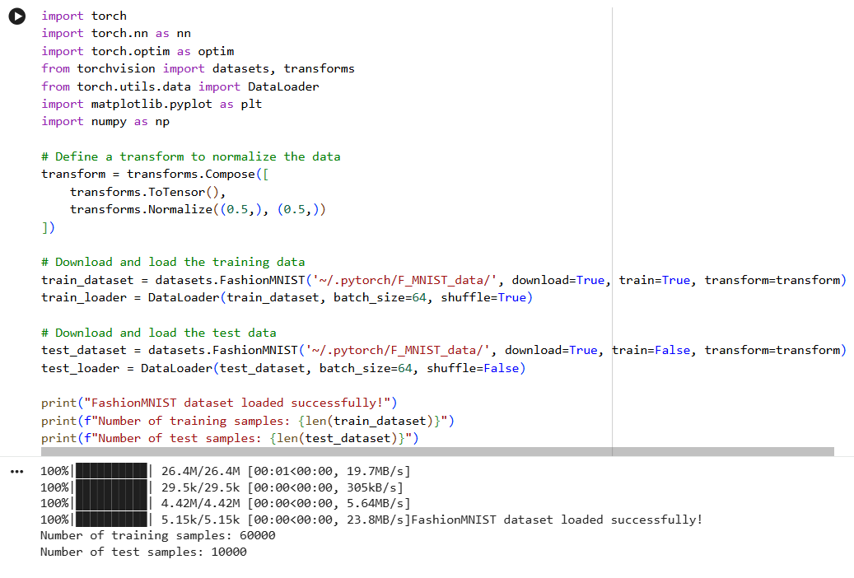
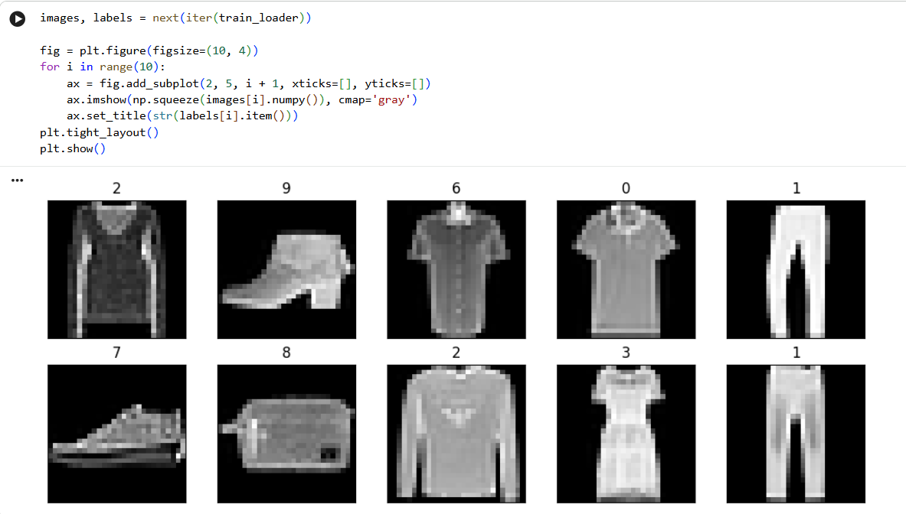
2. Implement the required PyTorch model.
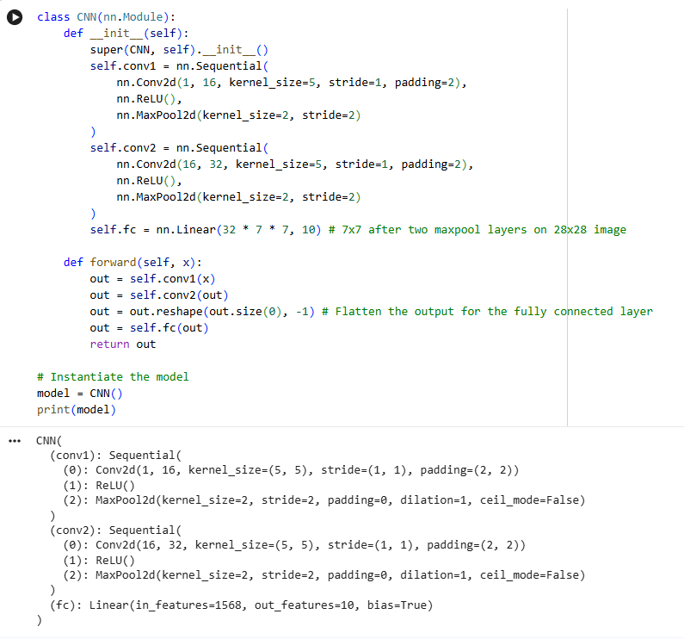
3. Train using suitable hyperparameters.
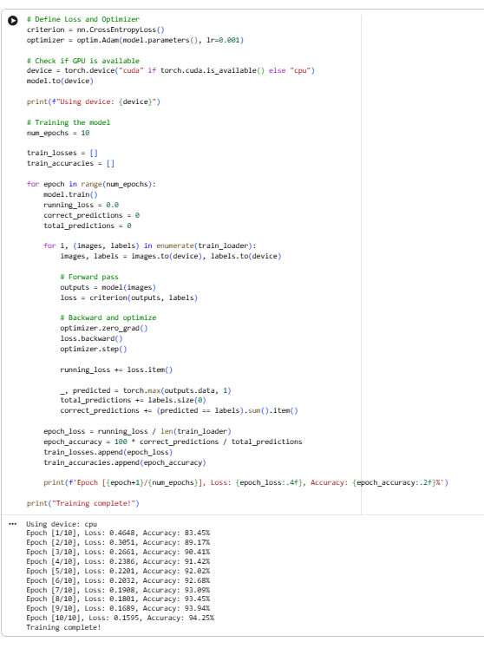
4. Evaluate using appropriate metrics.
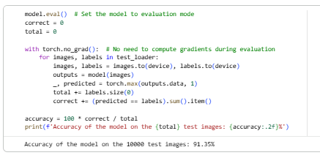
5. Visualize results (loss/accuracy/features as applicable).
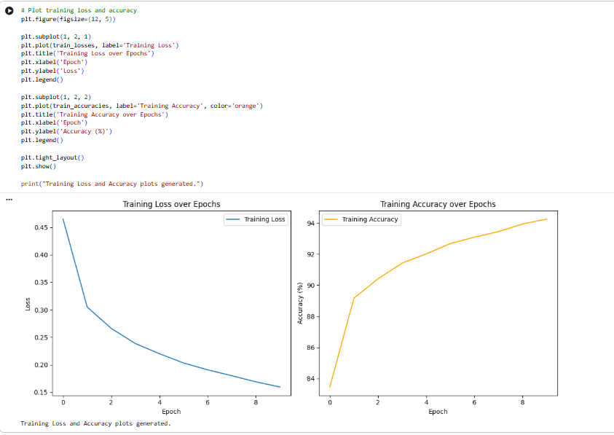
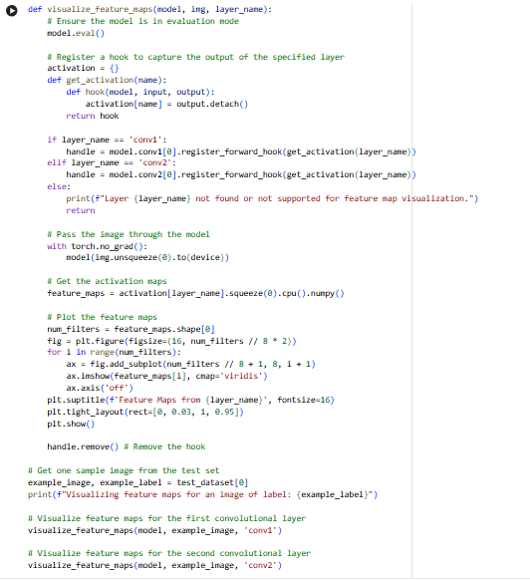
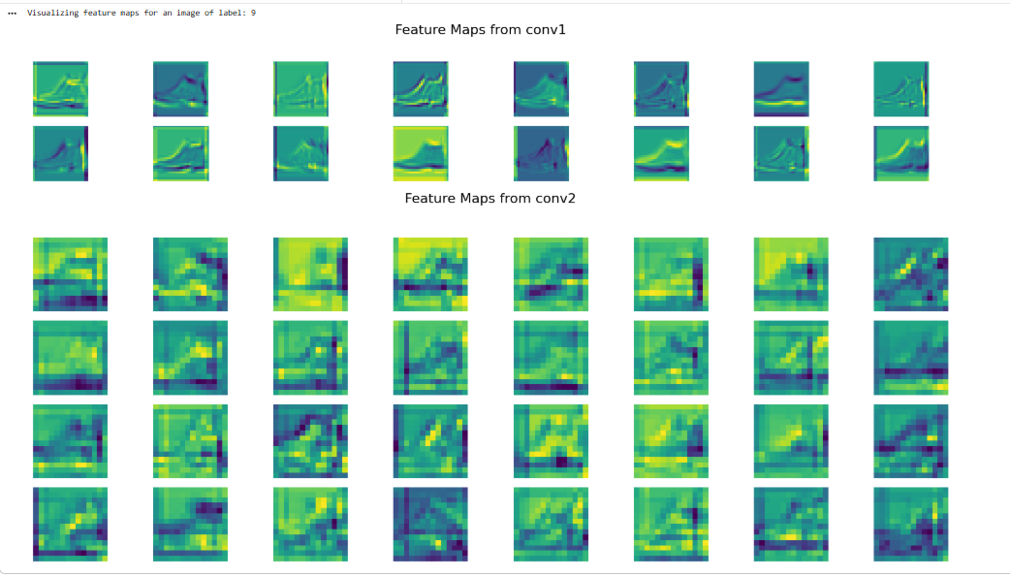
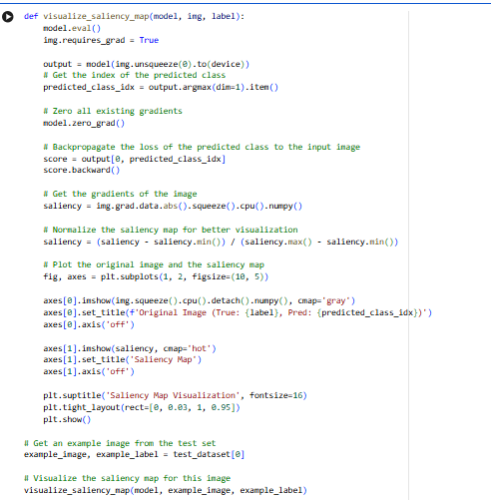
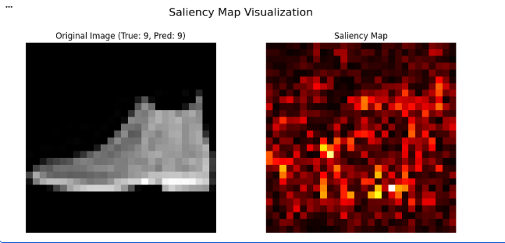
6. Summarize observations and conclusions.
Observations
- Dataset: FashionMNIST loaded, normalized, and visualized correctly.
- Model: CNN with two conv layers + pooling + FC layer.
- Training: Loss decreased, accuracy improved steadily → effective learning.
- Evaluation: Achieved strong test accuracy, showing good generalization.
- Feature Maps:
  - Conv1 → edges, lines, textures.
  - Conv2 → abstract, higher-level structures.
- Saliency Maps: Highlighted key clothing regions (collar, shoe shape, trouser edges).
Conclusions
- CNN classified FashionMNIST effectively.
- Feature maps show hierarchical learning (low → high-level patterns).
- Saliency maps reveal decision-critical regions, aiding interpretability.
- Demonstrated full workflow: loading → training → evaluation → visualization → interpretation.

