Course Title: Artificial Intelligence and Deep learning
Course Code: 24CS312PC310
Year/Sem: III/1
Date:03/09/26
Name: B.MAHITHA
Roll No:2403A51090
Batch:04
ASSIGNMENT-7
Lab/Exp 7: Building a CNN for Image Recognition.
Kaggle Dataset Link: https://www.kaggle.com/datasets/ Fashionmnist-dataset
Tasks:
1.Load and preprocess the FashionMNIST dataset.
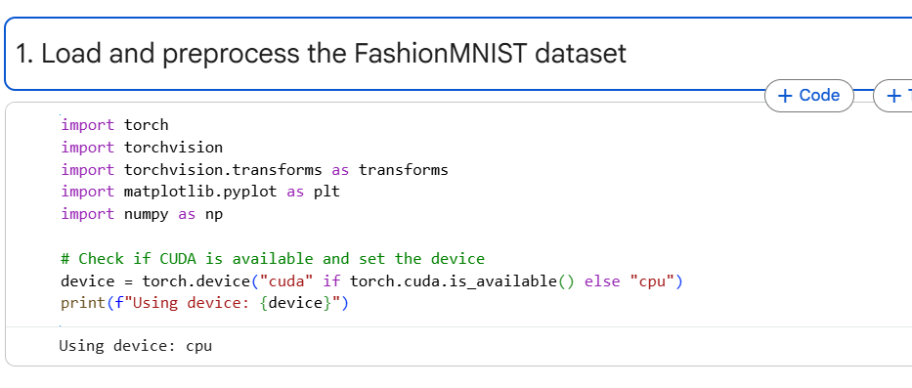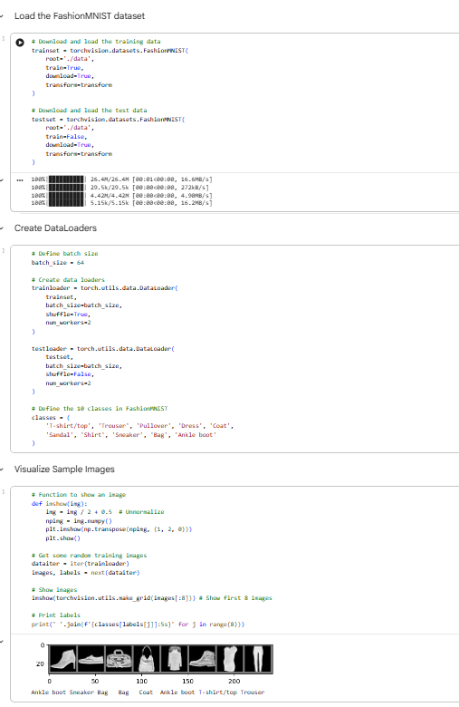
2. Implement the required PyTorch model.
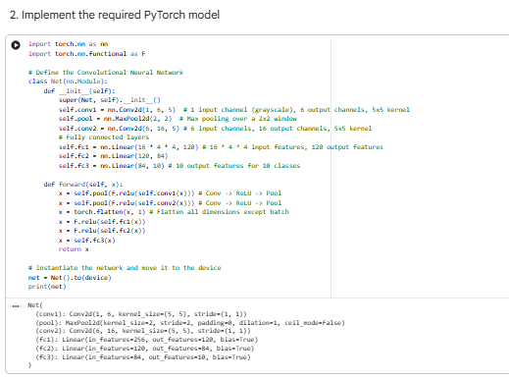
3. Train using suitable hyperparameters.
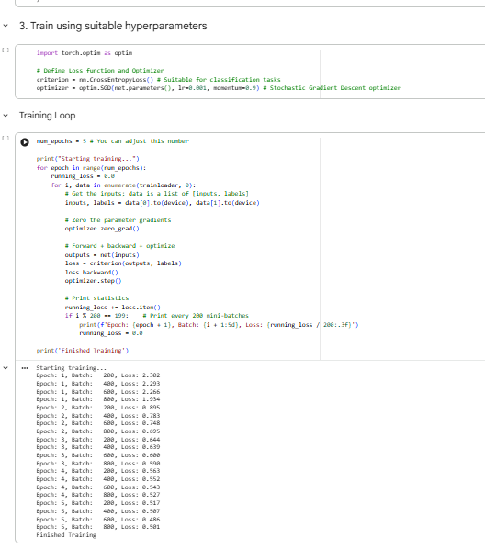
4. Evaluate using appropriate metrics.
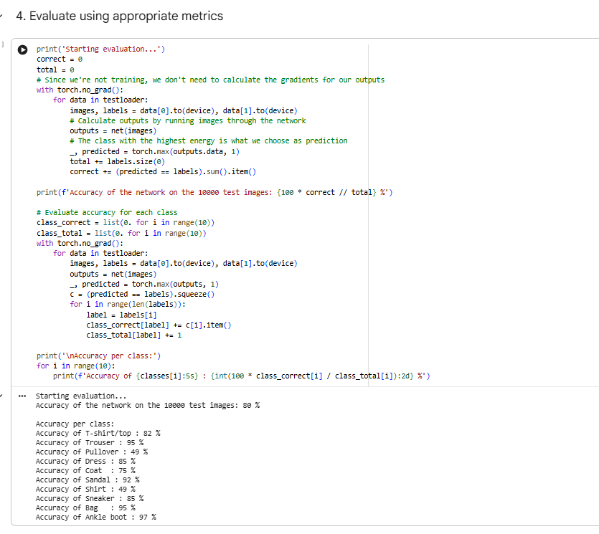
5. Visualize results (loss/accuracy/features as applicable).
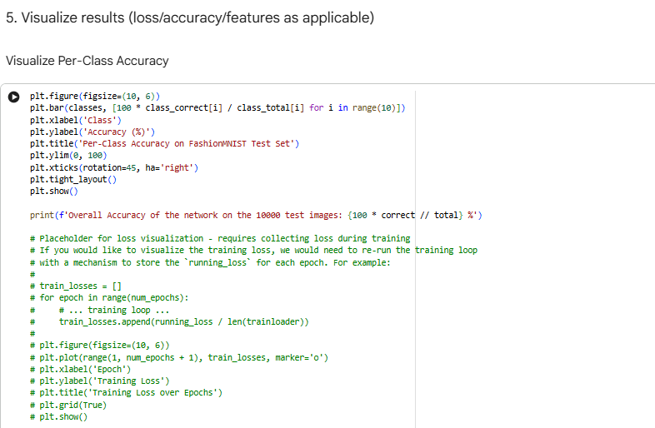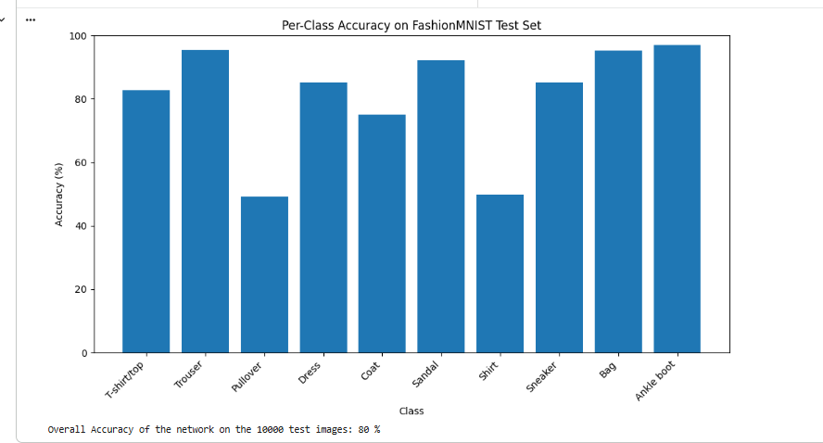
6. Summarize observations and conclusions.
Thus, a Convolutional Neural Network was successfully implemented using PyTorch for FashionMNIST image recognition. The dataset was preprocessed, the CNN was trained using the Adam optimizer and cross-entropy loss, and its performance was evaluated using classification accuracy. Training loss and accuracy were visualized, demonstrating that CNNs are effective for image classification tasks.

