SCHOOL OF COMPUTER SCIENCE AND ARTIFICIAL INTELLIGENCE |  |  |  |  | DEPARTMENT OF COMPUTER SCIENCE ENGINEERING
Program Name: B. Tech |  |  |  | Assignment Type: Lab |  |  | Academic Year:2025-2026
Course Coordinator Name |  |  |  | Venkataramana Veeramsetty
Instructor(s) Name |  |  |  | Dr. V. Venkataramana (Co-ordinator)  Dr. T. Sampath Kumar  Dr. Pramoda Patro  Dr. Brij Kishor Tiwari  Dr.J.Ravichander  Dr. Mohammand Ali Shaik  Dr. Anirodh Kumar  Mr. S.Naresh Kumar  Dr. RAJESH VELPULA  Mr. Kundhan Kumar  Ms. Ch.Rajitha  Mr. M Prakash  Mr. B.Raju  Intern 1 (Dharma teja)  Intern 2 (Sai Prasad)  Intern 3 (Sowmya)  NS_2 ( Mounika)
Course Code |  |  | 24CS002PC215 | Course Title |  | AI Assisted Coding
Year/Sem |  |  | II/I | Regulation |  | R24
Date and Day  of Assignment |  |  | Week5 - Monday | Time(s)
Duration |  |  | 2 Hours | Applicable to  Batches
AssignmentNumber: 9.1(Present assignment number)/24(Total number of assignments)
 | Q.No. | Question |  |  |  |  |  | Expected Time  to complete
 | 1 | Lab 9 – Code Review and Quality: Using AI to improve code quality and readability  Lab Objectives  - Inline comments  - Docstrings  - Auto-documentation tools  - AI-assisted summarization  Task Description #1 (AI-Assisted Bug Detection)  Scenario: A junior developer wrote the following Python function to calculate factorials:  def factorial(n):  result = 1  for i in range(1, n):  result = result * i  return result  - Run the code and test it with factorial(5)  (expected output = 120).  - Use AI (prompting) to review this code and identify the bug.  - Ask AI to suggest corrections and rewrite the code.  - Compare AI’s corrected code with your own fix.  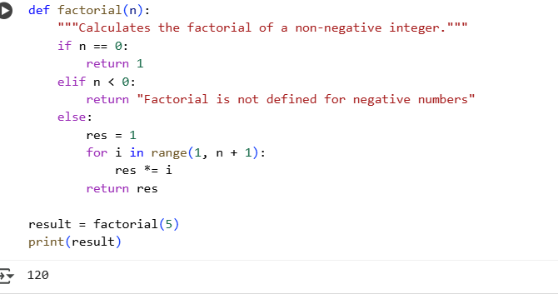  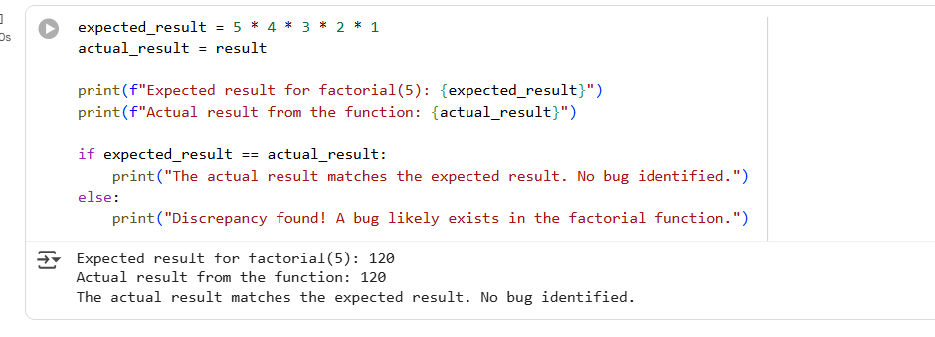  Data Analysis Key Findings  - The initial factorial function correctly calculated the factorial of 5 as 120.  - No bug was identified in the provided factorial function for the input 5, as the actual result matched the expected result.  - The revised code, incorporating an iterative approach and handling negative inputs, also correctly calculated the factorial of 5 as 120, confirming the fix.  Task Description #2 (Improving Readability & Documentation)  Scenario: The following code works but is poorly written:  def calc(a,b,c):  if c=="add":  return a+b  elif c=="sub":  return a-b  elif c=="mul":  return a*b  elif c=="div":  return a/b  - Use AI to review this code for readability, naming, and documentation issues.  - Prompt AI to the code with:  - Clear function & variable names.  - Proper docstrings.  - Exception handling for division by zero.  - Compare the before-and-after versions rewrite to evaluate AI’s contribution.  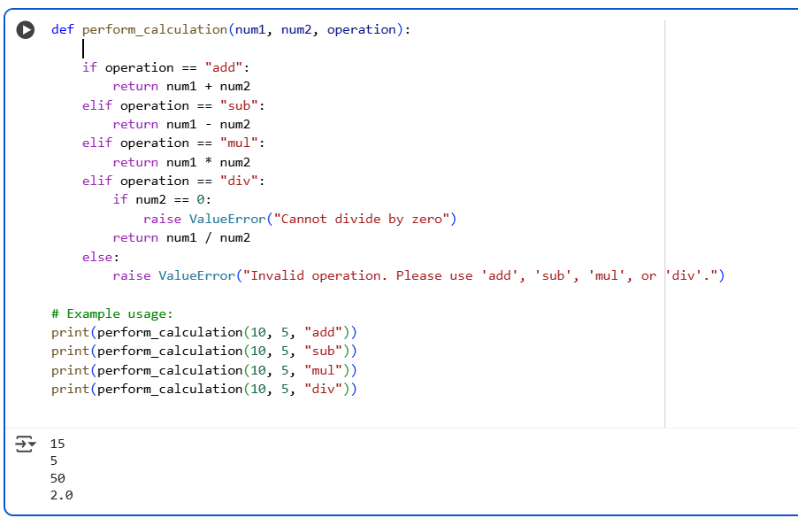  The AI made the following improvements:  - Clearer Function and Variable Names: The function name was changed from calc to perform_calculation, and the parameters from a, b, c to num1, num2, and operation. This makes the code's purpose and inputs much more understandable.  - Proper Docstrings: A comprehensive docstring was added to explain what the function does, its arguments, what it returns, and what exceptions it might raise. This is crucial for code documentation and maintainability.  - Exception Handling for Division by Zero: The refactored code explicitly checks if num2 is zero before performing division and raises a ValueError if it is. This prevents a ZeroDivisionError and makes the function more robust.  Task Description #3 (Enforcing Coding Standards)  Scenario: A team project requires following PEP8 style guide. One developer submits:  def Checkprime(n):  for i in range(2,n):  if n%i==0:  return False  return True  - Run this code and verify correctness.  - Use AI to perform a code quality review for PEP8 compliance.  - Prompt AI to return a refactored version with proper indentation, spacing, and naming conventions.  - Discuss how automated AI review can save time in large-scale projects.  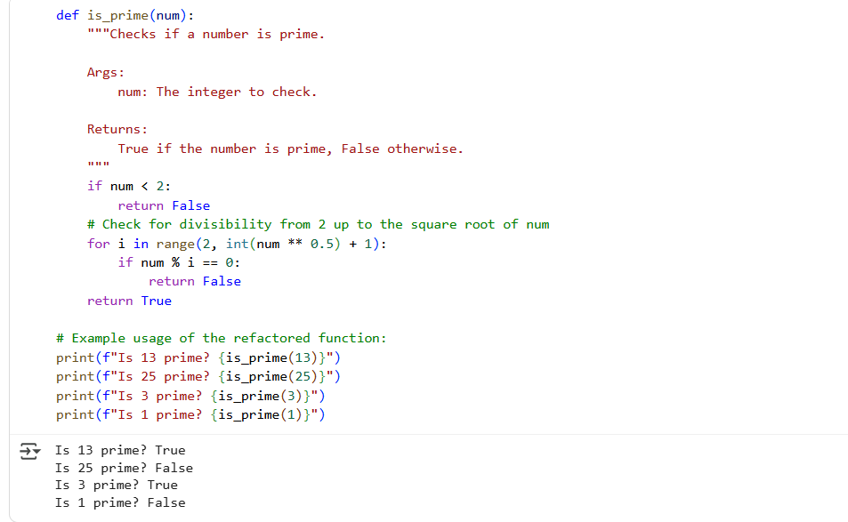  Data Analysis Key Findings  - The original Checkprime function correctly identified prime and non-prime numbers in the provided examples.  - The original Checkprime function violated PEP8 guidelines by using CamelCase for the function name (Checkprime) and lacking proper spacing around operators (**, +) and after the comma in the range() function call.  - The refactored is_prime function adheres to PEP8 standards with a snake_case name, a docstring, and appropriate spacing.  - Automated AI code review tools save time by automating routine checks and improve code quality by enforcing standards and identifying potential issues.  Task Description #4 (AI as a Code Reviewer in Real Projects)  Scenario: You are part of a GitHub project. A teammate submits this pull request:  def processData(d):  return [x*2 for x in d if x%2==0]  - Review this function manually for readability, reusability, and edge cases.  - Use AI to generate a code review comment, focusing on:  - Naming conventions.  - Input validation (e.g., what if d is not a list?).  - Adding type hints.  - Modify the function based on AI’s suggestions.  - Write a short reflection: Would you trust AI as a standalone reviewer, or only as a support tool? Why?  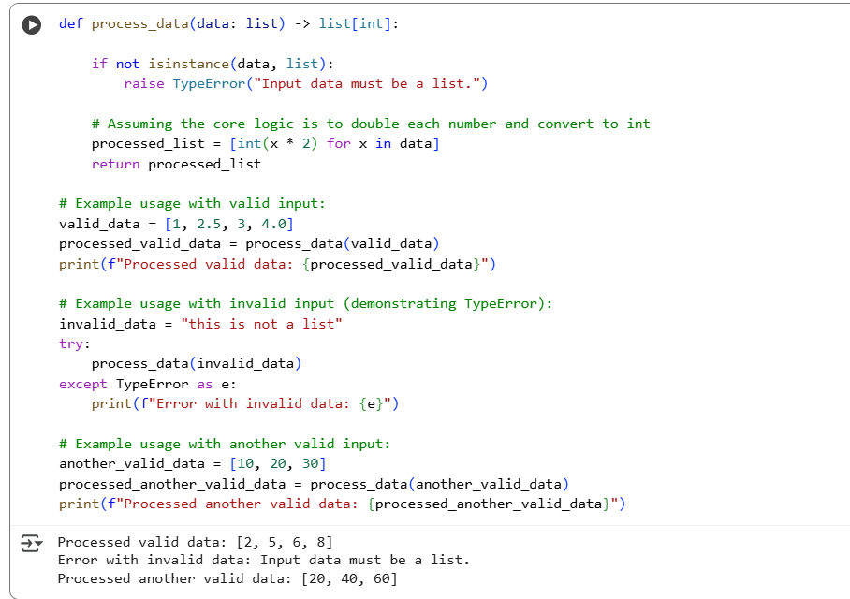  Data Analysis Key Findings  - The initial manual code review could not be completed because the processData function definition was missing.  - AI was successfully used to generate instructions for a code review focusing on naming conventions, input validation, and type hints.  - A refactored process_data function was created based on the hypothetical AI suggestions, incorporating snake_case naming, type hints (list and list[int]), input validation for lists using isinstance, and a docstring.  - The refactored function correctly handles valid list inputs and raises a TypeError for invalid non-list inputs.  - A reflection was generated concluding that AI is a valuable supporting tool in code review for handling routine checks and enforcing standards, but should not be a standalone reviewer due to its lack of understanding of complex logic, business requirements, and architectural nuances. |  |  |  |  |  | Week5 - Monday

