Project Design Phase-II
Customer Journey Map

Scenario: A Service Desk agent handles an IT incident from reporting and creation through investigation, resolution, closure and knowledge reuse.
Customer Journey Map:
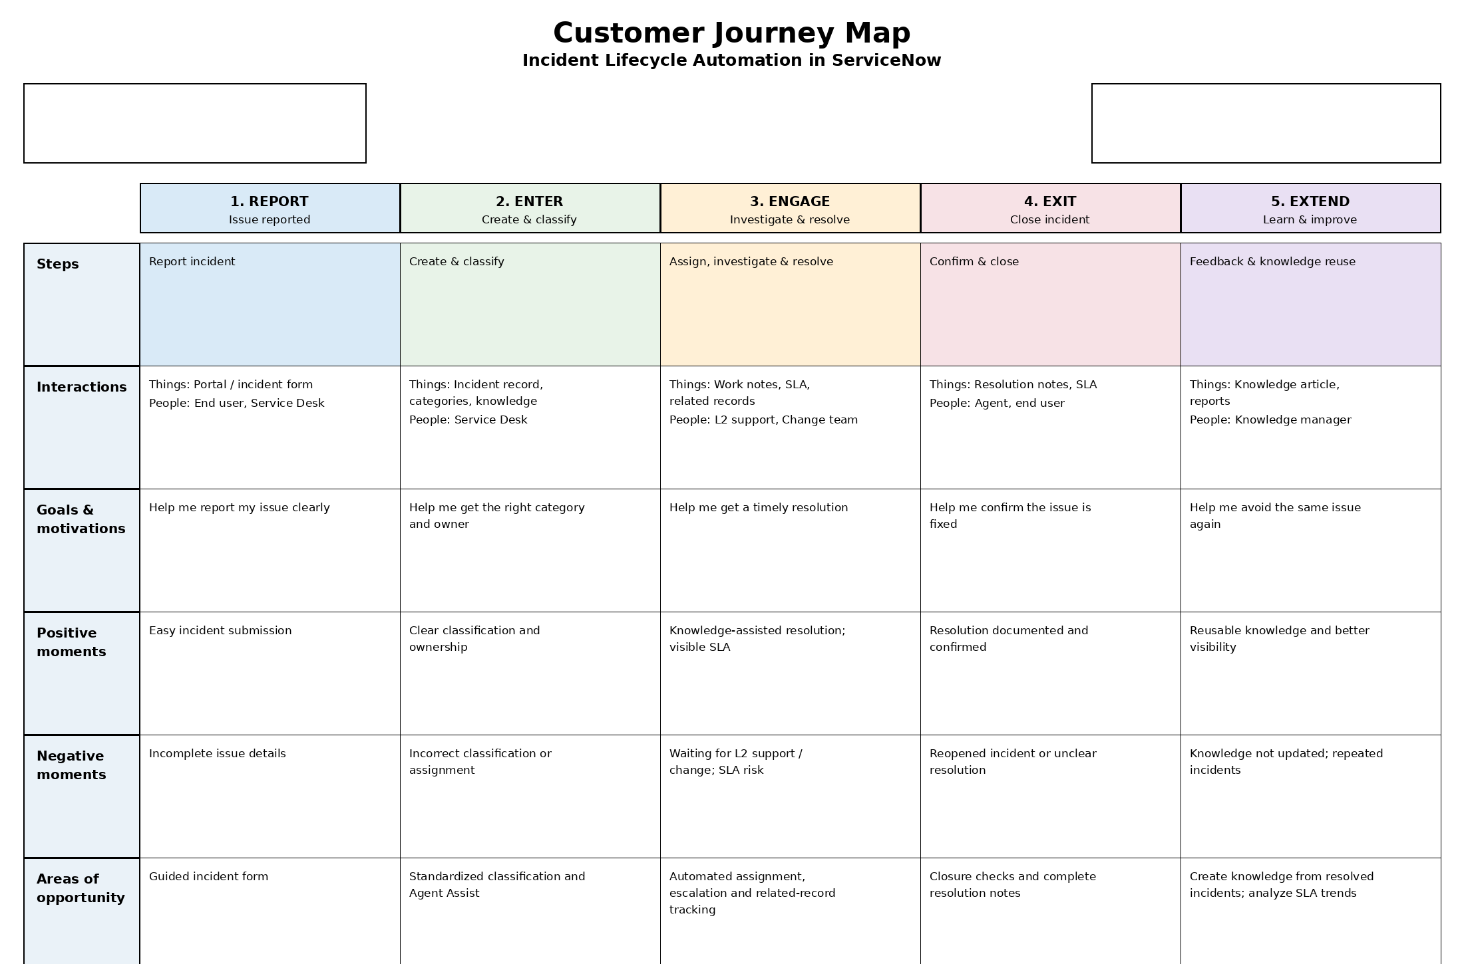
The journey map follows the supplied template structure: Steps, Interactions, Goals & Motivations, Positive Moments, Negative Moments and Areas of Opportunity.
Reference: Customer Journey Map example/template supplied for Project Design Phase-II.

