Project Design Phase-II
Data Flow Diagram & User Stories
Date
Team ID | ____________________________
Project Name | Incident Lifecycle Automation in ServiceNow
Maximum Marks | 4 Marks

Data Flow Diagrams:
The DFD shows how incident information enters ServiceNow, is classified and processed, moves through assignment/investigation and resolution, and is retained for SLA, knowledge and related-record tracking.
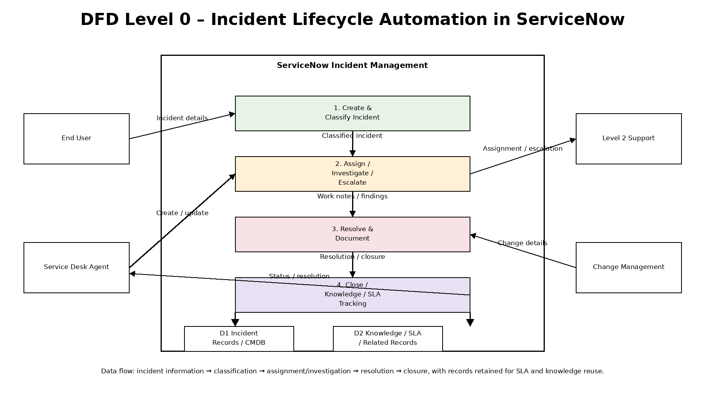
DFD Level 0 – Incident Lifecycle Automation in ServiceNow
User Stories
The following user stories translate the project requirements into user-centred tasks with measurable acceptance criteria.
User Type | Functional Requirement (Epic) | User Story Number | User Story / Task | Acceptance Criteria | Priority | Release
Service Desk Agent | Incident Creation | USN-1 | As a Service Desk agent, I can create an incident with caller, description, service/CI and contact details. | Incident record is created with required information and a unique number. | High | Release-1
Service Desk Agent | Incident Classification | USN-2 | As a Service Desk agent, I can classify an incident using category, subcategory, impact, urgency and priority. | Classification fields are saved and priority reflects the selected impact/urgency. | High | Release-1
Service Desk Agent | Knowledge & Agent Assist | USN-3 | As a Service Desk agent, I can search for relevant knowledge while handling an incident. | Relevant knowledge results can be viewed and attached to the incident. | High | Release-1
Service Desk Agent | Assignment & Escalation | USN-4 | As a Service Desk agent, I can assign or reassign an incident to the appropriate support group. | Assignment group and owner are visible and the incident is routed to the selected team. | High | Release-1
Level 2 Support | Investigation & Resolution | USN-5 | As a Level 2 support member, I can investigate an escalated incident and record work notes, findings and resolution. | Investigation activity and final resolution details are recorded on the incident. | High | Release-2
Change Management Team | Emergency Change | USN-6 | As a change manager, I can review a change request linked to an incident that requires an emergency change. | Change request is linked to the incident and its status is visible from the related records. | Medium | Release-2
Service Desk Agent | Child Incident Management | USN-7 | As a Service Desk agent, I can create child incidents for related user issues. | Child incidents are linked to the parent and their status is traceable. | Medium | Release-2
Service Desk Agent | SLA & Activity Tracking | USN-8 | As a Service Desk agent, I can monitor SLA information and incident activity. | SLA status and activity history are visible on the incident. | High | Release-2
Service Desk Agent | Closure | USN-9 | As a Service Desk agent, I can resolve and close an incident after documenting the resolution. | Required resolution information is entered and the incident reaches the configured closed state. | High | Release-3
Knowledge Manager / Agent | Knowledge Creation | USN-10 | As a knowledge manager or authorized agent, I can create a knowledge article from reusable resolution information. | A knowledge article is created with appropriate content and can be reused for future incidents. | Medium | Release-3

Reference basis: Data Flow Diagram & User Stories template supplied for Project Design Phase-II.

