Project Design Phase-II
Technology Stack (Architecture & Stack)
Date
Team ID | ____________________________
Project Name | Incident Lifecycle Automation in ServiceNow
Maximum Marks | 4 Marks

Technical Architecture:
The architecture represents the ServiceNow cloud platform, its Incident Management workflow and related platform services. The diagram identifies users, application logic, data storage, integrations and operational services.
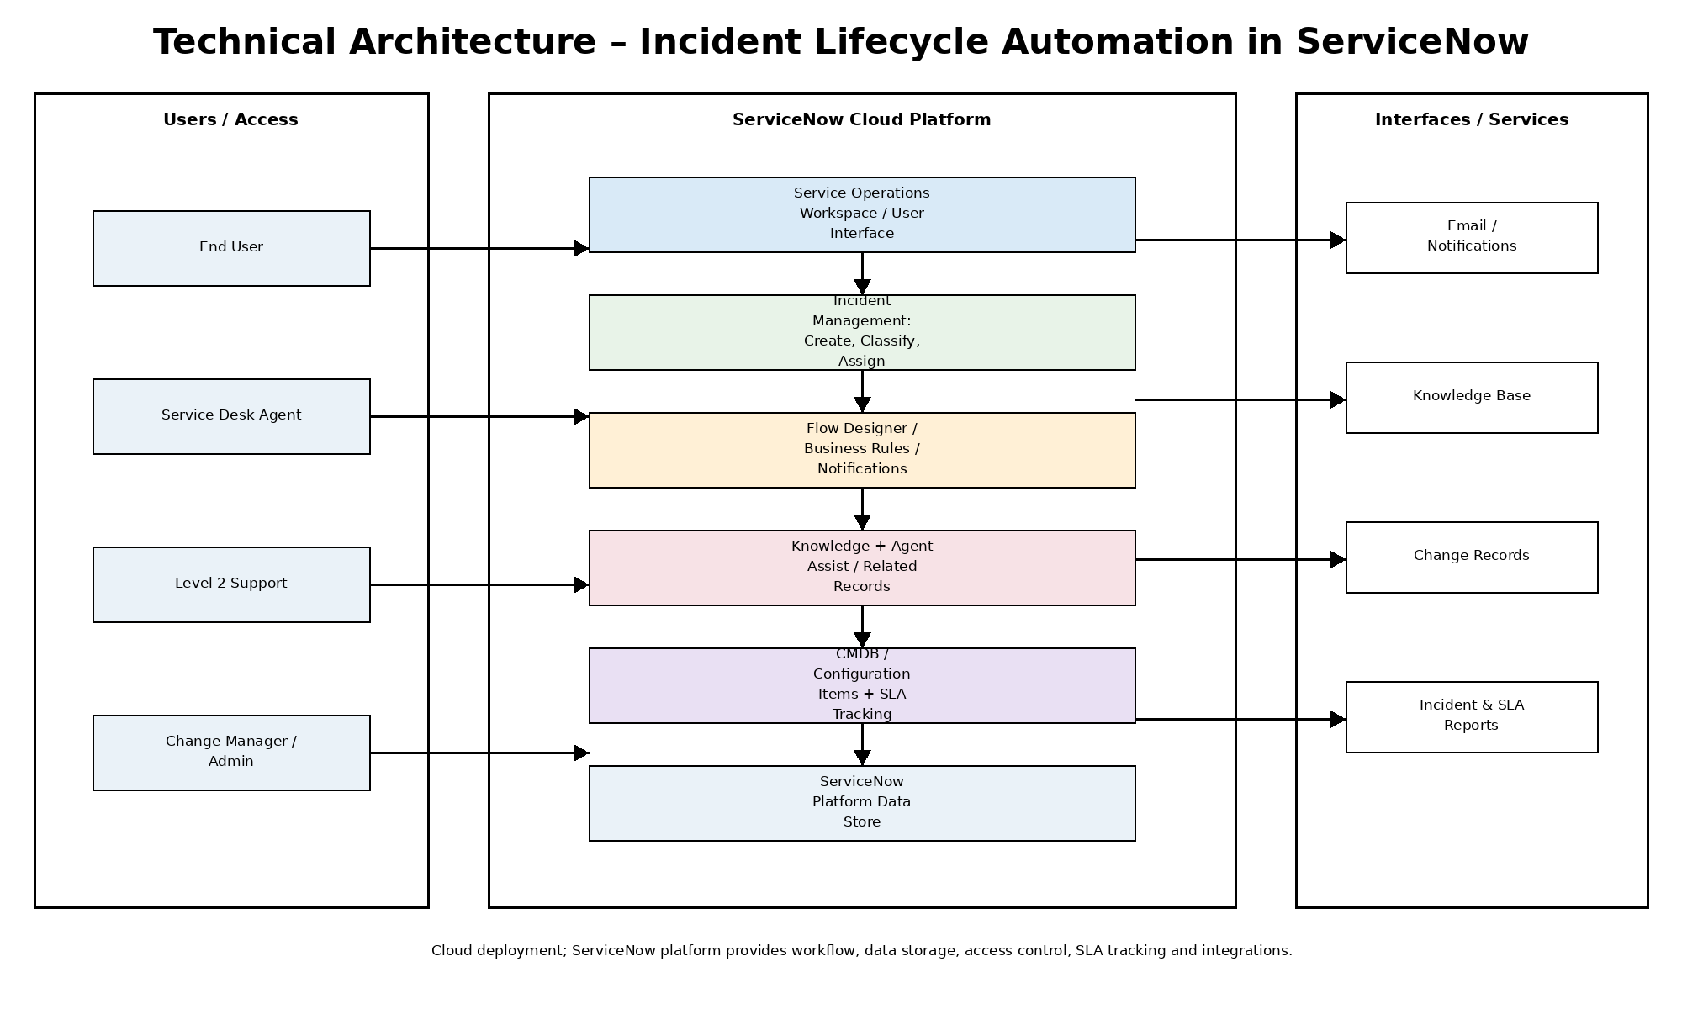
Technical Architecture – Incident Lifecycle Automation in ServiceNow
Table-1: Components & Technologies:
S.No | Component | Description | Technology
1 | User Interface | Interface used by agents to create, classify, update and monitor incidents. | ServiceNow Service Operations Workspace / web UI
2 | Application Logic-1 | Incident lifecycle rules for classification, assignment, state changes and escalation. | ServiceNow Incident Management + Business Rules
3 | Application Logic-2 | Workflow automation for approvals, related records and notifications. | ServiceNow Flow Designer / Workflow
4 | Application Logic-3 | Knowledge assistance during incident investigation and resolution. | ServiceNow Knowledge / Agent Assist
5 | Database | Structured incident, task, user and configuration data. | ServiceNow platform database
6 | Cloud Database | Cloud-hosted application data managed by the platform. | ServiceNow cloud data services
7 | File / Attachment Storage | Stores incident attachments and supporting files. | ServiceNow attachment storage
8 | External Interface-1 | Communication and operational notifications for incident updates. | ServiceNow email / notification services
9 | External Interface-2 | Related change and configuration information used during incident handling. | ServiceNow Change Management / CMDB
10 | Machine Learning Model | No separate ML model is required for this project scope; knowledge assistance is platform-based. | Not applicable
11 | Infrastructure | Application deployment and access through the ServiceNow cloud platform. | ServiceNow Cloud / SaaS

Table-2: Application Characteristics:
S.No | Characteristics | Description | Technology
1 | Open-Source Frameworks | The solution is primarily configured on the ServiceNow platform; no separate open-source application framework is required for the core workflow. | ServiceNow platform
2 | Security Implementations | Role-based access, ACLs and controlled access to incident and related records protect operational data. | ServiceNow roles, ACLs and authentication
3 | Scalable Architecture | Platform-based modules and reusable workflows allow additional support groups, incidents and knowledge records to be added without changing the core lifecycle. | ServiceNow modular platform + Flow Designer
4 | Availability | Cloud-hosted ServiceNow services provide access to incident management and related records for authorized users. | ServiceNow Cloud
5 | Performance | Use structured forms, controlled workflows and targeted knowledge/SLA views to keep incident handling efficient. | ServiceNow platform services

References retained from the supplied Technology Stack template: C4 Model, IBM Cloud Architecture, AWS Architecture, and the template's architecture-diagram guidance. The supplied template also asks the architecture to identify application logic, infrastructure boundary, external interfaces, data storage and ML interface where applicable.

