Project Design Phase
Problem – Solution Fit Template
Date | ________________________________________
Team ID | ________________________________________
Project Name | Incident Lifecycle Automation in ServiceNow
Maximum Marks | 2 Marks
Problem – Solution Fit Template:
The Problem-Solution Fit means that the identified customer problem is addressed by a solution that fits the customer’s situation, behaviour, constraints and channels.
Purpose:
☐ Solve complex problems in a way that fits the state of customers.
☐ Use existing mediums and channels of behaviour for solution adoption.
☐ Use the right triggers and messaging for communication.
☐ Solve frequent, urgent or costly problems and build trust.
☐ Understand the existing situation to improve it for the target group.

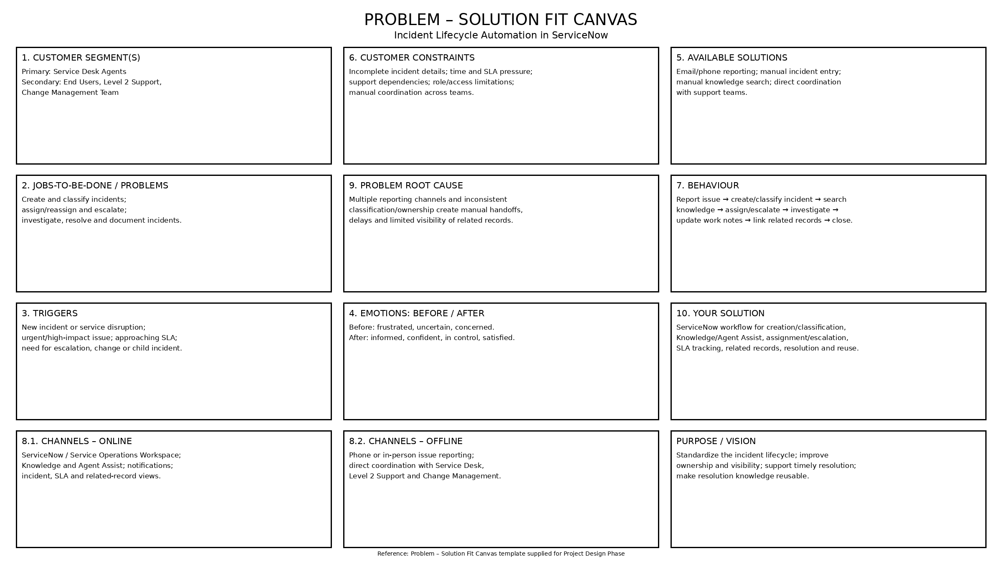
Reference: Problem – Solution Fit Canvas template supplied for Project Design Phase

