Project Planning Phase
Project Planning Template (Product Backlog, Sprint Planning, Stories, Story points)
Date | ________________________________________
Team ID | ________________________________________
Project Name | Incident Lifecycle Automation in ServiceNow
Maximum Marks | 5 Marks
Product Backlog, Sprint Schedule, and Estimation (4 Marks)
Based on the Incident Lifecycle Automation in ServiceNow workflow
Sprint | Functional Requirement (Epic) | User Story Number | User Story / Task | Story Points | Priority | Team Members
Sprint-1 | Incident & Service Setup | USN-1 | Configure the required service and service offering for incident management. | 3 | High | Project Team
Sprint-1 | Incident & Service Setup | USN-2 | Create an incident with the required user, service, description and impact information. | 3 | High | Project Team
Sprint-1 | Incident Classification | USN-3 | Classify an incident using category, subcategory, urgency, service and CI. | 3 | High | Project Team
Sprint-1 | Incident Classification | USN-4 | View incident activity and SLA information after classification. | 2 | High | Project Team
Sprint-2 | Knowledge & Agent Assist | USN-5 | Use Knowledge and Agent Assist to find relevant information while working on an incident. | 3 | High | Project Team
Sprint-2 | Assignment & Escalation | USN-6 | Assign or reassign an incident to the appropriate support group. | 3 | High | Project Team
Sprint-2 | Level 2 Investigation & Resolution | USN-7 | Investigate an escalated incident, update work notes and document the resolution. | 5 | High | Project Team
Sprint-2 | SLA & Activity Tracking | USN-8 | Monitor incident activity and SLA progress throughout the lifecycle. | 2 | Medium | Project Team
Sprint-3 | Emergency Change | USN-9 | Create and link an emergency change request when an incident requires an urgent change. | 5 | High | Project Team
Sprint-3 | Child Incidents | USN-10 | Create and link child incidents to a parent incident for related issues. | 3 | Medium | Project Team
Sprint-3 | Incident Resolution | USN-11 | Record cause, resolution notes and required closure information. | 3 | High | Project Team
Sprint-3 | Related Records | USN-12 | Verify links between the incident, change request, child incidents and activity history. | 2 | Medium | Project Team
Sprint-4 | Knowledge Article Creation | USN-13 | Create a knowledge article from a resolved incident for future reuse. | 3 | High | Project Team
Sprint-4 | Lifecycle Validation | USN-14 | Validate the complete incident lifecycle from creation through closure. | 3 | High | Project Team
Sprint-4 | Testing & Final Validation | USN-15 | Test classification, assignment, escalation, SLA, related records and knowledge creation. | 5 | High | Project Team
Sprint-4 | Testing & Final Validation | USN-16 | Document final results and verify that the implemented workflow satisfies project requirements. | 3 | Medium | Project Team
Completed sprint totals: Sprint-1 = 11 | Sprint-2 = 13 | Sprint-3 = 13 | Sprint-4 = 14 | Total = 51

Project Tracker, Velocity & Burndown Chart: (4 Marks)
Sprint | Total Story Points | Duration | Sprint Start Date  (Planned) | Sprint End Date  (Planned) | Story Points Completed  (as on Planned End Date) | Sprint Release Date  (Actual)
Sprint-1 | 11 | 6 Days | 17 Aug 2026 | 22 Aug 2026 | 11 | 22 Aug 2026
Sprint-2 | 13 | 6 Days | 24 Aug 2026 | 29 Aug 2026 | 13 | 29 Aug 2026
Sprint-3 | 13 | 6 Days | 31 Aug 2026 | 05 Sep 2026 | 13 | 05 Sep 2026
Sprint-4 | 14 | 6 Days | 07 Sep 2026 | 12 Sep 2026 | 14 | 12 Sep 2026
Velocity: 51 / 4 = 12.75 Story Points per Sprint.
Average velocity per day: 12.75 / 6 = 2.125 Story Points per Day.
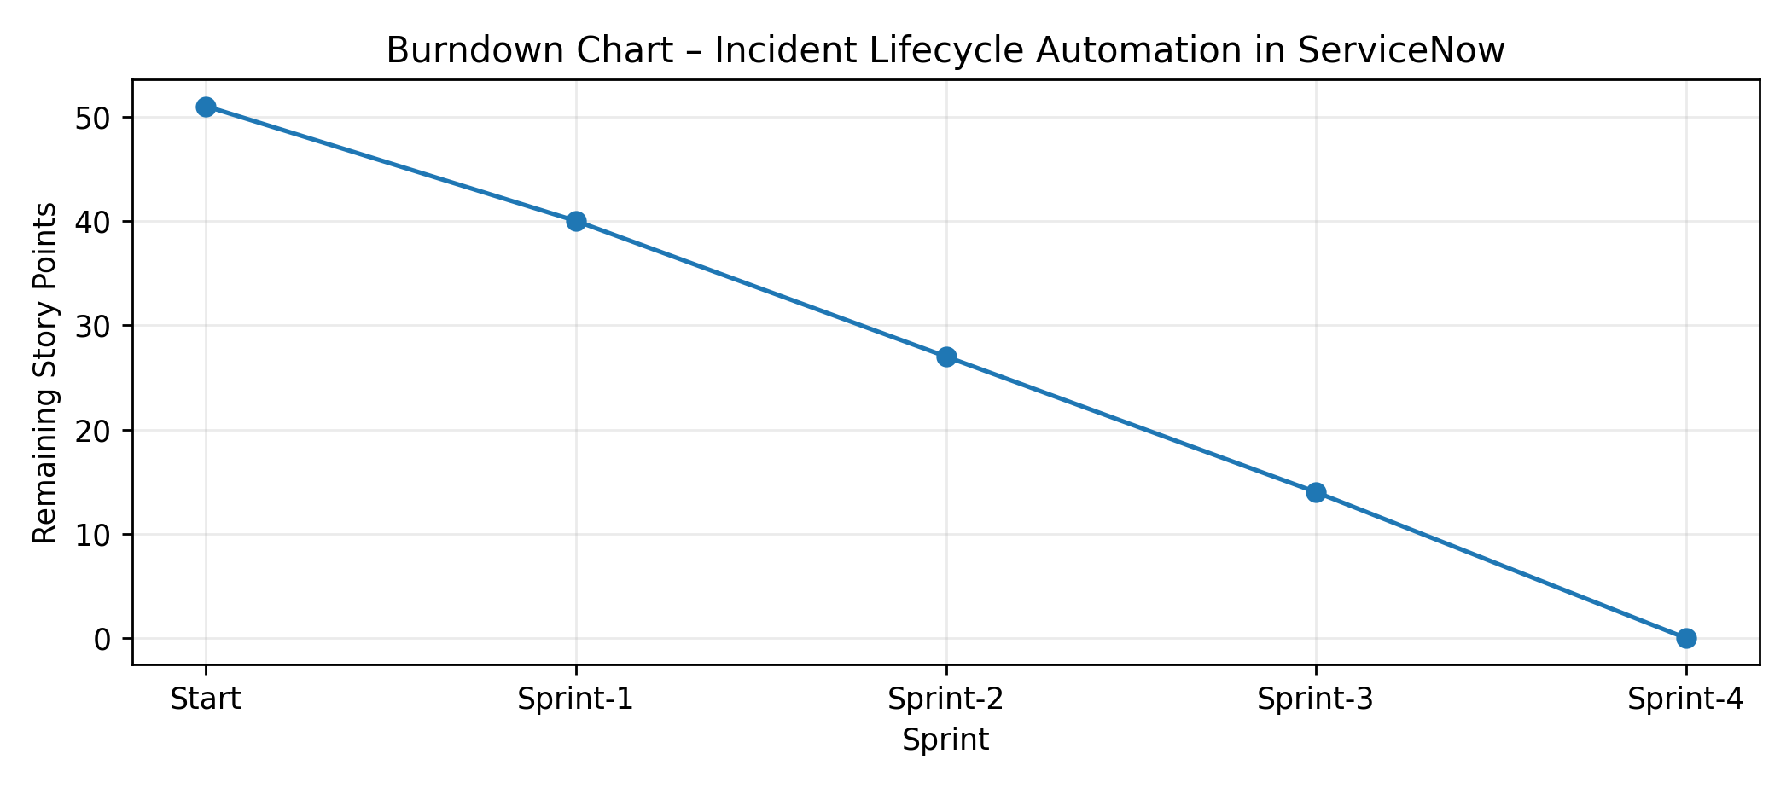
Burndown Chart: The chart represents the completed project work reducing from 51 planned story points to 0 across four sprints.
References:
https://www.visual-paradigm.com/scrum/scrum-burndown-chart/
https://www.atlassian.com/agile/tutorials/burndown-charts
https://www.atlassian.com/agile/project-management
https://www.atlassian.com/agile/tutorials/how-to-do-scrum-with-jira-software
https://www.atlassian.com/agile/tutorials/epics
https://www.atlassian.com/agile/tutorials/sprints
https://www.atlassian.com/agile/project-management/estimation

