Project Design Phase
Solution Architecture
Date | ________________________________________
Team ID | ________________________________________
Project Name | Incident Lifecycle Automation in ServiceNow
Maximum Marks | 4 Marks
Solution Architecture:
Solution architecture is a complex process – with many sub-processes – that bridges the gap between business problems and technology solutions. Its goals are to:
• Find the best tech solution to solve existing business problems.
• Describe the structure, characteristics, behavior, and other aspects of the software to project stakeholders.
• Define features, development phases, and solution requirements.
• Provide specifications according to which the solution is defined, managed, and delivered.
Solution Architecture Diagram:
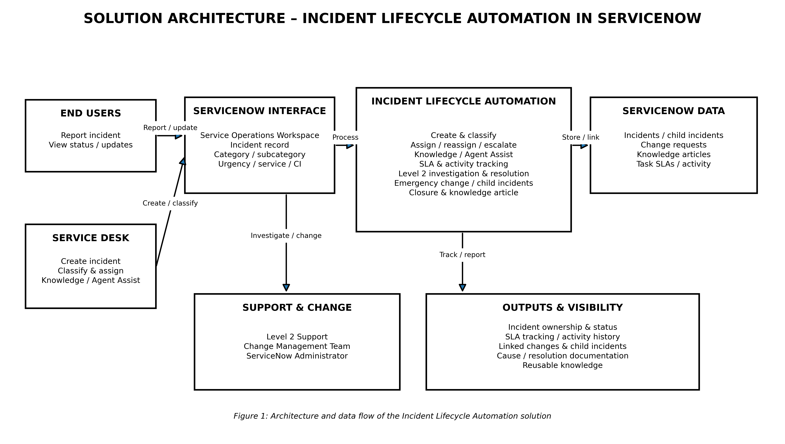
Reference: https://aws.amazon.com/blogs/industries/voice-applications-in-clinical-research-powered-by-ai-on-aws-part-1-architecture-and-design-considerations/

