The pretension forces PV and the torques MA shown in the table below are recommended values for metric standard and fine-pitch threads according to ISO 261, 965-2 and head supporting dimensions according to DIN 912, 931-2, 7984, ISO 4014, 4016, 4017, 4032 and permit a 90 % exploitation of the screw yield strength. The coefficient of friction μges = 0.14 (new screws, without aftertreatment, non-lubricated) has been taken as a basis.
This table shall be used only when no relevant data are contained in the drawings!

Screws with metric standard and fine-pitch threads acc. to ISO 262, 965-2
μges = 0.14
 |  | Property Class
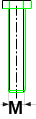 | 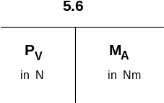 |  |  | 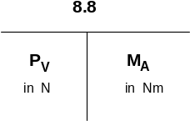 |  |  | 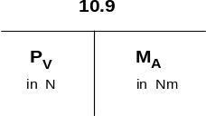 |  |  | 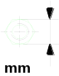
M 3 | 966 |  | 0,59 |  | 2206 | 1,34 |  | 3109 | 1,88 |  |  | 5,5
M 4 | 1677 |  | 1,34 |  | 3825 | 3,04 |  | 5374 | 4,32 |  |  | 7
M 5 | 2736 |  | 2,65 |  | 6257 | 6,03 |  | 8806 | 8,48 |  |  | 8-9
M 6 | 3864 |  | 4,51 |  | 8836 | 10,3 |  | 12405 | 14,7 |  |  | 10
M 8 | 7090 |  | 10,8 |  | 16230 | 25,5 |  | 22751 | 35,3 |  |  | 13-14
M 10 | 11278 |  | 21,6 |  | 24791 | 50,0 |  | 36284 | 70,6 |  |  | 16
M 10x1,25 | - |  | - |  | 27753 | 51,1 |  | 39030 | 71,8 |  |  | 16
M 12 | 16475 |  | 38,3 |  | 37657 | 87,3 |  | 52956 | 123 |  |  | 18
M 14x1,5 | - |  | - |  | 57369 | 146 |  | 80904 | 206 |  |  | 21
M 16 | 31087 |  | 93,2 |  | 71196 | 210 |  | 100027 | 299 |  |  | 24-26
M 20 | 48641 |  | 180 |  | 111305 | 412 |  | 156415 | 579 |  |  | 30
M 24 | 70019 |  | 309 |  | 160338 | 711 |  | 225552 | 1000 |  |  | 36
M 24x2 | - |  | - |  | 179461 | 761 |  | 252030 | 1069 |  |  | 36
M 27 | 92280 |  | 461 |  | 210842 | 1049 |  | 296159 | 1481 |  |  | 41
M 30 | 112286 |  | 623 |  | 255952 | 1422 |  | 359902 | 2010 |  |  | 46
M 30x2 | - |  | - |  | 294198 | 1571 |  | 413839 | 2210 |  |  | 46
M 33 | 139744 |  | 848 |  | 319695 | 1932 |  | 449142 | 2716 |  |  | 50
M 36 | 164261 |  | 1089 |  | 374612 | 2481 |  | 527595 | 3491 |  |  | 55
M 39 | 197113 |  | 1412 |  | 451104 | 3226 |  | 633506 | 4531 |  |  | 60
M 42 | 225552 |  | 1746 |  | 515827 | 3991 |  | 726688 | 5609 |  |  | 65
M 48 | 297140 |  | 2638 |  | 679597 | 6021 |  | 956144 | 8473 |  |  | 75
M 56 | 411877 |  | 4227 |  | 940453 | 9650 |  | 1323891 | 13582 |  |  | 85
M 60 | 481504 |  | 5247 |  | 1098339 | 11964 |  | 1544540 | 16867 |  |  | 90
M 64 | 544266 |  | 6306 |  | 1245438 | 14416 |  | 1750478 | 20300 |  |  | 95
M 72 | 759392 |  | 9882 |  | 1620036 | 21081 |  | 2278175 | 29645 |  |  | 105
M 80 | 958921 |  | 13741 |  | 2045697 | 29314 |  | 2876762 | 41222 |  |  | 115
M 90 | 1240994 |  | 19934 |  | 2647452 | 42525 |  | 3722982 | 59801 |  |  | 130

