Mounting Dam Border Working Instructions
The dam border consists of the dam ring, one or more lining rings and one or more scatter rings.
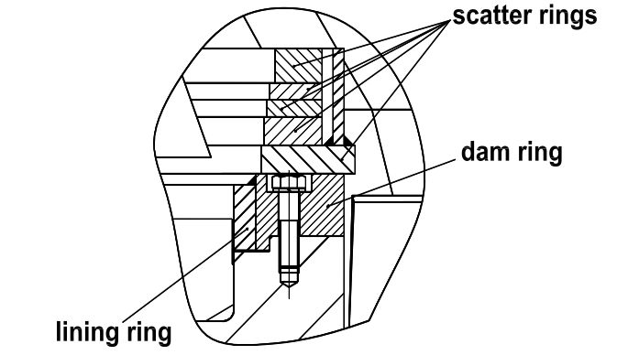
Fig. 1 principle sketch
For reasons of transportation and mounting the rings are delivered in multipart style, i.e. as ring segments.
In this case all the segments are provided with edge preparations and will be welded to single rings at site.
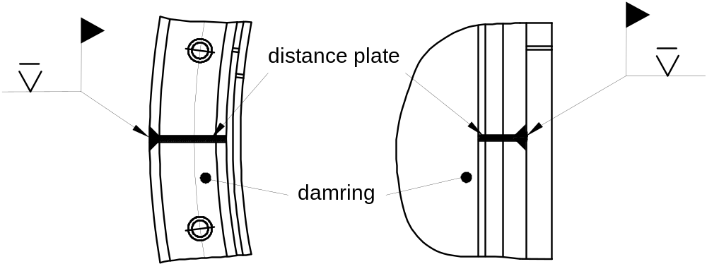
Fig. 2 principle sketch
For this the partition gaps have to be filled with distance plates to prevent the hole circles from distortion. Rings laying one over one another shall be arranged with displaced partition lines.
The exact arrangement and fastening of the different rings has to be carried out as it is shown in the corresponding arrangement drawing "Table cpl.".

