Slip-Ring Sealing, Type "G" Mounting Instructions
Table of Contents:
Sheet
1. Introduction 1
2. Determination of Distance ”X” 1
3. Preparations of Installation 2
4. Installation of the Sealing 2

1. Introduction
One set of slip-ring sealings mainly consists of four component parts:
- two superfinished slip-rings, figure 3
- two O-rings, figure 4 a + b
As an installation aid, a spiral cord is included in the delivery; the cord has to be shortened to the length required (figure 4a); see installation of the sealing, point 4. It is also possible to use an O-ring of adequate size for this purpose. For larger units it is, however, recommended that a proper installation tool be used.
A slip-ring sealing must be replaced in pairs only.
The superfinished slip-ring is a precision part made of chilled cast iron. In order to protect the slip-ring from damage, it is imperative to avoid dust, shocks and impacts during the installation.

2. Determination of Distance ”X”
See figure 1 : for the fixed position version,
see figure 1a : for the adjustable version.
During this trial installation the seal pieces proper, item 19, should be removed to avoid damage.
The carrier, item 2, is screwed on to the sealing sleeve with the aid of three screws.
In the fixed position version the carrier, item 1, is pushed over the roller axle until it lies against the shoulder. The adjustable version is pushed until dimension "X" is reached.
Using a feeler gauge, distance "X" can be measured.
The preparations for installation may be started when distance "X" corresponds to the size indicated in the drawing.
Should distance "X" be too short, with the fixed position version, then the carrier, item 2, has to be turned off to the extend required to maintain the dimension indicated in the drawing.

3. Preparations of Installation
See figure 1 : for the fixed position version
see figure 1a : for the adjustable version.
3.1 The carrier, item 1, is pre-drilled to receive the spring pins or clamping screws, item 11.
3.2 The carrier is pushed to the correct position on the roller axle.
Now the blind holes in the roller axle for the clamping screws or spring pins, item 11, are bored together with the holes in the carrier. This is to ensure that the holes of the carrier are aligned with those of the roller axle.
It is advisable to mark the position of the carrier relative to the roller axle, to subsequently allow the easy fitting of the spring pins or insertion of the screws. To prevent the swarf from penetrating into the bearings, mask gap "X" using adhesive tape.
With the holes drilled for item 11, the carrier, item 2, can be removed from the sealing sleeve, in order to install the sealing units.
A sealing unit is understood to comprise:
item 1, 19 and sealing ring
as well as
item 2, 19 and sealing ring.

4. Installation of the Sealing
4.1 For smaller sealing units the following procedure can be used: The spiral cord, as the installation aid, is shortened in length to the extent that it bears against the clamping cone when applying a slight contact pressure (figure 4). The installation aid is intended to prevent the sealing ring from slipping upwards on the clamping cone seat when forcing the ring into the carrier, thus protecting the sealing ring. Since the installation aid will have to be removed again after mounting, it is advisable to attach, as a retrieval aid, a longer adhesive tape to both ends of the spiral cord. For larger units the proper installation tool should be used (see drawing ”Dimension Sheet: Installation Tool”, the number of this can be found in the parts list ”Slip-Ring Sealing.” The application of the tool may be seen in figure 4b.
4.2 Apply to both retaining lip and clamping cone a water/spirit mixture (ratio 1:1), using a brush or a suede cloth.
4.3 Then pull the sealing ring over the clamping cone face. The sealing ring must be located straight and parallel to the slip-ring (see figure 4c); the moulded nose must point to the seal face.
4.4 The carries, item 1 and 2, must be carefully cleaned and degreased. Subsequently moisten the clamping cones using the water/spirit mixture.
The slip-ring , item 19, including the sealing ring and the installation aid, is now uniformly forced against the carriers, item 1 and 2. When the installation radius of the carrier (figure 2) is located above the highest point of the sealing ring, the sealing ring will slide - like a press-button - between slip-ring and carrier.
4.5 The installation aid is now removed from the slip-ring. It should then be assured that the sealing ring is positioned between slip-ring and carrier evenly and free from distortion. The nose moulded on to the sealing ring is helpful for this purpose; it shows whether there was any distortion during installation work or not.
The work described under 4.1 - 4.5 to be performed for the two sealing units.
With the two sealing units installed, the carrier, item 2, is screwed on to the sealing sleeve. Previously coat the contact surface with EPPLE 37. Provide the two contact areas of the slip-rings, the seal faces, with an oil film. Then push the carrier, item 1, over the roller axle to the extent that the holes for the spring pins or clamping screws are in alignment. The spring pins can now be driven in or the screws (previously treated with Loctite) can be tightened (see marking on axle and carrier).
For pressing on the carrier, item 1, it is suggested to provide a clamping device. A 40 x 10 mm (1.5 x 0.4 in) flat bar has proved suitable as a clamping device, which is bent and drilled according to figure 5.
Figure 1 Figure 1a
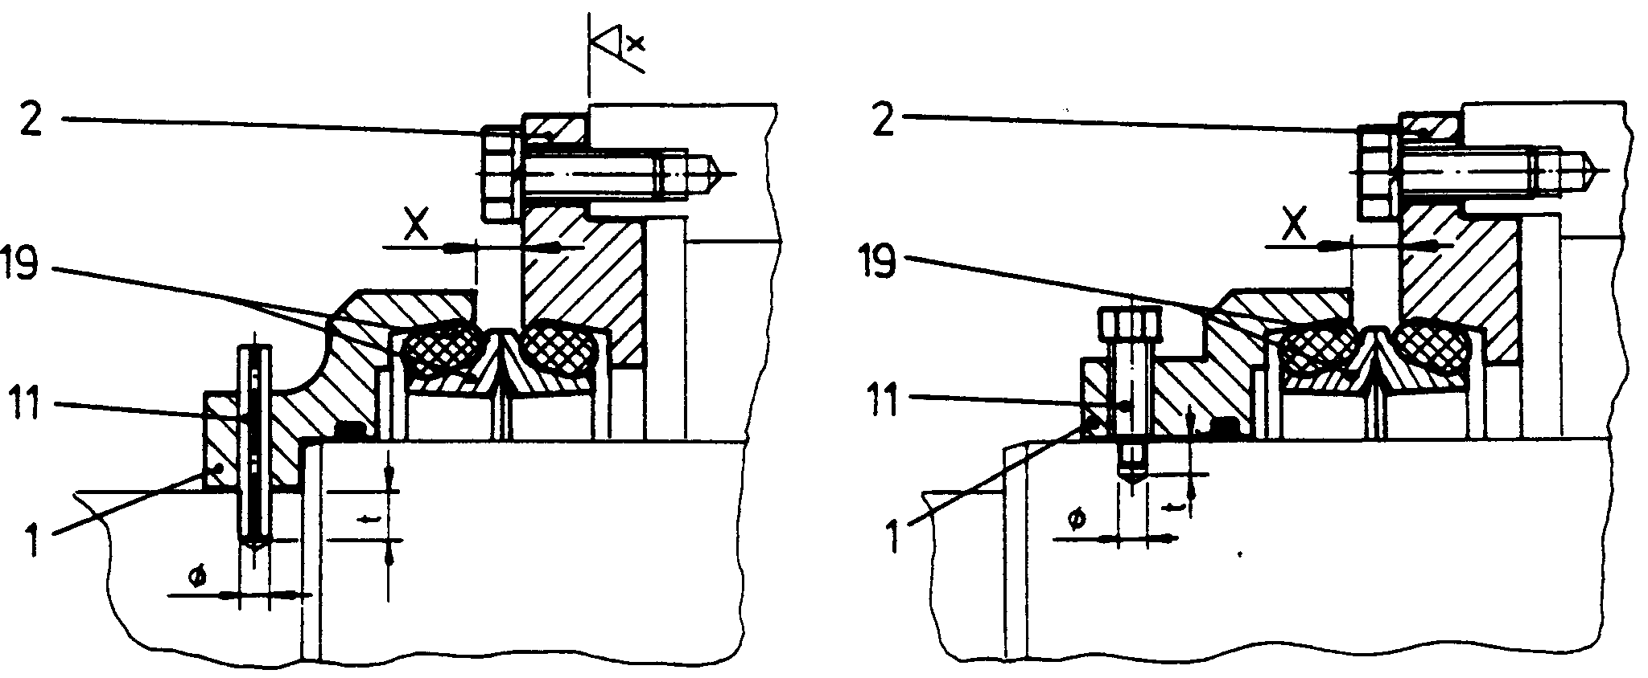
_____________________________________________________________________________
Figure 5
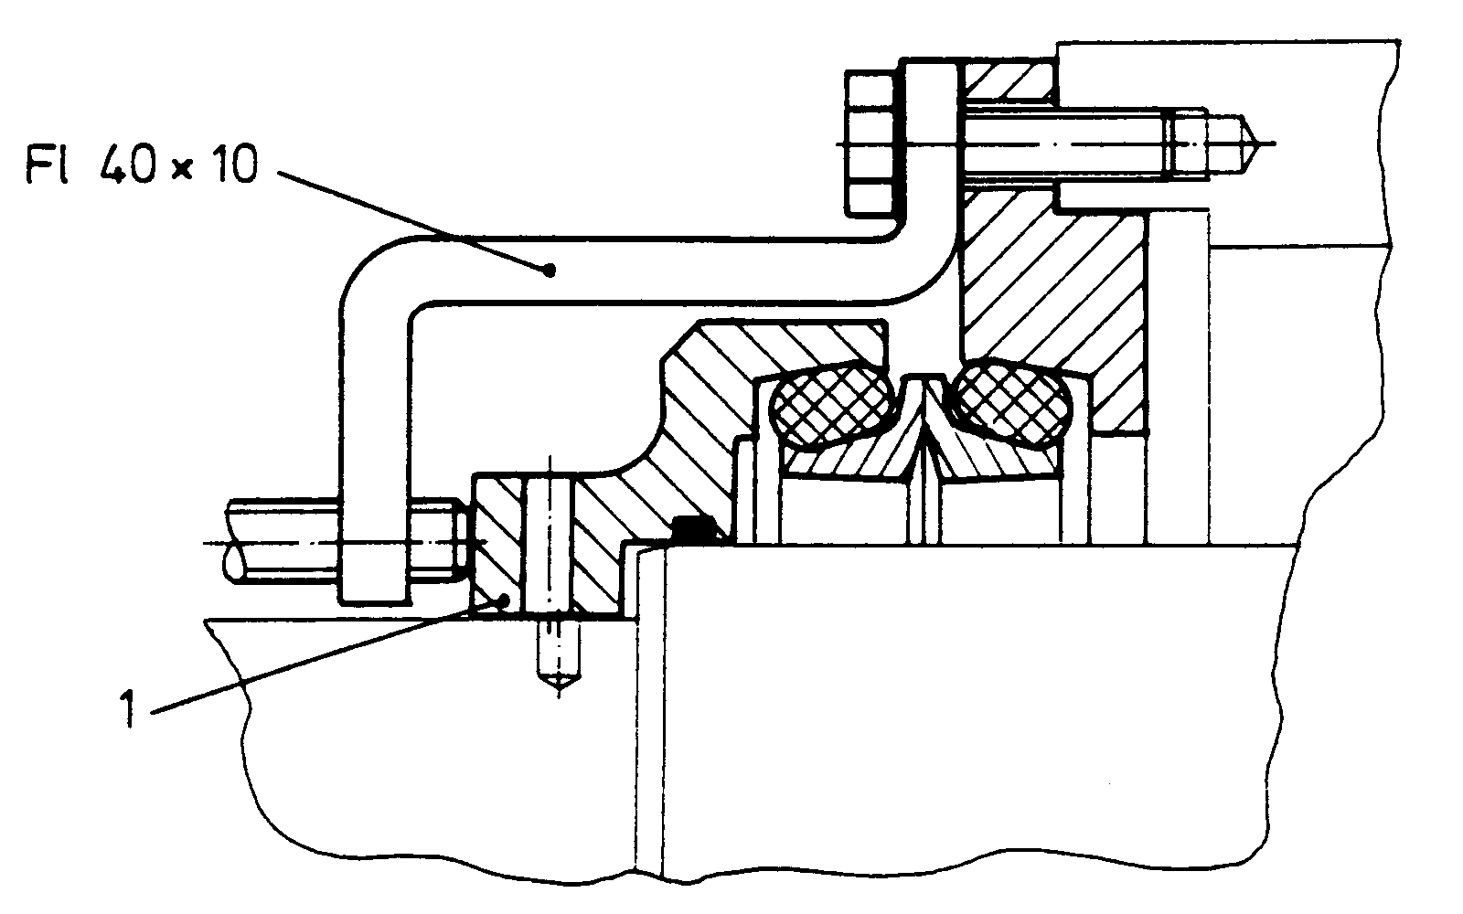
Installed position Figure 2
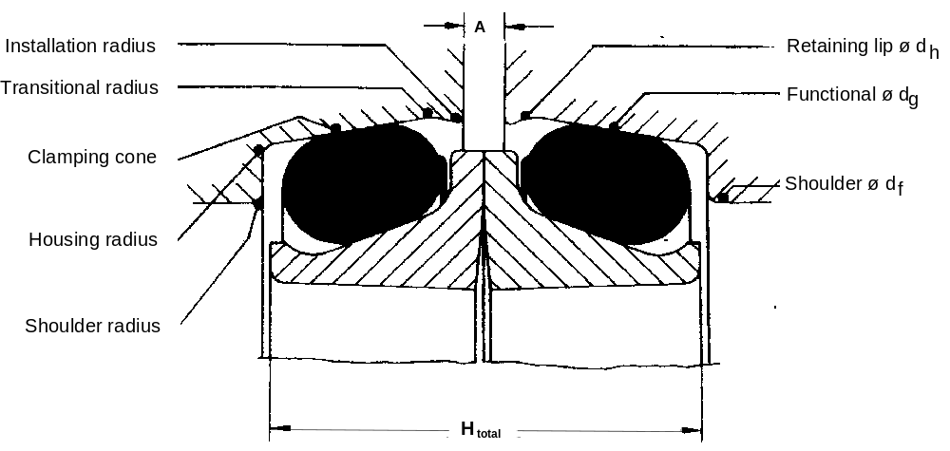
Seal-Ring with O-ring Figure 3
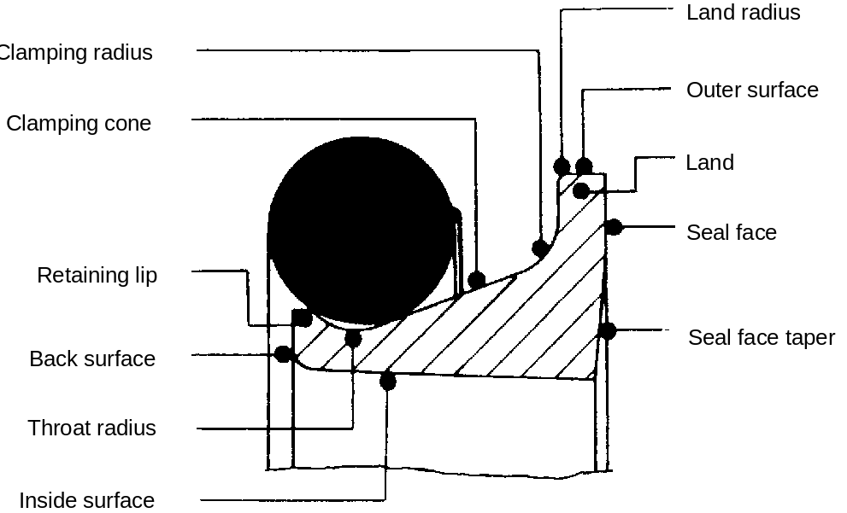
Seal-Ring with O-ring Figure 4
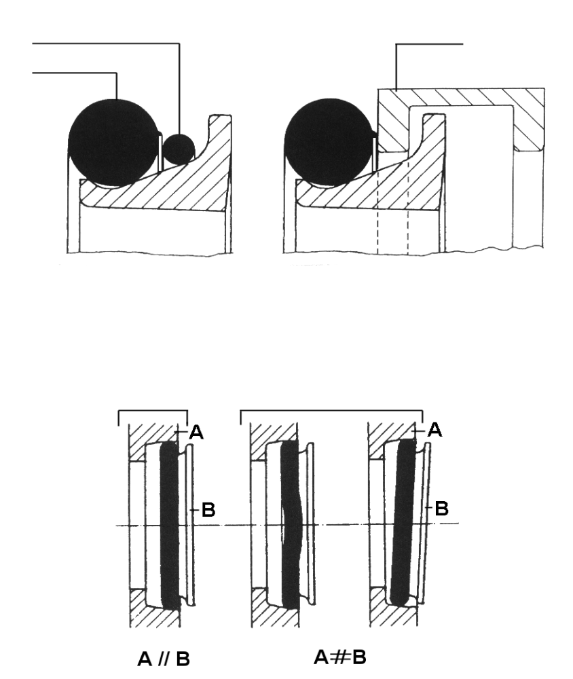
Installation Aid
Seal Ring
Installation Tool
correct
wrong
Figure 4a
Figure 4b
Figure 4c

