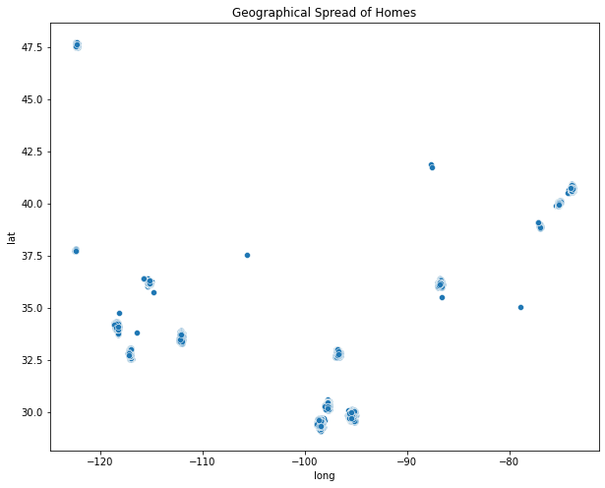

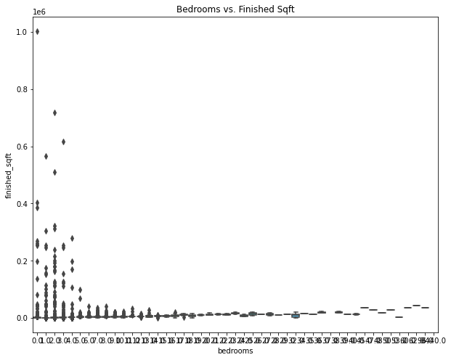

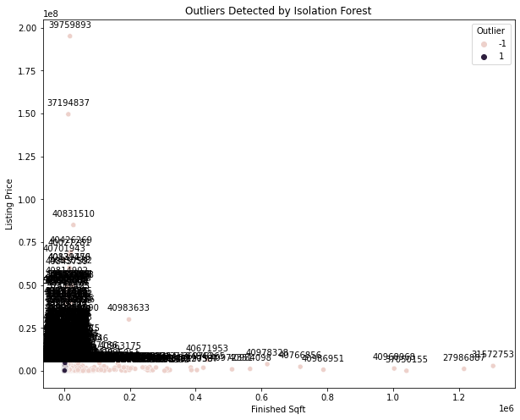

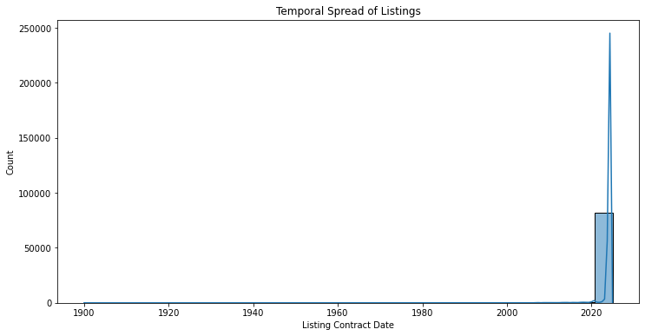

Descriptive Statistics for Numeric Attributes:

finished_sqft bedrooms bathrooms listing_price

count 7.345400e+04 79075.000000 76672.000000 8.411200e+04

mean 2.284015e+03 3.074334 2.274377 1.067901e+06

std 1.205212e+04 12.353739 9.383289 6.827188e+06

min 0.000000e+00 0.000000 0.000000 0.000000e+00

25% 1.168000e+03 2.000000 1.000000 3.250000e+05

50% 1.658000e+03 3.000000 2.000000 5.500000e+05

75% 2.336000e+03 4.000000 3.000000 1.000000e+06

max 1.304622e+06 3440.000000 2560.000000 9.390000e+08

Unique Values for Categorical Attributes:

home_type ['condo' 'single-family' 'cooperative' 'multi-family' 'misc' 'townhouse'

'land' 'unknown' 'mobile' None]

status ['SOLD' 'OTHER' 'UNKNOWN' 'OFF_MARKET' 'FOR_SALE' 'PENDING' 'WITHDRAWN'

'COMING_SOON']

Min listing_contract_date: 1900-01-01 00:00:00, Max listing_contract_date: 2024-12-27 06:00:00

Min on_market_date: NaT, Max on_market_date: NaT

Min pending_date: 1800-01-01 00:00:00, Max pending_date: 2024-03-27 19:21:42

Min last_sold_date: 1800-01-01 00:00:00, Max last_sold_date: 2025-08-01 00:00:00

Min off_market_date: 1800-01-01 00:00:00, Max off_market_date: 2024-03-27 19:20:18

Number of missing values per column:

id 0

listing_key 78

source_system 0

address 0

usps_address 4

status 0

listing_contract_date 534

on_market_date 84112

pending_date 57164

last_sold_date 67141

off_market_date 53019

original_listing_price 33808

listing_price 0

last_sold_price 68416

home_type 12

finished_sqft 10658

lot_size_sqft 16505

bedrooms 5037

bathrooms 7440

year_built 4835

new_construction 0

has_pool 0

state_market_id 0

city_market_id 0

zipcode_market_id 0

neighborhood_level_1_market_id 12863

neighborhood_level_2_market_id 14130

neighborhood_level_3_market_id 69461

long 5

lat 5

crawler 0

dtype: int64

Outlier Homes:

id finished_sqft listing_price

27 186061 16000.0 21000000.0

51 201161 4820.0 5995000.0

78 315906 2226.0 5900000.0

84 319861 12200.0 1075000.0

87 453401 0.0 4500000.0

... ... ...

83913 37466528 4220.0 1399900.0

83989 37486866 NaN 6000000.0

84035 37528922 2700.0 518000.0

84036 37529004 5760.0 899900.0

84050 37532082 3550.0 1500000.0

Outliers in 'finished_sqft' column:

id listing_key source_system ... lat crawler outlier

27 186061 358560 SFAR ... 37.795891 SFAR -1

51 201161 342932 SFAR ... 37.792541 SFAR -1

84 319861 360373 SFAR ... 37.748022 SFAR -1

89 547854 363274 SFAR ... 37.802682 SFAR -1

124 1909180 None ATTOM ... 37.783362 ATTOM -1

... ... ... ... ... ... ...

83832 37515342 802832824816 BRIGHT MLS ... 39.938372 BRIGHT MLS -1

83855 37455887 802827853984 BRIGHT MLS ... 40.006420 BRIGHT MLS -1

83913 37466528 802828848464 BRIGHT MLS ... 39.970383 BRIGHT MLS -1

83923 37467931 802828173276 BRIGHT MLS ... 39.945300 BRIGHT MLS 1

84036 37529004 802834245106 BRIGHT MLS ... 39.956350 BRIGHT MLS -1