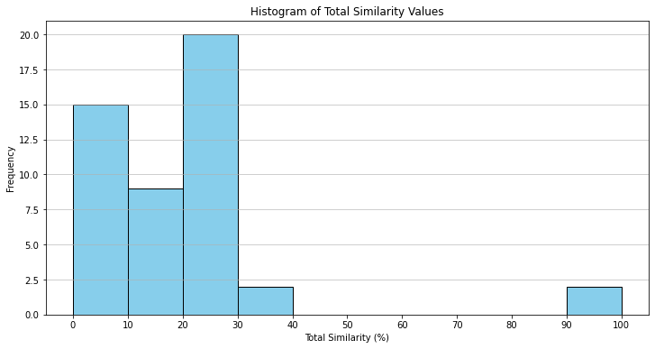

id bedrooms ... zipcode_market_id total_similarity_scaled

0 186 2.0 ... 1687 0.000000

334 33684935 2.0 ... 1687 0.000000

551 38170234 2.0 ... 1687 0.000000

1536 40210805 2.0 ... 1687 0.180031

1173 39964066 2.0 ... 1687 3.790994

1293 40051761 2.0 ... 1687 4.245937

1202 39979075 2.0 ... 1687 4.659522

1641 40026654 2.0 ... 1687 4.683243

1500 40154354 2.0 ... 1687 4.927136

2666 37240407 2.0 ... 1687 6.615536

2023 40818753 2.0 ... 1687 7.848993

2224 40818754 2.0 ... 1687 7.854467

2324 40818726 2.0 ... 1687 7.894609

1731 40546929 2.0 ... 1687 7.906165

2217 40931137 2.0 ... 1687 7.963337

2536 37243555 2.0 ... 1687 11.655800

2101 40824934 2.0 ... 1687 16.100015

1333 37472993 2.0 ... 1687 16.669910

1239 40004757 2.0 ... 1687 17.696575

2518 37072724 2.0 ... 1687 17.790848

2550 37117066 2.0 ... 1687 18.628966

1982 39898959 2.0 ... 1687 18.642346

557 38175185 2.0 ... 1687 19.180615

326 33583935 2.0 ... 1687 19.180615

1885 40737064 2.0 ... 1687 20.204846

2062 40830654 2.0 ... 1687 20.245597

2627 37184063 2.0 ... 1687 20.706014

2251 40943629 2.0 ... 1687 22.260607

2121 40870439 2.0 ... 1687 25.187938

2047 40824648 2.0 ... 1687 26.280897

577 38182464 2.0 ... 1687 26.749221

307 32984850 2.0 ... 1687 26.791796

1875 39929280 2.0 ... 1687 27.466305

2259 40945591 2.0 ... 1687 28.319020

559 38175383 2.0 ... 1687 28.613395

6 147772 2.0 ... 1687 29.766568

1506 40163768 2.0 ... 1687 29.770217

1042 39954132 2.0 ... 1687 29.778732

95 824032 2.0 ... 1687 29.781165

2673 37203724 2.0 ... 1687 29.802452

1474 39924939 2.0 ... 1687 29.814008

464 37573231 2.0 ... 1687 29.928961

1534 40210624 2.0 ... 1687 29.946599

76 241186 2.0 ... 1687 29.992215

57 229715 2.0 ... 1687 30.472703

97 1166312 2.0 ... 1687 30.472703

2665 37200905 2.0 ... 1687 99.971414

2788 37520711 2.0 ... 1687 100.000000

[48 rows x 6 columns]