Who Has the Most Luck in 2026 - Fire Horse Year? (And Why That's the Wrong Question)
- Mar 30
- 5 min read
People keep asking me: "Who has the most luck in 2026?"
I'll answer that question. But first, I need to tell you why it's the wrong question to ask.
I'm the Firepig. I was born in 1947, and I've been reading Chinese astrology for over three decades. I've done more than twenty thousand readings. And I can tell you this: luck is not something that happens to you. It's something you create.
But let me start with what you came here for.

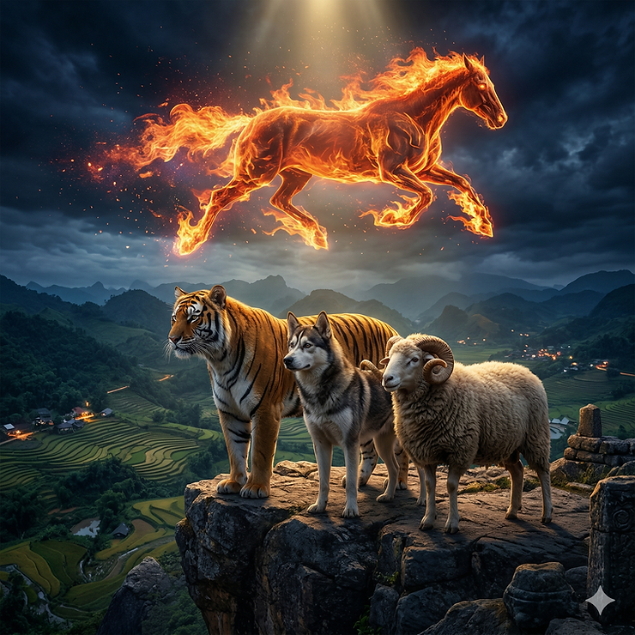

Who Has the Best Alignment in 2026?
From a Chinese astrology perspective, people born in the year of the Tiger, Dog, and Sheep have the best luck in 2026 in terms of opportunities. These three form what we call a "Trinity" with the Horse. They're naturally aligned with this year's energy.
But here's where it gets more nuanced.

The element of your birth year matters. Since Water clashes with this year's Fire, it's not a lucky year for people born in a Water year, even if they're a Tiger, Dog, or Sheep. A Water Tiger in a Fire Horse year? You've got the right animal, but the wrong element. There's friction.

On the other hand, people born in an Earth year have enhanced luck thanks to this year's Fire. Fire produces Earth in the elemental cycle. So Fire Horse year is feeding your energy. That's powerful.

And it's not just the year. The months matter too. Tiger, Dog, and Sheep months are auspicious if your sign is compatible with one of them. So even if your birth year isn't perfectly aligned, you might have windows of opportunity during specific months.

But Alignment Doesn't Guarantee Anything
Here's where most people misunderstand Chinese astrology.
They think: "I'm a Tiger born in an Earth year. This is my year. I just need to wait for good things to happen."
Wrong.

Luck isn't something that happens to you. It's something you create.
There are two key factors beyond sign compatibility: timing and readiness.
Timing is at the core of Chinese astrology - along with place, which is feng shui. You need to know when to move. When to act. When to wait. The signs tell you about the energy, but you still have to read the moment.

Readiness is not specific to Chinese astrology. It's life. Shakespeare said it best: "Readiness is all." You can have all the luck in the world, but if you're not ready, you won't benefit from it.

Think about lottery winners. They're few and far between. But "normal" luck - the kind most people experience - usually presents itself in the form of an opportunity. And even readiness doesn't help if you're not decisive.

So if you think luck is coming your way because the planets or signs are favorably aligned, and all you need to do is sit back and wait to reap its benefits, you're deluding yourself.

What the Great Minds Said About Luck
I'm not the only one saying this.
Thomas Jefferson said, "I am a great believer in luck, and I find the harder I work, the more I have of it."

Seneca, the Roman philosopher, said, "Luck is what happens when preparation meets opportunity."
Bruce Lee said, "I don't believe in pure luck. You have to create your own luck. You have to be aware of the opportunities around you and take advantage of them."
These men understood something fundamental: luck is active, not passive.

Chinese astrology gives you a map. It tells you where the opportunities are likely to appear. It tells you what kind of energy the year carries. It tells you when to push and when to hold back.
But it doesn't do the work for you.

How to Think About Luck in a Fire Horse Year
Fire Horse year is fast. Opportunities come quickly. They also disappear quickly.
If you're a Tiger, Dog, or Sheep - especially if you're born in an Earth year - this is your time. But you have to be ready. You have to be watching. And when the moment comes, you have to move.

If you're not in one of those signs, don't think you're out of luck. You just have to be more intentional. Work harder. Stay alert. Position yourself where opportunities are likely to emerge.

And remember: the Horse is yang energy. It rewards boldness. It punishes hesitation.
This is not a year for people who are waiting for luck to find them. This is a year for people who are creating their own luck.

A Real Example: The Dog Year Client Who Wasn't Getting Lucky
I had a client - born in a Dog year, Earth element. 2014 was a Wood Horse year. Not as intense as Fire Horse, but still a Horse year, which means it's favorable for Dogs.
He came to me and said, "Bill, I know this is supposed to be a good year for me. But nothing's happening."

I asked him, "What have you done?"
He said, "I've been waiting for opportunities to show up."
I told him: the year is aligned in your favor. That means when you act, the wind is at your back. But you still have to act. The Horse doesn't come to you. You have to ride it.
He went back and started making moves. He reached out to old contacts. He put himself in rooms where deals were happening. He made offers. Within three months, he landed the biggest contract of his career.

That's what I mean by creating your own luck. The year gave him favorable conditions. But he still had to do the work.

What If You're Not in a Favorable Sign?
You work harder. You stay sharper. You don't give up.
Luck isn't binary. It's not "you have it" or "you don't." It's a spectrum.
Even in a year that's not aligned with your birth sign, there are still windows of opportunity. You just have to be more deliberate about finding them.

And honestly? Some of the most successful people I know made their breakthroughs in years that were challenging for their sign. Because they had to be more intentional. They couldn't coast.
Fire Horse year is intense. It's volatile. That creates chaos. And chaos creates openings.

If you're alert, if you're ready, if you're willing to move when the moment comes - you can create luck in any year.

The Bottom Line
Luck is not a gift. It's a practice.
Chinese astrology tells you when conditions are favorable. It tells you when to lean in and when to be cautious. But it doesn't do the work for you.

If you're a Tiger, Dog, or Sheep born in an Earth year, this is your time. Use it. Don't waste it waiting for luck to find you.
If you're not in one of those categories, don't despair. Work harder. Stay alert. Create your own opportunities.

And for everyone: remember that readiness and decisiveness matter more than any alignment. The universe doesn't reward passivity. It rewards action.
Fire Horse year is running. The question is: are you riding it, or watching it pass by?

