3 temperatures (3,7, 20 °C)

2 varieties of canola (Zarfam and RGS003)

3 ABA priming treatments (50, 100 or 150 µM), besides hydro-priming and control

2 duration of priming (24, 40 h)

3 storage condition (no deterioration, priming before deterioration, priming after deterioration)

3 replications

The explanatory variables were including temperature, variety, treatment and storage condition which all of them were categorical. Count number of germinated seeds (called g) which was out of 50 planted seeds, was the response variable.

Data exploration showed that data set do not obey normal distribution (even after transformation). Moreover, 120 out of 270 observations of germinated seeds were zeros. So, generalized linear model were chosen to model germinated seeds in a zero inflated framework. Data were analyzed using R (i386 3.0.0). At first a generalized linear model (family=poisson) was fitted with counted number of germinated canola seeds (g) as the response variable and interactions between storage situation (storage), temperature (temp), variety (var) and priming treatments (treat) fitted were used as explanatory variables (table1).

Table1. Anova results for maximal model (having 4-way interactions of storage situation (storage), temperature (temp), variety (var) and priming treatments (treat); Signif. Codes are 0 ‘***’ 0.001 ‘**’ 0.01 ‘*’ 0.05 ‘.’ 0.1 ‘ ’ 1

Df Deviance Resid. Df Resid. Dev Pr(>Chi)

NULL 269 6851.5

storage 2 3284.7 267 3566.8 < 2.2e-16 ***

temp 2 1213.0 265 2353.8 < 2.2e-16 ***

treat 4 133.3 261 2220.5 < 2.2e-16 ***

var 1 1.0 260 2219.5 0.324863

storage:temp 4 1188.8 256 1030.7 < 2.2e-16 ***

storage:treat 8 245.9 248 784.8 < 2.2e-16 ***

temp:treat 8 118.8 240 666.1 < 2.2e-16 ***

storage:var 2 156.8 238 509.2 < 2.2e-16 ***

temp:var 2 80.7 236 428.6 < 2.2e-16 ***

treat:var 4 29.3 232 399.3 6.891e-06 ***

storage:temp:treat 16 13.8 216 385.5 0.615765

storage:temp:var 4 1.4 212 384.2 0.848700

storage:treat:var 8 104.2 204 280.0 < 2.2e-16 ***

temp:treat:var 8 24.2 196 255.8 0.002139 **

storage:temp:treat:var 16 25.5 180 230.3 0.060990 .

For better interpretation of dataset, a series of model simplification techniques were applied. Contrasts of each variable were tested separately (table2).

Table2. Model summary of separated contrasts for different explanatory variables; Signif. Codes were 0 ‘***’ 0.001 ‘**’ 0.01 ‘*’ 0.05 ‘.’ 0.1 ‘ ’ 1 ; Priming treatment levels were control (no priming), hydro priming, priming with 50 µM, 100 µM and 150 µM. Storage levels were priming after deterioration (det_prime), primed and then deterioration (prime_det) and putting in normal situation (no_det). There were two levels of variety (Zarfam and RGS003). Temperatures were 3,7 and 20°C.

|  |  |  |  |  |  |
| --- | --- | --- | --- | --- | --- |
|  | Estimate | Std. Error | t value | Pr(>|t|) |  |
| **priming treatments** |  |  |  |  |  |
| intercept | 1.2853 | 0.122 | 10.536 | <2e-16 | *** |
| Control vs. Hydro | -0.4508 | 0.1929 | -2.337 | 0.0202 | * |
| 50 vs control | 0.3891 | 0.1929 | 2.017 | 0.0447 | * |
| 100 vs Control | -0.4508 | 0.1929 | -2.337 | 0.0202 | * |
| 150 vs Control | -0.4157 | 0.1929 | -2.155 | 0.0321 | * |
| 50 vs hydro | -0.0617 | 0.1929 | -0.32 | 0.7493 |  |
| 100 vs hydro | 0.0588 | 0.1929 | 0.305 | 0.7607 |  |
| 150 vs hydro | 0.03517 | 0.19289 | 0.182 | 0.855 |  |
| 50 vs 100 | -0.002898 | 0.192891 | -0.015 | 0.988 |  |
| 100 vs 150 | 0.02363 | 0.19289 | 0.123 | 0.903 |  |
| 50 vs 150 | -0.002898 | 0.192891 | -0.015 | 0.988 |  |
|  |  |  |  |  |  |
|  |  |  |  |  |  |
| **storage** |  |  |  |  |  |
| intercept | 1.28535 | 0.0869 | 14.791 | <2e-16 | *** |
| det_prime vs no_det | -1.4765 | 0.1064 | -13.87 | <2e-16 | *** |
| det_prime vs prime_det | 0.07286 | 0.10643 | 0.685 | 0.494 |  |
| prime_det vs no_det | 1.5494 | 0.1064 | 14.558 | < 2e-16 | *** |
|  |  |  |  |  |  |
| **variety** |  |  |  |  |  |
| intercept | 1.28535 | 0.12294 | 10.455 | <2e-16 | *** |
| RGS003 vs Zarfam | 0.06378 | 0.12294 | 0.519 | 0.604 |  |
|  |  |  |  |  |  |
| **temperature** |  |  |  |  |  |
| intercept | 1.2853 | 0.1068 | 12.036 | <2e-16 | *** |
| 3C vs 7C | -0.1854 | 0.1308 | -1.418 | 0.157 |  |
| 7C vs 20C | 0.9608 | 0.1308 | 7.345 | 2.49E-12 | *** |
| 3C vs 20C | -1.1462 | 0.1308 | -8.763 | 2.25E-16 | *** |

For the next step, non-significantly different levels of each variable combined with each other, and the new model was created by dummy combined variables. Non-significant interactions were omitted and the model was compared with null model using AIC. Model was plotted to see how it has improved interpretation of dataset. Table 3 shows the result of anova using Chi test.

Table3. Anova results for minimally adequate model usig Chi test; Signif. Codes are 0 ‘***’ 0.001 ‘**’ 0.01 ‘*’ 0.05 ‘.’ 0.1 ‘ ’ 1

Df Deviance Resid. Df Resid. Dev Pr(>Chi)

NULL 269 6851.5

Combinedstorage 1 3259.5 268 3592.0 < 2.2e-16 ***

Combinedtemp 1 969.7 267 2622.3 < 2.2e-16 ***

Combinedtreat 1 132.3 266 2490.0 < 2.2e-16 ***

Combinedtemp:Combinedtreat 1 4.7 265 2485.3 0.03006*

Combinedstorage:Combinedtreat 1 53.6 264 2431.7 2.412e-13 ***

Combinedstorage:Combinedtemp 1 1182.3 263 1249.4 < 2.2e-16 ***

It is worth to note that it was tried to make more complex contrasts by interaction between different variables, but unfortunately no result was gained. So, the experiment was continued by using the results of main effect contrasts. Variety variable was removed as no significant difference was seen between Zaerfam and RGS003 (table 3). In the new model none of the 4-ways or 3-ways intercations were showed significant p-values. Two-way interactions between storage, treatment and temperature were highly significant which were plotted by conditional boxplot to see how they can affect the number of geminated canola seeds (Fig 1:3).

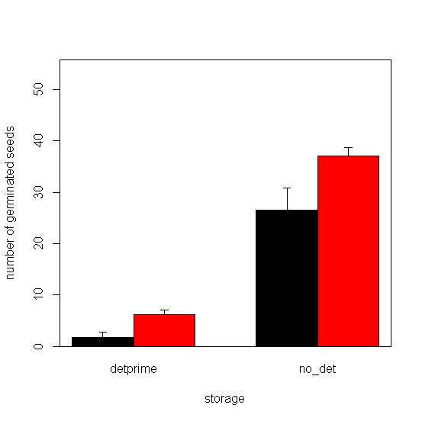

Figure 1. Interaction of storage and treatment on number of germinated canola seeds; black columns represent Control and the red ones represent combination of 50,100,150 micromolars of ABA plus hydropriming. Storage levels are putting seeds in adverse storage condition (detprime) and putting seeds in normal situation (no_det). X-axis is the average of germinated seeds number (out of 50 seeds) and error bars are standard deviation.

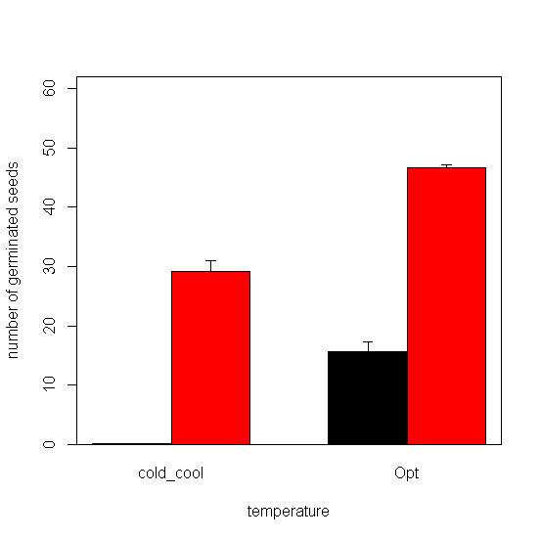

Figure 2. Interaction of temperature and storage situation on number of germinated canola seeds; black columns represent adverse storage condition and the red ones represent normal situation. Temperatures levels are putting seeds are combination of 3 and 7 °C (cold_cool) and 20 °C (Opt). X-axis is the average of germinated seeds number (out of 50 seeds) and error bars are standard deviation.

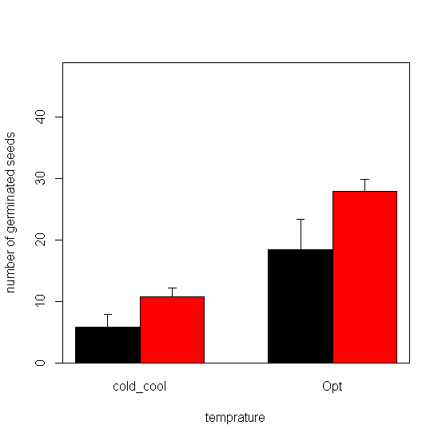

Figure 3. Interaction of temperature and treatment on number of germinated canola seeds; black columns represent Control and the red ones represent combination of 50,100,150 micromolars of ABA plus hydropriming. Temperatures levels are putting seeds are combination of 3 and 7 °C (cold_cool) and 20 °C (Opt). X-axis is the average of germinated seeds number (out of 50 seeds) and error bars are standard deviation.